How to Change the Principal Investigator
The individual who creates the application in InfoEd is automatically added to the protocol as the Principal Investigator.
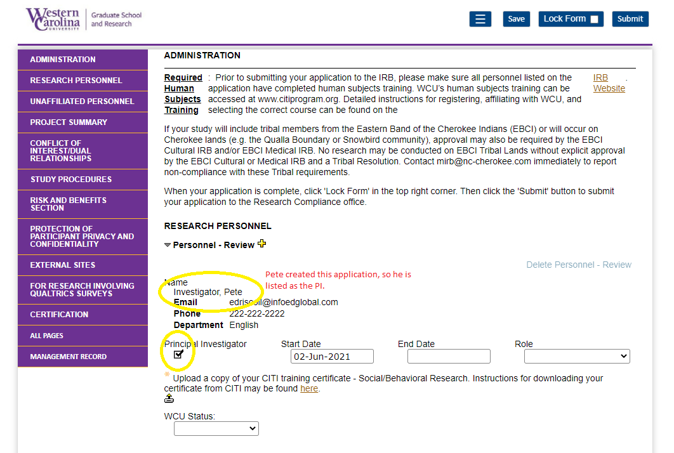

Click the plus (+) sign to add another WCU affiliated person the research team.
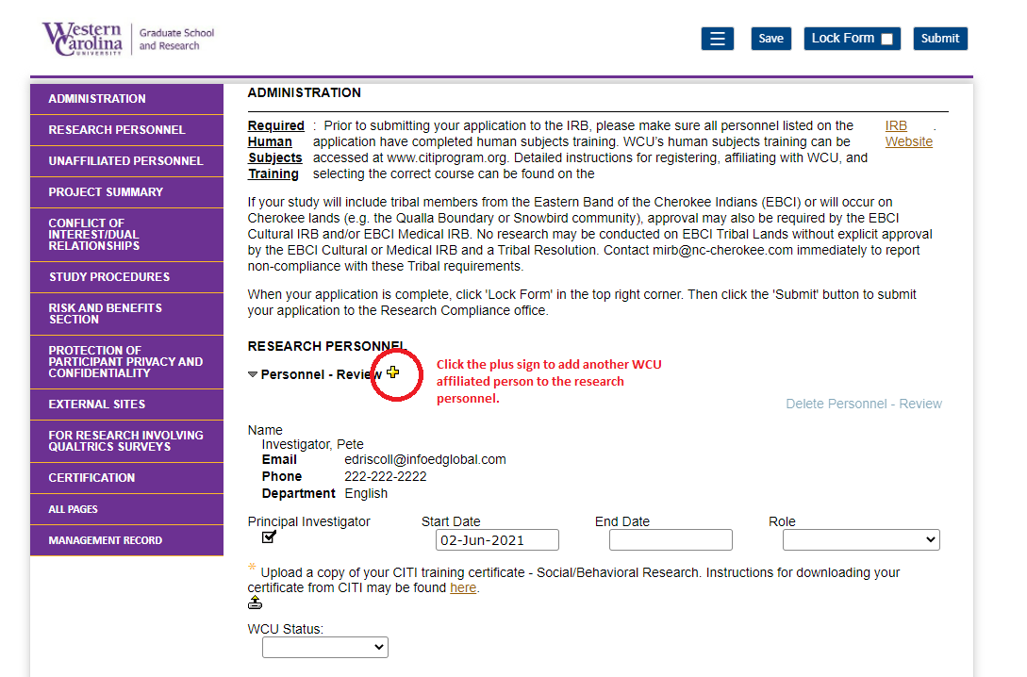

A popup will appear. Type the name of the person you wish to add to the research team and select the person from the dropdown list. Then click ‘Select’ in the top right corner.
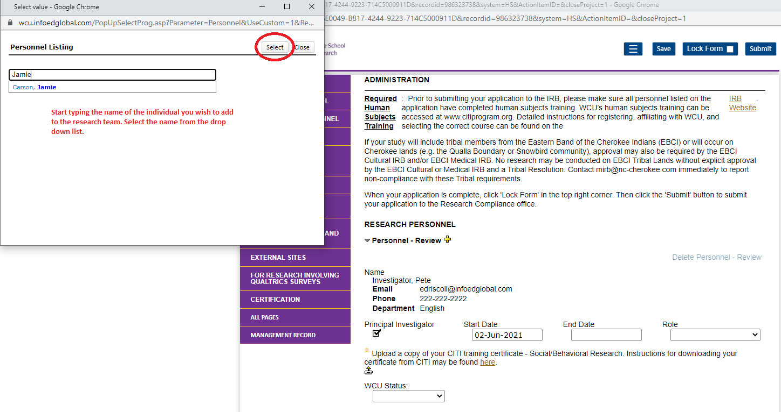
The newly added research team member will appear below the creator of the application.
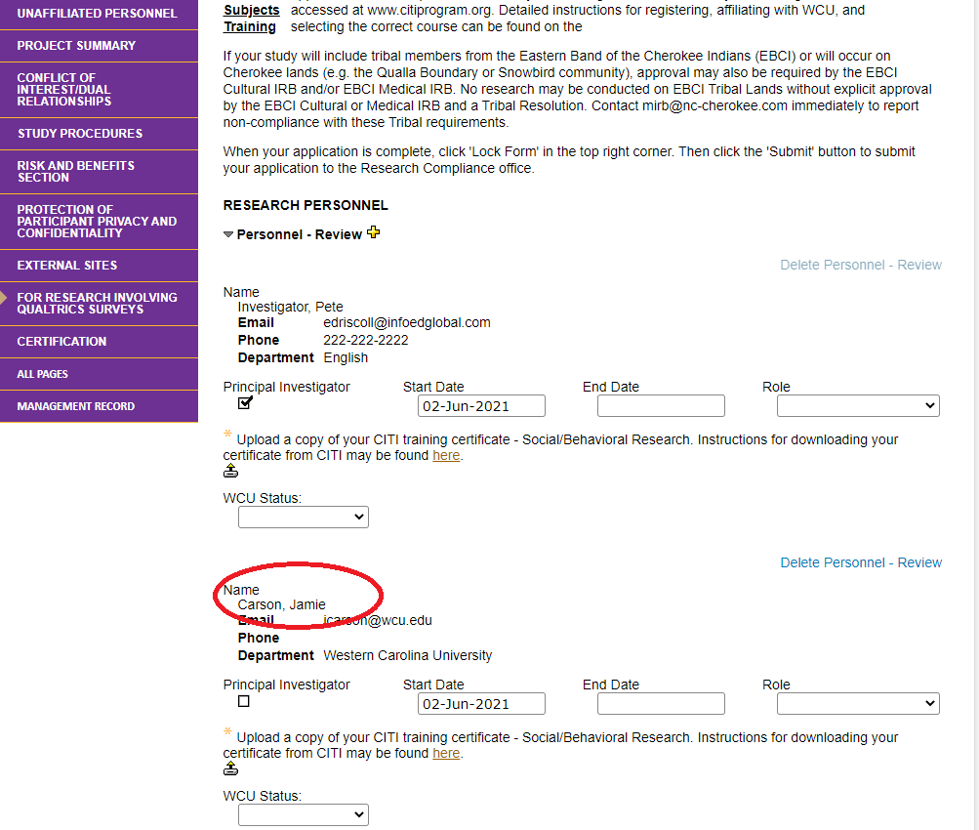
Check the box that says “Principal Investigator” under the name of the person that was added. This removes the check mark in the PI box from the original creator.
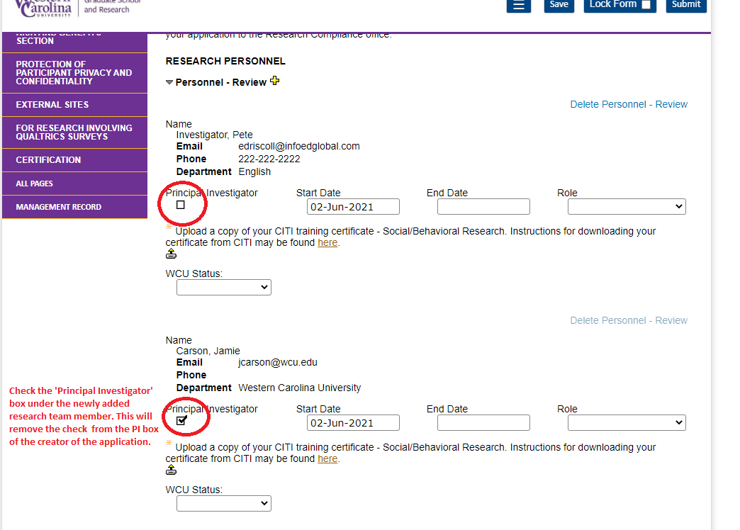
The Principal Investigator is now changed.

