How to Upload a Document
The process for uploading a document is the same, no matter which compliance eform you need to submit.
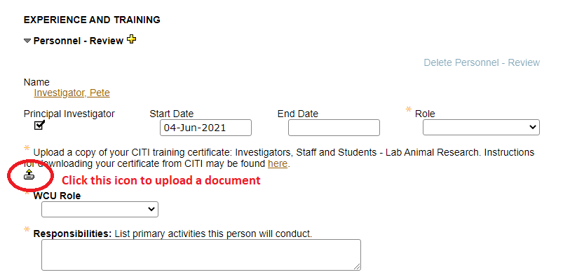
Click the icon to upload a document. A popup will appear. Click ‘Choose File’. Find the document you wish to upload.
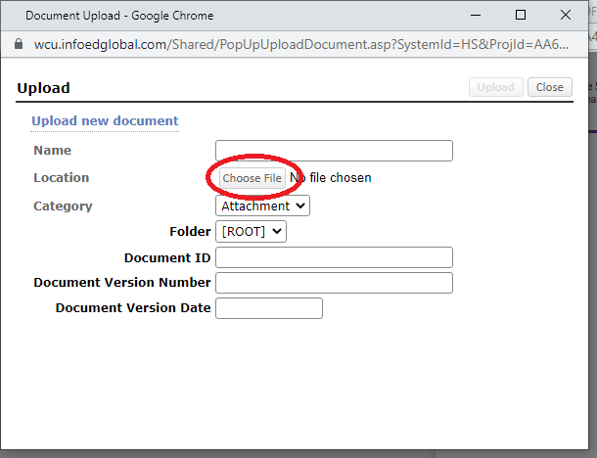

Name the document. No other information needs to be entered. Click ‘Upload’. The upload is now complete.
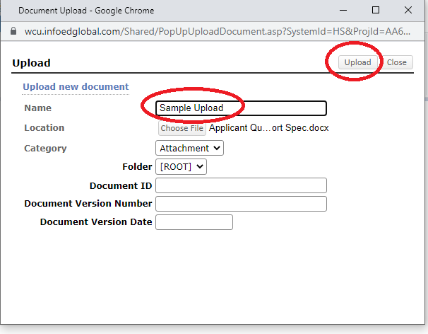
The popup will close, and you will be returned to the application. To verify that your document was uploaded, click on the reading glasses that now appear next to the upload button.
