Western Carolina University
Office of Institutional Assessment

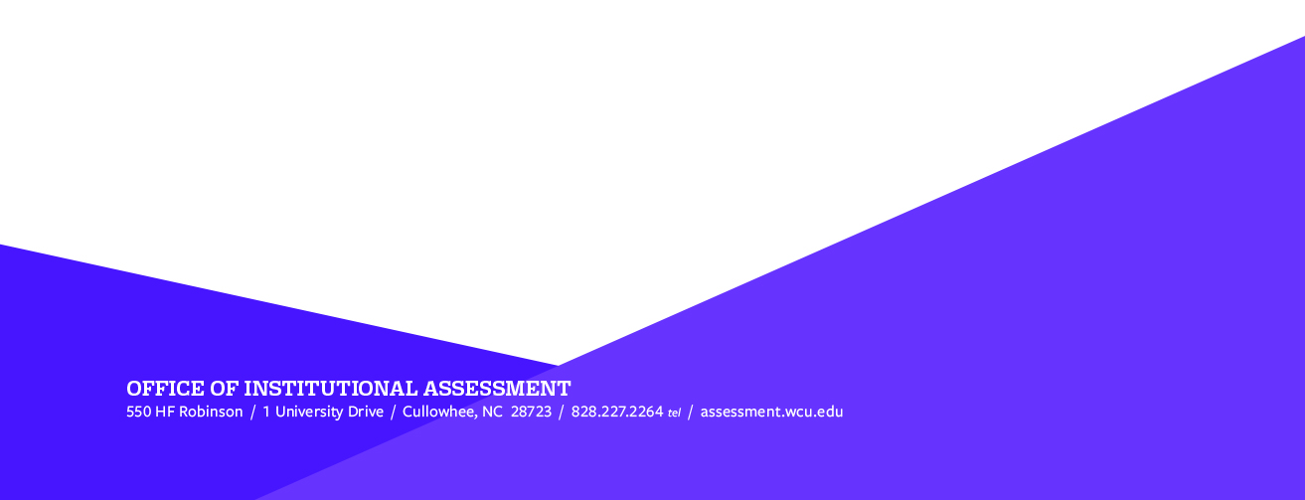
Academic Programs CIR

Contact us for assistance

assessment@wcu.edu

Table of Contents

- Student Learning Outcome
  - Data Collection & Assessment Method – When, Where, Why, Who, & How
  - Target Expectation & Rubric/Scoring Method
  - Assessment Results & Analysis of Data

- Follow Up on Previous Improvement Actions from the last Assessment Cycle

- Recommendations for Continuous Improvement

- Faculty and Stakeholder Involvement in Assessment

- Carnegie Community Engagement

- All Programs: Assessment Plans

- All Programs Curriculum Maps

- CIR Feedback

- Student Learning Outcome
Click '+Program' and select the outcome to be assessed from the drop-down list. Each subsequent outcome you choose will appear in the order it’s added – thus, the first outcome you select will be listed as SLO #1, the second you choose from the list will be listed as SLO #2, etc.

  - Data Collection & Assessment Method – When, Where, Why, Who, & How
When and Where did the assessment occur? For example – the semester/year of the assessment, the course name and number, etc.
Why were these particular courses or assignments chosen for the assessment? Who was included in assessment? Please list the total number of students being assessed, their academic levels, and their modality (residential, residential-online, or distance-online).
What method did you use to collect data on this SLO (exam, assignment, survey, etc.)
Why/How did you choose this particular assessment method? Is this a direct measure of learning (meaning it doesn't rely solely on a student's perception of their own learning)?
Response:

  - Target Expectation & Rubric/Scoring Method
Target: What is your baseline expectation of student performance? In other words, what percentage of student work does the program expect will meet or exceed expectations for this measure? Please attach the rubric, exam questions/answers, or other criteria you used to define student performance (e.g., exceeds, meets, or below expectations). You can attach the rubric or other documentation by clicking “File+” OR copy/paste into the field set.
Response:

  - Assessment Results & Analysis of Data
What were the results of your assessment? For example, what percentage of student work exceeded, met, or fell below expectations. As you assess your program’s SLOs, please disaggregate your data when possible – meaning please break down the data into smaller informational categories. (Examples: student year at the university, distance v. residential students, or performance on specific test questions, etc.) How do these results compare with your program’s baseline target expectation? What do the results suggest regarding student performance against this outcome? Please compare to previous assessment results, if available. *FOR DUAL MODALITY PROGRAMS ONLY (Programs that offer fully in-person AND online versions of their degree) - You must disaggregate your data by students in your online vs residential degrees.
Response:

- Follow Up on Previous Improvement Actions from the last Assessment Cycle
Please provide a detailed account of how your program has utilized past assessment outcomes from the most recent set of SLOs assessed and CIR feedback to guide adjustments in curriculum or instruction since the previous assessment cycle. Please describe the changes and their impact in detail. Additionally, incorporate any pertinent insights gained and subsequent actions taken during the preceding cycle.
Response:

- Recommendations for Continuous Improvement
What actions will your program take to improve student performance based on the SLOs and information assessed during this cycle? Please include detailed information - for instance, HOW you expect this action to impact student performance based on this assessment cycle, WHEN you anticipate implementing this improvement, and WHO is responsible for implementing the action.
Response:

- Faculty and Stakeholder Involvement in Assessment
Which faculty participated in this year’s assessment process? What was their role? And if applicable, describe any external stakeholders involved in the assessment (e.g., advisory boards, industry professionals who provided input, external reviewers who provided feedback, etc.)
Response:

- Carnegie Community Engagement
How has your program engaged with the community through teaching, learning, research, and creative activities? Please indicate any projects, partnerships, or outcomes that illustrate this connection with the community. You may include links and attachments as examples. (Provide as much detail as possible as this will help our re-classification efforts for the Carnegie Community Engaged designation.)(The Office of Institutional Assessment may contact your program for more information.)
Response:

- All Programs: Assessment Plans
Please attach your program’s current assessment plan here. This assessment plan should cover the years 2022-2027 (the second half of WCU’s 10 year accreditation cycle). The assessment plan can be in whatever format works best for your department/unit.
Response:

- All Programs Curriculum Maps
Please attach the program's most recent curriculum map.
Response:

- CIR Feedback
The Office of Institutional Assessment will review and provide feedback on your CIR. Once it’s finished, it will be posted here. It will also be emailed to individual program directors and department heads.
Response by OIA:

