STUDENT COURSE SURVEY AT WESTERN CAROLINA UNIVERSITY
PROCEDURAL MANUAL

PROVISIONAL VERSION
October 2022

STUDENT COURSE SURVEY AT WESTERN CAROLINA UNIVERSITY

OVERVIEW

Western Carolina University uses an online course evaluation system, Anthology Course Evaluations, for gathering and disseminating the results of student perceptions of learning. The process and procedures for student evaluations are the same across the campus so that data collected can be as uniform as possible. These procedures are outlined in this manual. It is recommended that all faculty review this document. Student assessments are often referred to by the acronym SCS (Student Course Survey). This term refers to the online evaluations done using the Course Evaluations system. SCS data are an integral part of the reappointment, tenure, and promotion process at WCU as well as essential for our continuous improvement efforts

Table of Contents
History and Background 4
Student Course Survey Forms 6
Evaluation of cross-listed courses 9
Timeline 10
Course Evaluation Specifics 12
What Students Receive and See 12
What Faculty Members Receive and See 18
Getting Results 24
Frequently Asked Questions 36
From Students 36
From Faculty 36
Questions or Problems 39

History and Background

Student Course Surveys (SCS), previously referred to as Student Assessment of Instruction (SAI), are important to both faculty and administrators. Required for use in teaching evaluation procedures by UNC Policy Manual (400.3.1.1[G]) the WCU Faculty Senate, in collaboration with the Provost Office and the Office of Institutional Planning and Effectiveness (OIPE), has worked to review, implement, and revise the online Student Course Surveys since the 2004-2005 academic year. The Faculty Senate, on behalf of the General Faculty, continues to update and address issues with student evaluation instruments recognizing its role in the collegial review process and the innate flaws of student survey instruments as documented in literature. (See the Summary of Findings and Rationale Section of the Spring 2022 report from the Student Questionnaire Task Force.)

Development of the Online Instrument and Procedures
Early versions of WCU student evaluations were implemented using scannable response forms and a software system that became increasingly unreliable and finally obsolete. When the UNC System Offices mandated all constituent universities to create a uniform mechanism for measuring performance, a Student Assessment Instrument (SAI) Task Force was formed by the Faculty Senate to take the lead on this work. The Task Force agreed that compiling university-wide data on student assessment of instruction would be useful, and any new instrument needed to uniform and universal bases for evaluation.

As the types and modalities of courses grew more diverse, the Task Force recommended developing different versions of assessment instruments to offer the flexibility to address the distinctive aspects of WCU’s many departments and programs. The Faculty Senate developed a list of standardized questions to be used in course evaluation, and 12 different versions of SAI instruments were created to match the needs of distinct types of courses. A resolution adopting these 12 “master” question sets was passed by the Faculty Senate in 2005.

Additional task forces were created to review online course evaluation systems to provide the uniform mechanism for student evaluations. After determining using current software on campus was not logistically feasible, external vendors were considered and Academic Management System’s product, CoursEval3, was selected. In Spring 2007, a pilot program was conducted with five volunteer departments and results were evaluated to determine the utility and efficacy of the online system. The pilot was successful, and CoursEval was open to all faculty and departments as of the Fall 2007 academic year.

Updates

Summer Session Timelines: As the many starting/ending dates and course durations of the summer session made implementing the SAI in the allotted timeframes specified in policy, the Faculty Senate modified the timeline for course evaluations for summer sessions in March, 2012. (See the resolution here.)

Revised Assessment Instrument: Building on the work of three consecutive years of Faculty Senate councils and task forces dedicated to researching, reviewing, and revising SAI process, procedures, and uses, the 2021-2022 Student Questionnaire Task Force recommended replacing the current SAI survey in their March 2022 report with a new student perceptions of learning instrument of student perception of teaching effectiveness to be named the Student Course Survey. At their March 23, 2022 meeting, the Faculty Senate voted to adopt the “Student Course Survey”, the student perceptions of learning instrument recommended by the Student Questionnaire Task Force, starting with the Fall 2022 semester.

Student Course Survey Form

The current student course survey (SCS) below was approved by the WCU Faculty Senate on March 23, 2022 and is to be the student survey instrument used for all courses at WCU, regardless of modality, starting with the Fall 2022 semester.

The student-facing view of the survey consists of 14 statements or questions. The first ten statements address aspects of Organization and Clarity, Course Environment and Rapport, and Overall Satisfaction – elements of the third area for the evaluation of teaching at WCU, Student Response to Instruction (See Faculty Handbook, 4.05 B 1.(e)). Questions 11 and 12 are intended to provide context to student evaluations and are NOT to be considered in the student ratings of teaching or satisfaction. Question 13 asks students to identify their anticipated grade, and the final two questions are open-ended, as with previous instruments.

View to be seen by students:

 | Statements/Questions | SA A D SD
1.  2.  3.  4.  5.  6.  7.  8.  9.  10. | In this course, the subject matter was explained clearly.  The organization of this course (e.g., due dates, required assignments, resources) was communicated clearly.  Clear guidelines were provided for the work required in this course.  Grades and/or other feedback enabled me to know how I was doing throughout this course.  Students were encouraged to use available resources (e.g., textbooks, readings, websites, library materials, tutoring, or office hours) to improve their understanding of course content.  The instructor was available during office hours or via email.  The instructor encouraged participation and/or students’ questions.  The instructor treated me with respect.  The subject matter was presented in an interesting and engaging way.  Overall, I was satisfied with this course.
11.  12. | On the next two items, compare this course with others you have taken at this institution.  Amount of coursework.  Difficulty of subject matter. | Much less than most | Less than most | About average | More than most | Much more than most | N/A or cannot answer
13. | What grade do you expect to receive in this course?
14.  15. | Open-ended questions:  Describe the most important aspects of this course that fostered your learning.  Describe changes that could be made to this course to foster learning.

View with sub-scales and annotations for faculty and administrators:

 | Statements/Questions | SA A D SD
1.  2.  3.  4.  5.  6.  7.  8.  9.  10. | Organization and Clarity  In this course, the subject matter was explained clearly.  The organization of this course (e.g., due dates, required assignments, resources) was communicated clearly.  Clear guidelines were provided for the work required in this course.  Grades and/or other feedback enabled me to know how I was doing throughout this course.  Students were encouraged to use available resources (e.g., textbooks, readings, websites, library materials, tutoring, or office hours) to improve their understanding of course content.  Course Environment and Rapport  The instructor was available during office hours or via email.  The instructor encouraged participation and/or students’ questions.  The instructor treated me with respect.  The subject matter was presented in an interesting and engaging way.  Overall Satisfaction  Overall, I was satisfied with this course.
14.  15. | Open-ended questions:  Describe the most important aspects of this course that fostered your learning.  Describe changes that could be made to this course to foster learning.

Course Workload and Difficulty

(The following questions are for context only, and are not of inclusion in the assessment)
11.  12. | On the next two items, compare this course with others you have taken at this institution.  Amount of coursework.  Difficulty of subject matter. | Much less than most | Less than most | About average | More than most | Much more than most | N/A or cannot answer
13. | What grade do you expect to receive in this course?

Each semester a list is compiled by the Office of Institutional Planning and Effectiveness (OIPE) and distributed to each department head. This list indicates all of the courses for which evaluations are slated to be conducted, and the instructor(s) associated with each course.

Evaluation of Cross-listed Courses:
Many of the courses coded as cross-listed in Banner need to be combined to represent a single course section for faculty evaluations. Since courses are cross-listed for various reasons it is difficult to determine which courses to combine as one. Therefore, the following guidelines will be used.

Guidelines for Evaluating Cross-Listed Courses
Courses which are coded as cross-listed in Banner will be set up for Course Evaluations using the following procedures:

- An instructor’s cross-listed courses which have the same level (UG/GR), instructional method and schedule/activity type, and are under a single department will automatically be combined into one course evaluation for a given evaluation period.

- Graduate and undergraduate courses which are cross-listed will be evaluated separately.

- For all other cross-listed courses which a department wishes to have evaluated as one course, the department head must inform the OIPE and identify the courses. Examples are (a) cross-listed courses with different delivery methods which are essentially the same, such as cross-listed EDHE531 lecture sections with face-to-face and online methods; (b) cross-listed multi-departmental courses which are identical except for the course name, such as BIOL 361 and CHEM 361.

The standard files sent by OIPE which request changes to course evaluation forms will contain additional fields which will identify cross-listed courses and will allow department heads to flag those courses falling under #3 above which they wish to have evaluated as one.

Timeline

For courses with a 15 week duration:
The Student Course Survey (SCS) period shall begin on the Sunday three weeks before the beginning of finals week and close on the Sunday one week prior to the beginning of finals week, thus SCSs will be open for two weeks.

For courses with duration less than 15 weeks and greater than four weeks duration: The SCS period shall begin on the Sunday two weeks from the end of classes and close on the Sunday of the final week of classes, thus SCSs will be open for one week.

For courses with duration less than four weeks and greater than or equal to two weeks: The SCS period shall begin on the day five class periods from the last class period and close prior to two (including the last class) class periods from final class period, thus SCSs will be open for 60 hours.

For courses with duration less than two weeks:
The SCS period shall begin three (including the last class) class periods from the last class period and close prior to one class period from final class period, thus SAIs will be open for at least 48 hours.

For classes with fewer than 5 students, the following disclaimer shall be added to the StudentCourse Survey:

“We welcome your feedback on the course and the instructor. Please be aware that because this is a course that has five or fewer students in it, your professor may be able to determine from whom your comments came. In this course, as in all courses regardless of their size, your instructor will not see your comments or ratings until after final grades have been submitted.”

Revised Timelines for Summer Courses

A WCU Faculty Senate Resolution on Modification to Summer CoursEval passed in March 2012 updated course evaluation policy for summer courses.

For courses with duration less than two weeks:
These courses are to be evaluated on paper, or by online form provided to students, by departments. No Course Evaluation is to be administered by OIPE or through the Course Evaluation system.

For courses with ending dates within one week of each other:
The SCS period shall be combined into the same open/close period for course evaluations, with the open/close dates adjusted slightly if needed to accommodate varying length courses.

For courses with duration less than 15 weeks and greater than 4 weeks
The SCS period shall begin on Sunday two weeks from end of classes and close on the Sunday of the final week of classes; being open for one week. The Sunday open/close day will be adjusted according to the actual ending dates of the courses involved so there is approximately one week remaining after evaluations close.

For 15-week and 8-week courses ending within one week of each other:
The SCS period opens on the Sunday three weeks from the end of classes and closes on the Sunday of the final week of classes; being open for two weeks. The Sunday open/close day will be adjusted according to the actual ending dates of the courses involved so there is approximately one week remaining after evaluations close.

For Mini-mester (less than 4 weeks) course:
The SCS period will be opened/closed with minimal modification to the normal policy (above). If other courses meeting more than 2 weeks are scheduled outside of the normal mini-mester dates but end within one week of the mini-mester courses, the course evaluations will be combined, and the open/close dates adjusted accordingly as long as mini-mester evaluations are not negatively impacted. The Office of Institutional Planning and Effectiveness (OIPE) issues the dates when Course Evaluations will be open before each semester begins on the Course Evaluation website (https://www.wcu.edu/learn/office-of-the-provost/oipe/surveys/courseval.aspx). Faculty are strongly encouraged to put these dates on syllabi as it helps both students and instructors remember opening and closing dates of assessments.

What Students Receive and See

Course Evaluations Specifics

Course Evaluations will be open when approximately 80% of the course is completed. During this period, email notifications will be sent to students’ Catamount email accounts indicating that course evaluations are now open. These emails include instructions about when and how to log-on to the Course Evaluations system. The University will also have banners, flyers, and an advertisement on digital banners displayed around campus. There will also be postcards mailed to every student mailbox at WCU and announcements on the campus radio to encourage student participation in the course evaluations. Figures 1 – 3 illustrate student views of Course Evaluations.

Figure 1. Initial email to students.

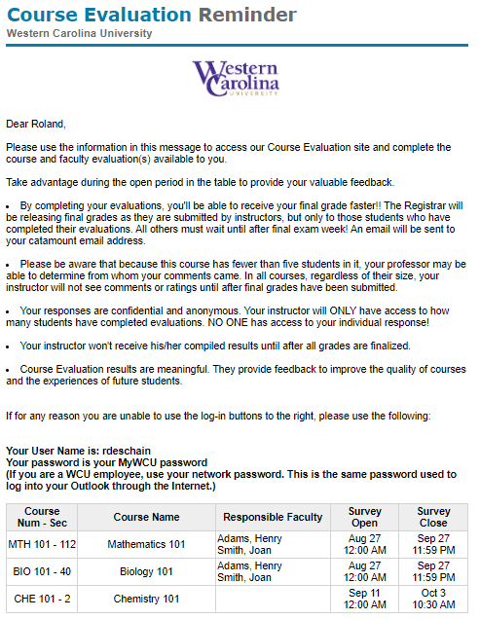
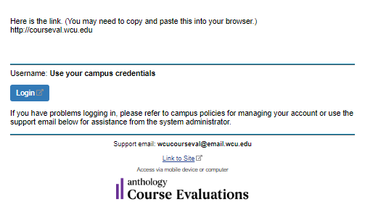

Student View:
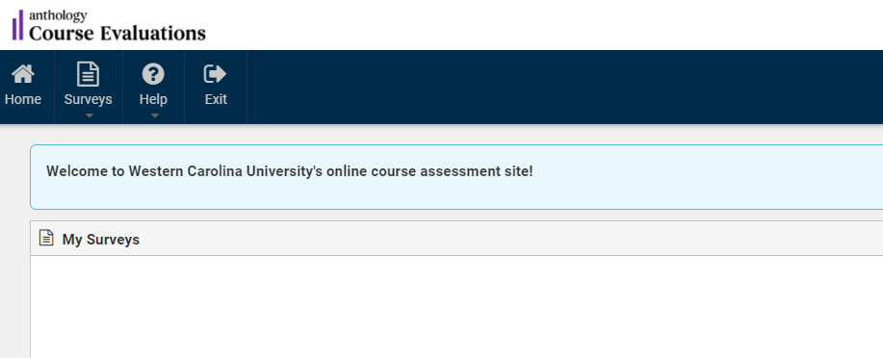

Surveys are listed by Available, Completed, and Missed Surveys
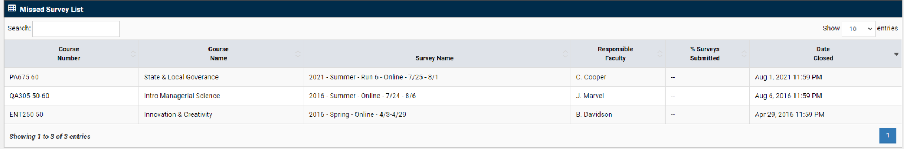

Figure 2. Student views of the Course Evaluations website.

(2022) Sample Student Course Survey

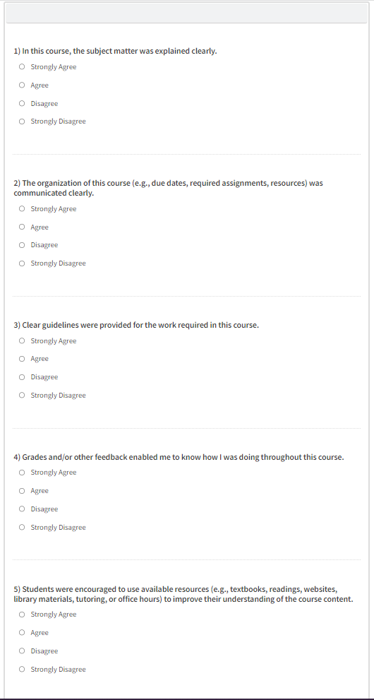

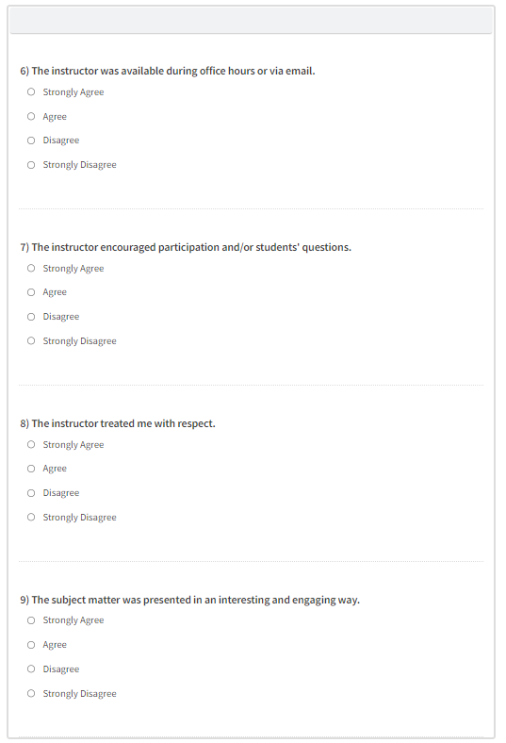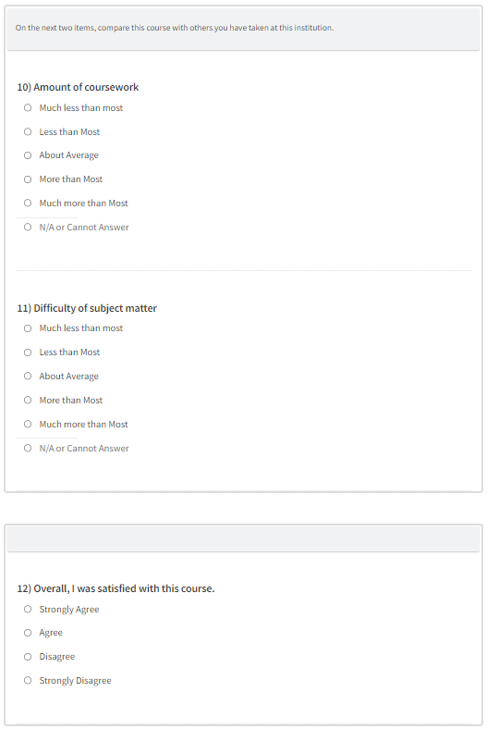

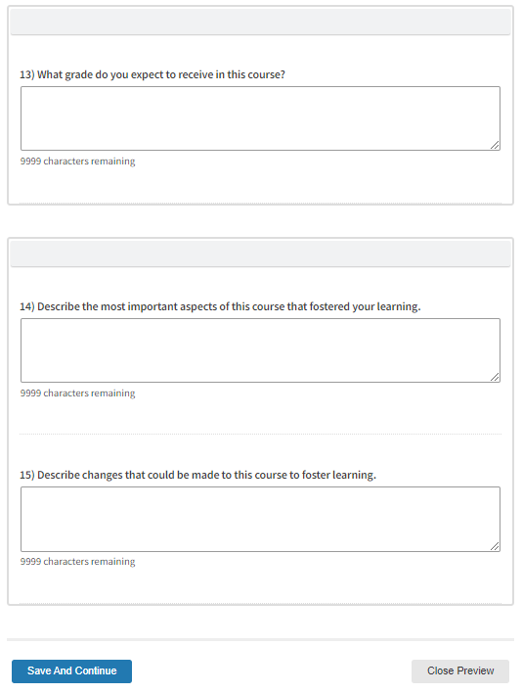

Figure 3. Student view of survey.

Open-Ended Questions
The SCS contains a section with the following two open-ended questions:

  - Describe the most important aspects of this course that fostered your learning.
  - Describe changes that could be made to this course to foster learning.
Students have a text box in which to respond to these questions.

All open-ended responses are viewable only by the specific faculty member, department head, and dean. Open-ended responses may be included in reappointment, tenure, promotion, and annual evaluation documents. The inclusion of open-ended responses is at the discretion of individual faculty.

All students’ responses are intended to provide formative information, i.e., be constructive in helping faculty to continue to improve teaching. Faculty may choose to use them as part of the summative evaluation, however, that is not the primary purpose.

What Faculty Members Receive and See

For each given course (or courses, if within the same evaluation period) faculty members receive a message three days prior to their Course Evaluations opening (Figure 4). Then an additional email is sent to the faculty member alerting him/her that Course Evaluations is open (Figure 5). Halfway course evaluation reminder emails are sent to the faculty member indicating the percentage of students that have responded at that time (Figure 6). At this point, it is appropriate to remind students of the importance the course evaluation process and encourage them to participate.

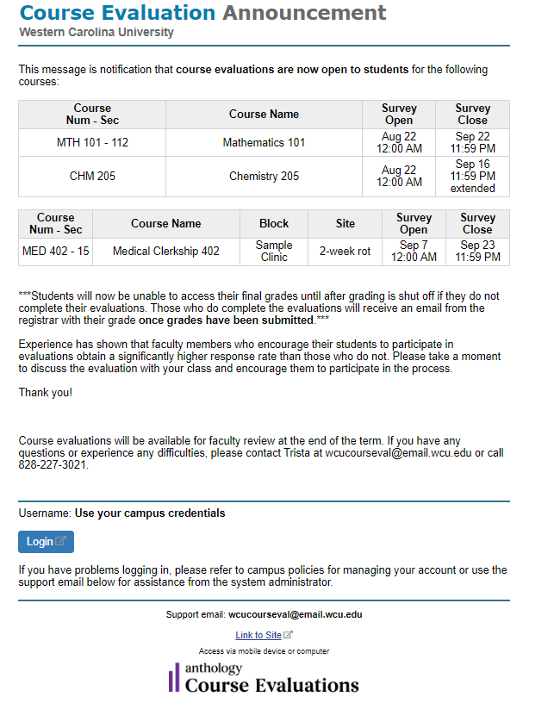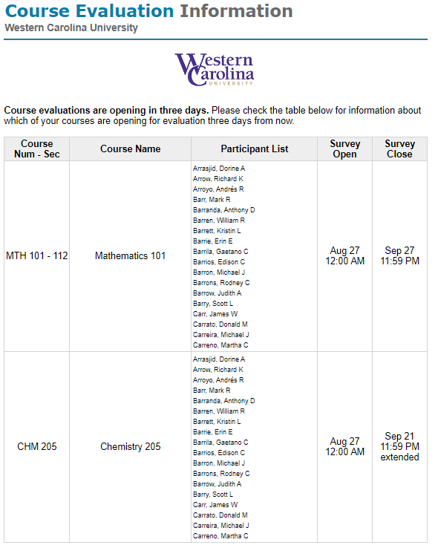
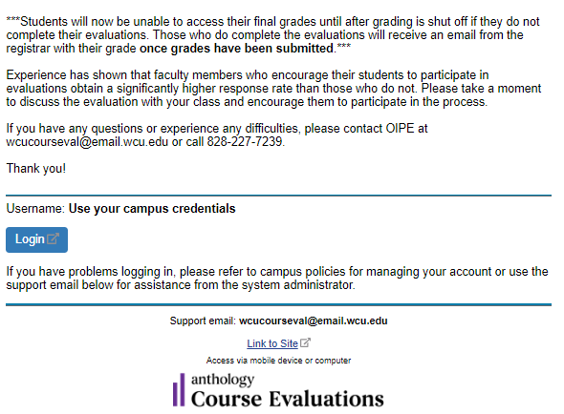

Figure 4. First faculty notifications that the Course Evaluations SCS will open in a few days.

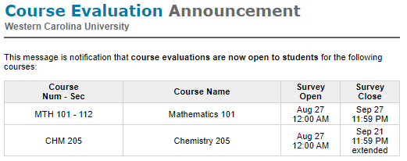
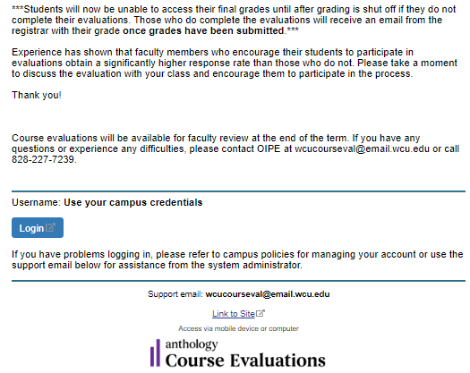

Figure 5. First faculty notification that the Course Evaluations SCS are open.

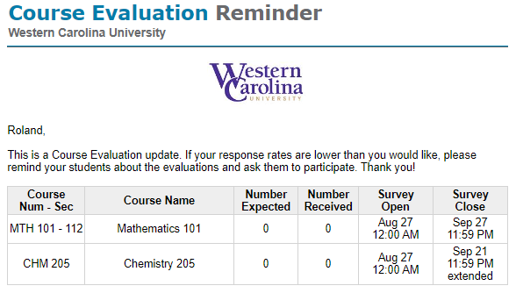
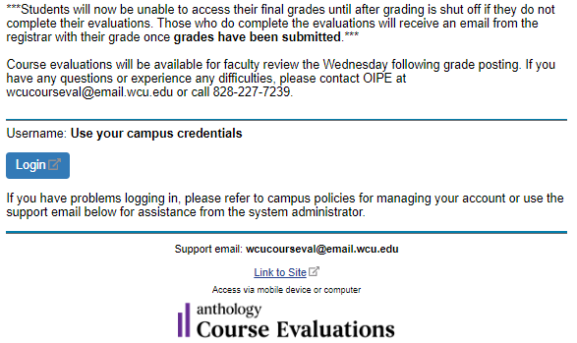

Figure 6. Email to the faculty indicating response rate.

Getting Results

After final grades have been recorded, a last Course Evaluations email will be sent to the faculty member and department head indicating survey results are available. This email contains password and username information. Faculty will go to the Course Evaluations site and enter their MyWCU username and password. These are usually the same as the Outlook passwords (i.e., not 92 numbers). Once logged into the system the Home page is the view (with active links) for Evaluation Reports and Course Section Reports. The Course Section Reports has two options to view, breakdown is the details of this course survey and comparison offers the individual survey mean, with department mean, with the mean of all course surveys in the term. There is also an option to view Individual Surveys from the Reports Menu at the top of the Home Page.

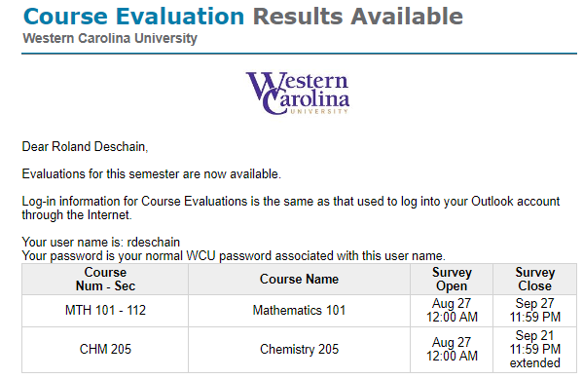
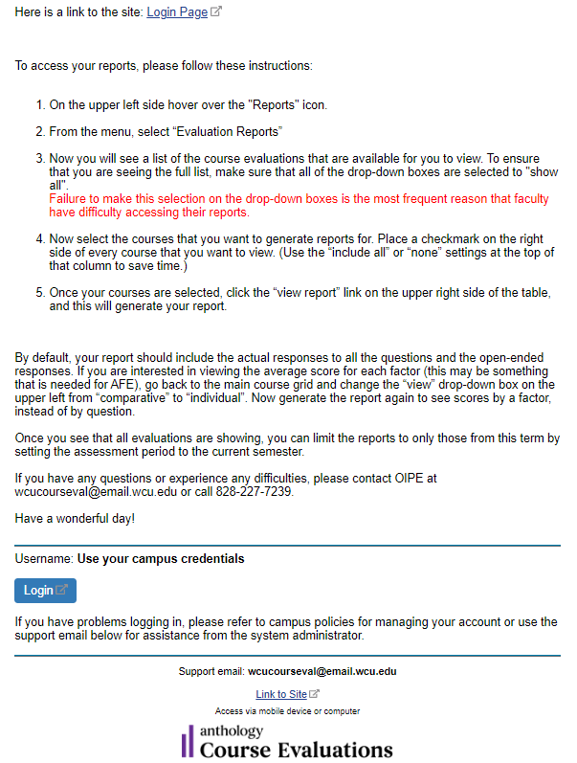

Figure 7. Email to the faculty indicating surveys are available.

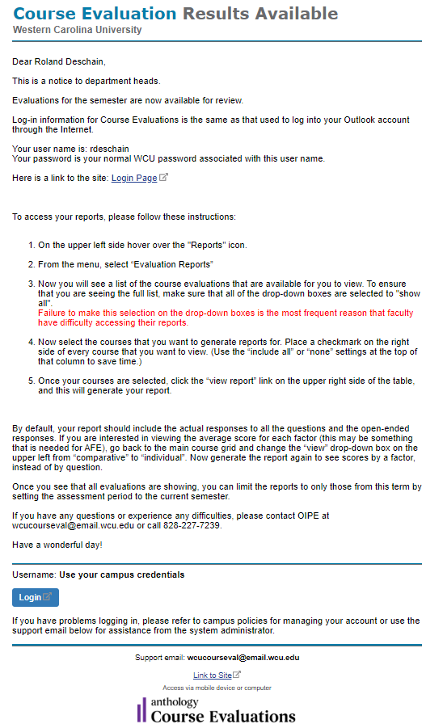

Figure 8. Email to the department heads indicating survey results are available.

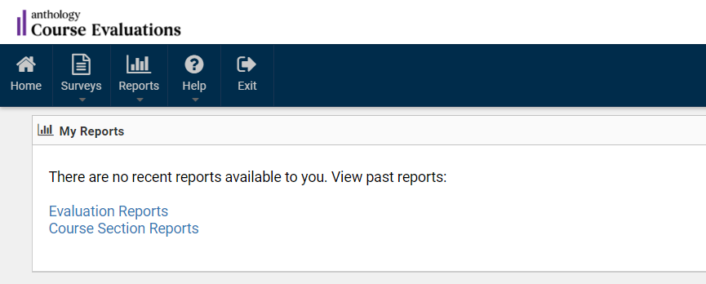

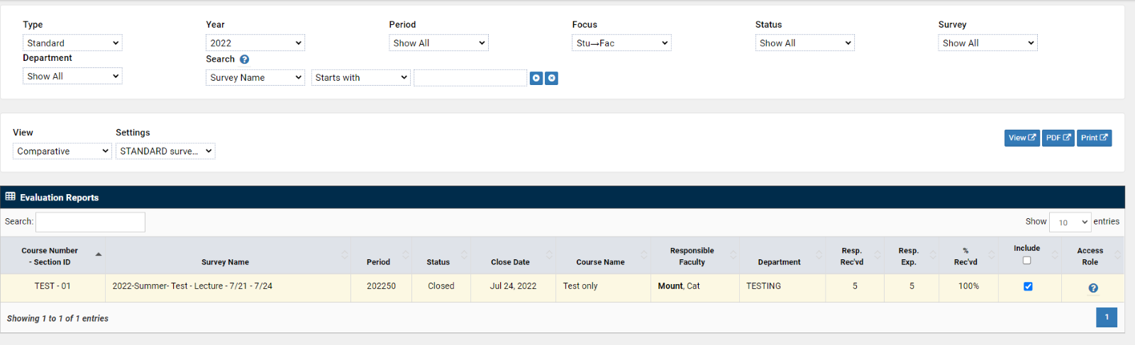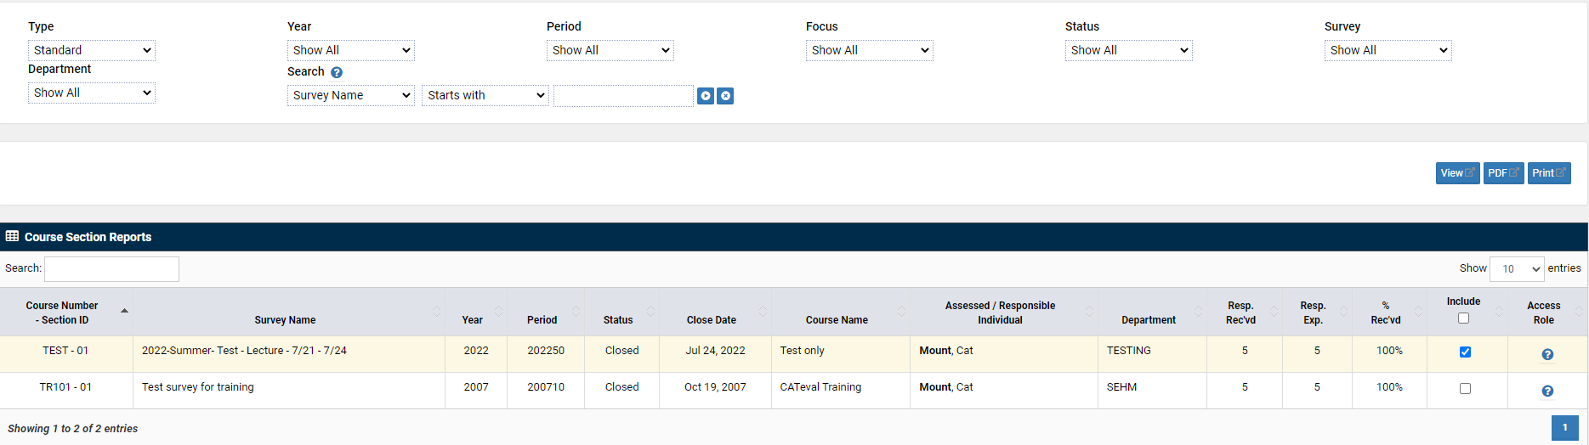

Figure 9. Summary Screens on Course Evaluations for survey results.

Please note that evaluation reports are available indefinitely while the faculty member is employed at WCU. The reports are no longer available to that faculty member once he/she/they leave() WCU employment.

To view course results, click in the ‘Include’ box, the second to last column on the table. Then choose the method to view the report by selecting one of the blue buttons-View, PDF, or Print above the Evaluation Reports table. This opens a new window that lists the results for each course section that has been selected. It should look similar to the following report (Figure 10):

Comparative Evaluation Report
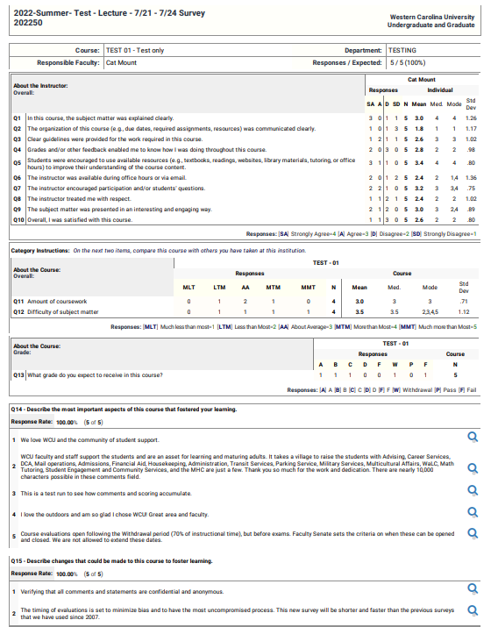

Individual Reports

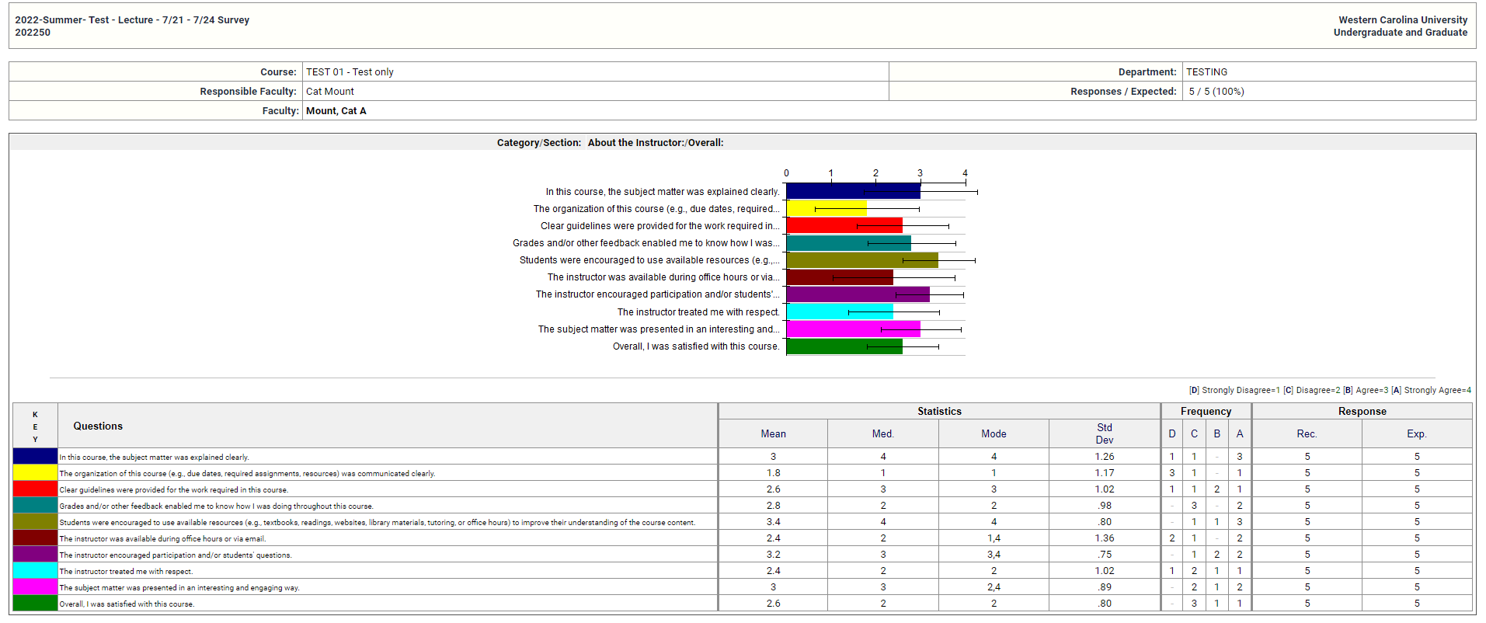

Individual Reports (Overall)

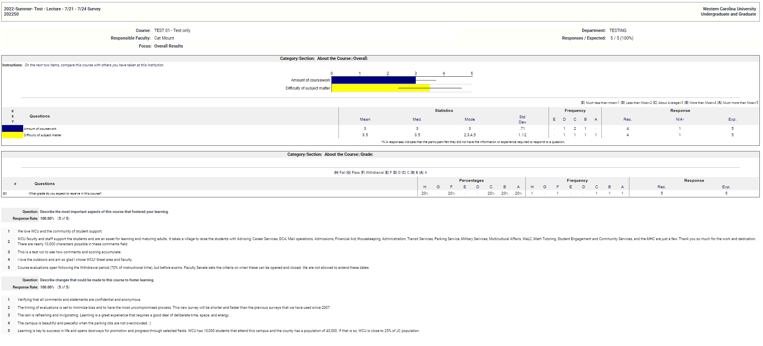

Figure 10. Typical detailed Course Evaluations reports.

Scaled Responses

Results are broken down into the major categories of the surveys as it is administered to students. To view the report by category, stay on Evaluation Report, but change the view to “individual”. Faculty will be able to see how many students Strongly Agreed (SA), Agreed (A), Disagreed (D), or Strongly Disagreed (SD) with each category in the survey. These qualitative responses are then converted into their numerical equivalents as follows:

Strongly Agree | 4
Agree | 3
Disagree | 2
Strongly Disagree | 1

To the right of the number of responses received in each category, a table provides the median, mode, standard deviation, the N, and the mean for each category and for the course as a whole (Figure 8).

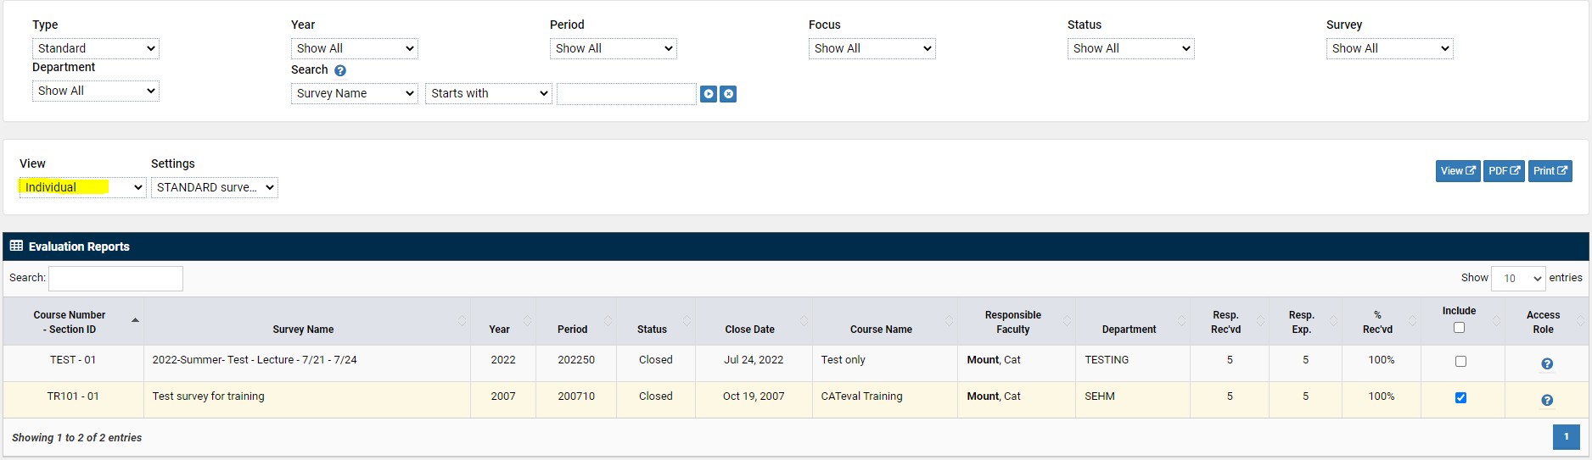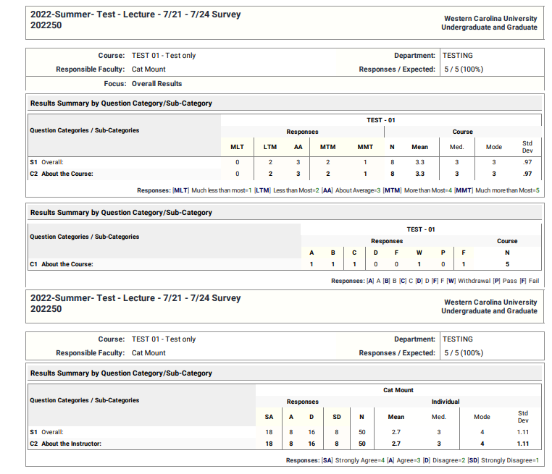

Figure 11. Summary Course Evaluations report.

Each category -labeled S1, S2, etc. - represents the two types of questions based upon multiple faculty teaching (and being evaluated) or singular to the course (expected grade, amount of work, and difficulty of subject matter.) To get result breakdowns by individual question stay on Evaluation Report but change the view to “comparative.” (See instructions under Open-Ended Responses below.)

To print results, look to the upper right-hand side of the Main Screen for the word “PRINT” (Figure 12). This will open a new window in the Print Preview.

Figure 12. Retrieving reports from main results page.

Figure 13. Main results page.

Faculty may be required to include these reports in reappointment, tenure, and promotion documents as well as annual faculty evaluation dossiers. The exact format for including information in these documents may vary by department and college.

Open-Ended Responses

Open-Ended responses can be viewed in two reports: a) the Evaluation Report where the view is set to comparative, or b) the Course Section Report t is clicked (Figure 15). There is also an option under Reports for Individual Reports. In the Individual Report, a full report can be viewed (including scaled and open-ended responses) for each individual class. Color charts are also provided. The responses to the open-ended questions follow the scaled responses on this report. They appear in individual text boxes (Figure )15.

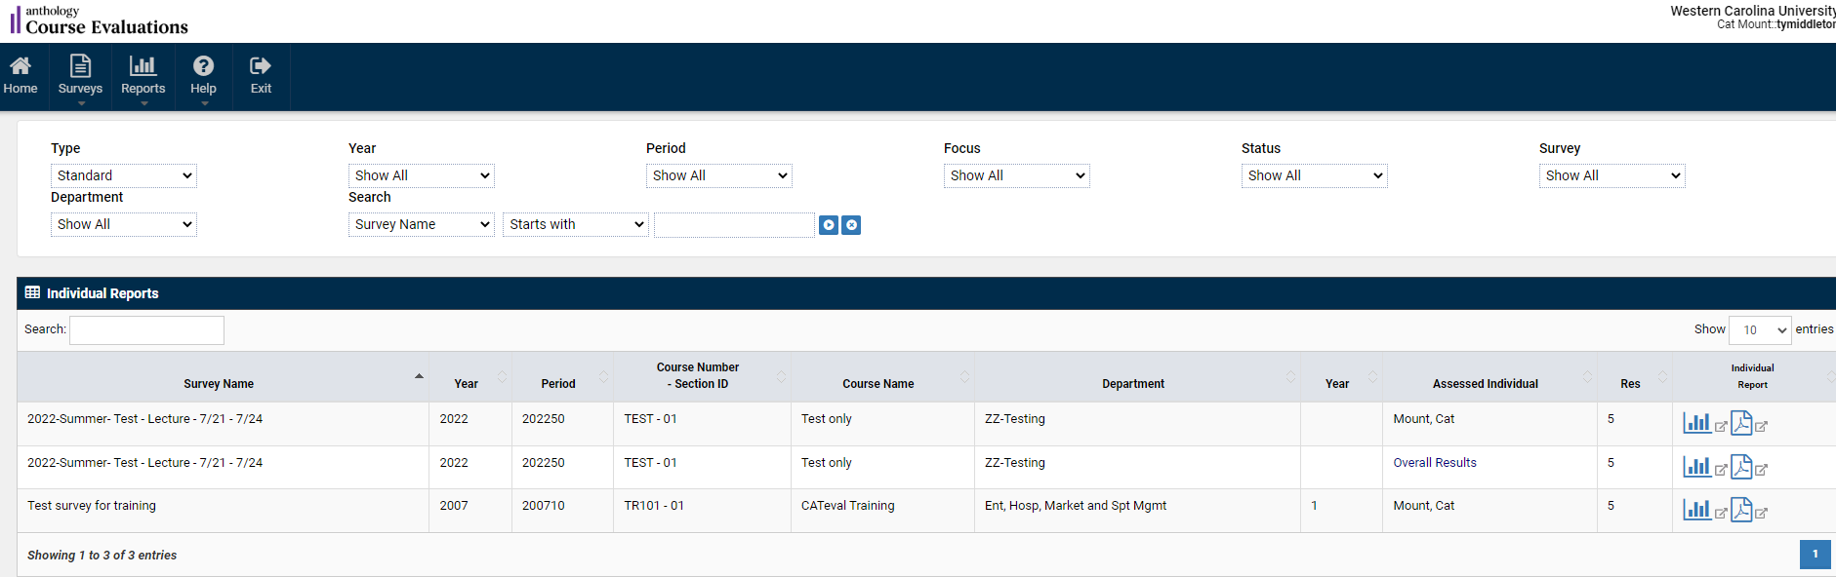

Figure 14. Individual course report page.

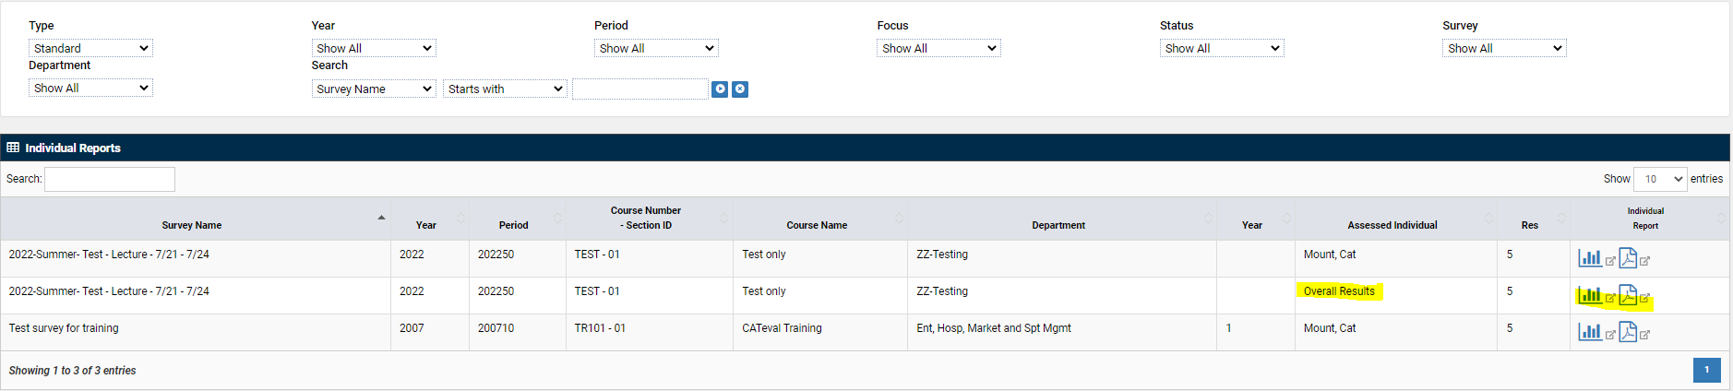

Figure 15. Open-ended student responses.

Frequently Asked Questions
From Students
- Why are Student Course Surveys important?
Student Course Surveys are important for two reasons. Course evaluation results are meaningful. They provide feedback to improve the quality of courses and the experiences of future students.

- What if I don't want to complete a survey (or surveys) regarding my courses?
While students are strongly urged to complete course evaluations, the process is voluntary.

- Will my survey be confidential?
All surveys are kept strictly confidential.

- When are the surveys shared with faculty?
Faculty are only allowed access to the evaluation after all grades for all course sections for the semester have been posted.

- Can I see past surveys of WCU faculty?
Access to past evaluations is not available.

.
- Why am I not allowed to complete the course evaluation after the final exam?
The open and close dates are set by the Faculty Senate. It is set to be after Withdrawals and before Exams.

- May I use another email other than my student email?
No. The system is set up to match your MyWCU username and password.

- I completed the wrong survey. Can you please open my course evaluation back up?
Yes. We will mark the evaluation as incomplete and you may make revisions during the survey window, or until you resubmit it.

From Faculty
- How does the use of online course evaluation systems like the one from Anthology affect response rates?
This answer depends greatly on how the program is administered. Variations in response rates exist. Most research indicates that the initial phases of implementing an online course evaluation system will result in lower response rates than traditional paper systems (the average is approximately 30%; WCU had a response rate of ~70% for several years, but it has dropped noticeably since COVID-19, closer to 60% of full terms and 30% of smaller part of terms.

- What can I do to improve response rates?
Faculty can help increase response rates by announcing to students the change in the evaluation system and leading a discussion in class on how their evaluations are used by the individual faculty members and the University. The University will be using a variety of methods to inform students about the new Course Evaluations system by Anthology including banners, flyers, postcards, and radio announcements on WWCU-FM. In some departments administrative staff or department heads may visit classes to make announcements to the classes.

Computer labs are available on campus and faculty can reserve time to facilitate evaluations as a class. Again, reminding students and identifying ‘timelines’ on the syllabi are beneficial. Faculty should not provide incentives to their courses, except as part of a Faculty Senate-approved campus-wide incentive plan.

- How will the use of Course Evaluations affect the quality of student responses? Available evidence indicates that no difference occurs in quantitative ratings (comparing online and in class written evaluation formats), and that written comments (both positive and negative) tend to be longer in online evaluations than on evaluations filled out by hand in class.

- How will I know if my students have filled out an evaluation?
Faculty members receive reminders by email during the evaluation period with completion rates. Similar reports will go to department heads when the results are available, which is two days after grades at the end of each semester.

- How long do students have to complete the surveys using the Course Evaluations system?
The evaluation period will last from 4 weeks (full term, regular semester) to three days (short and/or summer parts of term) depending on the length of the course and proximity to the end of the course.

- What will be done with the survey results once they have been entered? Who gets to see them?
Currently, the information is stored by Anthology, the company that hosts the Course Evaluations system, and downloaded into reportable tables by WCU’s IT data architect. The information will be accessible to the same people that get to see faculty paper-based evaluations, i.e., individual faculty, department heads, and deans. It will also be made available to the Office of Institutional Planning and Effectiveness (OIPE) to compile and distribute without attribution to individual instructors. Faculty will be able to read student responses and view summary reports (sample reports) after the evaluation period ends and grades are posted.

- How do I know to which type of survey, i.e., lecture, lab, seminar, etc., my course is assigned?
The upgrade to the Anthology Course Evaluations system allows for a single survey, which can be universally applied to a variety of instructional modalities.

- Why do I only have only one option for evaluation type?
The questions are designed to be inclusive of instruction types and methods. The upgrade to Anthology capabilities and offerings provides departments with more flexibility and the potential for departmental questions to be added in the future (in addition to these standard questions).
- Do I have to use Course Evaluations from Anthology? Can I use supplementary evaluations?
Yes, to both questions. Superseded evaluation processes such as those that are paper based are more costly and inefficient in light of newer technology. Also, with the growing number of courses being taught online, these newer evaluation systems make more sense.

Faculty are invited to supplement the data from the online evaluation forms with other instruments as they wish; additional costs of such supplements will be borne by the department and/or the individual faculty member.

Feedback is a valuable resource, but be cognizant of the possibility for survey fatigue that may result.

- One of my students did not complete the evaluations. Can you please open it back up for them?
No. The open and close of surveys are based upon specific criteria and timeline from the Faculty Senate, which is after withdrawals and before exams.

- I am both an employee and a student of WCU. Can you please send this to my personal email account?
No. Anthology only allows one email account for each individual. It is the practice that faculty default to their employee accounts and staff default to student accounts due to the high volume of student workers and Graduate Assistants. The credentials are dependent on the email because of the matching username and password associated with each account (Single Sign-On).

Questions or Problems

What do I do if I have a problem with, or question about, the Anthology Course Evaluations system?

If the problem is largely technical in nature (login problems or difficulty viewing certain screens), contact WCcourseval@email.wcu.ed . wcucourseval@email.wcu.edu.

Contact Information:
Office of Institutional Planning & Effectiveness
H.F.R. Administration Building 440 Office phone: (828) 227-7239
Email: WCcourseval@email.wcu.edu wcucourseval@email.wcu.edu

If the problem or question relates to using the data to improve teaching scores, faculty are urged to discuss the matter with the appropriate department head. The Coulter Faculty Center is also available to all faculty members for guidance and assistance.

Contact Information:
Coulter Faculty Center for Excellence in Teaching and Learning Hunter Library 172
Office phone: 828-227-7196

Student Evaluations at Western Carolina University: Procedural Manual
Edited and Revised by Faculty Affairs Council
Provisional Version - October 2022

