Submitting Your Professional Development Grant
Step 1: Travel prior approval should be done in Chrome River using fund number provided by your department (this fund will not be used for travel reimbursement. If you are awarded a PDG grant a fund number will be provided.) Click here to go to Chrome River (travel.wcu.edu)
Step 2: Once you have approval from Chrome River you will need to print the PDF of the approval sheet and attach it with your PDG application.
In Chrome River, select your pre-approved submission.
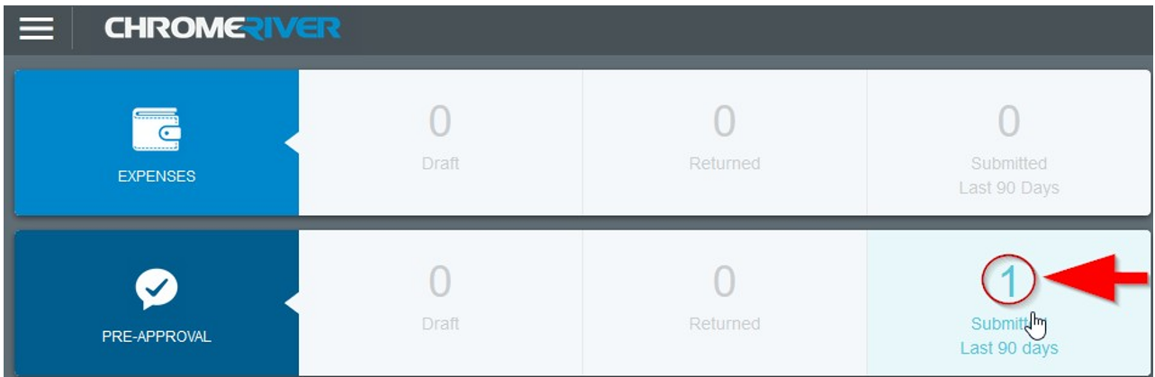
On the next screen, you will need to select the title of the submitted pre-approval.
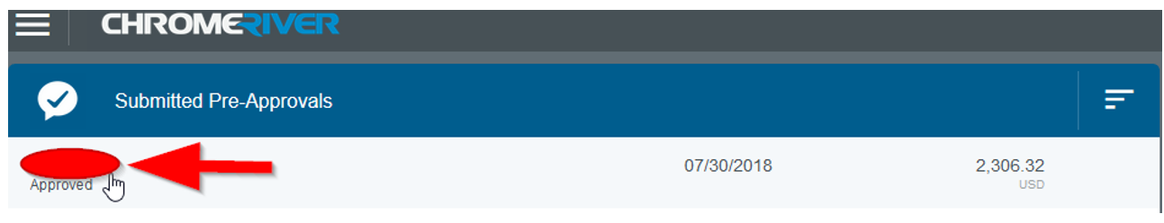
You will now have the option to print the PDF. Please attach the PDF to your PDG application.
Step 3: Complete the application (page 2)
Step 4: Email the PDG Application with all supporting documents through the CFC webpage on the WCU website or by emailing John Hawes at jhawes@wcu.edu
Deadlines for 2021-2022 Submission are September 24, 2021 / January 28, 2022 / March 25, 2022.
All payment reimbursement must be processed by June 15, 2022. If not, the reimbursement will be funded out of the applicant’s college fund. See Controller’s Office page for travel rules and guidance.

For Chrome River Questions contact Anita Hall sahall@wcu.edu
For Travel reimbursement questions contact Carrie Hockman cbhockman@wcu.edu
For all other questions contact John Hawes jhawes@wcu.edu
Professional Development Grant Proposal Cover Sheet  Western Carolina University  Coulter Faculty Commons  172 Hunter Library  Cullowhee, NC 28723 | Signature  Click or tap here to enter text.  Date

Applications that are eligible for the Chancellor’s Travel Fund are not eligible for a Professional Development Grant.
Does this activity qualify for the Chancellor’s Travel Fund? ☐Yes ☐No
*For example: If you are tenured or tenure track and are the sole presenter, you are likely eligible forth the Chancellor’s Travel Fund
Did you apply to present at this conference or event? ☐Yes ☐No
Please fill out all form fields. Incomplete applications will not be considered.
Applicants Name | Click or tap here to enter text.
Department / Office # | Click or tap here to enter text.
Professional Development Grant Proposal Title | Click or tap here to enter text.
Name of Activity | Click or tap here to enter text.
Activity Site | Click or tap here to enter text.
Travel Dates | Click or tap here to enter text.
# of Professional Development Grants received in the past 2 years | Click or tap here to enter text.
Brief title of all Professional Development Grants received in the past 2 years | Click or tap here to enter text.

Please complete the following questions (250-word limit) Attach additional sheets if necessary.
Please describe the proposed activity and explain how it would meaningfully contribute to the professional development of the applicant.
Click or tap here to enter text.

How would the proposed activity strongly support program, department, and/or university mission?
Click or tap here to enter text.

What is your status with WCU?
☐Tenured ☐Tenure Track ☐Non-Tenure Track
☐Adjunct ☐Emeritus ☐Phased Retirement

Expense | $ Cost of Expense | Support Source | $ Amount of Support
Total estimated cost (from travel preapproval form) | Click or tap here to enter text. | Department | Click or tap here to enter text.
 |  | College | Click or tap here to enter text.
 |  | Applicant | Click or tap here to enter text.
 |  | Other | Click or tap here to enter text.
Total Anticipated Expenses | Click or tap here to enter text. | Total Support | Click or tap here to enter text. | Amount Requested  Click or tap here to enter text.

If this proposal cannot be fully funded from state resources, are you willing to pay the difference? ☐Yes ☐No

*** PLEASE NOTE: If funded, your name, title of grant proposal, and award will be published. ***

