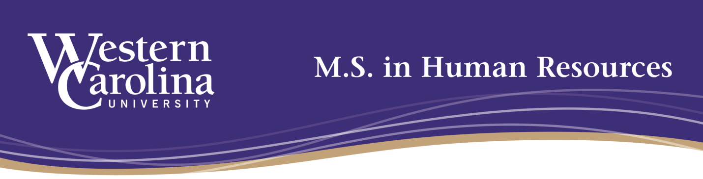

WCU MSHR Advisory Board Meeting: Summary Minutes
3/31/2022
12:00 noon (EDT)
Advisory Board Members attending: Nancy Dwyer, Alex Hall, Anne McClintic, Rachel Sossoman, Holly Waltemyer
Absent: Carolyn Laws, Shelley McGrail, Angela Wagner
Staff attending: John Sherlock, Marie-Line Germain, Siham Lekchiri, Sarah Minnis

- Welcome and Introductions
  - Welcome remarks from John Sherlock, Program Director
    - Summary: MSHR enrollment continues to be strong; 120+ students in the program (presenting challenges in having enough classes to meet demand, but it’s a good problem to have : - ), our program continues to be one of the largest grad programs at WCU; Faculty evaluated as very strong performers via TPR process (tenure/promotion/reappointment) and AFE process (annual faculty evaluation). Reminder that, while MSHR Advisory Board only meets formally once a year, input is needed/valued throughout the year.

  - Brief introductions and career/life updates were shared by committee members

- Program Updates
  - MSHR Pro Bono Consulting
    - See infographic below that Dr. Germain shared to highlight the continued growth and success of this service-learning initiative:

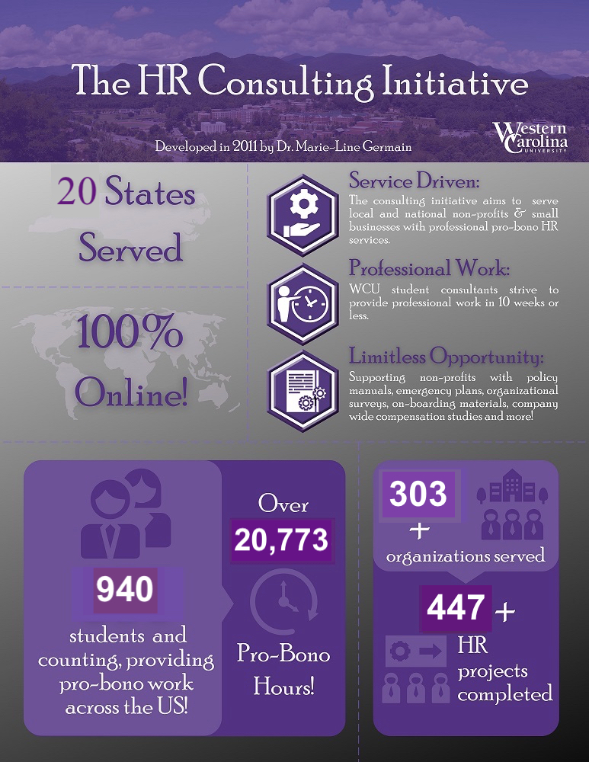
    - A donation was recently received (donor asked to remain anonymous) that will provide funding to contract a Consulting & Research Assistant to: 1) Create and disseminate an alumni survey regarding the HR consulting; and 2) Create an HR Consulting Digital Library: processes, checklists, and consulting templates for consulting students to use in HR 670 and HR 671.

    - The software/collaboration platform used for the HR670/671 consulting projects recently has been changed and upgraded from Samepage to Basecamp.

  - Curriculum Updates
    - Dr. Minnis provided an update on work in progress in WCU’s Curriculum Review process to merge our elective HR613 (performance management and coaching) and HR660 (talent development) into one course, 660 (Talent Performance & Development) which will cover the spectrum of performance management process through talent development and highlight coaching as a best practice for employee development.

Additionally, Dr. Minnis discussed a new elective course offering, HR669 (Introduction to HR Consulting Theory and Practice), to provide students a background on the theory and practice of HR consulting prior to the 670 and 671 consulting practice courses. This course should be especially valuable to students with little or no HR consulting experience.

  - Collaboration with students on HR scholarship
    - See citations below of collaborative scholarship with students led by Dr. Germain and Dr. Lekchiri:
Beaty, J., Cooter, S., Jones, C., & Germain, M.-L. (2022, June). Challenges in Employee Training & Development: Using Digital HR During the COVID-19 Pandemic. Eastern Academy of Management International. (June 7-11). Lyon, France.

Barton, M., Horton, A., McNeil, M., & Germain, M.-L. (2022, June). Using Technology to Optimize Employee Motivation. Eastern Academy of Management International. (June 7-11). Lyon, France.

Arthur, A. R., Biswas, H. M., Longest, K. N., & Lekchiri, S. (2022). Women in Leadership: An Exploration of the Need for Gender-Focused Leadership Development. 2022 Academy of Human Resource Development Virtual Conference in the Americas.

  - “Dear Human Resources” podcast
    - Dr. Germain reported that 45 podcasts episodes have now been recorded since the creation of the podcast show in January 2021; With no formal marketing/promotion, the podcasts have nevertheless attracted listeners from across the U.S. and abroad (Australia, Russia, Ireland, Brazil, China, South Africa, etc. See chart below.) Finding interesting speakers for the podcast has been easy and the emphasis on talking about HR topics not typically discussed is a selling point of the podcast.

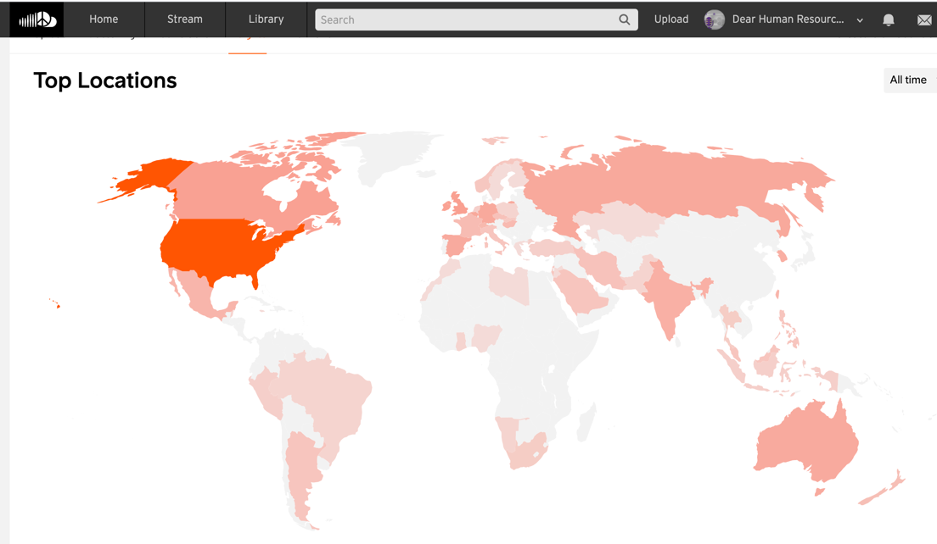
    - Dr. Minnis’ husband, Kelly Minnis, was acknowledged for his pro bono technical assistance. He handles the mixing for each podcast recording. Below is the link to the podcast show:
https://soundcloud.com/user-421935966?utm_source=clipboard&utm_medium=text&utm_campaign=social_sharing

- Discussion of any New Business Items

  - While the topic has been brought up before, alumni fundraising initiatives was brought up for further discussion. In particular, it was mentioned that little to no travel funding was available for MSHR students to present at conferences with MSHR faculty (see item II, b above) so that students were not going to be able to attend. There was consensus that the MSHR alumni base has never been formally asked to donate and would likely be very willing to contribute to specific initiatives (e.g. pro bono consulting, podcasts, student travel, external awareness, etc.) if asked. It was agreed that discussion on this topic should be continued.

  - In terms of current HR trends/topics relevant to the MSHR program, there was brief discussion about how population demographic changes have and will continue to impact recruitment; additionally, it was noted that it will be important for HR to utilize predictive analytics to contribute to innovation and change management initiatives.

- Adjournment – 12:58pm.

