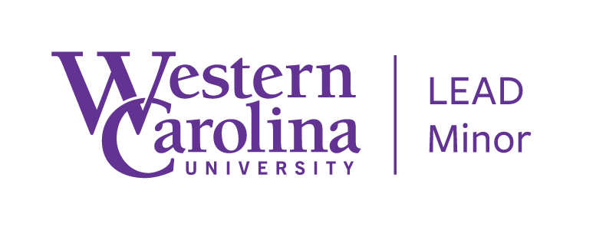
Advisory Board Meeting
April 8, 2022

Minutes

Introductions / Attendance
Palin Berkana-Wycoff (yes), Leslie Cavin (yes), Amanda Hanson (yes), Jeff Hughes, Sam Miller, Sarah Minnis (yes), April Perry, Callie Shultz

Review of Minutes from March 31, 2021

# of “current” students who have declared the minor
- Fall 2018 = 78
- Fall 2019 = 64
- Spring 2021 = 42
- Fall 2022 = 47

# of students enrolled in LEAD courses by Fall term (duplicated)
- Fall 2018 = 221
- Fall 2019 = 253
- Fall 2020 = 186
- Fall 2021 = 238

# of student enrolled in LEAD courses by Spring term (duplicated)
- Spring 2019 = 126
- Spring 2020 = 149
- Spring 2021 = 155
- Spring 2022 = 153

# of graduates
- Spring 2018 = 8
- Spring 2019 = 11
- Spring 2020 = 11
- Spring 2021 = 13
- Spring 2022 = 10 (confirmed); 4 (maybe) (total TBD)

Recruitment
- Classroom visits did not really happen.
- Emails to declared students
- Emails to any student currently in a LEAD course this term
- Email to all LEAD instructors
- Email to all Partner-Program elective instructors for Fall 2021
- Majors Fair update
- Still on “to-do” list – make some graphics re. Why and Outcomes for the website
- Connect with Career Services more
- Can we connect with USI courses to share about the minor?

Updates (previously discussed and new)
- Advising Day – 2 students showed up and 3 student emails
- Working with Residential Living training RA’s for LLCs
- Paused work on possible new LLCs
  - Look into African American Studies minor for any partnership or cross-over possibilities.
- LEAD Study Abroad
- Website updates
- Marketing Video paused Spring 2021. Tried again in Fall 2021. Moving to Fall 2022.
- New hire for HESA / LEAD / Educational Leadership
  - Yancey stepping down as program director

Other Discussions
- Looking for instructors for some LEAD LLCs

