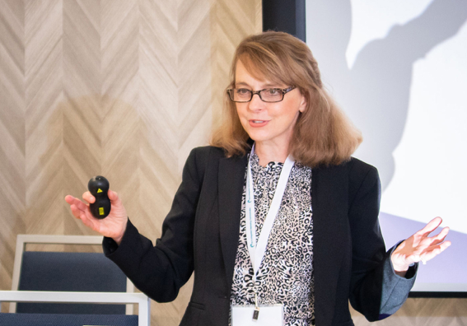

Dr. Betty Farmer
Professor, Consultant & Trainer
Western Carolina University/Farmer Communications

Dr. Betty Farmer is an award-winning professor of communication and public relations at Western Carolina University and a highly sought-after communication consultant and trainer for Western North Carolina businesses and organizations.

Betty specializes in leadership communication, managerial and supervisory communication, crisis communications, emotional intelligence and gender communication. She has provided communication training for a wide variety of individuals hailing from government, education, business and non-profits. Training workshops cover a variety of topics, including assessing and developing emotional intelligence, preparing leaders to respond effectively during crises, giving and receiving constructive feedback, conflict management, nonverbal and listening skills, and powerful presentation skills. She provides public workshops and customized on-site programs, as well as one-on-one coaching.

She is a graduate of Leadership Ashville class of 38. She will earn a Coaching Certification from the Institute for Social and Emotional Intelligence in June, 2021. She holds the Ph.D. in Communication with emphases in public relations and organizational communication and a Master’s in Journalism, both from the University of Tennessee, Knoxville. She has a Bachelor’s in English/Communications from the University of Virginia at Wise.

Betty has received dozens of awards for her teaching and community engagement, including national awards from the Association of Marketing and Communication Professionals and WCU's inaugural Excellence in Community Engagement Award. Her scholarship has appeared in the top communication and community engagement journals.

She has worked professionally as a journalist, public relations practitioner and fundraiser. Hallmarks of her professional approach include her "can do" attitude, collaborative leadership style, strategic mindset, attention to detail, and follow through.

Contact Betty at bfarmer@wcu.edu. Connect with her on LinkedIn.

