Read These Before You Begin!
- The bolder the text and the larger the image, the easier it will be to remove the excess vinyl from your final print. Go for a bold and large typeface and a simple image design.
- Test your printout on paper first!
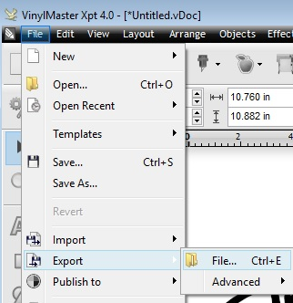

You can do this by using the Export function to save the image as a .jpg or .png file and then print the image.
Be sure to name the image and take note of its location so you can find the image to print.

Additional Tips
If you cannot find a desired font in this the default list, you can add other options by clicking Font Manager (blue arrow).  Remember the name of any fonts you add from the Font Manger. It will place your selected font in alphabetical order and you will need to find it once you return to this screen. | 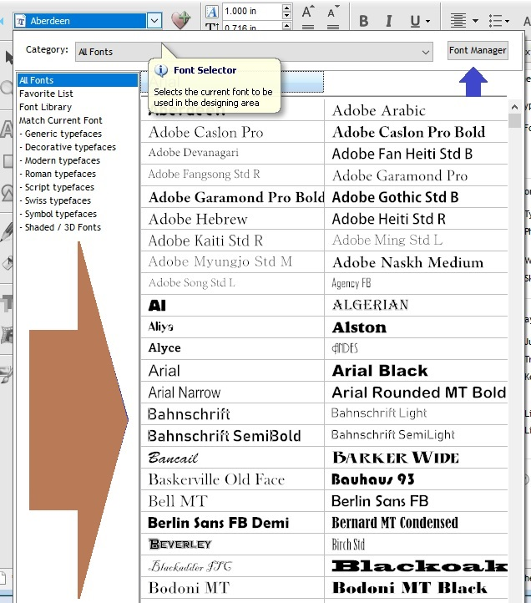
To use Arc Text above AND below your image, click the Text on Arc tab under the Text Tools option (blue arrows).  Click the radio button in the “Above and Below” button (Big Blue Arrow)  Press Return on your keyboard to put the text below. You can then type the text you want to put below the arc. | 