Vinyl Cutter Software Step-by-Step Instructions
To load vinyl into the machine, see Vinyl Cutter Instructions. The following are instructions for preparing and printing your image after you have loaded vinyl into the machine.
Open the software from  the computer’s desktop by double clicking on VinylMaster Xpt | 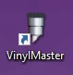
Open new document. | 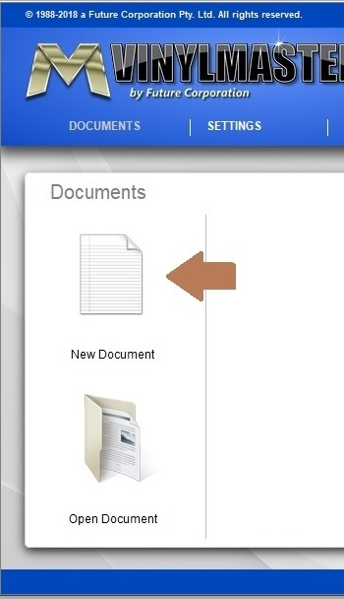  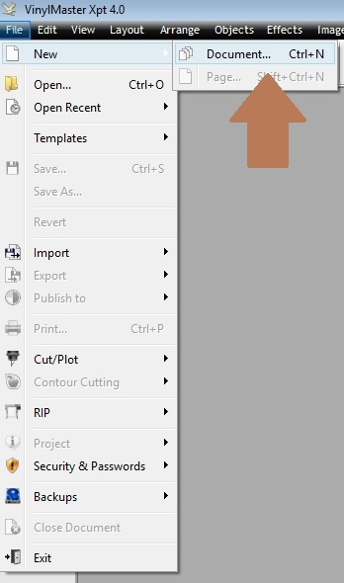  OR
Select Vectorize (Trace) Image…from Images pull down menu. | 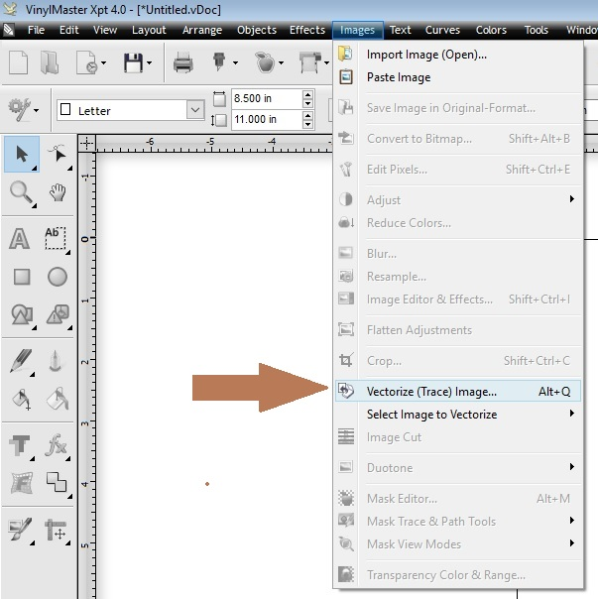
Choose an image. Some ready-made images are available in the Pictures > Certification Images folder on the PC—or you can upload one of your own pictures.  Click Open when selected. | 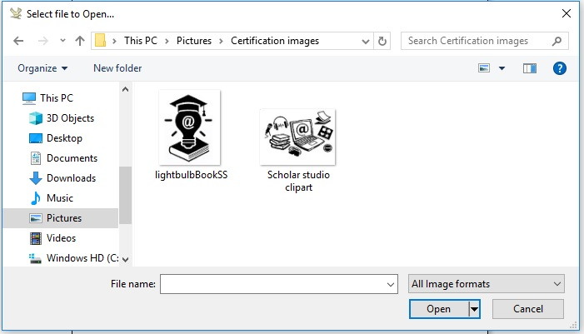
The image will be automatically vectorized, but you can adjust the trace settings (blue arrow) as needed.  Click 1. Trace with each change in settings. (brown arrow).  When you are finished with the trace, click 2. Accept (green arrow). | 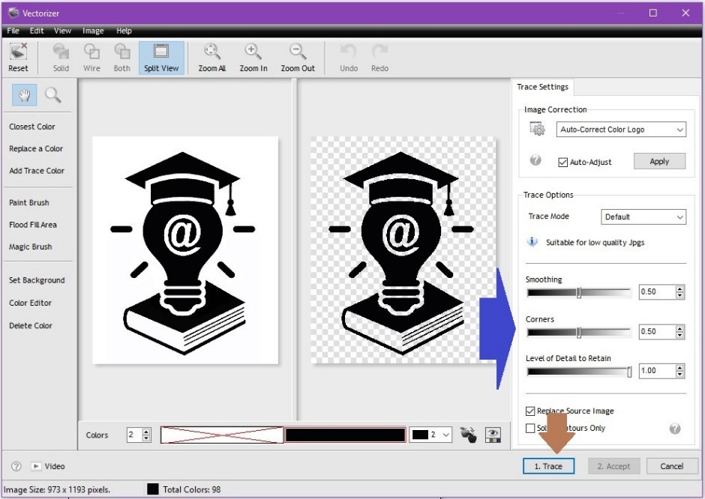
Click image to activate the image tools (it may take a while to activate).  Click the X in the middle of the image to drag it around the page (brown arrow).  To resize the image, click and drag the corner squares (blue arrows).  The outer squares (green arrows) allow you to rotate the image. | 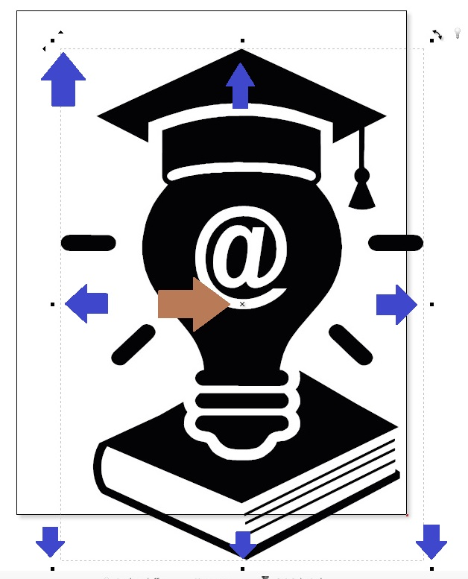
Use the toolbar to select the kind of text you want for your image. The example in our instructions will use Arc Text.
Right click text mode button on menu and select Arc Text. | 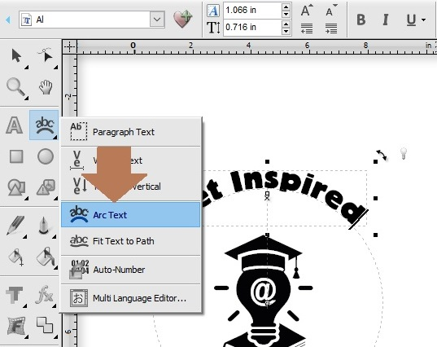
Select your desired font (brown arrows). Font options are under Text Tools (blue arrow). | 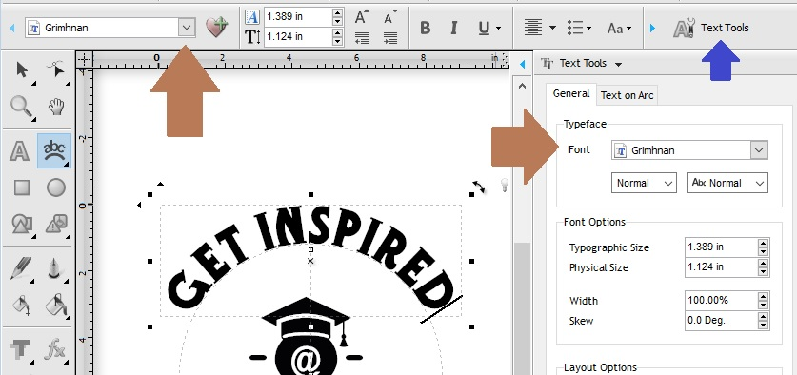
Resize the font by clicking and dragging small squares (brown arrows).

Click on the X to move the text box.
If you add arc text below the image, you may need to adjust the “kerning,” the size between the letters, in the layout options on the general tab.  You may have to select Text Tools to see these tabs. | 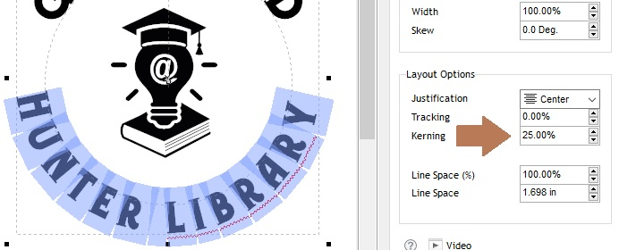
To create a border around the project, choose a shape (brown arrow). The examples here are for a circle.  Click in the center of the image and drag outward to cover entire image. The shape will cover your image in black (don’t worry, this will be adjusted later). | 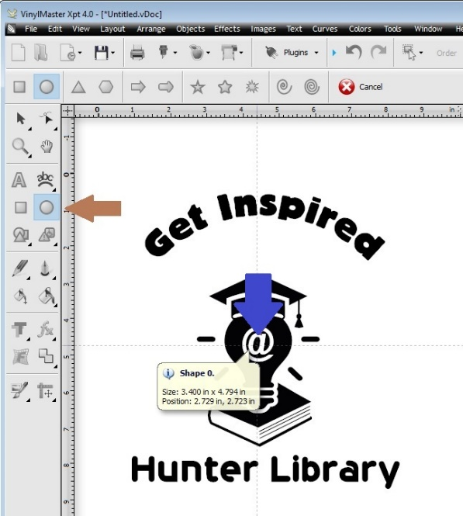
Click and drag the black squares to size the shape around the image. You can move the shape around by clicking on the X in the middle of the shape. | 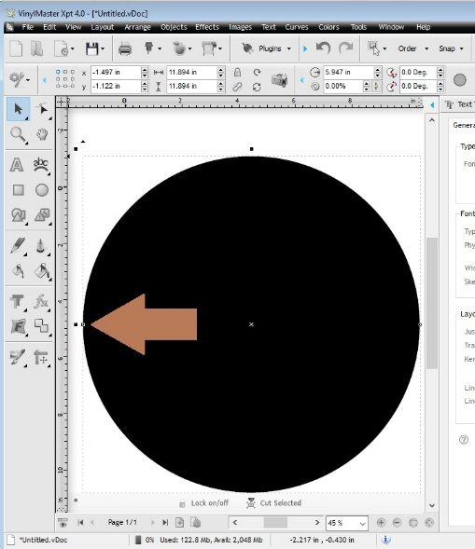
There is a small, clear, square on the left side of the shape. If you hover your mouse over it, it will show the label, “Inner Border.”  As you drag the small dot, the black shape will narrow to a border. Your text will reappear! | 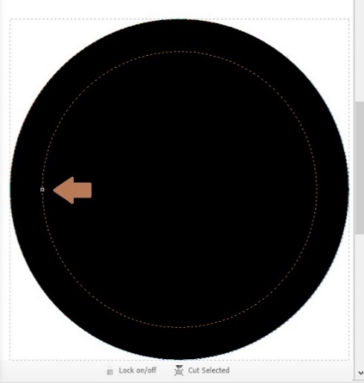  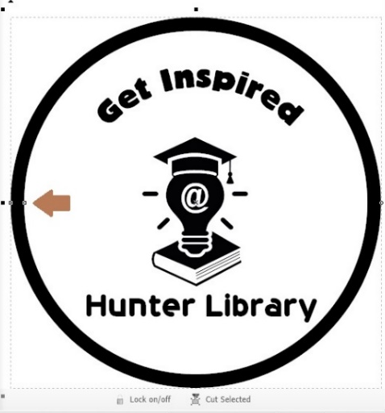
To save the project, select Save or Save As from the File Menu. Include your name and date in the saved project.  If you want to test print your image on paper first, see Vinyl Cutting Tips. | 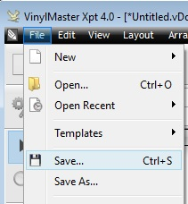
Make sure you don’t have any objects selected--otherwise it will only send the selected item to the cutter. There should be NO small squares around any part of the image.  MAKE SURE THE VINYL IS LOADED AND CORRECTLY SET TO THE RIGHT LOCATION (see Vinyl Cutter Instructions).  Select Cut/Plot under File menu, then Send to Cutter… | 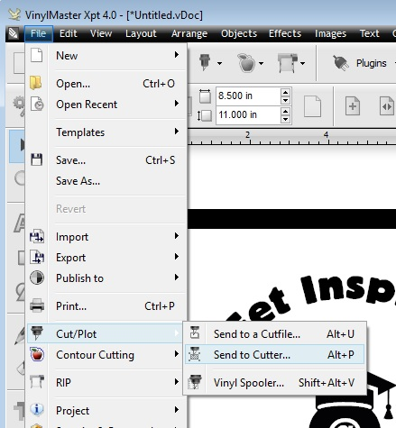
Make sure “Separate by Color” is NOT checked.  We recommend selecting Auto Weed-Box, Weld Text, and Easy-Lift Weed Marks.  If you want to flip your printout so that it sticks to the inside of a window, select the Mirror box. | 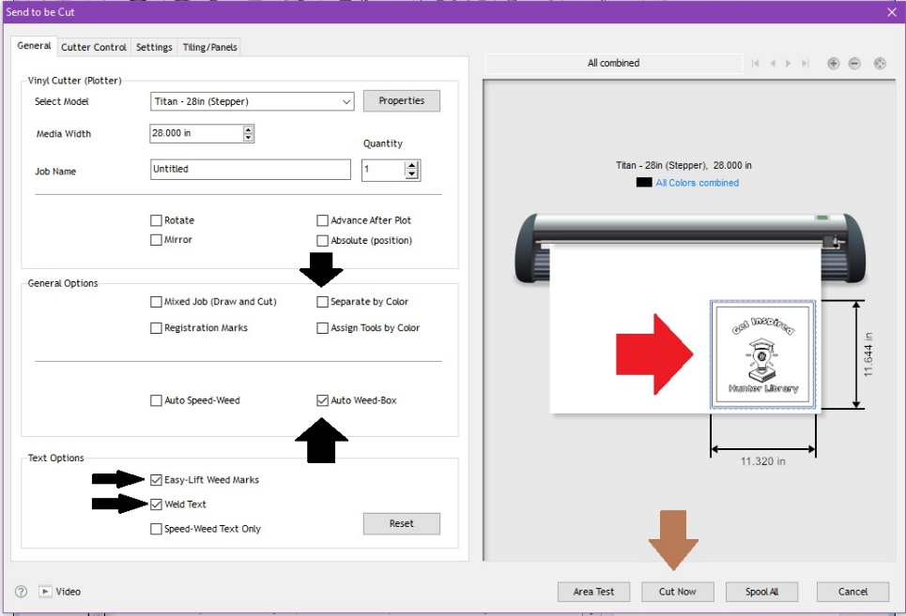
Check the size of your cut to be sure that is the size you expect to cut (red arrow).
If all is right, Click Cut Now

Click Yes to proceed with cutting. | 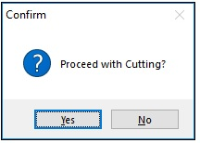
The Vinyl Spooler keeps track of the progress of the prints if you are printing multiple colors. Click Done when finished.  Close the program when printing is complete. | 