Vinyl Cutter Step-by-Step Instructions
When you stand in front of the vinyl cutter, you will see the word TITAN on the left side of the cutter.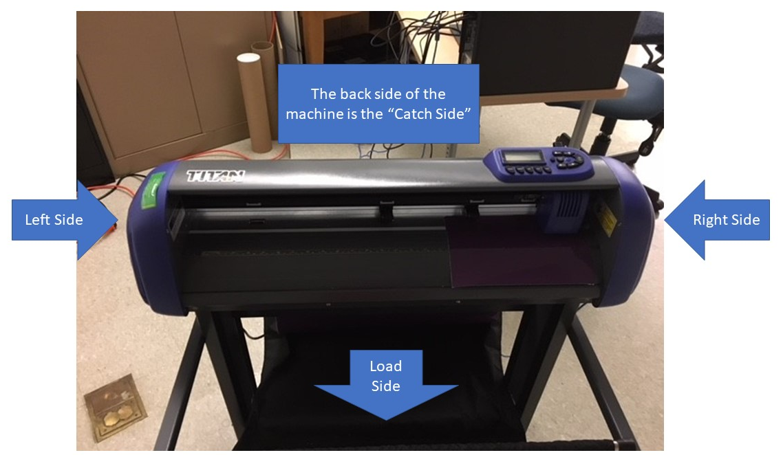
This is your view if you were standing to the right of the machine, looking down.
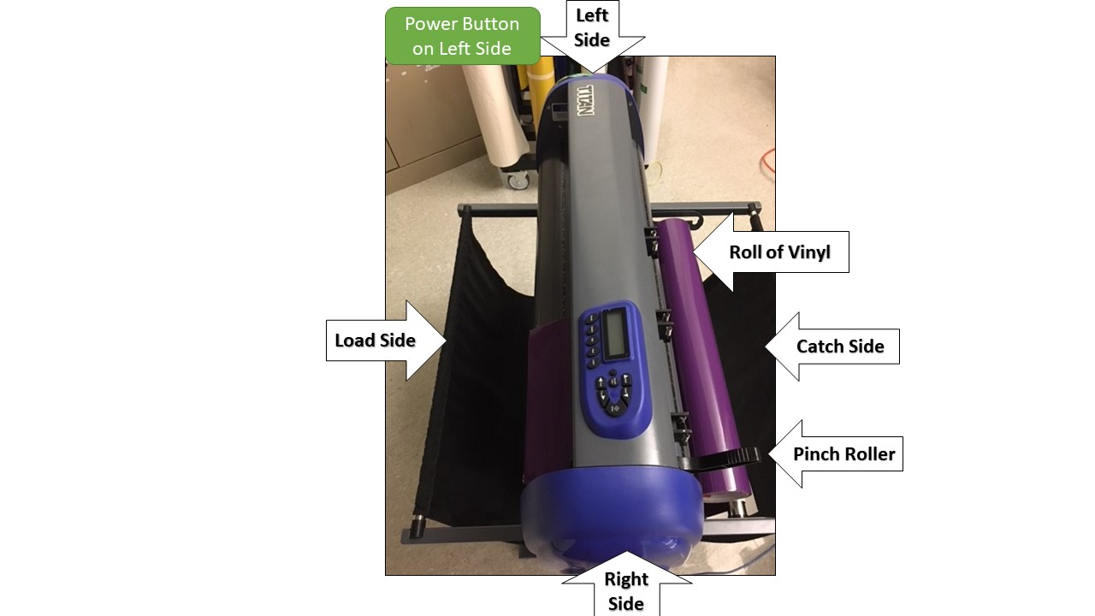
- 1. Load selected roll/sheet of vinyl into the cutter with color side up.  - 2. Open pinch-roller so you can slide in the vinyl (green arrow).  - 3. Use ruler/guide (on both the Load and Catch sides) to line the vinyl.  - 4. Close pinch-roller to secure the vinyl in machine (green arrow). | 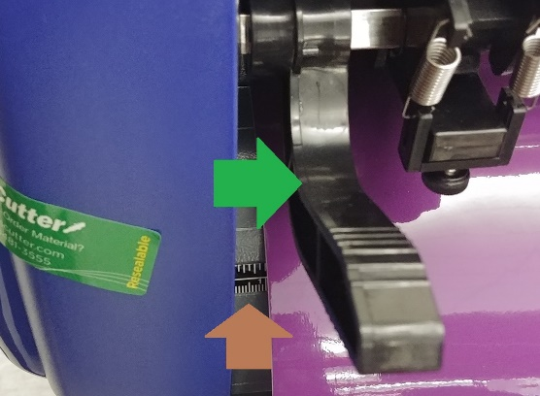  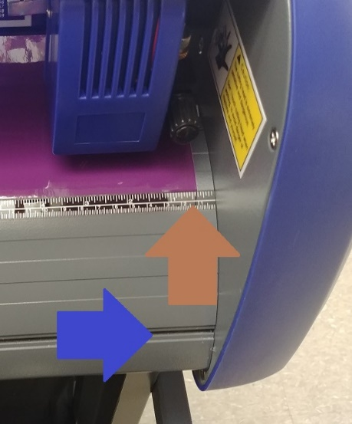  Line up the vinyl on the right-hand side of the machine as pictured above.
1. Push the On/Off Line Button (yellow arrow); the display screen will say “Move XO.”  2. Using the directional keys (blue arrows), move the vinyl to desired starting location.  3. Push Enter button (orange arrow) | 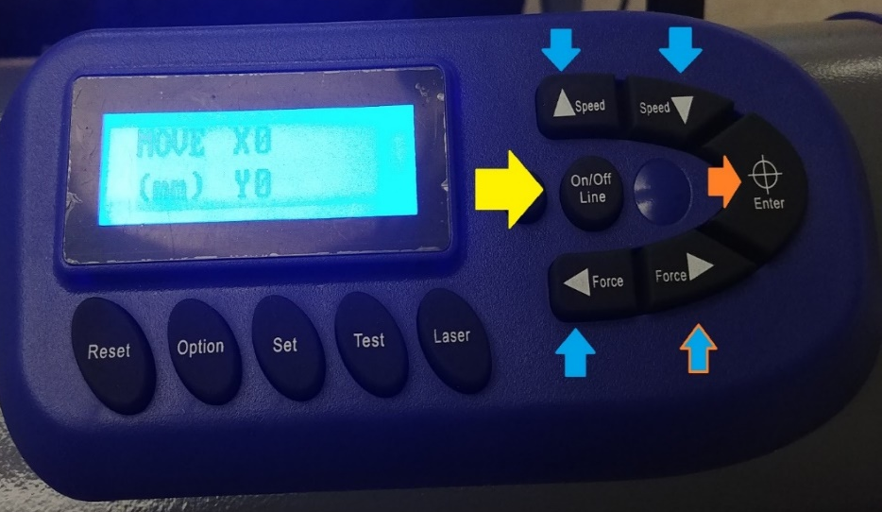  The vinyl on the load/front side will line up with the guide/ruler as pictured.
See Vinyl Cutter Software Instructions for preparing your image for printing and sending it to the Vinyl Cutter.
To remove vinyl:  1.Push the On/Off Line button (yellow arrow). The display will say “Move XO.  2. Using the directional keys, move the vinyl so that the are you want to cut lines up with the groove (blue arrow) so you can CAREFULLY run a utility knife to make a straight cut. | 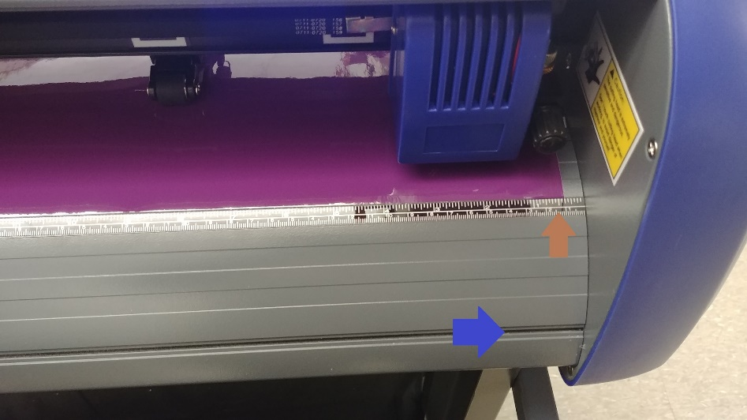  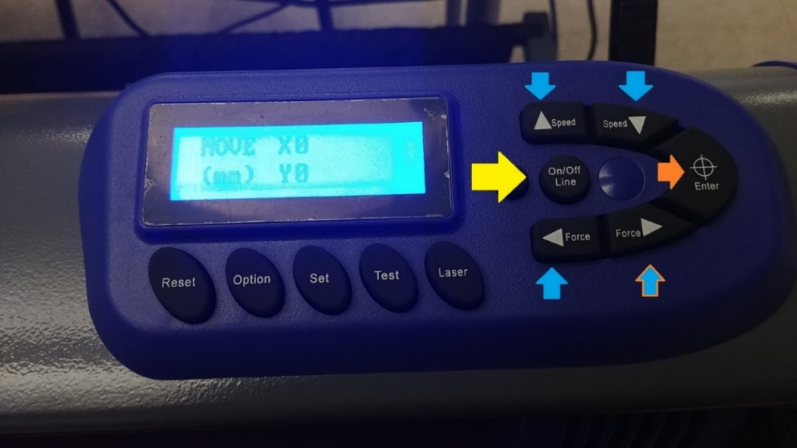  Use the groove at the bottom for to aid in cutting.
The process of removing the unwanted vinyl is called “weeding.” Use the tools provided to “weed” your image. Refer to a paper printout of your image so you know which pieces you need to remove.  Pay careful attention to centers of letters such as (e or a) or the dot above the i. | 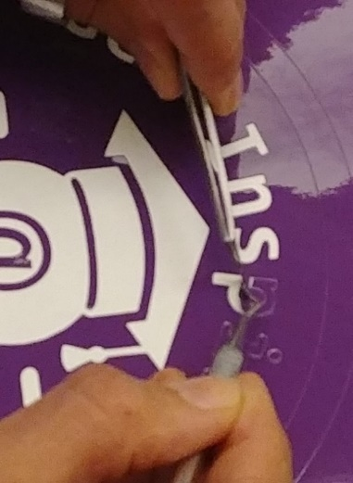  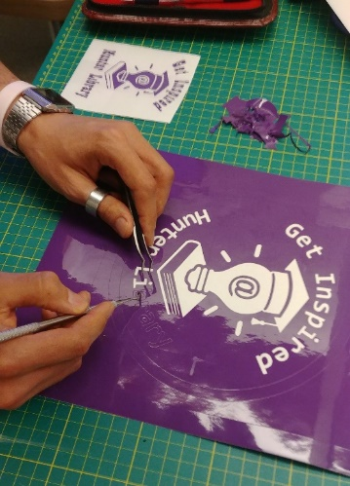  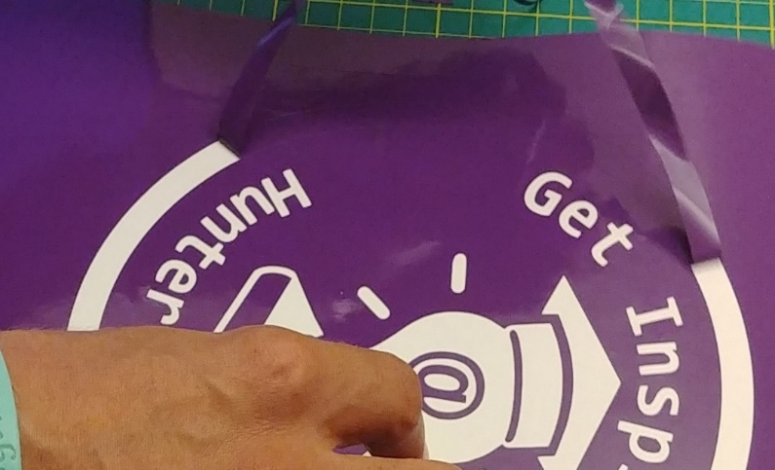  In this example, the center of the P is not removed.
Your image is now ready to cover with transfer tape. Select desired tape and use the squeegee provided to get good contact between the transfer tape and your image.  Cut waste to make a clean edge for transferring your image. | 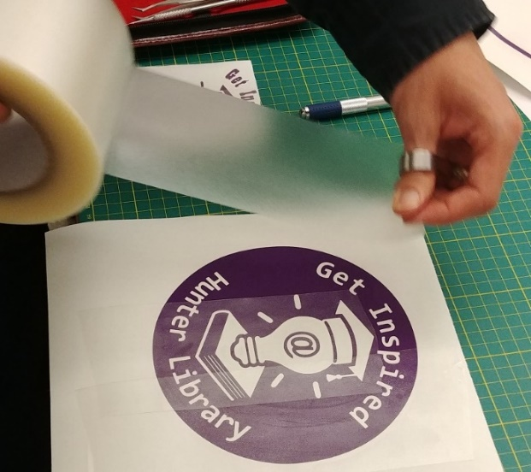  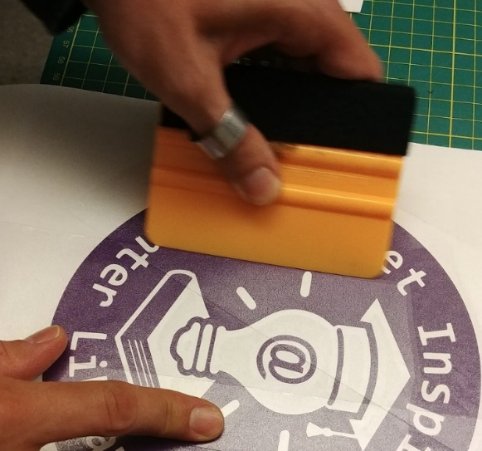  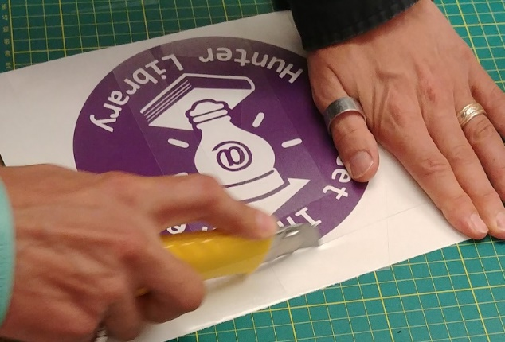
Apply image to intended surface; use the squeegee or a credit card make sure the image has adhered to the surface. Carefully pull the tape away from the image. | 