Extended Hours Pilot – Spring Semester
Technology Commons and Library

Technology Commons:
Additional weekly hours needed: 19.5 hours
Additional salary needed: $4,000 – 7,000
- Mix of Hourly/Student staffing

Library:
Additional weekly hours needed: 19.5 hours
$9,219 = 2x20hr positions (evening, weekends)

Current Regular Hours:
Saturday 12pm – 7pm
Sunday 12pm – 12am
Mon – Thurs 7:30am – 12am
Friday 7:30am – 6pm

Pilot Hours:
Saturday 9am – 7pm
Sunday 10am – 2am
Mon-Thurs 7am – 2am
Friday 7am – 7pm

Marketing
- IT Weekly
- Table tents
- Website
- Media
- Student associations

Physical structure requirements:

Temporary solution - partition: < $1,500

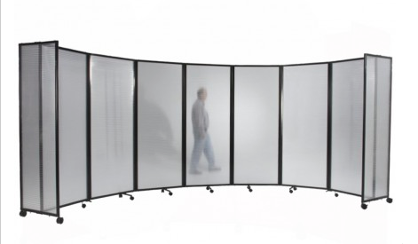

Permanent Solution – Costs

Permanent door – one time construction cost: $14,000
  - $7,900 for door (without crash locks)
  - Includes moving drinking fountains, any clean up, painting etc.

