[](https://www.google.com/url?sa=i&rct=j&q=&esrc=s&source=images&cd=&cad=rja&uact=8&ved=0CAcQjRw&url=https://www1.cfnc.org/applications/WCU_Dist_Ed/apply.html?application_id=3631&ei=-VJvVbTpCJD8sASLlYKgBg&bvm=bv.94911696,d.cWc&psig=AFQjCNGkZRJXdnIB6jwFB-1ewfDB0-zXuQ&ust=1433445489710504)

**Police Department**

**Annual Report 2019-2020**

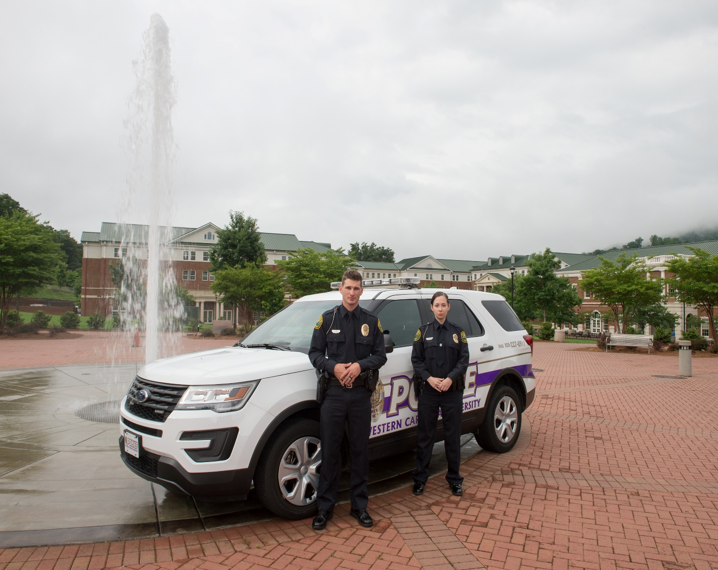

Greetings,

Once again, the Western Carolina University Police Department has compiled an Annual Report to capture many of our activities and service projects for the past year. This document describes essential statistical data, personal achievements, and our outreach to the community. My goal is that this information will give you a glimpse into the service that is provided by the officers that work within our community. We remain committed to ensuring that the campus community is a safe and secure learning environment for our faculty, staff, students and guests.

Community cooperation continues to be a critical piece of our operations and we would not be as successful as we are without each member of the community contributing to a safe campus. It is up to each one of us to help foster a secure and supportive environment at Western Carolina University. Your commitment to the WCU community is to be commended and I look forward to continuing to partner with you in the future as we strive to make Western Carolina University a safe learning environment for all.

This year we have faced many unusual challenges and we have been asked to perform in manners that have not previously existed but together we have continued to support our campus community and implement new procedures to ensure the safety of our team. Again this year my staff has demonstrated that they are committed to creating a safe place for students, faculty, staff, and visitors to enjoy regardless of what concerns exist within our community. The years that we have spent training and preparing for any situation paid off this year as we adjusted our duties to meet a new crisis that has not been experienced before. I am proud of the work that my staff has done this year and I hope that you continue to know that we will face any situation in order to ensure the safety of our campus.

The Police Department is currently working through some organizational changes where job descriptions and duties may be reflected a little different than what is shown on the current organizational chart but these changes will provide a more efficient service to our community and allow us to maintain the highest standards of accountability.

I hope that you find this report beneficial as you experience the many services that are provided on a daily basis by a trained staff that cares for each member of our community. As a university, we are all responsible for and to each other to keep our campus community safe.  Please feel free to contact me at 828-227-3201 with any questions.

Sincerely,

Steven D. Lillard

Steven D. Lillard

Chief of Police

**Western Carolina University Police Department**

***Mission*:**Our mission is to provide professional community-oriented police service.  We are committed to creating and maintaining an active community partnership and assisting the community in identifying and solving problems to improve the quality of lives on our campus. We respect the cultural and ethnic diversity of our University.

***Values*:**We are capable, caring people doing important and satisfying work for the citizens of our community.  Therefore, we respect, care about, trust and support each other.  We are disciplined and reliable.  We keep our perspective and sense of humor.  We balance our professional and personal lives.  We involve our community in decisions that we make.  We have a positive, can do attitude.  We cultivate our best characteristics:  initiative, enthusiasm, creativity, patience, competence, and judgment.  We do nothing to discredit or dishonor ourselves or our department.

***Vision*:**The Western Carolina University Police Department is a proactive police agency dedicated to excellence through quality community service.  We ensure quality community service through accountability to each other and the citizens, who are the source of our authority. We maintain the quality professionalism of employees through training, development, and education for personal and professional growth with a constant emphasis on innovation and improvement.

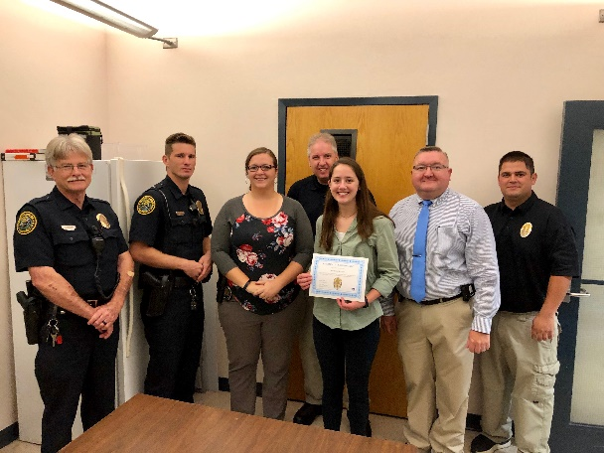

***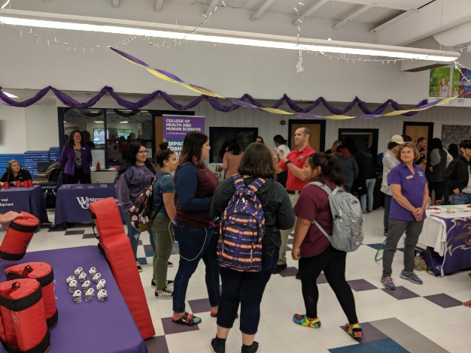***

.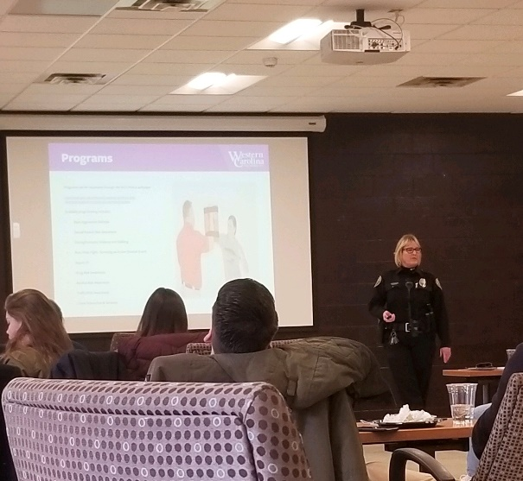

**Western Carolina University Police Department**

The Western Carolina University Police Department (WCUPD) is comprised of twenty-six (26) fully certified and commissioned law enforcement officers authorized under sections 17C and 116‐40.5 of the North Carolina General Statutes. Officers employed by the university are required to complete the same training as other agencies that serve a county or municipal population. The initial training process requires completion of the certification course, passage of the state exam and completing the physical assessment within the prescribed time limits.

The Police Department is a full-service agency that performs the same duties with the same authority as other agencies within the region. University Police Officers work closely with surrounding local and state law enforcement units to address concerns that may not occur on campus but that have an impact on the university community. University Police Officers also work closely with the Department of Student Community Ethics and the staff of Residential Living when addressing violations of the Student Code of Conduct.

Officers are available to assist the community 24 hours a day, 7 days a week. The department strives toward building partnerships with the university community to provide a safe environment.

The police department is currently divided into three (3) distinct sections. Those areas include Administration, Investigation/Clery Compliance, and Operations.

* The Administration Section primarily consists of the Chief of Police, the Assistant Chief of Police, and the Administrative/Investigative Support Officer. There is also one (1) Lieutenant assigned to the Administration Section that serves as the Business Support Officer for the department. This section is responsible for the direction, management, and policies of the Department. The Chief and Assistant Chief are typically available for consultation and assistance at all times. Careful coordination takes place to ensure that an Executive level officer is always available to aid the Operations and Investigation sections with any emergent situation. In addition, the Chief and Assistant Chief are standing members on several committees and teams including the Behavioral Assessment Team and the Student Concern Response Team. The Chief and Assistant Chief act as the primary Incident Commanders for law enforcement emergencies and most campus special events.
* The Operations Section represents the uniformed police staff who are responsible for campus patrol and responding to calls for police services. Patrol operations consist of vehicle patrol, foot patrol and bicycle patrol depending upon staffing levels, special concerns and the needs of the community. Patrol officers are also expected to conduct preliminary investigations into criminal acts that are reported or suspicious activity that is observed. In addition, Patrol officers enforce traffic laws, the Student Code of Conduct, and certain University policies. Members of the Patrol Section also participate in a wide variety of community outreach programs, staff numerous athletic & special events each year and take part in a number of University initiatives. When fully staffed, the Patrol Section consists of 1 Lieutenant, 4 Sergeants, and 14 patrol officers. Patrol shifts are scheduled in twelve-hour increments with fixed day and night shift assignments.
* The Investigation/Clery Compliance Section is comprised of 1 Lieutenant, 1 Sergeant and 1 Investigator. This section is responsible for the overall duties associated with Clery Compliance, Victim’s Services, Evidence Room Management, Community Outreach and Records Retention. This section is also responsible for investigating criminal behavior that has been reported. These investigations are comprised of crime scene processing, conducting interviews of persons involved and compiling evidence for prosecution. In addition to these duties, the Support Services Section must comply with several federally mandated statistical recording requirements regarding criminal activity on campus.

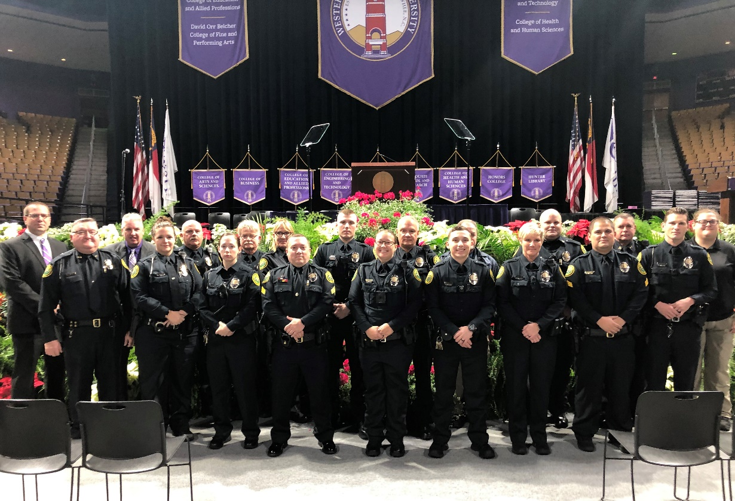

*WCU Officers preparing for Fall Commencement*

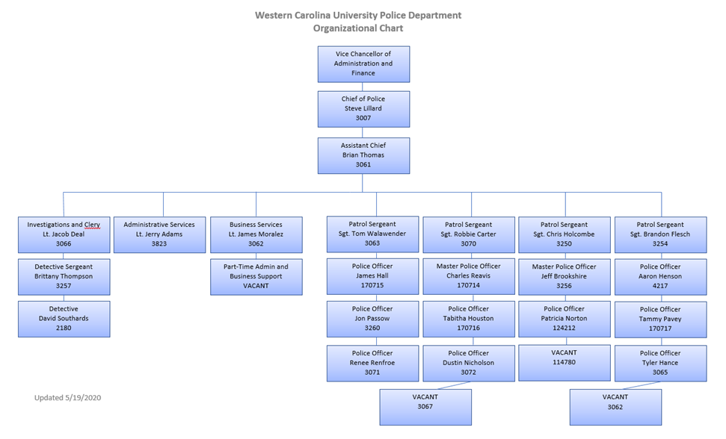

**Police Core Operations 2019-2020**

**Patrol Section:** The uniformed patrol officers that are on duty around the clock are the backbone of our agency. They respond to calls for service and perform crime prevention activities as part of their daily tasks. Their focus is on the safety and security of each member of the community and are required to work well with other campus partners.

**Statistical Data**

|  |
| --- |
| WCU Police Statistics |
| July 1, 2019 – June 30, 2020 |
| |  |  | | --- | --- | | Computer Aided Dispatch (CAD) Calls for Service | 14,365 | | Arrests | 87 | | Incident Reports | 579 | | Operations Reports | 390 | | State Citations | 81 | | Campus Traffic Citations | 38 | | University Judicial Citations | 123 | | Parking Tickets | 77 | | Special Event Hours | 1,744.75 | | Bike/Foot Patrol Hours | 767.25 | | Area Checks | 5,567 | | Traffic Stops | 426 | | Dorm Walking Patrols | 1,512 | | Academic/Other Bldg. Walking Patrols | 1,325 | | Accident Investigations | 77 | |

**Community Outreach:** The WCU Police Department participates in a wide variety of outreach activities both on and off campus. Police Officers give presentations that benefit the students and provide them with critical information that can assist them in their endeavor to be successful at WCU. Many of the topics that are covered address issues that are common among college students and helps keep the community informed on the dangers of certain behaviors.

|  |  |
| --- | --- |
| *C:\Users\sdlillard\AppData\Local\Microsoft\Windows\INetCache\Content.Word\UMC Youth Program2 7-10-19.jpg* | C:\Users\sdlillard\AppData\Local\Microsoft\Windows\INetCache\Content.Word\No Shave Scholarship Fundraiser 1-6-20.jpg |
| *UCM Youth Program Presentation* | *“No-Shave” event for Staff Senate Scholarship Fund* |

**Community Engagement:** In addition to our outreach, the WCU Police Department partners with multiple groups within the community to facilitate a learning environment for interns and staff members as well as to participate in University affiliated community events.

|  |  |
| --- | --- |
| C:\Users\sdlillard\AppData\Local\Microsoft\Windows\INetCache\Content.Word\Battle of the Badges2 11-2-19.jpeg | Officers joined forces with other law enforcement agencies in the first ever “Battle of the Badges” flag football game versus members of the local fire departments.  The event raised money for the Fire and Live Safety Program of Jackson County. |

**Community Outreach and Programming Statistical Data**

|  |  |  |  |
| --- | --- | --- | --- |
| **Program:** | **Number of Presentations:** | **Total Attendance:** | **Sexual Assault Component:** |
|  |  |  |  |
| Alcohol Risk Awareness | 14 | 418 | 2 |
| Alcohol/Drug Risk Awareness | 7 | 355 | 5 |
| Campus Security Authority | 9 | 333 | 9 |
| Crime Prevention & Services | 27 | 755 | 25 |
| Dating/Domestic Violence & Stalking | 3 | 57 | 3 |
| Drug Risk Awareness | 0 | 0 | 0 |
| Open House | 3 | 5,568 | 3 |
| Other | 25 | 11082 | 12 |
| R.A.D. Class | 2 | 44 | 2 |
| R.A.D. Express | 9 | 259 | 9 |
| R.A.D. Full | 2 | 14 | 2 |
| Report IT | 8 | 251 | 0 |
| Run, Hide, Fight | 17 | 551 | 0 |
| Sexual Assault Risk Awareness | 4 | 425 | 4 |
| Traffic/DWI | 10 | 365 | 0 |
| **Total:** | **140** | **20477** | **76** |

**Special Events:** Western Carolina University is an active campus that is engaged with not only the local community but with regional partners and national organizations. Visitors are constantly present at the University for sporting events, conferences, meetings, and educational field trips. Many of these events require police involvement and the creation of an Incident Action Plan that would be used should a crisis occur while our guests are on campus. Off-duty officers are routinely required to report for work to assist with the safety and security of these events and it is considered a normal part of the department’s operations.

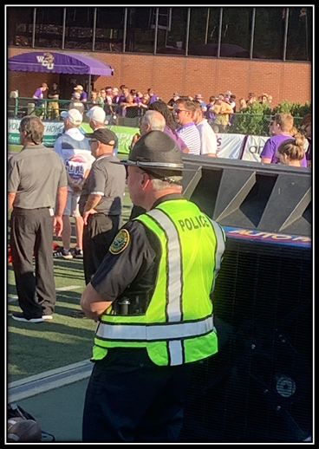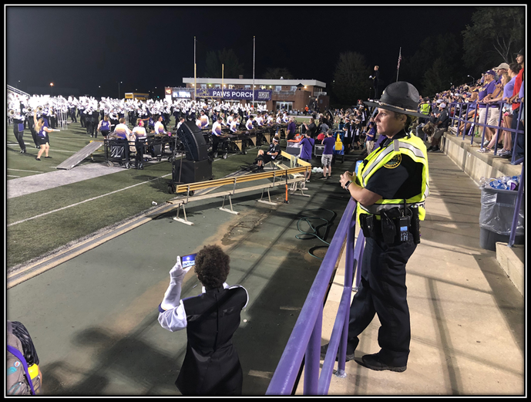

Officers providing security at athletic events.

**Special Event Statistical Data**

|  |  |  |
| --- | --- | --- |
| Event | Date | Total Overtime Hours |
| Student Move In | 8/16/19 – 8/18/19 | 214 |
| Speaking Event | 9/11/19 | 4 |
| Drag Show | 9/27/19 | 12 |
| All Home Football Games (6) | 8/31/19 – 11/16/19 | 900.5 |
| Mountain Heritage Day | 9/28/19 | 81 |
| Opioid Town Hall Event | 10/3/19 | 5.5 |
| Tournament of Champions | 10/19/19 | 24 |
| Homecoming Concert | 10/24/19 | 50.5 |
| Halloween Event | 10/29/19 | 6 |
| All Men’s Home Basketball Games (13) | 11/9/19 – 2/26/20 | 113.25 |
| All Women’s Home Basketball Games (16) | 11/5/19 – 2/22/20 | 108.5 |
| Sylva Christmas Parade | 12/1/19 | 15 |
| Winter Graduation Ceremony | 12/14/19 | 177.5 |
| Shop with a Cop | 12/17/19 | 4.5 |
| All Home Baseball Games (8) | 2/14/20 – 3/11/20 | 28.5 |
|  |  |  |
| \*Total Events: 54 |  | **Total Hours: 1,744.75** |

Total Hours do not include on duty Officers or Administrative Officers

\*26 Spring Semester Events Cancelled Due to Covid-19

**Criminal Investigations:** The WCU Police Department is tasked with the responsibility of investigating all crimes that occur within our jurisdiction. Extensive efforts are made to prevent crime but we are reminded that no community is immune from criminal behavior. The officers tasked with investigating crimes are well trained and able to effectively navigate the complexities associated with our federal mandates and general statutes. Those assigned to investigations must complete tasks such as crime scene processing, interview and interrogation, search warrant creation and courtroom testimony.

**Victim Services:** The Western Carolina University Police Department sent an additional staff member to the NC Victim Service Practitioner training program and we now have two certified practitioners within the department. This allows students and employees more access to a trained professional when dealing with the aftermath of criminal activity. This certification is sponsored through the NC Victim Assistance Network and allows the police department to understand and utilize the most up to date best practices for dealing with victims of crimes. In addition, the department has developed a consistent process of providing victims with multiple resources in a convenient packet that will allow them to process the information over time as they recover from the incident.

**Police Training Events 2019-2020:** In addition to the mandatory In-Service Training that is designated by the North Carolina Criminal Justice Training and Standards Commission each year, members of the University Police Department also undertake advanced training in critical topics that are related to the specific needs of a campus community.

Some of the key areas of training that were addressed this year include:

* Assistant Chief Brian Thomas Completed the Prestigious FBI National Academy
* Three staff members conducted an active shooter class for local SROs
* The Department Conducted a second Bike Patrol Certification Course
* Police Officer Aaron Henson was certified as a General LE Instructor.
* Two officers completed a precision rifle course designed for special event venues
* The Department began a new initiative to assist students in obtaining their law enforcement certification by attending the Basic Law Enforcement Training course between their academic semesters.

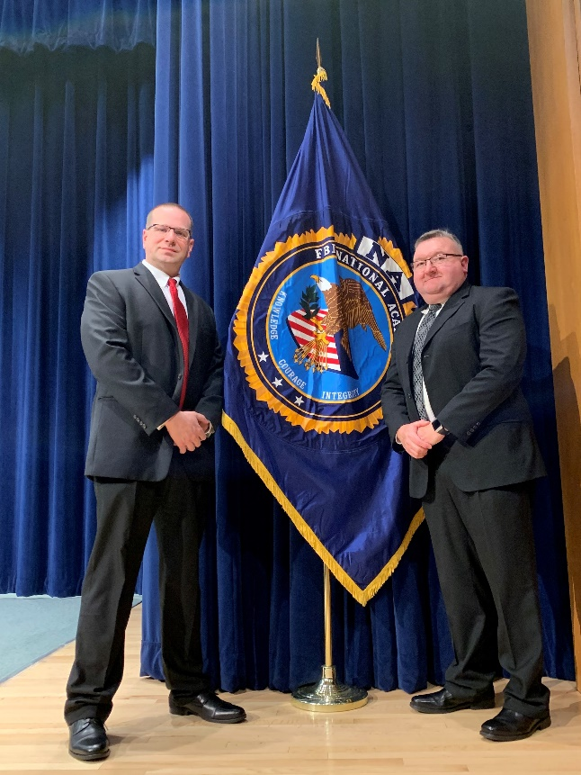 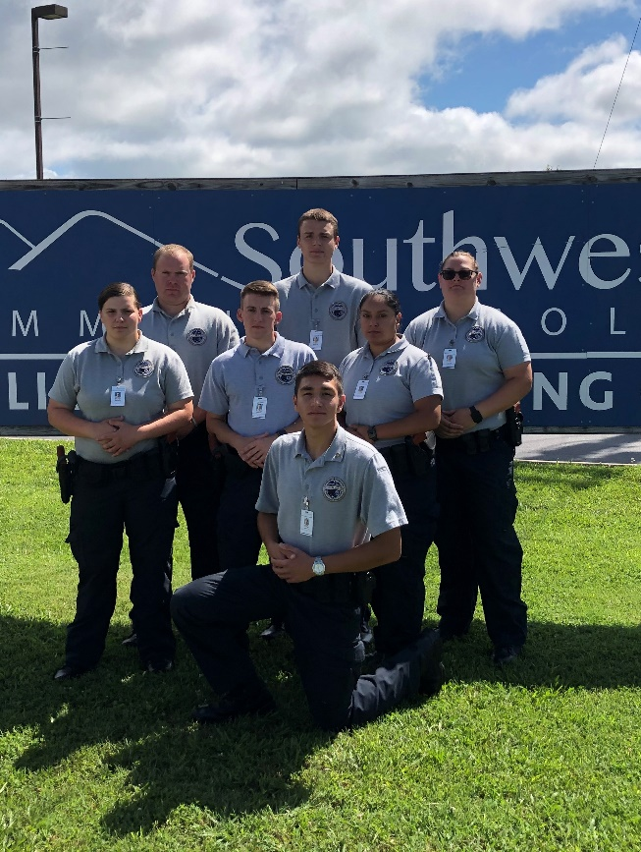

***Assistant Chief Thomas FBI NA Graduation BLET Students participate in new initiative***

**Police Experience and Professional Development 2019-2020**

The Western Carolina University Police Department is proud to be an experienced and developed agency capable of meeting the needs of our community members. The officers maintain a high level of professionalism and a true commitment to serving the campus in a manner that is conducive to the learning environment while also being a safe and secure area for our students, faculty, staff and guests. Currently, the members of the WCU Police represent hundreds of years of combined service in Law Enforcement. In addition, many of those years came from officers working in large metropolitan areas which helps to diversify the overall services that the police department is able to provide.

In addition to the vast hours of police training that are found at the WCU Police Department, our officers constantly strive to become better educated so that we can continue to grow our relationship with the campus community by understanding the needs of the students.

|  |  |
| --- | --- |
| C:\Users\sdlillard\AppData\Local\Microsoft\Windows\INetCache\Content.Word\Holcombe Degree2 1-30-20.jpeg | C:\Users\sdlillard\AppData\Local\Microsoft\Windows\INetCache\Content.Word\DSC_0202 (002).jpg |

***Sgt. Holcombe Receives His Bachelor’s Degree Retiring Officer Passow is recognized for his service***

|  |  |
| --- | --- |
| **C:\Users\sdlillard\AppData\Local\Microsoft\Windows\INetCache\Content.Word\Thompson.jpg** | *C:\Users\sdlillard\AppData\Local\Microsoft\Windows\INetCache\Content.Word\Norton Intermediate Cert1 3-25-20.jpg* |
| *Sgt. Thompson Receives her Master’s Degree* | *Officer Norton Receives her Intermediate Certificate* |
| *C:\Users\sdlillard\AppData\Local\Microsoft\Windows\INetCache\Content.Word\Flesch Promotion1 3-3-20.jpg* | C:\Users\sdlillard\AppData\Local\Microsoft\Windows\INetCache\Content.Word\Southards Promotion 12-14-19.jpg |
| *Officer Flesch is Promoted to Sergeant* | *Officer Southards is Promoted to Detective* |

**Clery Compliance 2019-2020**

The Clery Act is commonplace throughout institutions of higher education due to the emphasis that the law places on providing a safe and secure location for students, faculty, staff and visitors to engage in the learning process. This critical piece of legislation requires constant oversight so that our institution can remain compliant with the nuances of the law and corresponding regulations. We also strive to ensure that all available information related to campus safety is shared with the community so that everyone remains informed about criminal activity in the area. This is accomplished each year through the creation of our Annual Fire Safety and Security report that is presented to the US Department of Education and made available to the public.

This report contains items such as the collection and classification of crime statistics, maintenance of a daily crime log, the issuance of campus crime alerts to provide the campus community with information necessary to make informed decisions about their health and safety, and many other procedures that revolved around the safety of the community.

The statistics listed below are police department only statistics that make up a portion of the full report which is submitted in October of each year. The upcoming report will contain all police and university statistics for calendar year 2019 and will be used to help direct and modify our operations in order to address specific concerns.

This report provides statistics for the previous three years concerning reported crimes that occurred on campus or in certain off-campus buildings or property owned, leased or controlled by Western Carolina University.

**Clery Compliance Statistical Data**

|  |
| --- |
| **Table 1** |
| |  |  |  | | --- | --- | --- | | **Clery Defined Data**  **Criminal Offenses** | **7/1/2019-6/30/2020** |  | |  | | a. Murder/Non-negligent manslaughter | 0 |  | | b. Negligent manslaughter | 0 |  | | c.  Sex offenses\* |  |  | | Rape (except Statutory Rape) | 17 |  | | Fondling | 47 ( \*40 incidents were encompassed in two reports) |  | | d.  Sex offenses-Non forcible |  |  | | Incest | 0 |  | | Statutory Rape | 0 |  | | e. Robbery | 0 |  | | f. Aggravated assault | 2 |  | | g. Burglary | 12 |  | | h. Motor vehicle theft | 7 |  | | i. Arson | 0 |  | |
| **Table 2** |
| |  |  | | --- | --- | | **New VAWA (Violence Against Women Act) Offenses** | **7/1/2019-6/30/2020** | | Dating Violence | 6 | | Domestic Violence | 1 | | Stalking | 9 | |
| **Table 3** |
| |  |  | | --- | --- | | **Arrests (Clery Defined)** | **7/1/2019-6/30/2020** | | Weapons | 2 | | Drugs | 28 | | Liquor | 14 | |
| **Table 4** |
| |  |  | | --- | --- | | **Referrals** | **7/1/2019-6/30/2020** | | Weapons | 2 | | Drugs | 39 | | Liquor | 52 | |

