Faculty Senate Minutes
10/22/2020 Regular Business Meeting 3:00-5:00 pm via ZOOM
ADMINISTRATIVE PROCEDURES
ROLL CALL
- Present:
  - Indi Bose – present
  - Chancellor Kelli Brown - present
  - Todd Collins – present
  - Heidi Dent – present, arrived late
  - David De Jong - present, arrived late
  - Heather Mae Erickson - present
  - Cheryl Waters-Tormey - present
  - Garrett Fisher - present
  - Mariana Fisher - present
  - Enrique Gómez - present, arrived late
  - Yancey Gulley - present
  - Ian Jeffress - present
  - Bora Karayaka - present
  - Marco Lam - present
  - Will Lehman - present
  - Niall Michelsen - present
  - Sean Mulholland - present
  - Kadence Otto - present
  - Matthew Rave - present
  - Carrie Rogers - present
  - Roya Scales - present
  - Provost Richard Starnes - present
  - Vicki Szabo - present
  - Elizabeth Tait - present
  - Martin Tanaka - present
  - Drew Virtue - present
  - Laura Wright - present
  - Jessica Zellers - present
- Members with Proxies: Michael Boatright - proxy Laura Wright, Elizabeth Wark - proxy Mariana Fisher, Leigh Odom - proxy Elizabeth Tait
- Members Absent: Kristin Calvert

APPROVAL OF MINUTES
Approval of Regular Business Meeting Minutes from September 24, 2020
Motion to approve was made by Jessica Zellers. Seconded by Laura Wright. Voice vote was made.
- Michael Boatright - aye
- Indi Bose - aye
- Todd Collins - aye
- Heather Mae Erickson - aye
- Mariana Fisher - aye
- Yancey Gulley - aye
- Ian Jeffress - aye
- Garrett Fisher - aye
- Bora Karayaka - aye
- Marco Lam - aye
- Will Lehman - aye
- Niall Michelsen - aye
- Sean Mulholland - aye
- Leigh Odom - aye
- Kadence Otto - aye
- Matthew Rave -aye
- Carrie Rogers - aye
- Roya Scales - aye
- Vicki Szabo - aye
- Elizabeth Tait - aye
- Martin Tanaka - aye
- Cheryl Waters-Tormey - aye
- Drew Virtue - aye
- Elizabeth Wark - aye
- Laura Wright - aye
- Jessica Zellers - aye
Minutes approved.

EXTERNAL REPORTS
Chancellor’s Update: Chancellor Kelli Brown
Chancellor Brown recently attended WCU’s Culture in Conversations series. The photos posted in the library are daunting. There is one more series this semester that will be presented by Sky Sampson of the Cherokee Center.
The College of Education and Allied Professions has had some great things going on. Dr. Holly Pinter was named the Association for Middle Level Education’s National Middle Level Professor of the Year, and Dr. Roya Scales has been part of the Literacy Framework Group which is putting together a framework for teacher ed programs.
We have four more weeks to go until November 20th! Thank you to everyone for your hard work. We hosted a breakfast drive through this past Friday to celebrate.
We are seeing double digit numbers in COVID this week. There has been an uptick in testing as well as an increase in numbers across NC.
Jackson County Public Health Director Shelley Caraway, Sam Miller, Melissa Wargo and Chancellor Brown continue to discuss WCU and Jackson county numbers. There is nothing that indicates a specific age group - the numbers are community wide and we are seeing this across the state in Jackson county. Shelley Caraway will be adding two “D’s” to our current direction which stand for distance and duration.
Nearby apartment owners are hosting parties. We will soon reach out to apartment complex owners and managers. A recent governor’s message is that they are looking to public health and safety to encourage compliance. They could be fined, etc., if the rules aren't followed. Our increase in numbers are in students who live off campus, not on campus. We need them to be more compliant with the gathering rule.
From October 12-18, we have had 45 confirmed cases. This puts us at a 4.4% positivity rate right now. We are still under 5%. We have 40 students today in isolation on campus, and over 200 in self-isolation off campus.
Please continue to follow the updated COVID 19 dashboard. Thank you to Alison Joseph, Nathan Hodges, and Amelia Bryant for putting this together for us. Please take a look for up-to-date information.
We are also very thankful for the work that has been happening in health services. They are not only doing their jobs but are doing testing as well. If you see any of those folks, please thank them for their work.
Quarantine and isolation: we have added some extra beds (8-10) from The Villages and are hopeful we won’t have to use them.
Congratulations to Provost Richard Starnes and AJ Grube in their new roles. We received over 170 applicants nationally for the Provost search, and the best person for WCU was right here on our campus.
WCU athletics recently signed a collegiate coaching diversity pledge.
UNC System Racial Equity Task Force: There will be virtual town halls coming up in the near future - two for students, faculty, and staff, and we are encouraged to participate. Chief Diversity Officer Ricardo Nazario-Colon is a representative on that task force.
Please vote. One stop polling is on campus at the UC.
Question from Vicki Szabo: Can you speak about the budget cut exercise? There were questions about 10% being an unrealistic exercise. Why not choose a variable cuts exercise?
Response: I have not spoken with other chancellors. We worked internally to come up with a 10%. For us it does not mean a 10% across the board. It means that we need to think about what it would take. It means some may have more and some may have less. Some divisions could say 6%, 8%, etc. but at the end of the day we are talking about what a 10% would look like for the institution.
Question from Yancey Gulley: We have seen COVID numbers go up and faculty are talking about this on campus. I wonder if we are doing anything more than repeating ourselves more loudly to get ahead of this. Other than repeating, what we are doing; are there other initiatives? It’s great to add to the 95 beds for isolation, but we are almost half full already...it is worrisome to add more beds when resources could go other places.
Response: We are tired of hearing the same messages, but they say what's happening is that people are going to church. People are having family gatherings, going to weddings, and hanging out at local establishments. Jackson county is currently putting together a communications team and they will be looking at what other messaging we can do. In other places they are more stringent than Jackson county. There are some places that won’t let you walk downtown without a mask or enter a shop without one. They don’t want to shut down things, so they are talking about what else they can do around messaging. Chancellor Brown is open to ideas and suggestions.
Provost Richard Starnes added: they have looked at a couple other things to identify cases before they become clusters, and we recently completed a pilot study. Sometimes there are products that are made to sell and not to buy. The pilot test did not give us any actionable data to move forward with. We are looking at some solutions around surveillance testing. As it has evolved and continues to evolve, our response does as well. We are trying to identify things we can do and bring to action here on campus.
Question from David de Jong: How about the NC Covid tracker app?
Response: It can be confusing with contact tracers on the ground. There are concerns some might fake it. We are not pushing the tracker at this time. The governor went to phase 3 and allowed us to move from 10 to 25 indoors and 25 to 50 outdoors. Chancellor Brown has chosen to stay at the 10/25 to assist in mitigating the transmission.

Provost’s Report: Interim Provost Richard Starnes
Spring Semester Planning Calendar
In response to COVID-19, and based on broad feedback from faculty, students, staff, and others, the Spring 2021 academic calendar has been modified to delay the start of classes by two weeks, eliminate the week-long traditional spring break, provide a shorter mid-semester break, preserve advising day, and add an additional reading day.
- First day of classes: Monday, Jan. 25
- Reading Day: Wednesday, Feb. 24 (no classes)
- Advising Day: Tuesday, Mar. 9 (no classes)
- The last day to withdraw from a class with a “W”: Friday, Mar. 19
- No classes: Thursday, Apr. 1; Friday, Apr. 2; Monday, Apr. 5
- Last day of classes: Friday, May 7
- Final exams: Saturday, May 8 – Friday, May 14
- Tentative dates for commencement (subject to change):
  - Friday, May 14 (graduate)
  - Saturday, May 15 (undergraduate) The full calendar is posted on the website of the Office of the Registrar.
Student Support Services Update
During this unprecedented time dealing with a global pandemic, WCU has made extra efforts to lean in and support our catamounts. The support has increased awareness of academic policies, awareness of campus support offices, and therefore assisted students academically, medically, and communally. This support is through increased awareness of 5th and 8th-week grades as well as improved connections with multiple campus support offices across campus.
Advising Center, Honors College, Health Sciences, MAPS, and Suite 201 advisors
A student’s professional advisor is available to discuss strategies for improving their grades and the implications of a course withdrawal on academic progress. Please direct students to their professional advisor for additional assistance. You can direct students to the Advising Center, and they will connect the student with their assigned advisor, 828-227-7753.
Writing and Learning Commons & Math Tutoring Center
Last year, more than 3,685 WCU students visited the Writing and Learning Commons and Math Tutoring Center. Over half of our undergraduate students go to tutoring at some point in their academic careers. Students who take advantage of tutoring services report greater confidence in their ability to complete coursework and increased knowledge of the topics they cover in tutoring sessions. Students who go to tutoring also learn better study strategies that they can use when studying on their own.
The Writing and Learning Commons (WaLC) provides free academic support to help students in all of your classes. Students can visit the WaLC to learn more about small-group course tutoring, one-on-one writing tutoring, supplemental instruction, and individual academic skills consultations. Students can visit the WaLC website (http://tutoring.wcu.edu) to schedule an appointment using Navigate, or call 828-227-2274; all appointments are virtual.
The Mathematics Tutoring Center (MTC) provides free drop-in tutoring for students to find support for success in math classes. Virtual appointments are available Monday through Friday 8am-5pm. Please contact the Director, Sibley Bryan (fsbryan@email.wcu.edu), by emailing him or calling him directly at 828-227-3830 with any questions.
Office of Student Retention
The Office of Student Retention provides high-touch advising to students referred by faculty/staff as at-risk of not being retained or persisting. Faculty or staff who have identified a student needing advising support in addition to their other advisors can submit an Issue Alert about the student within the Navigate system (previously GradesFirst) and select “Retention Outreach” as the issue alert reason (steps here). Faculty or staff can also refer students by email to retention@wcu.edu or by phone to 828-227-7171.
Counseling and Psychological Services
If you feel that one of your students could benefit from counseling, please ask them to call Counseling and Psychological Services at 828.227.7469. In order to minimize the risk of spreading a potentially infectious illness, all clients for WCU Counseling & Psychological Services must call and schedule an appointment. To make an appointment, please contact the main office at 828.227.7469 during normal business hours (Monday through Friday, 8am to 5pm).
Office of Accessibility Resources
If a student has a disability or a medical condition that may result in their need to access services offered by the Office of Accessibility Resources, please contact Jack Kelly at 828-227-7127.
Hunter Library
Please visit the library website to check on hours, https://www.wcu.edu/hunter-library/.
Revisions to Section 400.1.5[R] of the UNC Policy Manual, related to Fostering Undergraduate Student Success:
Due to the lingering impact of COVID-19 on our student body and instructional modalities across the state, the UNC System Office policy related to Fostering Undergraduate Student Success has been revised. The previous regulation stipulated that students may only withdraw from or undertake a grade replacement for up to four courses (or 16 credit hours) without extenuating circumstances during their undergraduate career. As such, the regulation was previously amended to allow institutions to treat withdrawals and grade replacements for courses taken in the 2020 spring semester as being considered due to extenuating circumstances. The most recent revision has extended those provisions to courses taken during the Fall 2020 and Spring 2021 semesters. Course withdrawals and grade replacements taken during the Fall 2020 and Spring 2021 semesters due to the COVID-19 pandemic shall be considered taken due to serious extenuating circumstances. The updated regulation has also been posted to the UNC Policy Portal and can be accessed at https://www.northcarolina.edu/apps/policy/index.php?section=400.1.5%5BR%5D.
Eight-week Grades Data
Faculty from across campus recently submitted 8th-week grades to the Registrar’s Office. Faculty were requested to report 8th-week grades for more students than in previous semesters, to provide students with additional information about their academic progress. 3,302 students received at least one unsatisfactory 8th-week grade this semester, compared with 1,724 students in Fall 2019 and 644 students in Fall 2018. Professional Advisors have emailed students with poor 8th-week grades and reminded them of campus resources as well as the deadline to withdraw from a class(es). Communication with students often results in directing them to vital campus resources aiding in their student success.
Standing Committee on Faculty Salaries Update
The Standing Committee on Faculty Salaries resumed their work on September 30, 2020. The committee is comprised of the following individuals:
- Richard Starnes, Provost and Vice Chancellor for Academic Affairs
- Cory Causby, Associate Vice Chancellor for Human Resources
- Kadie Otto, Faculty Senate Chair / School Director, School of Entrepreneurship, Hospitality & Tourism, Marketing, and Sport Management, College of Business
- Morgan Kennedy, Assistant Professor, School of Art and Design, College of Fine and Performing Arts
- Krista Schmidt, Professor, Research and Instruction Services, Hunter Library
- Catherine Carter, Professor, Department of English, College of Arts and Sciences
- Carrie Rogers, Associate Professor, School of Teaching and Learning, College of Education and Allied Professions
- Sean Mulholland, Professor, School of Economics, Management and Project Management, College of Business
- Martin Tanaka, Associate Professor, School of Engineering and Technology, College of Engineering and Technology
- Anjana Sharma, Instructor, Department of Biology, College of Arts and Sciences
The committee will next meet on November 4, 2020. Dr. Cory Causby will discuss the results of the equity study completed in October.
Administrative Searches Update
College of Business Dean
Effective January 1, 2021, Dr. Angela J. (AJ) Grube will be the new dean of the College of Business. In a nationwide search that attracted an extraordinary pool of applicants, Dr. Grube impressed all constituencies with her passion for WCU, her commitment to the success of our students, and her vision for the College of Business. We are grateful to the members of the search committee, especially chair Dr. Jon Marvel, for their hard work during very challenging times and for crafting an excellent search process. We are also very appreciative for Dr. Debra Burke’s willingness to step into the role of interim dean. Her leadership, devotion to students, and long experience in the College of Business helped the college continue to move forward on many fronts – including the AACSB reaccreditation process – amid the vast challenges we have faced this past year. Please join me in congratulating Dr. Grube on her new leadership role.
College of Arts and Sciences Dean Search
A search committee will be established in the next few weeks to move forward on a search for the next College of Arts and Sciences Dean. Details will be forthcoming.
Hunter Library Dean Search
Upon the announcement of Dr. Farzaneh Razzaghi’s retirement at the end of the academic year, a search committee will be established in the next few weeks to move forward on a search for the next Dean of Hunter Library. We are thankful to Dr. Razzaghi for her dedication and service to WCU.
Campus Voting Site
To date, we have had 1,246 votes cast here on campus.
Question from Laura Wright: What about extending options for grade replacements for students?
Response from Larry Hammer: The catalog policy already has some provisions for students to appeal and petition to take it again. We encourage you to talk with your students and reach out to Larry to see what is possible.

Staff Senate: Chair Ben Pendry
Session two of the Culture in Conversation Series was great. Session 3 will be on November 10th, with Sky Sampson speaking.

The Question of the Month for Oct/Nov is pertaining to the budget exercise feedback: https://affiliate.wcu.edu/staffsenate/blog/2020/10/14/recap-action-items-meeting-of-budget-advisory-cmte-chancellors-leadership-council-and-academic-dept-heads/

Western Wednesday with Dr. Chris Cooper is on October 28th, register here: https://www.wcu.edu/engage/alumni/get-involved/alumni-events/index.aspx

SEANC joined our most recent staff senate meeting and provided an update on the work being done in Raleigh on behalf of all NC state employees.

Staff Senate ornaments are on sale now.
https://wcupg.wcu.edu/C20252_ustores/web/store_main.jsp?STOREID=287

Student Government Association Report: President Dawson Spencer
Internal Activities
- Judicial Branch
  - Meet on Thursdays at 6:00 pm.
  - Kaitlyn Alston was approved as Chief Justice, and interviews were hosted, and we now have a new judicial branch.
  - They held court last week and heard around all of the pending cases; they will be hosting every other week in person or virtual court.
- Legislative Branch
  - They host their weekly meeting on Monday nights at 6:00 pm Zoom.
  - We have an approved budget.
  - They have about five resolutions on their docket.
    - F20-01 Resolution to Change PRM Committee – OFFICIATED
    - F20-02 UNC ASG Delegate Selection Process – OFFICIATED
    - F20-03 Amend Director of Internal Operations Title - OFFICIATED
    - F20-04 WCU SGA Support of ASG Voting President - OFFICIATED
  - They are hosting a “Whee Talk” in collaboration with OOTD, CAPS, and our Senate committee of Health and Safety.
  - We also have guest speakers from the Chief of Police, Director of Health Services, Legal Counsel, and many more.
- Executive Branch
  - New Advisor
  - Bi-Weekly 1:1s
  - We will start hosting Professional Development classes for SGA.
  - Flu Shot Campaign [Every Tuesday in October from 12-3]
    - Biltmore Park... 35
    - HHS... 37
    - Brown... 36
    - Central – 35
  - Blood Drive [November 4th and 5th]
  - Appreciation Day for Housekeepers, Dining, etc. [TBD]
  - RoadSide Clean Up [October 31st 10:00am]
  - CORE Meetings are going great. The greatest concern of RSOs is recruitment and programming. CORE mtgs will be focused on training in a COVID world.
  - Legislative Database
  - Motivational Monday and Feature Friday
  - Website Revamp
  - Culture in Conversation
    - Part 2 – Tuesday, October 20, noon – 1 pm: Women, Equity, & Social Justice
    - Part 3 – Tuesday, November 10, noon – 1 pm: On Sacred Ground---The Cherokee
  - Tuition and Fees Committee has been kicked off.
External Activities
- Voting Town Hall [October 20th, 6:00pm]
- Recent acts of racism across the System [UNCC, WCU, UNCA]
- Events
  - Racial Equity Townhalls
  - Advocacy Plan for 2nd week of November [Mountain Region]
  - Fellow research
  - Raising Awareness of Students Rights and Resources
  - ChatBot on myWCU
- Initiatives
  - Academic Integrity
  - WCU Yearbook
  - ROTC Program
  - ASG Engagement
  - Student Honor Memorial at Graduation
  - Grade Distribution

Faculty Assembly Report: Reporting Delegate Vicki Szabo
The full report is available on SharePoint.
Forthcoming items include:
- The Governance committee will ask for senate representation on the BOT.
- There is a comparative fact sheet on governance across system institutions.
- Equity, diversity, and inclusivity policies data will be compiled and shared.
- 10 faculty signed up from WCU for the town hall on October 26th.
- The Academic Affairs report using system data has interesting data to review.

COUNCIL and COMMITTEE REPORTS
Academic Policy and Review Council: Chair Roya Scales
The council will meet on October 28th. They are working in subcommittees on a redesign of the curricular review process and reviewing procedures from the non-curricular taskforce report.
They are working through curriculum proposals.
Kadence Otto noted that the Social Justice Minor is coming forward at some point, and it would be great to bring back the Women's Studies Minor.
Collegial Review Council: Chair Carrie Rogers
The council met on October 14th and had a great conversation about collegial review in the time of pandemic. They will bring some items forward to the full senate at a later date.
They are looking at a continuance of an electronic workflow this year and will look at using it again next year. Please give them input to take forward. They will meet again on November 11th.
Kadence Otto noted that the electronic workflow is going very well. It will be interesting to receive feedback from others.
Faculty Affairs Council: Chair Sean Mulholland
The council met on October 19th and spent much of their time working through concerns about SAI’s. They also decided to split into two working groups. One led by Martin Tanaka about student perception of learning mechanisms. The other working group will focus on compensation and comparing compensation relative to tier 3 peer CUPA groups. The comparison will look at the 25th percentile.
Sean Mulholland shared his screen to show some preliminary data as an example.
Question from Laura Wright: Does this data include instructors/lecturers?
Response: Yes
Rules Committee: Chair-Elect Laura Wright
The rules committee met this past Tuesday. They are holding and waiting to hear from other committee chairs in terms of potentially reshaping and reforming the committees we currently have.
Senate Report: Chair Kadie Otto
Mental Health
Nancy Ford has updated the HR website with a new link for mental health resources as noted below:
https://secure.my.wcu.edu/division/AdminFinance/HRandPayroll/Pages/ComPsych.aspx
Please review and tell us what is missing and what else is needed.
Chair Otto met with Lee Smith and Jon Maddy from Facilities Management due to concerns from faculty. She asked about the chemicals being used in the buildings. They talked about the amount, time of day, sprays, etc. and Chair Otto was sent a copy of details on each one. She is looking for feedback as to whether or not we should put this information out there for the full faculty.
Heather Mae Erickson shared that we have to let the students know what chemicals and materials are being used in the area and there is a public site that it is listed on. She suggested contacting the safety office on this. It may be an OSHA thing.
Shea Browning shared that they are likely public documents in which case they could be posted. The concern is that there may be confusion with them and then the senate will start getting questions. The Senate will need to make the choice if they are public documents they would like to share.
Parking concerns: Chair Otto talked to Fred Bauknecht, the Director of Parking, and he shared information about faculty not on campus. Faculty can complete a form to say you do not want money automatically taken out of your paycheck if you are not on campus. $5 day pass or $8 weekly pass.
We need to stress equal pay for salaries for women. We stand for equity, justice and respect, and we need to back it up. Females should be paid the same as males. We are hopeful to find a way to move forward. We are standing up for minorities with our culture series, but we need to stand up with money as well.

NEW BUSINESS
Open Discussion on whether to use Fall 2020 SAI data for TPR and AFE
Laura Wright shared several comments from colleagues. She was on the taskforce and Chris Cooper and she compiled a report and it shows that SAI’s are biased. This simply reinforces these are not good metrics to evaluate faculty on even during a pandemic.

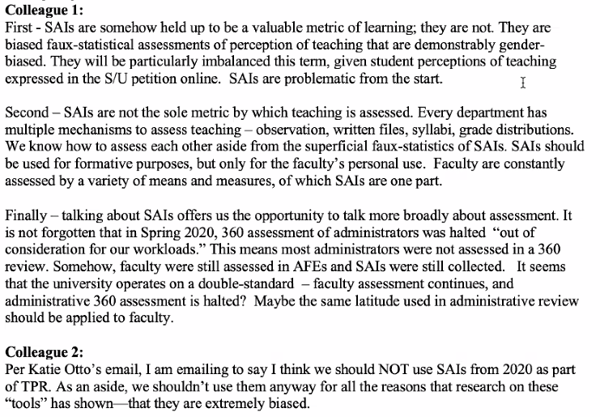

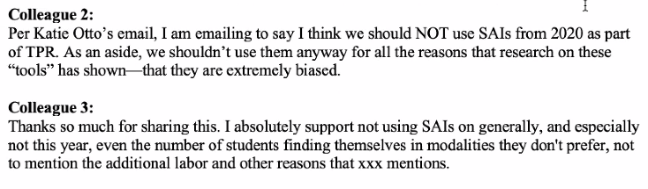

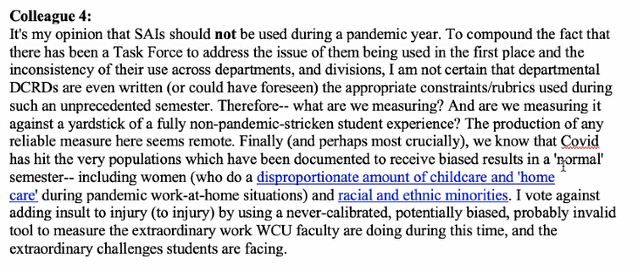
Enrique Gómez shared that many DCRDs include language about the SAIs. He proposes a standard statement about the context of SAIs for Fall 2020 and Spring 2021. Essentially, by the end of the semester we will have global data. People see it in comparison to previous semesters. It is incumbent for us to give some context.

Mariana Fisher ran a survey in HHS and had about 53 responses. Most faculty wanted it to be optional. Some are struggling, but some are recognizing the value as well. They would like it to be up to the faculty to include it or not.

Cheryl Waters-Tormey shared that the work that was done last year suggested that we use the SAI for too many purposes. It may be possible to get some help from Coulter about writing an additional anonymous survey this way. It is something in addition to look at besides the SAI. It may give us more valuable information. That is a possibility. It could be optional as well.

Martin Tanaka shared that he is leading a sub group on SAIs and this will look at what we are doing in the future. We will collect and assimilate feedback into something we can look at. The topic of today is focusing on SAIs for the current evaluation period - they are two separate issues and we should keep them separate so we can make a decision on the topic of discussion today and the immediate need.

Further discussion proceeded.

Mariana Fisher suggested that they vote yes, no, or optional for Fall 2020.
Kadie Otto shared that they should think about Fall 2020 and Spring 2021.

A suggestion was made to have further discussion on this in an overflow meeting next week on 10/28 at 3pm.

MEETING ADJOURNMENT
Cheryl Waters-Tormey motioned to adjourn.

No objections.
Meeting Adjourned.

