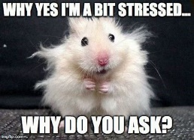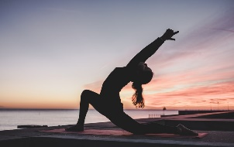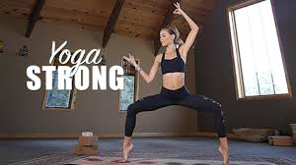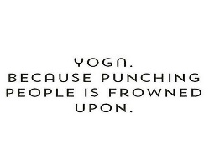

Managing Stress caused by Academics, Life, and…Everything in Between

There is A LOT of research backing up relaxation techniques to help manage stress and live a healthier life!
You might be wondering what is a relaxation technique? It can be anything really! Something that helps you to manage the emotions you are feeling and put them to the side for now so you can totally relax.
Smells and colors have even shown to influence stress. So, pull out those candles!
Self-care is also a very important part. Take the time to take care of yourself!! Take that bath, put on that face mask, or have a little dance party…whatever feels right.
Here are some other ideas for relaxation that are great with this new stay at home life we having right now!
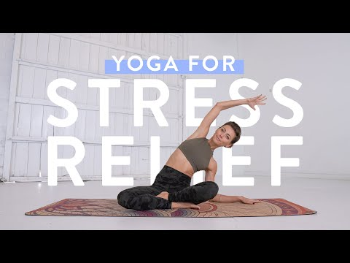
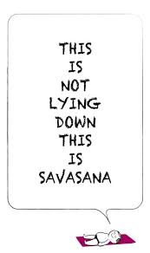
YogiApproved, is a great resource for yoga, meditation, and fitness videos at home. There are some on YouTube and they are also offering a free 30-day trial on their website!
PROMO CODE: STAYHOME
This is literally my favorite thing right now!!
Maybe you want to try some mediation? There are plenty of resources online. I am loving the Inscape App right now. Soothing music and instruction with different lengths some are just 8 minutes long.
Hope this helped! Remember to take care of yourself and seek help if your need it. If you still feel anxiety and these techniques do not help you, seek help! There are a lot of places out there to help you. CAPS is still there for us! https://www.wcu.edu/experience/health-and-wellness/caps/

