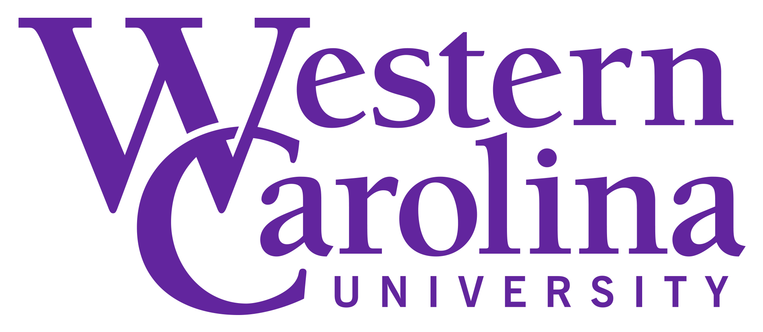
Student Learning Outcomes for Student
Employment Programs

What are Student Learning Outcomes?
Student Learning Outcomes (SLOs) are statements which define what students are to learn and demonstrate in terms of knowledge, skills, or abilities as a result from completing a program or task.

How do I begin constructing Student Learning Outcomes for my department’s student employment program?
Constructing Student Learning Outcomes should be a departmental effort. In general, though, SLOs should answer the following questions:
- What should students be able to do upon graduating?
- What skills, knowledge, or abilities should the student be able to demonstrate
- How will students be able to demonstrate what they have learned?

Each learning outcome will use one action verb according to the levels of Bloom’s Taxonomy (or, order of learning). (NOTE: A student must master the lower-levels first before moving on to higher levels of learning. See illustration below)
- Level One: Remember – Recall facts and basic concepts. Action verbs: Define, duplicate, list, memorize, repeat, state (e.g. memorize the department’s way of greeting visitor’s to the office)
- Level Two: Understand – Explain ideas or concepts. Action verbs: Classify, describe, discuss, recognize, locate, report, select, translate, paraphrase (e.g. paraphrase departmental functions to other student workers)
- Level Three: Apply - Use information in new situations. Action verbs: Execute, implement, solve, use, interpret, operate, schedule (e.g. implement communication skills to answer diverse questions about the department)
- Level Four: Analyze – Draw connections among ideas. Action verbs: differentiate, organize, relate, compare/ contrast, examine, experiment, question, test (e.g. Organize department’s lab inventory and supplies)
- Level 5: Evaluate – Justify a stand or decision; making a judgement call. Action verbs: Appraise, argue, defend, judge, select, value, critique, weight (Select best solution to a given problem
- Level 6: Create – Produce new or original work. Action verbs: Design, assemble, create, construct, develop, formulate, investigate (e.g. create student employment manual for department)

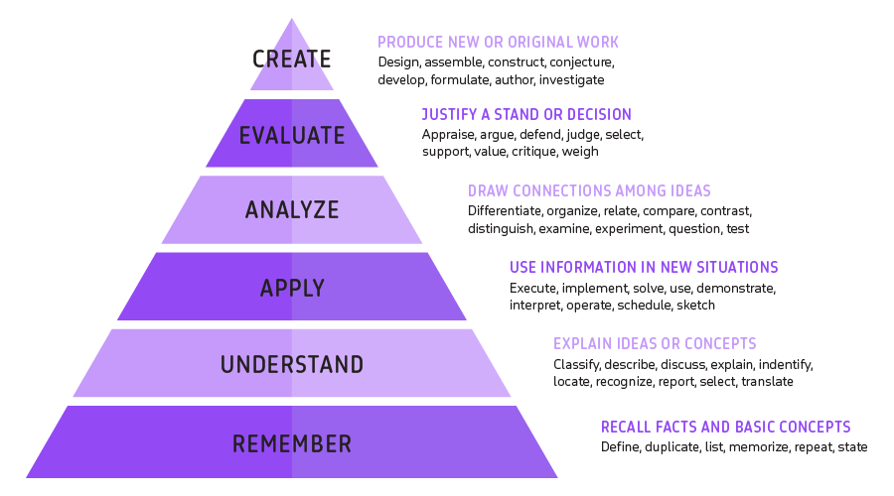

It’s also helpful to use the SWiBAT formula – Students will be able to…. (See examples at the end of this worksheet)

What should I consider when developing SLOs?
You should consider skill sets employers are looking for most in recent college graduates. Below is a graph created by the National Association of Colleges and Employers (NACE), illustrating skill sets employers need but find lacking in recent college graduates:
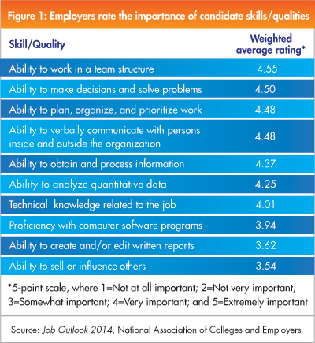
Using this information, NACE created what’s referred to as “Career Readiness Competencies.” Consider incorporating these concepts into your SLOs:
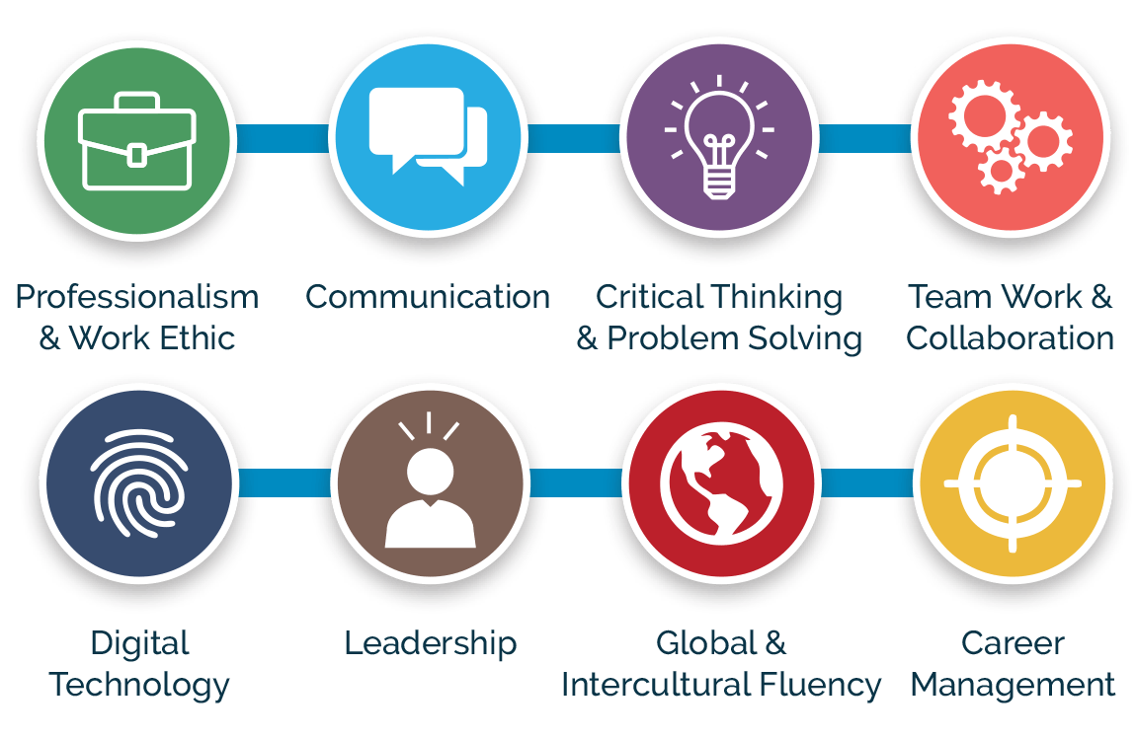

What makes a strong Student Learning Outcome?
Strong SLOs are S.M.A.R.T:
- S – Specific. Focuses on a specific skill set
- M – Measurable. Can you tangibly notice or measure the SLO (“gain appreciation” for something, for example, is not a SLO as measuring someone’s appreciation for something is neither measurable nor is it something that can be learned)
- A – Attainable. A first-year student, for example, will most likely not operate on the same level as a fourth-year student. Will a first-year student be able to create and edit professional documents without much supervision? Probably not (although it depends on the student), so make sure your SLOs are also realistic.
- R – Relevant. Are the skills your employment program helping your students to develop relevant to career and professional development? Does the SLO align with your department’s overall mission?
- T – Timely. Can you establish a time frame for which to measure this SLO?

Weaker Outcomes | Stronger Outcomes
Verbs are vague or not measurable (e.g. “gain appreciation for diversity” | Verbs are sharp, tangible, and measurable (describe, create, analyze)
Multiple verbs per outcome | One verb per learning outcome
Wordy, packing in multiple ideas | Brief and to the point
Focus only on lower levels of learning | Demonstrate multiple levels of learning

What are some examples of Student Learning Outcomes?
As a result of working in the _____ department, students will be able to:
- Demonstrate professional behavior in writing emails to external constituents
- Interpret complex university information in answering prospective student questions
- Use professional data tracking software to update departmental inventory
- Problem-solve a variety of challenges as they occur

How many SLOs should I create?
Because SLOs should also be assessed each year, we recommend at least 3 learning outcomes and no more than 5 total. Some departments will create separate learning outcomes for each position, while others will create broad learning outcomes that apply to all positions within the department

Need additional help?
The Center for Career and Professional Development is here to help! Additional resources might include:
- Student Learning Outcome generator
- National Institute for Student Learning Outcomes Assessment
- Hire Advantage Supervisor Program (learn about SLOs, how to assess them and so much more through this award-winning program)
- Consult Carrie Hachadurian, Student Development Coordinator: cphachadurian@wcu.edu or 828-227-3888.

