

WCU Staff Senate

WCU Staff Senate

Senator Handbook

Published by the Staff Senate PR Committee

2019

Contents

Introduction 3

What We Do 3

Bylaws 3

Name, Vision, and Purpose 3

Membership 4

Officers 5

Nominations and Elections 7

Executive Committee 8

Standing Committees: 8

Meetings 9

Amendments to the Bylaws 9

Appendix 9

Timelines 9

Proposed Schedule of Events 11

Membership Makeup 12

Roberts Rules of Order 13

Voting 13

Decorum 13

Meeting Mechanics 13

Monthly Meeting Agenda 14

Sample Agenda 14

Sharepoint Guide 15

Community Service 20

Objectives 20

Community Service and Engagement Projects in 2018 20

Members 22

Sub-Committees 26

Campus Committees 26

A Look Toward the Coming Year 27

2019-20 Election Results 27

Planned Initiatives for 2019-20 27

How to Be an Engaged Senator 28

# Introduction

The Staff Senate serves in an advisory capacity to the Chancellor and appropriate decision-making bodies by providing a regular, open senate to facilitate communication among all employees and the University administration concerning general employment interests and concerns and encouraging the development of constructive suggestions for more efficient and effective university planning operations. The Senate is not intended as a vehicle to deal with individual issues, grievances, or complaints, nor as a means to circumvent regular administrative channels.

# What We Do

* We seek to improve the quality of life at the University.
* We serve in an advisory capacity to the Chancellor and other University decision-making bodies.
* We raise money for scholarships available to the children of staff members.
* Senators are committed to promoting the training and support needed to allow staff members to excel, recognition of staff contributions, and respect for the worth of all individuals at WCU.
* We represent the voice of the staff at the University through outreach, forums, information sharing, committee participation, survey research and other means.
* We participate in service opportunities directly and work to engage staff in the WCU community broadly.

# Bylaws

## Name, Vision, and Purpose

1. Name: The name of the organization representing the interests and concerns of all SHRA and EHRA non-faculty staff members at Western Carolina University (WCU) shall be the Staff Senate. An elected representative to this organization shall be referred to as a Delegate.
2. Vision: The Staff Senate seeks to improve the quality of life at Western Carolina University for its students and all employees. This can be accomplished through mutual understanding, recognition of staff contributions, support for professional development and technical training, and respect for the worth of the individual.
3. Purpose: The Staff Senate serves in an advisory capacity to the Chancellor and appropriate decision-making bodies by providing a regular, open senate to facilitate communication among all employees and the University administration concerning general employment interests and concerns and encouraging the development of constructive suggestions for more efficient and effective university planning operations. The Senate is not intended as a vehicle to deal with individual issues, grievances, or complaints, nor as a means to circumvent regular administrative channels.

## Membership

1. Eligibility: The Staff Senate consists of elected representatives of SPA and EPA non-faculty employees. Membership on the Staff Senate shall be drawn from permanent part-time and full-time employees who have completed probationary requirements.
2. Representatives
3. Representation: The Staff Senate will be comprised of 28 elected Delegates. Representation shall be based on proportional representation on the following federal job classification codes: *Executive/Administrative, Professional, Technical, Clerical/Secretarial, Craftsmen, and Maintenance/Service*.
4. Duties: The duties of a Staff Senate representative are:
5. Participate in all meetings of the Staff Senate.
6. Serve on at least one standing committee of the Staff Senate.
7. Represent constituents by facilitating open lines of communication.
8. Serve as a Staff Senate designee on a university committee, if appointed.
9. All Staff Senate activities included above shall be considered to be part of the regular workday of each elected Staff Senate representative.
10. Participation: Senate members are expected to fulfill the obligations of attendance and represent Staff Senate at university functions.
    1. Required: Delegates are expected to attend monthly Senate meetings and Sub-Committee meetings (either in person or virtual meeting)
    2. Recommended: Community meetings, and committee meetings, such as meetings for all staff (Campus Talks)
    3. Attendance: The official minutes shall note beside each person listed as absent whether the absence is excused or unexcused.
    4. Unexcused Absence: If a Senate Delegate has an unexcused absence for three regularly scheduled Senate monthly meetings in a row, the delegate will be replaced automatically.
    5. Excused Absence: A delegate may be granted an excused absence by contacting the Senate secretary in advance of the regularly scheduled meeting to inform the secretary of the expected absence. This contact may be in person, by phone, by e-mail or in some other written form. Upon approval by the executive committee, a special variance may be granted for unexcused absences relating to personal illness, family emergency or other extenuating circumstances. It shall be the responsibility of the Senate Delegate to request such consideration in writing as soon after the absence occurs as possible. The Executive Committee shall consider these requests and include the determined action in the minutes of the next regularly scheduled meeting
11. Term of Office for Representatives: Each representative shall be elected to serve a three-year term (July-June). Campus-wide elections shall be held such that new representatives are elected and announced prior to end of March. All newly elected representatives will be strongly encouraged to attend the April and May meetings of the Staff Senate for introduction and orientation to the work of the Staff Senate and to become familiar with members so as to participate in elections to be held in June.
    1. UNC Staff Assembly delegates will be allowed to remain on the WCU Staff Senate with full voting privileges, even after Staff Senate term expiration, in order to complete respective terms with the UNC Staff Assembly.
    2. Following completion of the term on the UNC Staff Assembly, each delegate will rotate off the staff senate and will be required to take a one year leave before being eligible to serve again.

5. Re-election: A representative may be elected for a maximum of two consecutive terms. If a member serves out an unexpired term of one year or more, the individual may be elected to only one additional consecutive term.

1. Ex-Officio Members: Shall serve as non-voting members of the Staff Senate including but not limited to the Chancellor or the Chancellor’s designee, Director of Human Resources, and Past Chairs. Ex-Officio members shall function as a liaison between the university administration and the Staff Senate.

D. Delegate Vacancies: If a vacancy in a Staff Senate seat occurs, the alternate shall fill the position. An alternate is the person with the next highest votes within the same federal job classification code at the time of the election. A Delegate who experiences a change in federal job classification will be allowed to serve the remainder of the term. When a vacancy in the Staff Senate occurs and all alternates within the applicable federal job classification have been exhausted then the Executive Committee shall appoint a replacement from said classification if possible to serve until the end of the current fiscal year at which time the vacancy shall be filled through the normal election process.

If a temporary vacancy in a Staff Senate seat should occur through part-time employment (e.g., nine month position), health reasons (e.g., pregnancy, serious illness) or tragic event, the position can be filled during the temporary vacancy by the alternate. A Delegate’s seat shall be considered temporarily vacated if the absence is for six months or less. The seat shall be considered permanently vacated if the absence is for more than six months, and the alternate shall fill the seat.

1. The staff at-large members of the Chancellors Leadership Council are to be included in the distribution of Staff Senate meeting notices, agenda, minutes and any other information that is provided to the senate members. At-large members are welcomed; as are all staff members to attend any senate meeting however, mandatory attendance is not expected.

## Officers

1. Titles and Duties

1. Chair: In the event no member or only one member has the minimum number of years and is willing to serve as Chair then nominations will be open to any member. The duties of the Chair shall be:

1. Schedule and preside at all meetings of the Staff Senate and the Executive Committee of the Staff Senate
2. Serve as liaison to the Chancellor, the Chancellors Leadership Council, the Faculty Senate, the Student Government Association, and the Board of Trustees
3. Prepare a written report of the past quarter, give a two-minute brief to the Board of Trustees, and make that report available to the Staff Senate and to the Chancellor’s office by due date
4. Serve as a mentor to the Chair Elect to prepare them for taking over Chair duties the following year
5. Serve as a representative to the UNC Staff Assembly
6. Assume the Ex-Officio position of Past Chair for one year at the end of the term.
7. Chair-Elect: *Nominees should have at least one year* experience serving on Staff Senate in order to be nominated. In the event no member or only one member has the minimum number of years and is willing to serve as Chair-Elect then nominations will be open to any member. The duties of the Chair-Elect shall Preside at all meetings of the Staff Senate in the absence of the Chair or when requested to by the Chair
   1. Assist the Chair in performing duties
   2. Attend the Chancellors Leadership Council and the Faculty Senate with the Chair
   3. Develop and carry out procedures for making all appointments to standing committees.
   4. Assume the position of Chair at the end of the term.
8. Vice Chair: Nominees should have at least one-year experience serving on Staff Senate in order to be nominated. In the event no member or only one member has the minimum number of years and is willing to serve as Vice Chair then nominations will be open to any member. The duties of the Vice Chair shall be:
9. Preside at all meetings of the Staff Senate in the absence of the Chair-Elect or when requested to by the Chair
10. Assist the Chair in performing duties
11. Chair the Governance committee
12. Develop and carry out procedures for making all appointments to standing committees.
13. Secretary: The duties of the Secretary shall be:
14. Take minutes and attendance records of each Staff Senate meeting, including the distribution of minutes to Delegates at least five working days before the next scheduled meeting of the Staff Senate
15. Serve as Secretary of the Executive Committee
16. Be the custodian of all records.
17. The Secretary shall assume the role of the Chair in the event that the Chair, Chair-elect or Vice-Chair are not present at a Staff Senate meeting.
18. Treasurer: The duties of the Treasurer shall be:
19. General financial oversight of the Staff Senate financial accounts and budget
20. Bookkeeping, record keeping and financial reporting for the Staff Senate accounts
21. Parliamentarian: The duties of the Parliamentarian shall be:
22. Maintain order at meetings and to insure that Robert’s Rules of Order are being followed.
23. Determines quorum, counts votes (documents), and confirms that the vote carries.
24. Serve on the governance committee.
25. Lead a review of the Staff Senate Bylaws on an annual basis, prior to the April meeting. Proposed amendments to the Bylaws, as a result of this review, should be presented to the Governance Committee prior to a presentation to the general body.
26. Past Chair: The duties of the Past Chair shall be:
27. Act as liaison to the Chair and serve as Ex-Officio member of the Staff Senate.
28. Sit out one full-year at the end of this term before being re-elected to the Staff Senate unless completing an incomplete elected term.
29. Technologist: The duties of the Technologist shall be:
30. Serve on the WCU IT Council.
31. Act as the liaison for Staff Senate to WCU’s IT department.
32. Setup/Facilitate virtual meetings for Staff Senate meetings, as needed.
33. Manage, organize, and update the Staff Senate SharePoint website, and assist with the management of the Staff Senate public facing website.
34. Manage digital documentation and digitizing paper documents.
35. Assist Executive Council members with technology needs including: storage shares, accounts (distribution groups, email, wireless access for campus visitors, etc.).
36. Community Service Liaison: The duties of the Community Service Liaison shall be:
37. Coordinate Community Service/Engagement opportunities for Staff Senate initiatives.
38. Serve on the Public Relations Sub-Committee.
39. Be the custodian of all records pertaining to Staff Senate Community Service/Engagement.
40. Liaison with the Center for Service Learning on behalf of Staff.
41. Provide leadership for community service/engagement as needed.
42. Advocate for community service/engagement.
43. Be a point of contact for community members and partnerships.
44. Term of Office: Each officer will serve a one-year term and assume duties July 1 after election in April.
45. A representative shall not hold more than one office at a time, and no member shall be eligible to serve more than two consecutive terms in the same office. However, if a member assumes an unexpired term for less than six months, the member may be elected for the next two consecutive terms.
46. Unexpired Term: In the event that the Chair is unable to complete the elected term of office, the Chair-Elect shall assume the vacant office for the length of the unexpired term. A special election will be held at any regular meeting of the Staff Senate for Chair-elect in the event that the office of Chair-Elect is unable to complete the elected term of office, a special election will be held at any regular meeting of the Staff Senate for Chair-Elect. In the event the Vice-Chair is unable to complete the elected term of office, a special election will be held at any regular meeting of the Staff Senate for Vice-Chair. In the event any other Officer position becomes vacant a special election shall be held at any regular meeting of the Staff Senate by the Chair in order to fill the vacant office for the remainder of the term.
47. Officer Removal: If it is deemed an Officer is not fulfilling duties as described above, a 2/3 vote of the Staff Senate members present is needed in order to remove the Officer from the seat. Any member with cause to initiate removal should discuss the situation with the Parliamentarian who will bring it to the entire Staff Senate body (and notify the person in question) at the next scheduled meeting where a discussion with entire Staff Senate body will take place. A vote for removal will take place at the following scheduled meeting. In event that the officer in question is the Parliamentarian, or there is no Parliamentarian, then the officer to initiate the discussion will be the Secretary.

## Nominations and Elections

1. Delegates: Nominations and elections of Staff Senate Delegates shall be conducted in accordance with procedures established and carried out by the Governance Committee and approved by the Staff Senate. This process will take place during January/February and shall include:
2. Seeking open nominations campus-wide.

2. Recruiting possible candidates where necessary.

3. Conducting the campus-wide election by secret ballot in February.

4. Conducting run-off elections, if necessary.

5. Reporting election results no later than March 1.

6. Newly elected Delegates can attend the April, May, and June meetings.

B. Officers: The Staff Senate representatives shall elect Staff Senate officers. All Staff Senate members who will be serving in the upcoming term (newly elected representatives and those in second year of service) are eligible for election as an officer. Nominations and elections of Staff Senate officers shall be conducted in accordance with procedures established and carried out by the Governance Committee and approved by the Staff Senate. This process will take place during April and shall include:

1. Inviting nominations from Staff Senate members at the April Meeting. . Nominations from the floor for each office shall be in order.
2. Senators that accept nominations should notify the Governance Committee Chair prior to the June meeting. At the June meeting, nominated Senators should be prepared to share why the General Body should elect the Senator to the respective officer position.

3. Conducting the election of officers at the June meeting.

## Executive Committee

A. The membership of the Executive Committee shall consist of the six elected officers of the Staff Senate and the chairs of the four standing committees. The Executive Committee shall meet monthly or as needed to set the agenda of all Staff Senate meetings and to determine the appropriate discussion and disbursement of all issues and concerns which come to the Staff Senate (i.e., referral to a standing committee; establishment of a special committee or task force to consider an issue; referral to an administrative unit for clarification; placement on the agenda of the Staff Senate, etc.)

## Standing Committees:

A. The Chairs of each standing committee are required to attend the Executive Council meeting each month. Any Committee Chair that cannot attend the Executive Council should have someone else from that Committee attend on behalf of the committee. Each Committee should meet at least once a month.

A. Governance Committee: The duties of the committee will be to handle all nominations, elections, and orientation procedures for representatives and officers; to accept, study and recommend changes to bylaws and procedures; to provide staff names to university persons seeking staff representation on university committees; to address other issues and activities related to governance.

B. Public Relations Committee: The duties of the committee will be to plan and coordinate the communication function such that staff can exchange ideas with representatives on issues and concerns; to serve as the public relations agent of the Staff Senate. Methods of communication may include newsletters, press releases, and web page management. Additional responsibilities may include employee recognition activities, service projects, and other public relations issues.

C. Human Resources Committee: The duties of the committee will be to address all staff concerns and proposals in the area of salary/benefits, job classification, privatization, staff development and training, diversity/multiculturalism issues, and other human resources issues and activities.

D. Staff Senate Scholarship Selection Committee: The duties of this committee will be to solicit and accept applications (recruiting if necessary), certify eligibility and need of applicants, select an applicant by simple majority vote of the committee, recommend the candidate to Staff Senate for approval, and notify all applicants of results. The committee shall consist of a minimum of 5 members appointed by Staff Senate and chaired by a member of Staff Senate. The committee will be open to representation outside of Staff Senate (except for the Chairperson, committee members do not need to be members of Staff Senate to serve).

## Meetings

1. All meetings of the Staff Senate shall be open to all employees and students, and the public to observe and make comments as appropriate. Regular meetings of the Staff Senate shall be held at least once monthly. Special meetings may be called as needed with appropriate notice given to members.
2. Quorum: Seventy-five percent (75%) of the Staff Senate Delegates shall constitute a quorum, excluding ex-officio members. Delegates may contribute via proxy or in-person (including e-presence).
3. Voting: Fifty percent (50%) of a Quorum of Delegates is needed for a vote to pass. Delegates may vote via proxy or in-person (including e-presence). Amendments to the Bylaws require a two-thirds (2/3) majority vote. The Chair shall abstain from voting except when necessary to break a tie. Any Delegate may request a vote be taken by paper ballot.

C. Proxies: At all meetings a member may give, in writing, proxy to another member. Such proxy shall be filed with the secretary before or at the time of the meeting and announced at the beginning of the meeting.

D. Agenda/Order of Business: The Executive Committee shall set the agenda and outline the order of business for all meetings. Items may be added to the agenda at the meeting if approved by the members present. Order of business may be altered by general consensus during the meeting. Proposals for Staff Senate support or approval will follow the process of being presented first “for information” with a follow-up at the next Staff Senate meeting “for action.”

E. Parliamentary Authority: The rules contained in the current edition of Robert’s Rules of Order shall govern the Staff Senate and its committees in all cases to which they are applicable and in which they are not inconsistent with these by laws and any special rules of order the Staff Senate may adopt.

## Amendments to the Bylaws

1. The bylaws of the Staff Senate may be altered, amended, or repealed upon a two-thirds majority vote of the representatives present at any regular meeting, providing the proposed alteration, amendment, or repeal has been presented in writing, and accepted, at a regular meeting of the Staff Senate. Past versions will be kept for historical purposes.
2. The Staff Senate Bylaws will be reviewed annually, led by the Parliamentarian and coordinated through the Governance Committee.

## Appendix

All formal processes shall be listed in the Appendix section of the bylaws.

# Timelines

January =   
February = Senator Nominations  
March = Senator Elections  
April = National Service Week  
May = Graduation; Summer Retreat  
June = End of Academic Year cycle; Senators roll off; Officers are elected  
July = New Academic Year cycle begins; New Senators take office  
August = Fall Semester begins; Opening Semester Convocation  
September = Employee Appreciation Day  
October = Mountain Heritage Day;  
November =   
December = Winter Retreat; Graduation

# Proposed Schedule of Events

|  |  |
| --- | --- |
| June 12, 2019: | *Summer Retreat – New Officers Announced |
| July 10, 2019: | *Monthly meeting |
| August 14, 2019 | *Monthly meeting |
| August 2019 TBA: | Opening Ceremony Bardo Arts Center |
| September 5, 2019: | Employee Appreciation Day |
| September 11, 2019: | * Monthly meeting |
| September 28, 2019 | Mountain Heritage Day |
| October 9, 2019: | * Monthly meeting |
| November 13, 2019: | *Monthly meeting |
| December 11, 2019: | *Monthly meeting |
| December 2019, TBA: | Winter retreat (review goals, future surveys, etc.) |
| December 2019, TBA: | Holidays at the UC Fundraiser or Other Ornament Sales Events |
| January 8, 2020: | *Monthly meeting |
| January 2020: | Election process begins |
| February 12, 2020: | *Monthly meeting |
| March 11, 2020: | *Monthly meeting |
| April 8, 2020: | *Monthly meeting |
| April 2020, TBA: | Staff Forum with University leadership |
| April 2020, TBA: | Annual University Club Scholarship Fundraiser |
| May 13, 2020: | * Monthly Meeting/New Senators Invited |
| May/June 2020, TBA: | Summer retreat (yearly iniatives) |
| June 10, 2020: | *Monthly meeting |

Throughout the year, we will also engage in community service opportunities and scholarship fundraiser events.

# Membership Makeup



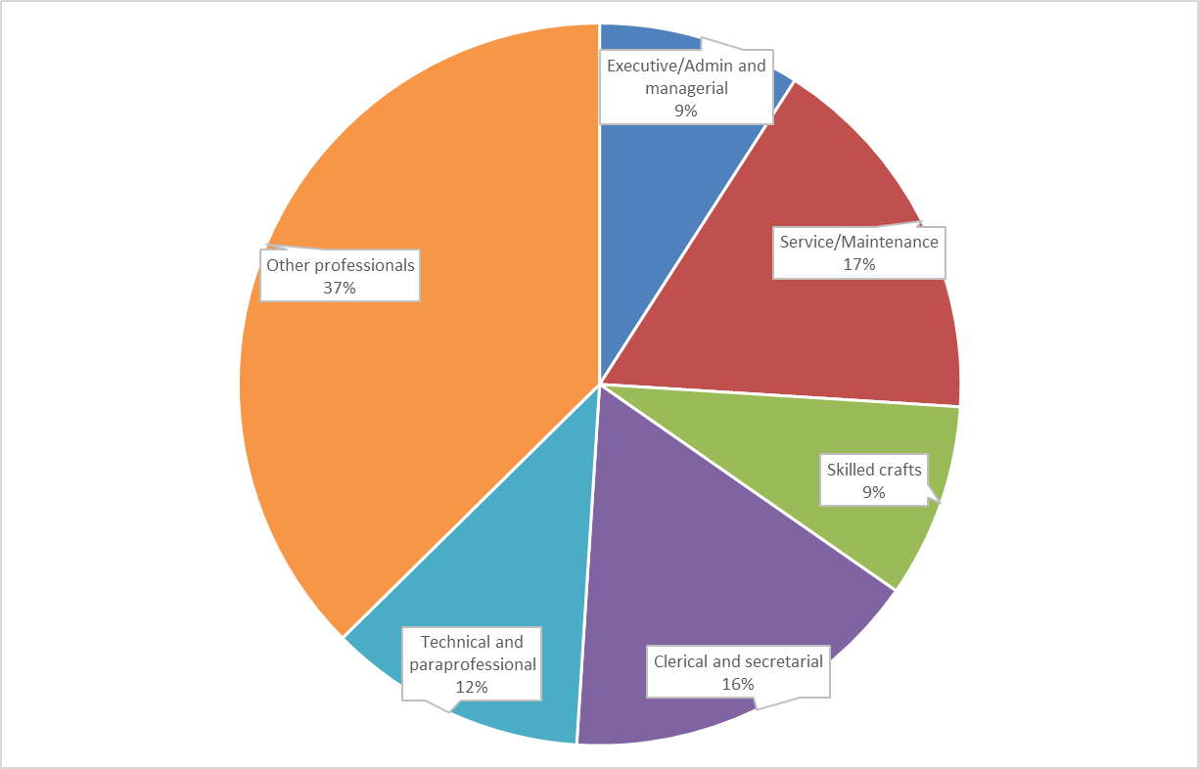

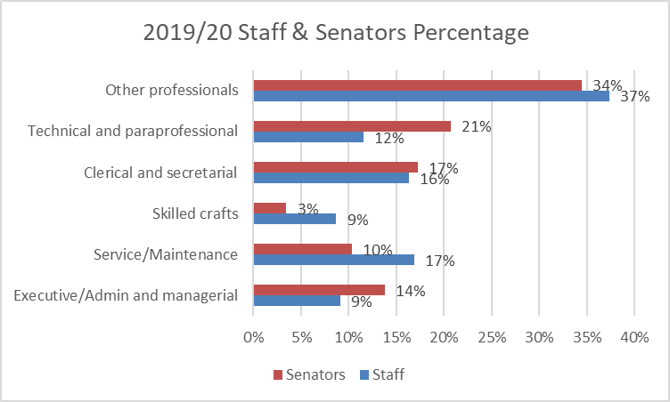

# Roberts Rules of Order

## Voting

Elections, Motions, and Resolutions

1. A Quorum (75% of Senators) must be present or have a proxy via another Senator to vote. The Proxy Senator will inform the Secretary prior to the vote. Elections can be by paper ballot or electronic.
2. By-law changes and motions can be voted by a show of hands or electronically. By-law changes require a 2/3 majority vote.
3. Elections and Motions are won by a majority vote.

## Decorum

No Senator shall speak twice to the same issue until everyone else wishing to speak has spoken. Remarks must be courteous in language and deportment - avoid all personalities.

## Meeting Mechanics

1. Call to Order (Chair begins meeting)
2. Chair requests Motion for Approval of Agenda Any one Senator may make a Motion to Approve another Senator will need to second the First Motion Chair Requests Approval of Minutes
3. Motion to Approve
4. Second
5. Chair calls for Reports from external reporters
6. Chair calls for Reports from Sub-committees
7. Chair follows Agenda list, then requests a Motion to Adjourn
8. A Motion is made and seconded
9. End of Meeting

# Monthly Meeting Agenda

## Sample Agenda

**WCU Staff Senate Meeting Agenda  
May 8, 2019 (8:30 - 10:30 a.m.)  
UC Cardinal Room**

1. Call to Order (Natalie Broom)
2. Roll Call
3. Parliamentarian’s Report (John Nickel)
4. Approval of Meeting Agenda (Natalie Broom)
5. Approval of Minutes from previous Meeting (Natalie Broom)
6. Welcome Guests
7. External Informational Reports
   1. Office of the Chancellor Updates
   2. Office of Advancement (Ben Pendry)
   3. Faculty Senate Report (Damon Sink)
   4. Human Resources Report (Cory Causby)
      1. New Employee Orientation (Chris Dahlquist)
8. Sub-committee Updates
9. Governance Committee (Hunter Yarborough)
10. HR Committee (Shawna Young)
11. PR Committee (Anita Hall)
12. Community Service (Kaitlin Ritchie)
13. Scholarship (Deidre Hopkins)
14. Treasurer’s Report (Dana Boyer)
15. Standing Committee Updates
    1. Professional Development (Deidre Hopkins)
    2. Employee Recognition (Alison Joseph)
16. Internal Information Reports
    1. UNC Staff Assembly Report (Pam Degraffenreid and Jason Foster)
17. Open Discussion
18. Old Business
    1. Strategic Plan
19. New Business
    1. June Retreat Update
    2. NCBI Training Opportunity
    3. Officer Responsibilities
20. Small Group Discussions
    1. Do you feel like you understand the directions and priorities of the institution? Do you understand the current challenges and opportunities? If not, how do you think campus leadership could best communicate with you? Please offer strategies related to how and where that communication could take place effectively.
    2. Report Out
21. Adjourn

Next Staff Senate Meeting  
June 12, 2019 – UC Cardinal Room

# Sharepoint Guide

Click on the following link <https://secure.my.wcu.edu/committee/StaffSenate/default.aspx> or type this URL into a browser to open the WCU Staff Senate Intranet site. The Intranet site is built on SharePoint 2013. This version of SharePoint works with the WCU standard supported browsers: Internet Explorer (IE), Mozilla Firefox, Google Chrome and Safari.

If you see a screen prompting you to login, enter your WCUid username and password. If accessing the Intranet from off campus, a connection to the WCU VPN ([vpn.wcu.edu](https://vpn.wcu.edu/)) must be established before connecting to the Intranet.

If this doesn’t work or you can’t get logged in for any reasons call the IT Help Desk at 227-7487 for assistance.

Once you have successfully accessed the Intranet (SharePoint) you will be on the Staff Senate Home Page. You should have a screen that looks similar to the one below.

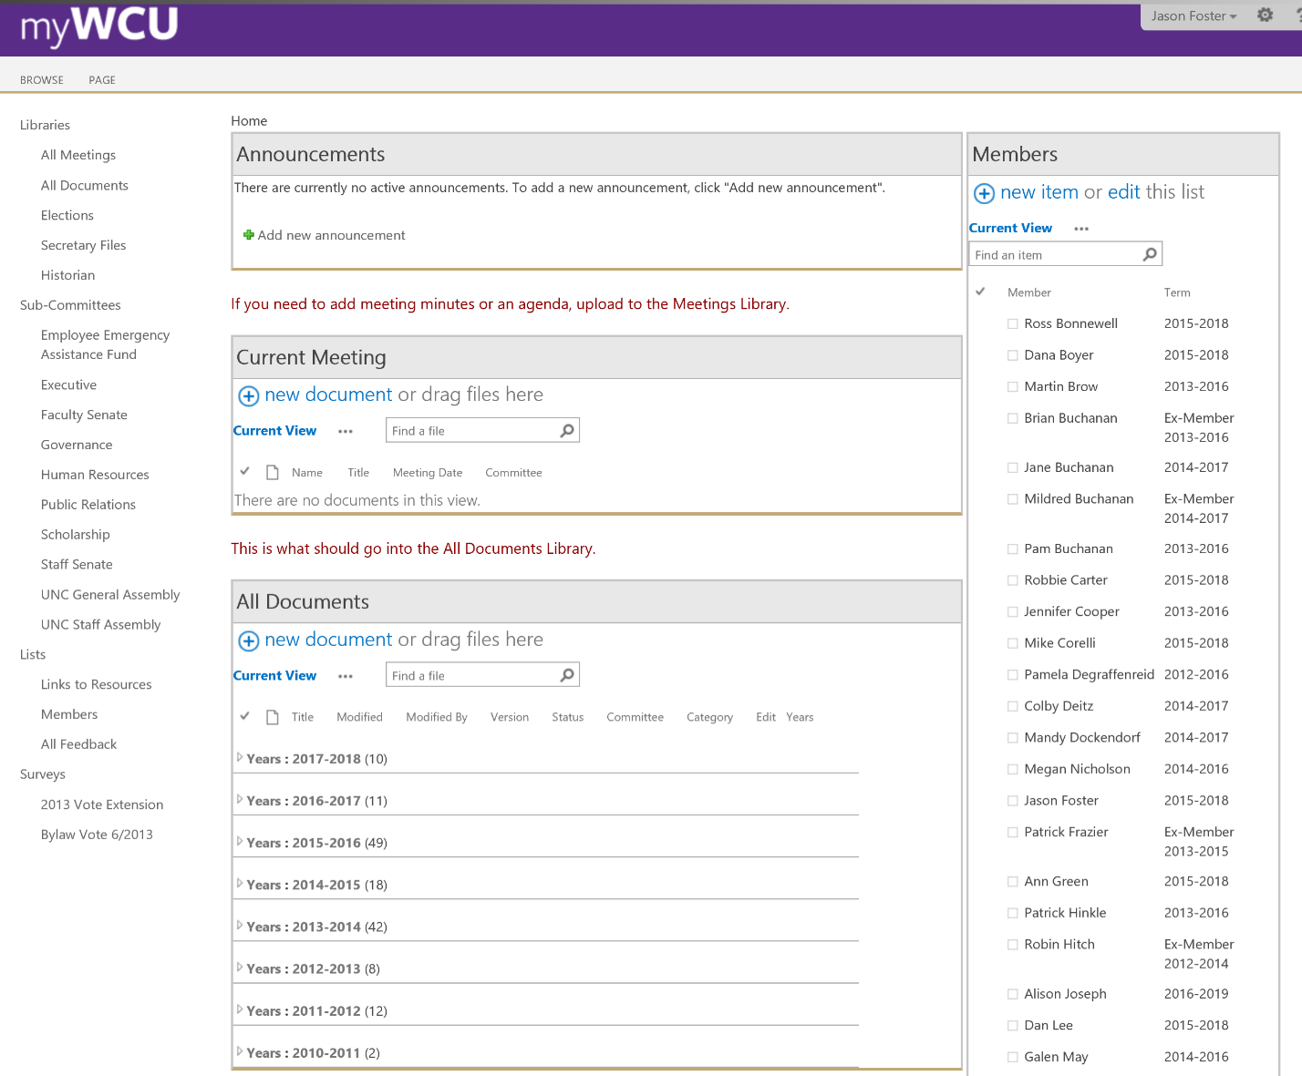

**Home Page**

The Staff Senate Home Page displays Announcements posted to the group and Current Meeting files to be reviewed, discussed and presented at the next meeting. All files covered during a meeting will be found on the Home Page. To view a file, click on the filename, make any necessary edits, or simply view it and close the file.

**How to Return to the Staff Senate Home Page**

Click on the Staff Senate link at the top left corner of screen to return to the Staff Senate home page.

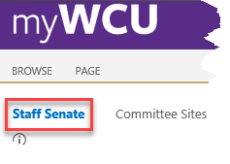

**Site Layout**

The Staff Senate site consists of several member tools found on the Quick Launch Bar (located at the left of screen) and shown below.

**Libraries**

Members and ad hoc committees draft documents related to resolutions, bylaw amendments and other activities that fall within their charge. These documents are presented to all senate members during senate meetings at the appropriate time. The basic steps are:

1. A Member drafts a document and uploads it to the Documents Library in the current academic year folder on the Intranet senate site.

2. Other Committee Members make changes to the document as needed saving the changes as minor versions (see Versioning).

3. The Committee Chair publishes a major version of the document when it is time to present the document at a senate meeting (see Versioning).

4. The Senate Chair creates a link from the meetings library to the document for ease of presentation during a meeting.

All Meetings Library contains all meeting agendas, minutes and other related files. It is organized into folders by academic year. The All Documents Library contains other senate related documents also organized in folders by academic year.

Elections, Secretary, and Historian libraries contain archives and information related to these roles.

**Sub-Committees**

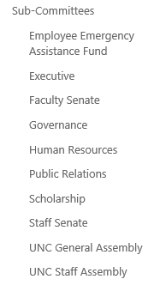

The following libraries are to be used by the various committees within Staff Senate as a repository for meeting minutes, agendas, photos, documents, etc.

**Announcements**The announcements displayed on the homepage are a web part displaying the default current view of the announcements app.

**Creating a new announcement**

* Choose the Announcements header and then choose add new announcement.

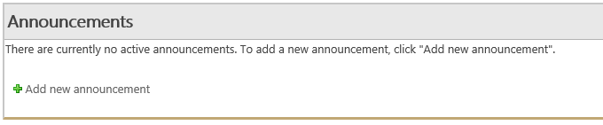

* Complete the fields then save.
  + Title – Title of the Announcement
  + Body – Content details of the announcement
  + Expires – Expiration date of the announcement

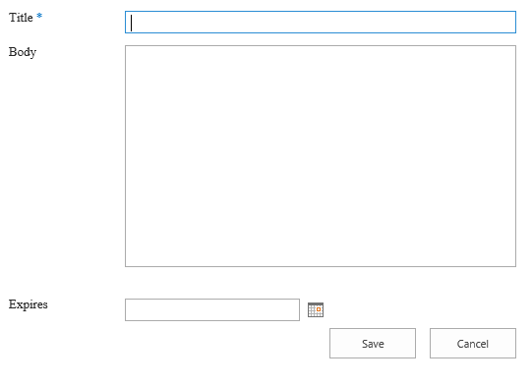

**How to add files to a Library or List**

To add a file to a Library or List that you are currently viewing go to the Documentation & How-to Library.

* Choose New Document, browse to the file on your machine, then choose OK. ( Alternatively – you can also drag files from your desktop)



Once you see the confirmation dialogue that your file was uploaded, complete the title fields that pop-up for the file. Here are some examples for Staff Senate Meeting Minutes.

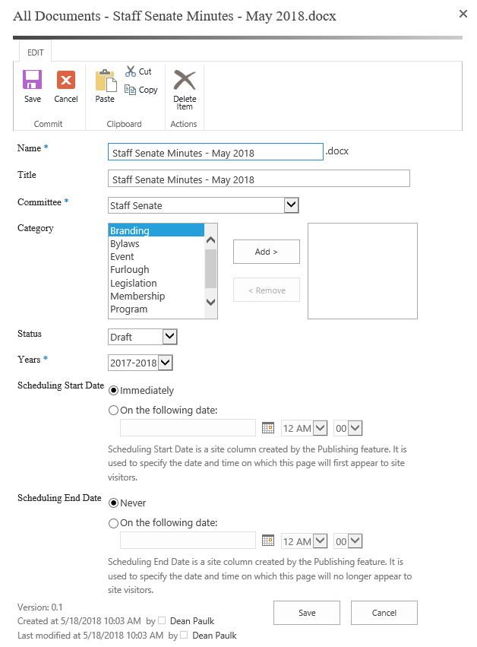

Once completed, you can select save. The file will automatically be sorted by the date you have selected.

# Community Service

## Objectives

* To encourage and facilitate opportunities for all WCU employees to engage in community service.
* To collaborate with the Center for Service Learning to identify and connect with new and existing community partnerships.
* To represent Staff Senate and WCU by engaging with and serving the local community in areas of need.
* To help fill a need within the community, especially in the summer, when many students and faculty are on break.
* For Staff Senators to work together as a team and gain leadership and team-building skills.

 Rationale

* Staff Senate service activities have increased in the past few years, therefore increasing the need for a dedicated senator/committee to organize and promote volunteer opportunities.
* Currently, there is no unit that is dedicated to facilitating and promoting employee service.
* Consistent community service could provide more opportunities for employees to share information about WCU to the community, therefore helping the community feel more connected to WCU and vice versa.
* Community service helps to cultivate sustainable partnerships with community organizations.
* Community service is in alignment with WCU’s Mission Statement and Core Values and Guiding Principles.
* Increased service helps Staff Senate become more visible and influential within WCU and the surrounding community.
* Service projects provide a very tangible Senate outcome, when it can sometimes be challenging to articulate accomplishments.

## Community Service and Engagement Projects in 2018

Community Table  
The Community Table is a nonprofit organization whose mission is to provide nutritious meals to neighbors in need in a welcoming environment.

 * Date: March 5   
Project: Assist with serving dinner and clean-up (2 hours)   
Participation: 4 Staff Senators and 1 family member

* Date: March 6

Project: Unload food truck and stock pantry (2.5 hours)

Participation: 12 Staff Senators and 3 WCU employees

* Date: March 8

Project: Assist with serving dinner and clean-up (2 hours)

Participation: 4 Staff Senators

* Date: April 27

Project: Assist with serving dinner and clean-up for Empty Bowl Event (2 hours)

Participation: 2 Staff Senators

* Date: May 1

Project: Unload food truck and stock pantry (2 hours)

Participation: 1 Staff Senator

Project C.A.R.E.   
Project C.A.R.E. (Community Action to Reach Elderly) provides safety modifications for low income elderly, homebound seniors and other qualifying persons in Jackson County.

 * Date: April 21   
Project: Built a ramp for a local community member’s home (4 hours)   
Participation: 5 Staff Senators, 1 WCU employee and 2 family members

# Members









# Sub-Committees

|  |  |  |  |  |  |
| --- | --- | --- | --- | --- | --- |
| **Staff Senate Committee Assignments** | | | | | |
|  |  |  |  | |  |
| **SENATORS** | **COMMITTEE NAME** | | | | |
|  | **Governance** | **Human Resources** | **Scholarship** | **Public Relations** | |
| Alison Joseph |  |  |  | X | |
| Anita Hall |  | X | X | X | |
| Annette Parris | X |  |  |  | |
| Bob Boylan | X |  |  |  | |
| Brittany Thompson |  |  |  | X | |
| Chris Parrish, Past Chair | X |  |  |  | |
| Claire Napoletano |  |  |  |  | |
| Colby Deitz, Vice-Chair | X |  |  | X | |
| Dana Boyer, Treasurer |  |  | X |  | |
| David Rathbone |  |  | X |  | |
| Dean Paulk, Secretary |  | X |  |  | |
| Deidre Hopkins |  |  | X |  | |
| Hunter Yarborough |  |  | X |  | |
| Jason Foster, Technologist | X |  |  | X | |
| John Nickel, Parliamentarian/Historian | X |  |  |  | |
| Kaitlin Ritchie |  |  |  | X | |
| Mandy Dockendorf, Chair |  | X |  | X | |
| Natalie Broom |  |  | X |  | |
| Robert Carter |  |  |  |  | |
| Shawna Young |  | X |  | X | |
| Travis Taylor |  | X |  |  | |
| Wendy Buchanan |  |  |  | X | |
| William Frady |  |  | X |  | |

# Campus Committees

Chancellor’s Leadership Council

Budget Advisory Committee

UNC Staff Assembly

Tuition and Fee Committee

IT Technology Advisory Committee

Graduate Council

Onboarding Committee

# A Look Toward the Coming Year

## 2019-20 Election Results

Congratulations to all the newly elected senators.

We look forward to another great year of serving the campus.

* Anne Aldrich, Provost’s Office
* Lisa Allen, College of Health and Human Sciences
* Ryan Brown, Residential Living
* Catherine Butterfield, Financial Aid
* Carrie Hachadurian, Center for Career and Professional Development
* Will Love, Division of Information Technology
* Chris Moore, Facilities Management
* Dana Patterson, Intercultural Affairs
* Chelsea Reavis, Parking Services
* Zara Schick, College of Education and Allied Professions
* Carrie Shuler, Residential Living
* Sarah Speed, Division of Information Technology
* Robert Walker, Residential Living
* Zachary Williams, Advising

## Planned Initiatives for 2019-20

Employee Reward and Recognition – In response to the feedback from the UNC Employee Engagement Survey, the Staff Senate will focus on employee reward and recognition, an area that the campus has identified as a growth opportunity. The Senate has secured a recurring allocation to address improvement strategies in this area. The Senate has drafted a proposal about how to allocate those funds to address the topic.

Professional Development – The Staff Senate has identified a need to provide a pool of centralized funds that is used to support staff training and development campus-wide. The need for this funding has been supported through an exploratory survey. One-time funding has been requested. If secured the Senate will need to develop and execute a strategic approach to dispersing this pooled resource fund.

Orientation and Onboarding – The way the university onboards new staff is crucial to their successful integration into the institution and their ability to be effective and efficient in their new role. While orientation for staff has improved in recent years, this continues to be an area that could benefit from enhancements, and one that staff routinely mention as a suggestion for improvement.

In addition to these primary initiatives, the Senate will continue to focus on:

* Staff Senate Scholarship fundraising and award process
* Community service engagement for employees
* Diversity and inclusion
* Employee wellness
* Internal governance and improvement to Senate processes and documentation

# How to Be an Engaged Senator

* Speak up during meetings (full Senate meetings, committee meetings, etc.). We want to hear your thoughts and questions!
* Try out a formal leadership role. The Senate is an excellent place to take a leadership role as an officer or within a sub-committee. These are often low commitment and give you a chance to see what you like, and find strengths outside of your normal position description.
* Find a specific interest or area of concern, and make it known. Staff Senate is meant to represent the interests of the larger group of staff on campus. If there is something you are concerned about, bring it forward. Chances are that many others share your concern.
* And speaking of …. Be a good listener. When you are out on campus, in meetings with your colleagues, or around other staff members, try to understand what their concerns are. What motivates them? What do they think Staff Senate should focus on? What issues impact them the most? What ideas do they have for improving life at WCU?
* Spread information. You will have access to lots more information than most of your colleagues, and much of that will come directly from senior-level administrators. When you hear about new developments, keep others in the loop. You can make updates at your department/division staff meetings, informally tell colleagues and friends, and/or make an email distribution list of contacts that you reach out to when you’re trying to spread the word about something.
* Correct bad information when you hear it. We’ve all been in the position before where we hear colleagues discussing changes/issues and they have the information wrong. Whether it’s rumors or just plain and simple incorrect facts about health care, parking, tuition waivers, personnel evaluations, etc. - when you hear folks discussing campus news and they have the wrong story, help to correct the information.
* Volunteer and encourage others to do the same. We have lots of community service opportunities available for the campus. Use your community service leave hours. Set an example. And get out in the community to lend a hand, and spread the good word about WCU.
* Help fundraise. You’ve heard about the Staff Senate scholarship. There are lots of opportunities to get involved with efforts to raise money for this cause. Sell ornaments at our booth at Mountain Heritage Day. Participate with the University Club in their annual fundraising effort (our biggest fundraiser of the year). Personally sign up for payroll deduction (as little as $5 per month) and encourage others to follow suit.
* Try out other events and opportunities. Come out to one of our semi-annual social gatherings, to get to know your fellow senators and their families. Participate in Homecoming Parade floating-making and candy-distribution. Work our booth at Employee Appreciation Day, and engage with staff members from across campus.
* Establish and maintain connections with colleagues across campus.
* Come up with ways to make Staff Senate your own!!