Posting Jobs in JobCat 2.0 (Symplicity)
- Go to: https://wcucareers-csm.symplicity.com/employers
- Log in with your username (e-mail address) and password.
- Click on Jobs
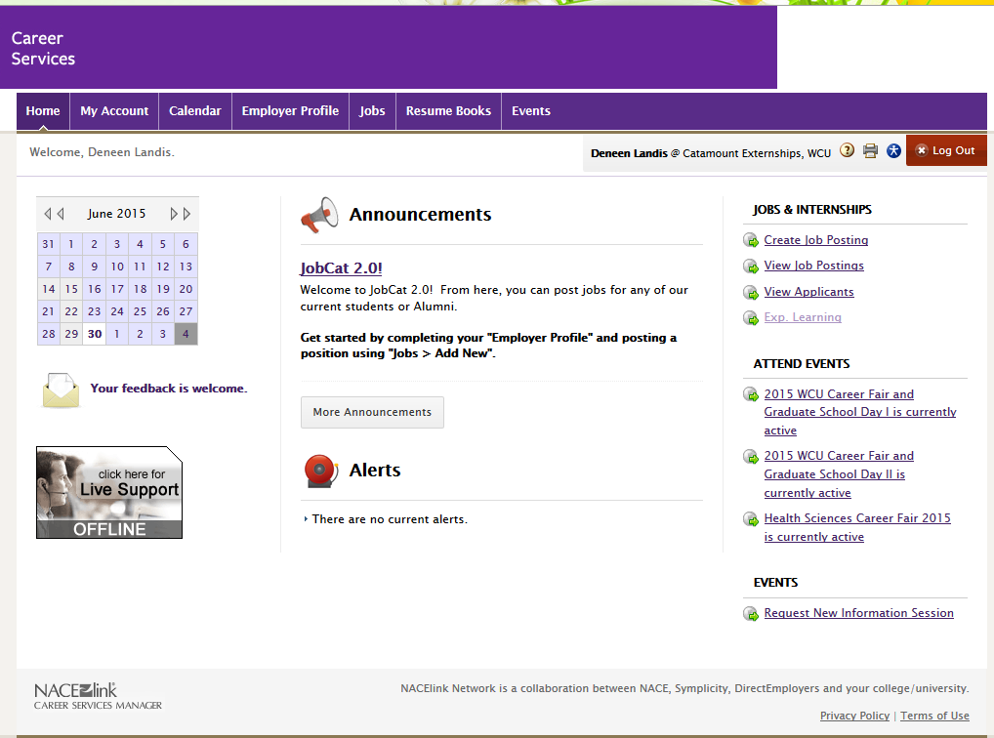
- Click on Add New

- Select Non-Work Study Student Employment for the Position Type.
- For Restrict Applications/Activate Screening ALWAYS select NO.
- Enter the job title and description. You can use basic HTML (to make text bold, etc.). If you do not know HTML and wish to use it in a job description, please see the attached sheet.
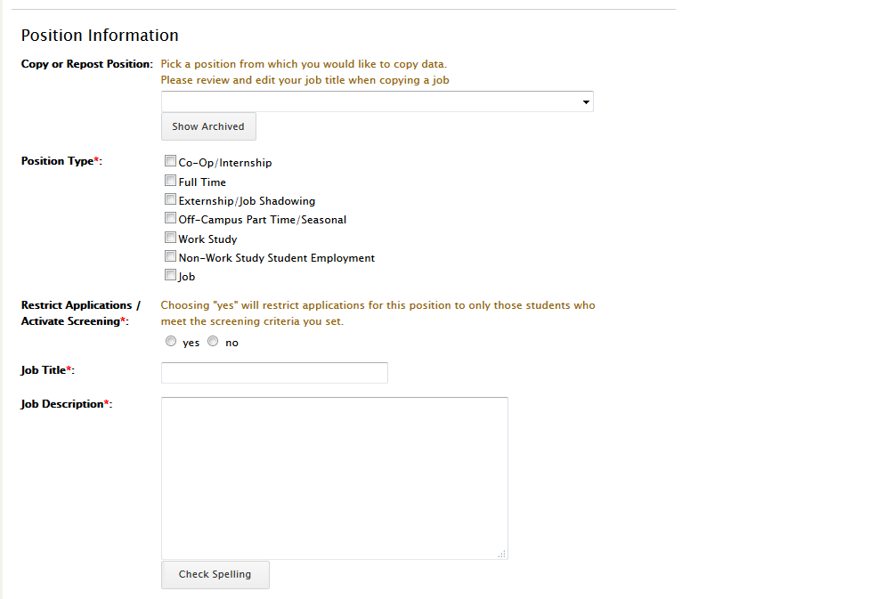

- Select whether the job is nationwide and, if not, enter the city, state, and country. If you say that it is NOT nationwide, it will require you to enter a city, state, and country.
- Enter the salary level/hourly rate.
- Enter the approximate hours a week.
- Set the posting date (we can set it in advance if needed). This is the date that the job will be visible to students.
- Set the expiration (or closing) date.
- Attach any relevant attachments. This is useful for jobs with applications to be filled out, or those with flyers.
- For resume submission method, please reference the following descriptions:
- E-mail will e-mail resumes to the contact as they come in.
- Online will accumulate the resumes online, so the contact will have to log in to JobCat 2.0 in order to view them.
- Other is for any job that has alternative application instructions (apply online, call the contact to set up an interview, and for ALL on-campus jobs).
- Automatic Application Packet Generation will e-mail a packet (file) of the resumes of all applicants when the job expiration (close) date has ended. This is only useful for those who have set the resume submission method to either e-mail or online.
- Set optional documents that the employer wishes students to attach. This is only useful for those who have set the application method to e-mail or online.
- Document notes is for explanations of the documents required (i.e. what does the employer mean when they require “Other Documents.”)
- Display Contact Information to Students: This box is helpful if you wish for any contact information to be visible to the students. If you check this box, it will open a new text box to input whatever information you wish for the students to see (this can be anything; it will NOT automatically input your contact information, you can customize this).
- 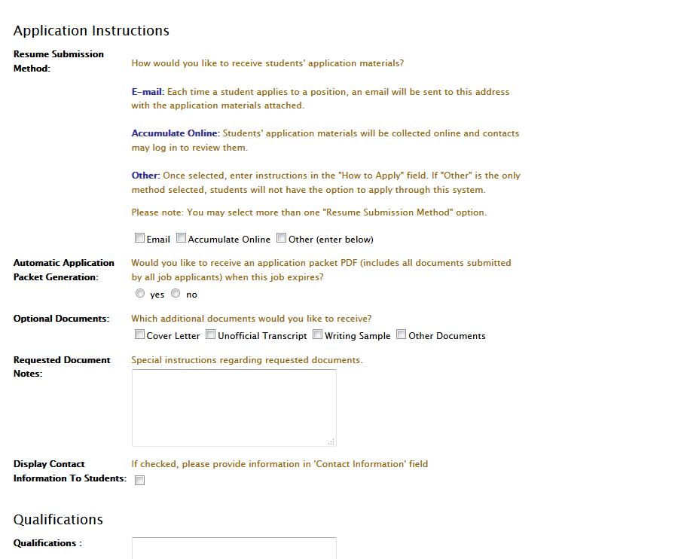

- Please input any qualifications into the text box.

- Hit the Submit button to submit the job to Career Services for approval!

Basic HTML for JobCat 2.0 (Symplicity)
To make text Bold:
<b> Text </b>

To make text Italicized:
<i> Text </i>

To make text Underlined:
<u> Text </u>

For a bulleted list (you must have the li tags in front of and at the end of each item on the list):
<ul>
<li>Item 1</li>
<li>Item 2</li>
<li>Item 3</li>
</ul>

