PRM 430: Entrepreneurship & Commercial Recreation

Parks & Recreation Management Department of Human Services

Fall 2020

Course # & Title: Entrepreneurship & Commercial Recreation, PRM 430 (3 credit hours)
Class Times: 8:00am-9:15am Tuesday/Thursday (face to face, hybrid, online)
Location: Reid 113B (small groups) ONLINE: entire class
Instructor: Debby Singleton, M.A., PRM Instructor
Preferred Pronouns: she/her/hers
Office: Reid 122J and via ZOOM
Office Hours: Via email Monday-Friday, 8am-5pm, weekends will vary.
PRM 430 Virtual hours via ZOOM: Thursdays 1:00-2:00pm or by appointment

Phone #: 828-227-3971 Office 828-508-1736 Cell
E-mail: singleton@wcu.edu

Purpose: This course is designed to explore the operation and management of commercial recreational businesses with emphasis placed on people skills, technical abilities, general management, and entrepreneurship. This course will challenge the student to think creatively and work cooperatively.

Course Format: PRM 430 is listed as “Hybrid-Web” for Fall 2020. This designation means that we can meet some face to face depending upon classroom space and the comfort levels of students and the instructor. It is my intention to create an engaging experience for students in a mostly online environment this semester. These opportunities will take place through synchronous class meetings over ZOOM during our designated class time and at other times through ZOOM or Blackboard Collaborate.

Face to face classroom meetings will most likely take place in small groups for “work days” on class projects. Our classroom is not large enough to accommodate all of us and be physically distanced for Covid-19 safety protocols. If face to face meetings are scheduled, they will be held during our designated class time and all students will need to adhere to the Catamounts Care guidelines (wearing a mask, washing hands, checking your symptoms, physically distancing).

Required Resources:
Crossley, J., Rood, S., Brayley, R., Price-Howard, K., & Holdnak, A. (2018). Introduction to Commercial Recreation and Tourism: An Entrepreneurial Approach (7th ed.). Sagamore-Venture: Urbana, IL.

Student Learning Outcomes:
Students will be able to…
- Discuss the history, characteristics, and business opportunities of the commercial recreation and tourism sectors (7.01) (Tests, Feasibility Study, Industry Report)
- Articulate their personal entrepreneurial qualities using principles of entrepreneurship and free enterprise (7.01) (Entrepreneurial Self-Assessment, Feasibility Study)
- Investigate business plan ideas through completion of a concept feasibility study. (7.03) (Entrepreneurial Self-Assessment)
- Develop business systems, risk assessments, marketing and financial management outcomes through guided assignments. (7.03) (Feasibility Study)
- Research, develop and present a comprehensive recreation-based business plan (7.03) (Feasibility Study)

Grade Distribution
Percentages | Percentages
>101% A+
92-100% A | 90-91.9% A-
88-89.9% B+ | 82-87.9% B
80-81.9% B- | 78-79.9% C+
72-77.9% C | 70-71.9% C-
68-69.9% D+ | 62-67.9% D
60-61.9% D- | <60% F

Course Assignments | Points
Exams (2 @ 100 points each) | 200
Entrepreneurial Self-Assessment | 100
Learning Module Assignments | 100
Feasibility Study  (8 chapters @ 50 points each, 100 points for other items in study) | 500
Feasibility Study Presentation | 100
Commercial Industry Report | 300
Commercial Industry Presentation | 100
Participation & Attendance | 100
Total Points | 1,500
*These assignments or points may change during the semester. Students will be consulted and notified of any changes in a timely manner.

Brief Explanation of ASSIGNMENTS:
• Exams: There will be two exams given this semester. The content will be based on the textbook chapter readings, lectures, and outside readings or viewings. (100 points each, 200 points total)

•Entrepreneurial Self-Assessment: A self-analysis and reflection to help you define your personal characteristics and basic skills needed for small business ownership (50 points).

•Learning Module Assignments: Learning modules will follow the course schedule and include small assignments and assessments. (100 points)

•Feasibility Study: As recreation professionals, many of us may elect to start our own business at some point. This assignment is designed to explore what it means to be an entrepreneur and what it takes to determine if you have a feasible business idea or not. This assignment is divided into 8 chapters, a cover page, table of contents, appendices, and references. The template and explanations are described in the text, chapter 4. This is the big daddy project of the semester. You have the option of forming a group of 3 or 4 or less. Due to class size, I will not be allowing individual feasibility studies this semester. (500 points)

• Presentation of Feasibility Study. Each group will present their feasibility study using a pecha kucha format and upload it to Blackboard by the due date. Students will be given 5 presentations to view and peer grade. (100 points total; 75 for presentation; 25 for peer reviews)

• Commercial Industry Report: The purpose of this assignment is to have students thoroughly investigate one type of commercial recreation enterprise or industry, in-depth. Please choose one of the industries listed in chapters 9, 10, or 11 of your textbook. Students will work in groups of 3 or 4 or less. (300 points)

• Commercial Industry Presentation: Here’s your opportunity to let us know what you’ve discovered in your industry report. Students will present their findings to the entire class during a live virtual class meeting. (100 points)

• Participation & Attendance for PRM 430 Hybrid Course:
Students enrolled in PRM 430 are expected to actively participate in class functions on a regular basis. Logging once a week into Blackboard is not sufficient to establish or maintain participation.

To maintain active participation, students must submit assignments on time, interact in class discussion (face to face, discussion forums, and virtual), do group work, and participate in other activities specified by the instructor.

Students are expected to log into the online class at least 4-5 times per week and spend at least 8-10 hours per week involved in activities for PRM 430 which is a 3 credit, upper level, core requirement for PRM.

To achieve the participation/attendance grade, the instructor will monitor your participation in the course. Failure to submit assignments on time, not participating in class discussions, not participating in assigned group work, or failing to do any work/tasks associated with the course will result in points being deducted from the participation/attendance grade.

Failing to log in and participate during the first week and/or the second week of class, will result in being dropped from the class for non-attendance.

Late Assignment Policy
All of the class assignments have a specified due date, so pay attention to the syllabus, schedule, and assignment modules in Bb. Late assignments will be penalized (1 day late = minus 10% of total grade; 2 days late = minus 20%; etc.) If you are having a problem completing an assignment on time, please ask the instructor for assistance. This policy includes weekend days.

Course Schedule: Please refer to the course schedule posted in Blackboard for the most current information. *The Schedule is “Fluid”, meaning that the topics for discussion may change depending upon student participation and interest; assignment dates may change due to student input or university scheduling; or unique opportunities may present themselves and be added. Students will be notified in a timely manner of schedule changes.

Course Evaluation Schedule: Students will be asked to participate in an online evaluation of this course. An email will be sent to students reminding them to complete the online course evaluations. The evaluations are scheduled to be available during the last month of the semester.

Netiquette Guide:
An online class format is still a class and certain behaviors are expected when you communicate with both your peers and your instructor. The purpose of this guide is to help you be a more effective and successful student when communicating in chat rooms, discussion boards and part of your online learning activities in this course.
1. Treat your instructor with respect.
2. Always use your professor’s proper title: mine is “Ms.” or “Professor”.
3. Use clear and concise language. Be respective of the reader’s time and attention.
4. Avoid using slang terms such as “wasup?” and texting abbreviations such as “u” instead of “your”.
5. Use standard fonts that are optimized for online reading along with consistent and readable size (12-14 point).
6. Avoid using the caps lock feature AS IT CAN BE INTERPRETED AS YELLING.
7. Limit and possibly avoid the use of emoticons. Not everyone knows how to interpret them.
8. Be causing when using humor or sarcasm as tone is sometimes lost in an email or discussion post and your message might be taken literally or offensively.
9. Be careful sharing personal information online (both yours and other’s).

Discussion Board “Netiquette” and Guidelines:
When posting on the Discussion Board, you should:
1. Make posts that are on topic and within the scope of the course material. If necessary, re-read the instructions from your instructor.
2. Take your posts seriously and review and edit your posts before sending.
3. Be as brief as possible while still making a thorough comment.
4. Always give proper credit when referencing or quoting another source.
5. Be sure to read all messages in a thread before replying.
6. Don’t repeat someone else’s post without adding something of your own to it.
7. Avoid short, generic replies such as, “I agree”. You should include why your agree or add to the previous point. The point of a discussion in an online course is to help you and your other students learn through in-depth consideration of important topics.
8. Always be respectful of others’ opinions even when they differ from your own. When you disagree with someone, you should express your differing opinion in a respectful, non-critical way.
9. Be open-minded as that is one of the major points of participating in an open classroom discussion.

E-mail Etiquette: Electronic mail to and from your “@catamount.wcu.edu” address is the preferred method of communication. Please follow common e-mail rules:
1. Use your @catamount.wcu.edu email address
2. Use a short and accurate subject header
3. Use a proper salutation (Hello, Good Morning, Greetings, etc.)
4. Introduce yourself in the first paragraph (if needed)
5. The message body should be written in a concise and clear manner. Please do not BS or ramble. Get to the point.
6. Leave-taking (departing farewell) should be appropriate. (Respectfully, Yours sincerely, Take care, etc.)
7. Sign your email with your full (First and Last) name
8. Proofread for content, spelling and grammar.

For the visual learners…

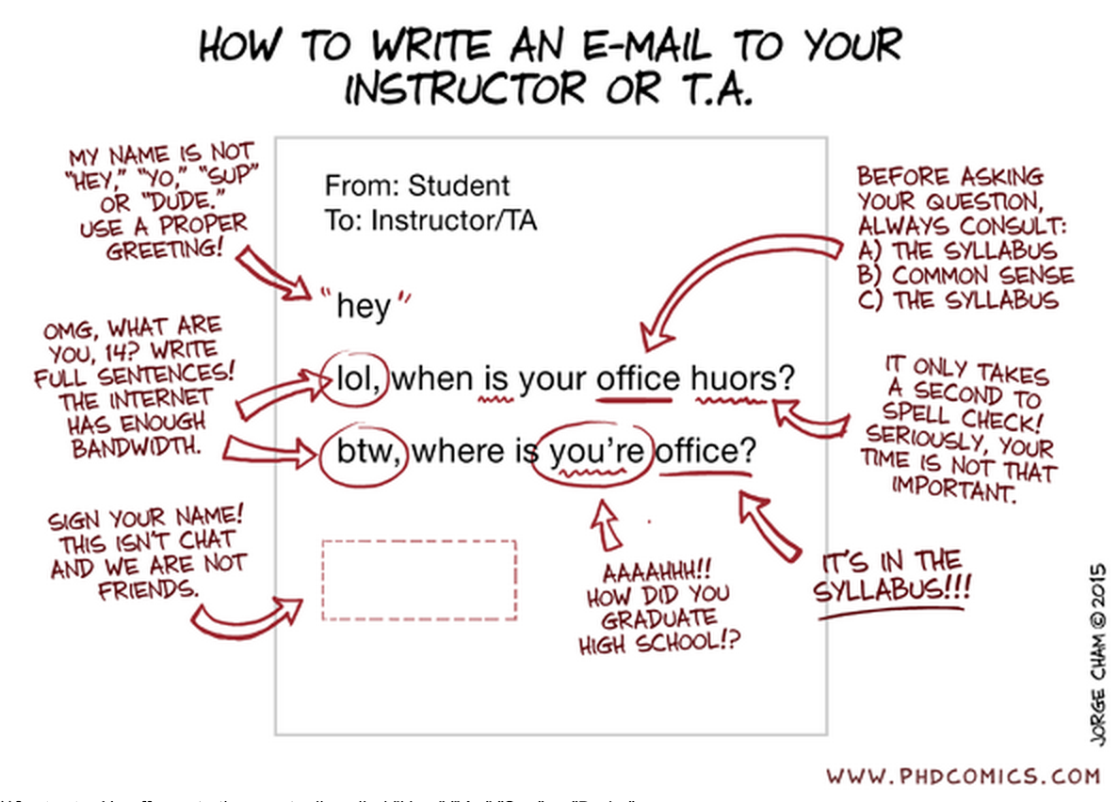

ZOOM Classroom Expectations:
The shared learning space of the college classroom is built on respect for each other and each other’s learning. Learning together means our actions can intentionally and unintentionally distract others from their learning goals. As responsible learners who respect the rights of others and vow to minimize avoidable distractions such as: non-academic technology use, coming in late, sleeping, off-topic discussions, doing other homework, eating, etc.

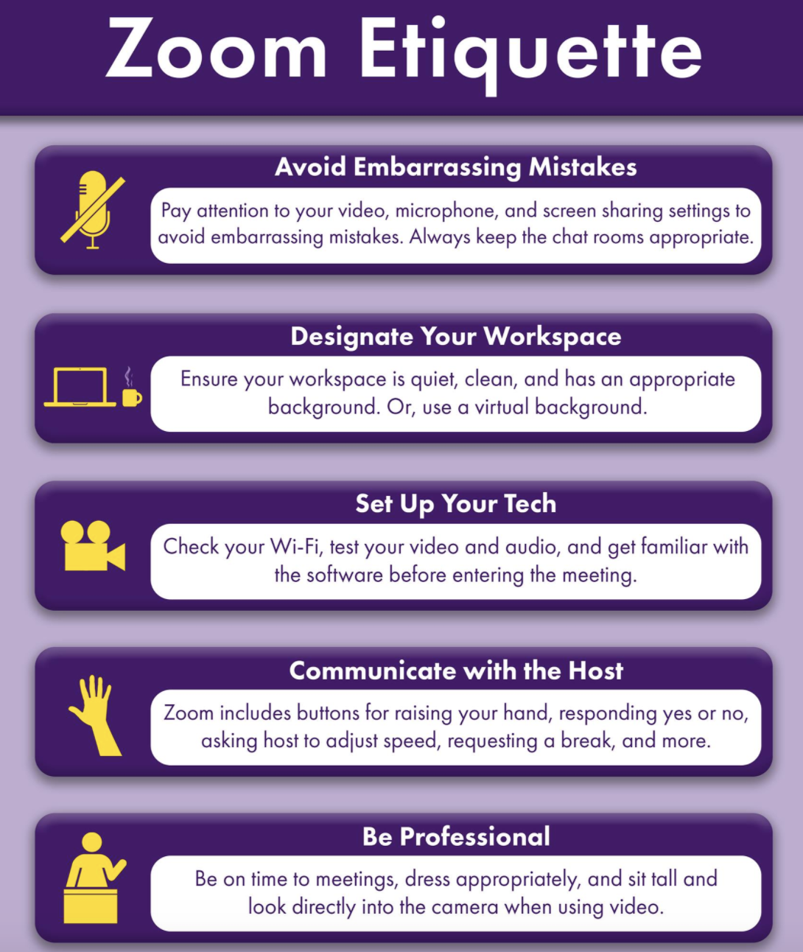

Appendix A: Boilerplate
“The university requires me to pass along to you a whole litany of contractual information, some of which you may find important, some of which you may not. I have placed this information at the end of this syllabus; I suggest you refer to it as necessary.”

University Expectations and Support Services

Civil Discourse at Western Carolina:
Consistent with WCU’s core values and our campus creed, the WCU community accepts the freedoms and responsibilities of our shared community. WCU encourages all to clearly express their own views while at the same time seeking to understand the varieties of style, identity, and opinion that are held in any diverse community. In order for us to sustain a learning environment that promotes and values freedom of expression, we have a shared charge to accept personal responsibility for our actions, reactions, and speech, while seeking to learn from the actions, reactions, and speech of others.

Classroom Expectations:
The shared learning space of the college classroom is built on respect for each other and each other’s learning. Learning together means our actions can intentionally and unintentionally distract others from their learning goals. As responsible learners who respect the rights of others and vow to minimize avoidable distractions such as: non-academic technology use, coming in late, sleeping, off-topic discussions, doing other homework, eating, etc.

HUNTER LIBRARY
Hunter Library provides students with access to thousands of information resources: print and electronic books, newspapers, and scholarly journal articles. These resources can be searched and often accessed online (http://library.wcu.edu) or can be searched and located in the library building. Students in need of research or library support can get help online (http://researchguides.wcu.edu/help), or from library research guides such as, http://researchguides.wcu.edu/education

WRITING & LEARNING COMMONS
The Writing and Learning Commons (WaLC), located in Belk 207, provides free course tutoring, writing tutoring, writing fellows, Supplemental Instruction, academic skills consultations, international student consultations, and online writing resources for all students. To schedule appointments for any of these services, visit tutoring.wcu.edu or call 828-227-2274. The Mathematics Tutoring Center in 214 Killian Annex provides free drop-in tutoring for mathematics courses and subject matter, course-specific tutoring appointments, and graduate and professional exam preparation resources. In addition to services provided by the WaLC and MTC, students also will have access to non-WCU tutors through Brainfuse.

TUTORING & ASSISTANCE

Tutoring for Distance Students:
For distance students (including students at Biltmore Park) who cannot attend tutoring sessions in the Writing and Learning Commons (WaLC) or the WCU Math Tutoring Center, tutoring support is available through Brainfuse HelpNow: https://www.wcu.edu/apply/distance-online-programs/current-students/tutoring-support.aspx

Math Tutoring Center:
The Mathematics Tutoring Center (MTC) in Killian Annex 214 provides tutoring for math courses and math-related content across the curriculum, workshops on study skills specific to math courses, and graduate and professional exam preparation resources. Until the COVID-19 Social Distancing order is rescinded, all MTC tutoring will be done online. For more information, including directions on how to set up online appointments, please visit http://mtc.wcu.edu/ or contact us at 828–227–3830.

Blackboard Support:
The learning management system for this class is Blackboard and can be found at http://wcu.blackboard.com

Additional help with Blackboard can be found at http://help.wcu.edu , (828) 227-7487 or by visiting the Technology Commons located on the ground floor of the Hunter Library.

Academic Toolbox:
The Academic Toolbox is available in all WCU courses via the course Blackboard site. It can be found in the left-hand side column. The Academic Toolbox contains information and contact information for nearly all of the resources needed by WCU students, including but not limited to: technology assistance, academic services, student support, co-curricular programs and university policies.

Academic Calendar:
This includes dates for all breaks, university closures, final exams, etc. The academic calendar can be found at http://www.wcu.edu/learn/academic-calendar.aspx

Final Exam:
The university final exam schedule can be found at
http://www.wcu.edu/learn/academic-services/registrars-office/

Syllabus Updates
This syllabus, along with its course schedule, is based on the most recent information about the course content and schedule planned for this course. Its content is subject to revision as needed to adapt to new knowledge or unanticipated events. Updates will remain focused on achieving the course objectives and students will receive notification of such changes. Students will be notified of changes and are responsible for attending to such changes or modifications as distributed by the instructor or posted to Blackboard.

Mentoring and Persistence to Success (MAPS)
Mentoring and Persistence to Success (MAPS) provides support to students who are first-generation (neither parent has a four-year degree), low-income, financially independent (emancipated youth, homeless or without consistent residence, or aged out of foster care), or those who have participated in the Academic Success Program (ASP) or Catamount Gap. For those who enroll, MAPS provides a variety of services, including academic advising, mentoring, and personal and social coaching. You may contact MAPS at (828) 227-7127 or email maps@wcu.edu for more information. MAPS is located in 205 Killian Annex.

INSTITUTIONAL POLICIES

Statement for Wearing Masks
As the WCU Community Creed articulates, members of the WCU community are expected to live by high standards of academic and personal integrity and embrace their responsibility as members of the Catamount community. In recognition of this responsibility, and in response to the best available science and current guidance from the Centers for Disease Control and Prevention, all students, as well as faculty and staff, must wear a mask (or other acceptable cloth face-covering) that covers their nose and mouth while in classrooms or in public spaces on campus in Cullowhee, as well as at our instructional site at Biltmore Park, and locations in Cherokee and Highlands. Students who do not have a mask or appropriate face covering on will be asked to leave the classroom and will only be permitted to return when they follow this basic public health recommendation; see below for specific guidance.

Students who do not have masks can obtain them at the locations, below:

Hinds University Center - Main Information Desk (2nd floor)
Hunter Library - Circulation Desk (main entrance)
Belk Building – College of Engineering and Technology Dean’s Office (Room 161)
Health and Human Sciences Building – College of Health and Human Sciences Dean’s Office (Room 201)
Biltmore Park Instructional Site – 3rd floor Information Desk

The mask/face covering requirement for students is an expectation of our student code of conduct and violations are subject to code of conduct proceedings and disciplinary action. Faculty and staff will communicate with the Department of Student Community Ethics regarding students who do not honor the requirement.

Community Vision for Inclusive Excellence Statement:
The diverse perspectives encountered at WCU are an important part of the preparation of students for roles as regional, national, and global leaders who contribute to the improvement of society. It is expected that members of the WCU community will not only coexist with those who are different from themselves, but also nurture respect and appreciation of those differences. We encourage civil discourse as a part of the learning enterprise, and as a campus we do not tolerate harassing or discriminating behavior that seeks to marginalize or demean members of our community.

Course Recording and Broadcasting:
Students may make visual or audio recordings (Recording) of any class related content, using any approved recording device (e.g., smart phone, computer, digital recorder, etc.) upon the prior permission of the instructor and subject to the following restriction(s). The Recording, along with the video capture of visible course materials (e.g., visible PowerPoint slides and/or visible lecture notes), shall be limited to the student’s personal, course related, educational use and shall be subject to all applicable copyright laws and institutional policies. The student may not transfer, transmit, or otherwise disseminate the Recording to any third party, including classmates, without the permission of the instructor. Any violation of these restrictions, or any other restriction verbally communicated by the instructor, may subject the student to the provisions of the WCU Academic Integrity Policy, the WCU Code of Student Conduct or both.

Meetings of this course may be broadcast and/or recorded. Broadcasting and recording are intended to complement the classroom experience. Instructors may broadcast and/or record courses for pedagogical use, student reference, to meet the accommodation needs of students with a documented disability, or any other reason deemed appropriate by WCU and/or the instructor.

Any recording of class that includes the image or voice of a student, or reference to the student’s name, would be considered FERPA. Thus, protected. If faculty intend on making the recording available for future viewing (any viewing that is not live) will require a waiver by each student. The waivers may be collected by email or as a Blackboard discussion board post or assignment with the following statement attached: By sending this email (by replying to this discussion board, by completing this electronic form – any use of WCU official identity verification) and typing my name below I acknowledge I have read and fully understand the terms of the VIDEO CONSENT AND RELEASE FORM FOR CLASS RECORDING and hereby release the University as stated in the Form.

If a student refuses to sign the waiver, then their likeness may not be included in any video made available. In other words, they would need to be excluded from video and not allowed to ask questions. If this happens faculty would be able to grade consistent with syllabi. In other words, the faculty member has the right to penalize the student by lowering their grade for not participating. The faculty member is also free to create alternative assignments at his or her discretion.

Course recordings will be available to students registered for the course pursuant to applicable university policy and instructor preference. All broadcasts and recordings are limited to personal, course related, educational use and may not be transmitted, transferred, distributed, sold, or posted on social media outlets without the written permission of the instructor. Unauthorized transmission, transfer, distribution, sale or posting of the broadcast and/or recording for any purpose other than the student's personal, course related, educational use is not permitted. Students are expected to follow appropriate university policies and maintain the security of passwords used to access recorded materials.

If the Lockdown Browser and Monitor are being used, it is necessary that the instructor have both a syllabus statement and a waiver on file.

Any course recordings for purposes beyond the normal conduct of a course (promotional videos, videos related to a governed research project, etc.) will require an additional waiver and appropriate approval (such as IRB approval).

University Policy 122

For a more detailed version of when a waiver might be needed see:
Policy Considerations of Classroom Technology Use

Accommodations for Students with Disabilities:
Accommodations for Students with Disabilities: Western Carolina University is committed to providing equal educational opportunities for students with disabilities. The Americans with Disabilities Act (ADA) is a federal anti-discrimination statute that provides comprehensive civil rights for persons with disabilities. Among other things, this legislation requires that students with disabilities be guaranteed a learning environment that provides for reasonable accommodation of their disabilities. If you believe you have a disability requiring an accommodation, please contact the Office of Accessibility Resources located in Killian Annex or call 828-227-2716. For additional information, visit go.wcu.edu/oar

Note that any content entered directly into Blackboard is accessible with common accessibility software and hardware and that Students can use the Ally icon beside any additional faculty content to attempt to create accessible alternatives for common attached documents.

Academic Integrity Policy and Reporting Process:
This policy addresses academic integrity violations of undergraduate and graduate students. Graduate students should read inside the parenthesis below to identify the appropriate entities in charge of that step of the process.

Students, faculty, staff, and administrators of Western Carolina University (WCU) strive to achieve the highest standards of scholarship and integrity. Any violation of the Academic Integrity Policy is a serious offense because it threatens the quality of scholarship and undermines the integrity of the community. While academic in scope, any violation of this policy is by nature, a violation of the Code of Student Conduct (Code) and will be addressed as outlined in that document. If the charge occurs close to the end of an academic semester or term or in the event of the reasonable need of either party for additional time to gather information timelines may be extended at the discretion of the appropriate academic Dean.

General:
This policy addresses academic integrity violations of undergraduate and graduate students. Students, faculty, staff, and administrators of Western Carolina University (WCU) strive to achieve the highest standards of scholarship and integrity. Any violation of this policy is a serious offense because it threatens the quality of scholarship and undermines the integrity of the community.
Instructors have the right to determine the appropriate academic sanctions for violations of the Academic Integrity Policy within their courses, up to and including a final grade of “F” in the course in which the violation occurs.

Definitions:
Cheating – Using, or attempting to use, unauthorized materials, information, or study aids in any academic exercise.
Fabrication – Creating and/or falsifying information or citation in any academic exercise.
Plagiarism – Representing the words or ideas of someone else as one’s own in any academic exercise.
Facilitation – Helping or attempting to help someone to commit a violation of the Academic Integrity Policy in any academic exercise (e.g. allowing another person to copy information during an examination).

Undergraduate and Graduate Academic Integrity Process:
Additional information is available on the Student Success website under Student Community Ethics: http://www.wcu.edu/experience/dean-of-students/academic-integrity.aspx

Sexual Harassment Policy
The University deems sexual harassment to include conduct constituting sexual harassment under Title VII of the Civil Rights Act of 1964 and Title IX of the Education Amendments of 1972.

