PARKS AND RECREATION MANAGEMENT
Western Carolina University

STUDENT HANDBOOK

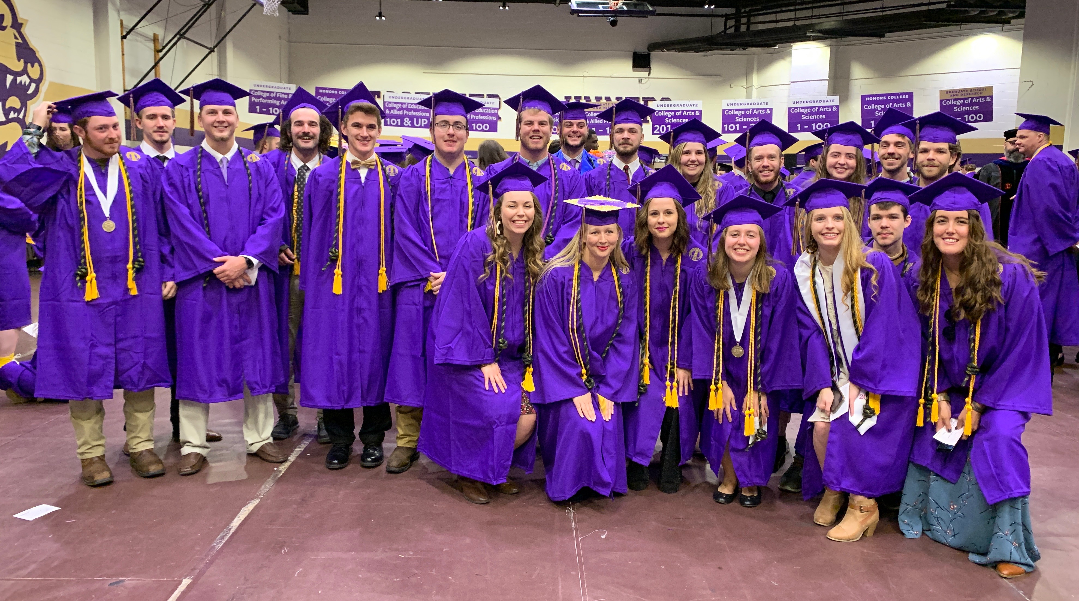

PRM December 2019 Graduates

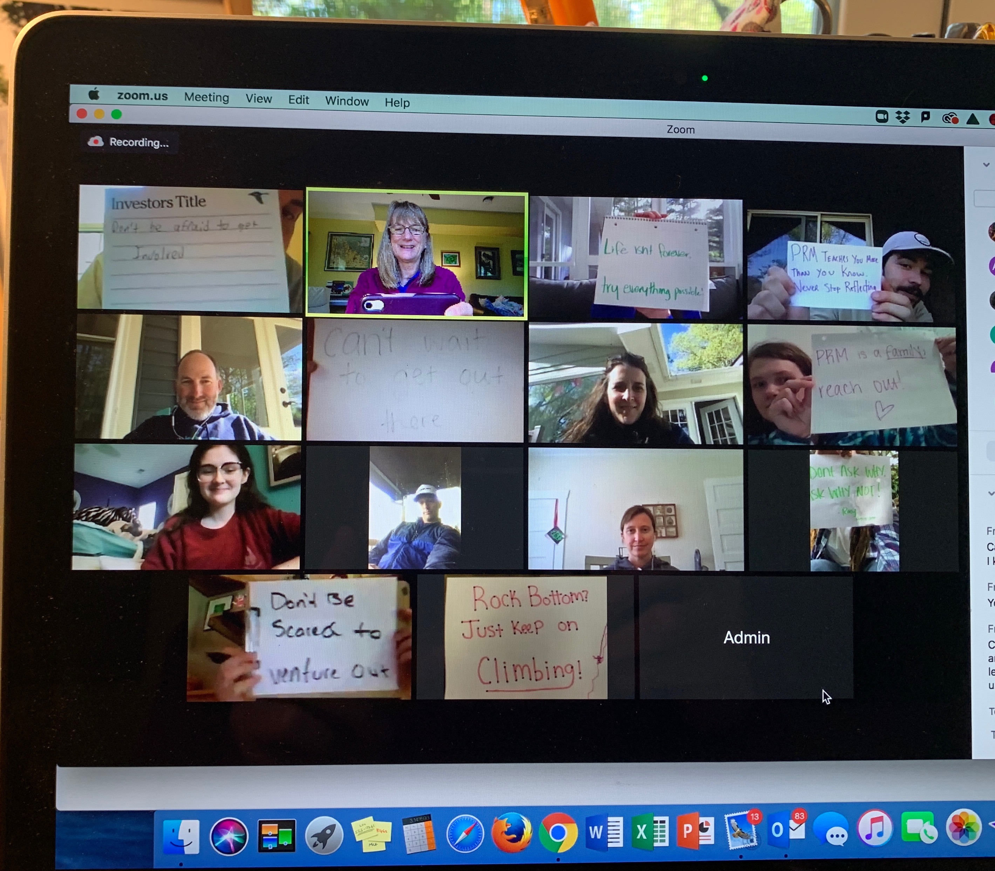

PRM May/August 2020 Graduates: Virtual Barbecue

Parks and Recreation Management Program
Human Services Department
College of Education and Allied Professions

Updated: October 2020
CONTENTS

PAGE

General Information 3

PRM Degree Requirements 4

Applying for Graduation 5

Courses and Sequencing 5-6

PRM Elective Courses 7-8

Professional Career Paths 8-9

PRM Major Opportunities 9-10
PRM Club, conferences, trainings, certifications, study abroad

Final Thoughts 10

Appendices 11-34

Staying in Touch with PRM 35

PRM Faculty 36-37

This handbook is designed to help students through the process of completing a PRM Major. It should be read in conjunction with the Current Undergraduate Catalog, found online: “catalog.wcu.edu,” which comprehensively covers all the university rules and regulations. Students are ultimately responsible for working with their advisor to design and complete their own program. Much of the information in this handbook is also featured on our PRM webpage which can be found here: http://www.wcu.edu/learn/departments-schools-colleges/ceap/humanserv/prm/

General Information

The B.S. in Parks and Recreation Management (PRM) consists of the Liberal Studies requirements, a generalist core, and career path electives. The generalist core gives students the broad knowledge that parks and recreation professionals need wherever they choose to work in the profession. This includes employment in outdoor leadership, city and county recreation, military recreation, resorts, tourist attractions, camps, leisure services, or the land agencies (Parks, Forest Service, Army Corps, etc.) among many others. While the major will prepare students for careers in parks and recreation management in general, students will also focus their course work on an area that fits the field of specialization of most interest to them. The potential career paths are: Community Recreation & Youth Development, Outdoor Leadership and Instruction, Commercial and Resort Recreation, Community Health & Wellness, and Recreation Resource Management (for the Parks, Forest Service, Army Corps etc.).

PRM Mission, Vision, Values
PRM Vision:
We envision a global community where individuals and groups can equitably and responsibly access spaces for recreation, pursue healthy active lifestyles, and promote social and environmental justice.

PRM Mission:
Our mission is to advance knowledge, educate professionals, engage communities, and affect positive social and environmental change using innovative, experiential, and equitable practices. PRM graduates are prepared to design, implement, and evaluate components of the leisure service industry.

Tagline: #WheeExplore

PRM Values:
Diversity & Social Justice
Lifelong learning
Professionalism
Environmental Stewardship
Healthy active lifestyles
Compassion
Integrity
Adventure
Experiential Learning
Community
Innovation
Engagement

PRM Degree Requirements

- Declare the major
First, welcome! We are excited to have you! In order to declare PRM as your major, you
must have a cumulative GPA of 2.5 and either be enrolled in PRM 250 or have completed PRM 250.

If you do not have a cumulative GPA of 2.5 or have not enrolled in or completed PRM 250, you will be listed as “undeclared, interested in PRM”. We will still assist with your advising in the major, depending upon your stage in your college career (eg. transfer student or junior), we may go ahead and assign you a PRM advisor. Your PRM advisor will advise you on your PRM academic path, but your advising center advisor will still be the best person to chat with you about liberal studies courses and requirements.

- Advisor Meeting

Students will be assigned an advisor when they declare PRM as their major, or in some cases when they are “interested in PRM.” In the initial advising meeting, students will work with their advisor to chart out their plan to graduate.

- 120 credit hours completed (with passing grades)
  - 42 credit hours of Liberal Studies
  - 38-41 credit hours of PRM Major required courses (depends upon First Aid course completed)
  - 37-40 credit hours Electives
  - 50% of the major credits must be upper division (300 & 400 level)

- Students must have a cumulative, overall 2.5 GPA to graduate with a PRM degree.

- Complete the Capstone Portfolio
Your professional documents such as a current resume and/or outdoor activity log, plus all projects, certificates, awards, and other examples of quality work, will be used to build a portfolio. The portfolio is a living document (Linked In and a depository of your PRM work) which you begin in PRM 260: Professional Planning in PRM, update in PRM 370: Capstone Internship Orientation, and turn in for a final submission in PRM 483/484: Capstone Internship.

Background Checks

Because students may work with minors during their coursework, all students are required to complete one background check during their time in the PRM program. The check occurs in PRM 361 or PRM 341 (if this is taken before PRM 361).
**Complete instructions can be found in Appendix E.

Applying for Graduation

- After approximately 90 hours – students must complete a comprehensive check with
their advisor to make sure that all the courses needed to graduate have been completed.

- The semester before the student is due to graduate, they must complete the online graduate application form in MyWCU (this will initiate a graduation fee to pay for the diplomas, gifts and ceremonies). **Students cannot graduate if they do not apply for graduation by the deadline.

- Finally, students must run a NEW audit/evaluation, which will show all complete or current courses in blue. If there is anything in red, this means that there is a problem that will stop the student from graduating. For anything red, students should see their advisor immediately.

Courses and Sequencing
The 4-Year Plan details the information that students need to know when planning what courses to take and when. In addition to this, the PRM Curriculum sheet (found in Appendix C), is a helpful tool. If you are a transfer student or a “discovery major” (you found PRM after starting in another major), use the planning document found in Appendix D to help guide your course planning.

B.S. in Parks & Recreation Management: Four-Year Plan

120 hours to graduate 2.5 GPA required to graduate

First Year (15 credit hours each semester, 30 credit hours total)
Liberal Studies Courses
- First Year Seminar (1st semester)
- C1: ENG 101
- C2: MATH 101, 130 or 170
- C3: COMM 201
- C4: HEAL 123, HEAL 111, or HSCC 101
- C5: Physical & Biological Sciences, 2 courses, take one first year and one second year (must be from two different disciplines)
- P1: Social Sciences, 2 courses (must be from two different disciplines)
- P3: History, 1 course
- P4: Humanities, 1 course
*At least one of the P courses must be an Upper Level Perspective

Second Year (14-16 credit hours per semester, 28-30 credits total)
Liberal Studies Courses
- C1: ENG 202
- C5: Physical & Biological Sciences (this is your 2nd one)
- P5: Fine & Performing Arts, 1 course
- P6: World Cultures, 1 course
*At least one of the P courses must be an Upper Level Perspective

Parks & Recreation Management Courses
- PRM 250: Foundation of PRM (3 credits): Introduction, gateway course for PRM majors. Complete essay to declare major.
- PRM 254: Introduction to Outdoor Pursuits (4 credits). This course is a pre-requisite for the outdoor leadership and instruction career path courses. OR…
- PRM 255: Active Recreation & Leisure Pursuits (3 credits)
- PRM 260: Professional Planning in PRM (1 credit). Try to take with PRM 250, 270, and 275. Must be taken sophomore or junior year. Pre-requisite for PRM 370. **Being phased out Fall 2020.
- PRM 270: Leadership & Group Dynamics (3 credits). Try to take this course with PRM 250, 275, and either PRM 254 or 255.
- PRM 275: Diversity & Inclusion in PRM (3 credits). Try to take this course with PRM 250, 270, and either PRM 254 or 255.
- Elective Course (3 credits), 1-2 depending upon schedule.
**If considering studying abroad, the planning and application process begins second year.

Third Year (13-15 credit hours per semester, 26-30 hours total)
Parks & Recreation Management Courses
- First Aid: You must complete a First Aid requirement. Choose from one of these four courses: Health 250, PRM 252, PRM 356, or PRM 357. (credits vary)
- PRM 361: Program Planning & Evaluation (4 credits). Must take BEFORE capstone internship. Best to take BEFORE PRM 430 and 461. Pre requisite is PRM 250.
- PRM 383, 384, and 385: Mini-Internships I, II, and III (1 credit each)
These courses are your mini-internships. Students must complete all three courses. They can be combined within a semester or two can be taken concurrently during the summer sessions with a maximum of two mini-internships for one work experience. Each mini-internship requires working 50 hours in an agency of your choice (connected with the field of parks and recreation). It is possible to do two mini-internships during an academic semester and during summer sessions.
- Elective Courses (3 credits): Choose 3-5 classes to assist with professional career path preparation. Consult with your PRM Advisor for options.
- Study Abroad: The third year is an excellent time to study abroad with GMIT in Ireland or one of our other international partners.

Fourth Year (13-15 credits per semester, 26-30 credits total)
Parks & Recreation Management Courses
- PRM 430: Entrepreneurship & Commercial Recreation (3 credits), currently offered fall semester only. Best if taken junior or senior year. Not recommended to take the same semester as PRM 361. Pre-requisite is PRM 361 or permission of instructor.
- PRM 461: Management & Administration of PRM (3 credits), currently offered spring semester only. Best if taken AFTER PRM 361 and 430. Pre-requisite is PRM 361 or permission of instructor.
- PRM 493/370: Capstone Internship Orientation (3 credits). This is the orientation to internship course and must be completed before the Capstone Internship (PRM 483 and PRM 484). This course is offered spring semester. *Moving to a 3 credit course Spring 2021.
- PRM 495: Senior Seminar (3 credits). In this class, you will complete a comprehensive research paper, plan and host the Senior Seminar Conference, and submit your final professional resume for review, so do not register for this course until your final spring or fall semester. Pre-requisite is PRM 361.
- Elective Courses (3 credits): Choose 3-5 classes to assist with professional career path preparation. Consult with your PRM Advisor for options.
- PRM 483: Capstone Internship I (pre-req PRM 370) (3 credits)
- PRM 484: Capstone Internship II (pre-req PRM 370) (3 credits)
You will take these two courses to complete your CAPSTONE INTERNSHIP. The capstone internship is 400 hours of work with an agency of your choosing. The courses can be taken sequentially during the summer or during a semester. It is strongly encouraged to NOT take any other classes with your Capstone Internship. Capstone Internship is designed to be completed in the summer session.

Elective Credits
Approximately a third of the degree requirements are elective credits. These can be courses within the PRM program or other majors across campus. They can be truly elective courses and may include a minor. The student’s advisor may suggest courses, which will help the student with career aspirations.

Some suggested electives for each of the possible career paths can be found in Appendix D. The majority of our PRM electives are open to all of our majors. If an elective is better suited for one of the professional career paths, it is * below.

Recreation Resource Management= RRM
Community Health & Wellness= CHW
Commercial & Resort Recreation = CRR
Outdoor Leadership & Instruction= OLI
Community Recreation = CR

Parks & Recreation Management Elective Courses

PRM 200 Introduction to Rock Climbing (Fall, Spring, or Summer) *CHW, CRR, OLI, CR
PRM 224 Survey of Outdoor Adventure Activities (instructor determines activities)
PRM 293 Topics in Parks & Recreation Management
PRM 300 Intermediate/Advanced Rock Climbing (Spring, or Summer) *CHW
PRM 310 Stand Up Paddling (Fall, Spring, or Summer)
PRM 313 Camp Counseling (Fall, every other even year) *CHW, OLI, CR
PRM 314 Organization & Administration of Camping Agencies (currently not being offered)
PRM 330 Aquatic Recreation Management (currently not being offered)
PRM 321 Interpretation & Environmental Education (Spring) *RRM, CR, OLI
PRM 322 International Adventure Travel & Global Citizenship (LS P6, online) *RRM, CHW, CRR, OLI, CR
PRM 333 Experiential Education Methods (pre-req PRM 254) (currently not being offered) *RRM, CHW, CRR, OLI, CR
PRM 340 Challenge Course Instruction (Fall) *CHW, CRR, OLI, CR
PRM 341 Group Facilitation Techniques (Spring) *CHW, CRR, OLI, CR
PRM 352 Beginning/Intermediate WW Kayaking (Fall, Spring, or Summer)
PRM 353 Beginning/Intermediate WW Canoeing (Fall, Spring, or Summer)
PRM 354 Outdoor Living & Expedition Skill (Fall, every other odd year) (pre-req PRM 254) *RRM, CHW, CRR, OLI, CR
PRM 360 Recreation Research (currently not being offered)
PRM 425 Advanced Climbing & Rescue Techniques (Fall, every other even year) pre-req PRM 200 or permission of instructor. Strong climbing experience needed. *RRM, OLI
PRM 426 Advanced Paddling & Rescue Techniques (Fall, every other odd year) pre-req PRM 352 and/or PRM 353 (need at least intermediate based experience in whitewater kayaking and canoeing). *RRM, CRR, OLI, CR
PRM 427 Wilderness Education (expedition based course offered in summer) *RRM, CHW, CRR, OLI, CR
PRM 433 Outdoor Recreation and Public Land Management (Spring)
PRM 434 High Adventure Travel & Outfitting (Spring) *CRR, OLI
PRM 435 Park & Recreation Sites, Facilities, and Programs (currently offered as a travel course with various topics)
PRM 454 Expedition Management & Leadership (Spring, every other even year) *RRM, OLI
PRM 485 These courses are three-credit internships that can be used to gain further experience, they can be done any semester including the summer. They count as electives.
PRM 486 This is a field experience class so that you can get credit for taking courses like Outward Bound, NOC or Landmark course. You have to sign up for PRM 486 in advance of the course. This is an elective course.
PRM 493 Topics in Parks & Recreation Management

Professional Career Paths Information
Below is a list and descriptions of the five PRM Career Paths: Community Recreation & Youth Development, Outdoor Leadership and Instruction, Community Health & Wellness, Commercial and Resort Recreation, and Recreation Resources Management. Information on the type of jobs within each path can be found in the “PRM Career Options” handout in Appendix B.

- Community Recreation & Youth Development:
This career path is designed for students who would like to work in the city and county recreation profession or within youth development (after school, non-profits, camps). Job duties would include planning sporting activities (soccer, baseball, football, basketball), assisting with community events and celebrations, working in a community recreation center or camp. Students should consider taking courses in parks and recreation management, health and physical education, business, sport management, and recreational therapy.

- Outdoor Leadership and Instruction:
This career path is designed for students who are interested in working in outdoor professional areas. Job possibilities include working for outdoor agencies, camps, boy and girl scouts, challenge courses, and experiential programs. Students should consider taking courses in parks and recreation, business and recreation therapy, and participating in an extended expedition-style course.

- Commercial and Resort Recreation:
This career path is designed for students interested in working the “for profit” areas of recreation. Job possibilities include resorts, recreation businesses, snow sports, retail establishments and park areas. Students may also be interested in exploring their own commercial recreation business. Students should consider taking courses in parks and recreation, business, entrepreneurship, hospitality and tourism, accounting, and management.

- Recreation Resource Management:
This career path is designed for students interested in working for various land agencies such as the National Park Service, National Forest Service, Army Corps of Engineers, and state parks. Students should consider taking courses in parks and recreation, natural resource management, biology, geology, history, geography, emergency management, and criminal justice.

5. Community Health and Wellness:
This career path is designed for students interested in providing health promotion programming to the community. Students may find employment in recreation departments, health departments, local government, schools and national organizations. Students should consider taking course work in parks and recreation, sport management, health and physical education, environmental health, nutrition and political science.

Other Unique PRM Major Opportunities

The PRM Club
The PRM Club is part of the Student Government Association at WCU. Membership in the club enables students to get to know other PRM students and broadens your network of professional contacts. The club engages in service for the region including the Adopt a Trail and Campsite program for the Great Smoky Mountains National Park. We encourage students to use the club to gain leadership experience. The PRM Club has organized hikes, paddles, and movie nights in Reid Gym. They have been involved with planning and organizing the Cullowhee Canoe Slalom, the Adventure Education Conference, and fundraising events for the PRM Scholarship fund. For more information on PRM Club activities, check out their Facebook Group: https://www.facebook.com/groups/PRMclub/
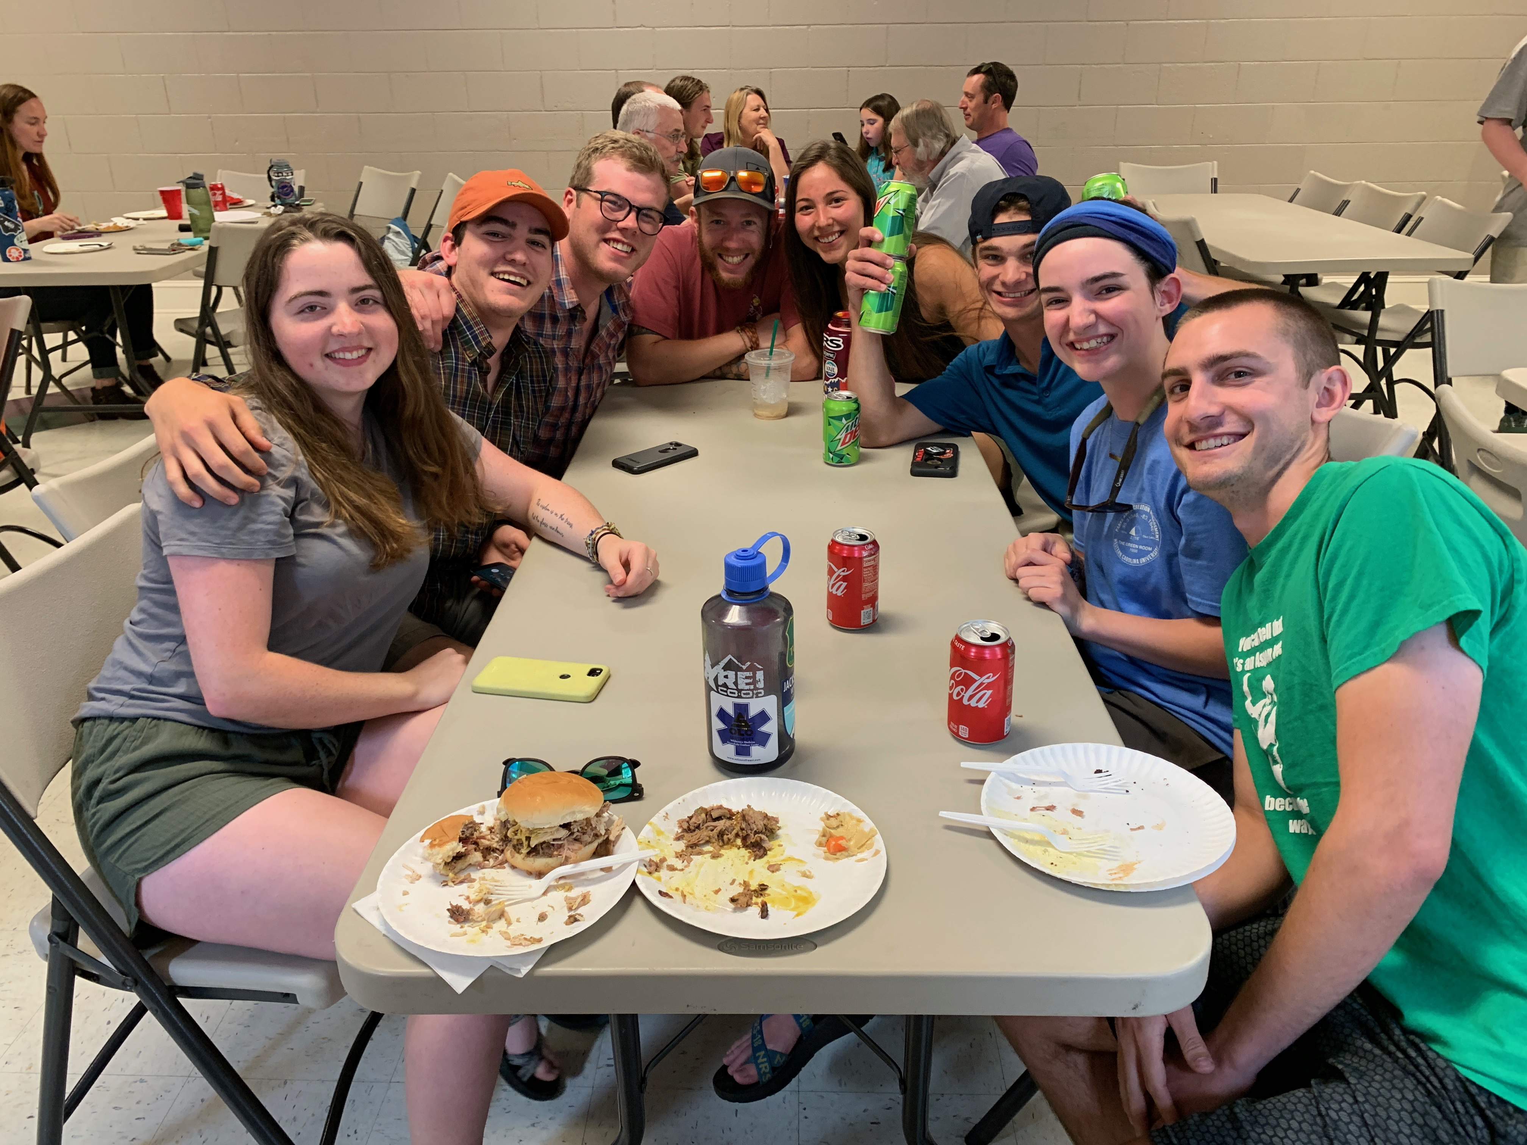
PRM Seniors at the PRM End of the Year Banquet, May 2019. The Banquet is a club sponsored event.

The Adventure Education Conference (AEC)
Twenty-five plus years ago, the PRM Program started the Regional Adventure Education Conference. We organized it for four years then started a rotation with other colleges in the region; Warren Wilson, Southwestern Community College, Montreat College, North Greenville University, UNCA, and Brevard College. The PRM Club organizes the conference when it is hosted at WCU (usually every 5th year). Regardless of whether or not we are hosting, we encourage you to attend. The conference is for students and run by students and costs very little, another great way to get involved!

Certifications and Trainings
As a PRM major, there are opportunities to obtain certifications related to your professional career path. These include first aid, CPR, Wilderness First Aid, Wilderness First Responder, Leave No Trace Trainer Certification, Wilderness Education Association Outdoor Leader Certificate, and National Ski Patrol’s Outdoor Emergency Care plus Mountain Travel & Rescue 1. In addition to certifications offered in PRM courses, students are eligible to receive academic credit for courses and training completed with Landmark Learning, Southwestern Community College’s Law Enforcement Training Program, NOLS and Outward Bound. Discuss these options with your advisor.

Study Abroad
There are possibilities to study abroad for around the same cost as studying at WCU. We have a special agreement with the Galway Mayo Institute of Technology (GMIT) in Ireland where PRM students can attend their Outdoor Education program for an entire year. Find out more information about GMIT at: https://www.gmit.ie/outdoor-education/bachelor-arts-outdoor-education-and-leisure. Students who choose to study at GMIT join their cohort-based program as a Year Three student. There are many opportunities for students to study abroad or at another university within the United States. If you are interested, meet with your PRM advisor and WCU’s Office of International Programs and Services.

Final Thoughts
“Work hard and play hard”, that old adage holds especially true for PRM majors at WCU. Our location gives us some of the finest recreation areas in the country. Take advantage of this as you study hard and produce the best work that you can -- strike a good balance of recreation, play and work to make your experience here at Western both fruitful and enjoyable. We wish you well in your endeavors

APPENDICES

Forms to Guide You
The following forms are designed to help you through the strategic planning process and through the academic curriculum. They are available in the Appendix section and on our PRM webpage.

Appendix A: PRM Career Options
Appendix B: Curriculum Check Sheet(s)
Appendix C: Transfer & Discovery Major Course Sequence Plan
Appendix D: Electives Check Sheets (Meet with your advisor for guidance)
Appendix E: Background Check Information & Instructions

PRM 495 Senior Seminar, May 2019
Senior Symposium
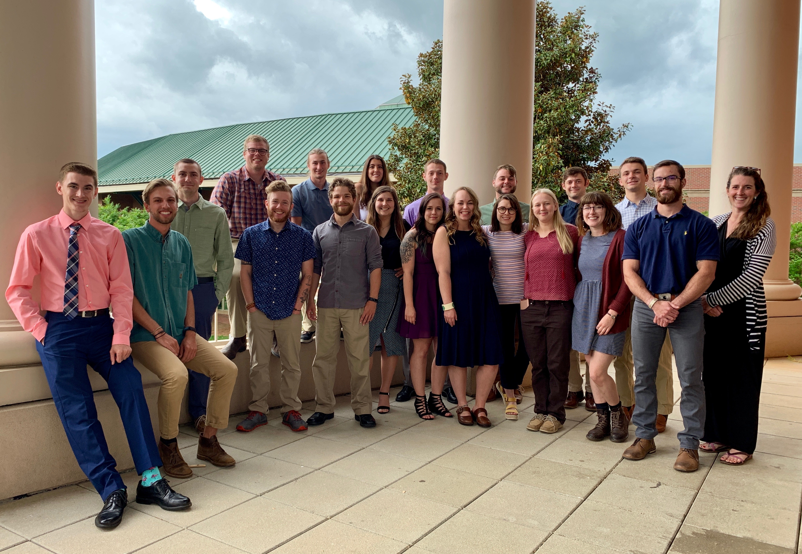

Appendix A
Parks & Recreation Management: What Can I Do With This Degree?

Community Recreation & Youth Development
Areas | Employers | Strategies
Program leader, coordinator  Department administrator  Facility manager  After school program director  Aquatics director  Senior Center administrator  Campus recreation coordinator  Recreation Coordinator | City & country parks and recreation centers  Community centers  YMCA/YWCA  Military recreation  College campus recreation  Public and Private K-12 schools  4 seasons resorts, ski industry, golf & tennis clubs, hotels, city & country recreation departments, private recreation facilities | Choose appropriate mini-internship sites. Gain experience through summer employment. Choose capstone internship in an agency similar to where you would like to work. Join NRPA. Attend professional meetings and conferences. Be involved with LMP and Base Camp. Be involved with PRM club activities. Take elective classes in SM, HPE, PSC, HM.
Camp Counselor  Summer camp director  Program Director | Camps | Choose appropriate mini-internship sites. Gain experience through summer employment. Choose capstone internship in an agency similar to where you would like to work. Join NRPA and ACA. Attend professional meetings and conferences. Be involved with LMP and Base Camp. Be involved with PRM club activities. Take elective classes in SM, HPE, PSC, RTH, ELEM
Notes:

Community Health and Wellness
Areas | Employers | Strategies
Group Exercise/Fitness Instructor  Personal Trainer  Campus Recreation coordinator  Aquatics director  After school physical activity coordinator  Health and Wellness Instructor/Director  Recreation Leader/Supervisor  Senior Fitness Instructor-Trainer  Health and Wellness Program Coordinator  Physical Activity Coordinator  Grant Writer | YMCA-YWCA  City, county recreation departments  Public and Private K-12 schools  Senior Centers or developments  Health Departments  Colleges, universities  School districts  Health Departments  Cooperative Extension agencies  Private, for profit fitness centers  Non-profit after school programs  Youth Centers  Non-profits promoting physical activity and wellness | Choose appropriate mini-internship sites. Gain experience through employment. Choose capstone internship in an agency similar to where you would like to work. Join NRPA, Attend professional meetings and conferences. Be involved with LMP and Base Camp. Be involved with PRM club activities. Take elective classes in SM, HPE, PSC, ENVH, ND. Obtain certifications required for future jobs: FA-CPR, Instructor, Personal Trainer, Wellness Coach, other certifications for lifetime sports. Write a grant as part of a class project. Volunteer for after school programs. Get involved with wellness and physical activity initiatives.
Notes:

Commercial & Resort Recreation
Areas | Employers | Strategies
Recreation Program Director  Recreation Manager  Activity Director  Activity Instructor  Events Manager | 4 seasons resorts, ski industry, golf & tennis clubs, hotels, city & country recreation departments, private recreation facilities | Choose appropriate mini-internship sites. Gain experience through summer employment. Choose capstone internship in an agency similar to where you would like to work. Join NRPA, PSIA-AASI. Attend professional meetings and conferences. Be involved with LMP and Base Camp. Be involved with PRM club activities. Take elective classes in SM, HPE, PSC, HM
Conference & Event Planner | Resorts, outdoor industry private businesses, convention centers, city/county recreation departments | Choose appropriate mini-internship sites. Gain experience through summer employment. Choose capstone internship in an agency similar to where you would like to work. Become active in PRM club, LMP, Base Camp, and volunteer for special events in area. Take elective classes in SM, PSC, HM
Adventure Travel Guide  Trip Leader  Travel Guide Planner | Outdoor companies such as NOC, Mountain Sobek, Backroads and non-profits such as Sierra Club and Audubon Society. Entrepreneurial opportunities.  Road Scholar and college study abroad programs. | Choose appropriate mini-internship sites. Gain experience through summer employment. Choose capstone internship in an agency similar to where you would like to work. First aid certifications, proficiency in an outdoor skill, travel experience, 2nd language skills. Travel agency experience. Take elective classes in MFL, HM, GEOG, HIST, NRM, SM, COMM. Do personal adventure trips.
Commercial Recreation Attractions  Manager, director, employee | Railroads, theme parks, amusement attractions, destination theme resorts, cruise ships, packaged resorts | Same as all of the above.
Notes:

Outdoor Leadership & Instruction
Areas | Employers | Strategies
Instructor-youth at risk  Instructor for people with disabilities  Instructor for corporate programs | Non-profits such as Outward Bound and Project SOAR or State Agencies such as Camp Woodson or private camps such as Eckerd, entrepreneurial opportunities | Acquire outside certifications such as WEA, ACA, Outdoor Emergency Care, WFR, etc. Work outdoor summer jobs in camps, NOC, LMP, Base Camp, Project SOAR, and other agencies. Attend outdoor conferences and workshops. Organize common adventures with peers to gain experience in a variety of activities. Choose appropriate mini-internship sites. Choose capstone internship in an agency similar to where you would like to work. Take elective classes in RTH, NRM, SPED, HPE, PSY. Volunteer with youth programs.
Instructor of outdoor activities | Private companies such as NOC, Endless River Adventures, Backroads Tours. Non-profits such as NOLS, OB, & WEA, camps. Rafting companies, adventure travel companies. Entrepreneurial opportunities. | Acquire outside certifications such as WEA, ACA, Outdoor Emergency Care, WFR, etc. Work outdoor summer jobs in camps, NOC, LMP, Base Camp, Project SOAR, and other agencies. Attend outdoor conferences and workshops. Organize common adventures with peers to gain experience in a variety of activities. Choose appropriate mini-internship sites. Choose capstone internship in an agency similar to where you would like to work. Complete an expedition based course. Take elective classes in PRM, PSY, NRM, EMT.
Mountain Guide | Mountain guide companies such as Exum, Mountain Travel Sobek, NOLS, IWLS | Same as above plus: Attend mountain guide climbing camps such as Mt. Rainer or Mt. Hood. Go on an expedition/trip with a company you are interested in working for.
Snowsports instructor  Ski Patrol  Backcountry snowsports guide | Ski resorts | Acquire outside certifications such as WEA, ACA, Outdoor Emergency Care, WFR, etc. Acquire certifications with PSIA, NSP. Attend on snow clinics, outdoor conferences and workshops. Work with one of the area resorts such as Cataloochee, Sapphire Valley, Wolf Laurel. Choose appropriate mini-internship sites. Choose capstone internship in an agency similar to where you would like to work. Take electives in HPE, SM, HM, EMT.
Program or agency director | See all of the above | See all of the above pertaining to area of interest.
Notes:

Recreation Resource Management
Areas | Employers | Strategies
Ranger  Interpreter  Naturalist  Trail Crew  Resource Management | Park Service  Forest Service  Army Corps of Engineers  State parks | Complete park ranger training course at SCC. Get involved in volunteer rescue work, take search and rescue courses. Work with Base Camp, LMP, volunteer with GSMNP or area National Forests. Become involved with SCA and Adopt-A-Trail. Complete Project Wild, Aquatic Wild workshops. Take a course with the GSM Institute at Tremont. Find a mentor in the agency you are interested in working for. Choose appropriate mini-internship sites. Choose capstone internship in an agency similar to where you would like to work. Take electives in NRM, GEOG, GEOL, BIOL, EDM, EMC, PRM, ART, CJ, SCI.
Notes

Appendix B
B.S. Parks and Recreation Management: 8-semester plan
This is a suggested plan for PRM majors.
Freshman Year
Fall Semester – 15 Credit Hours | Spring Semester – 15 Credit Hours
ENGL 101 | C5
MATH 101 | P1
P1 | COMM 201
HEAL 123, HEAL 111, or HSCC 101 | P3
First-Year Seminar | P4
Sophomore Year
At least one course in perspectives must be an upper level perspective
Fall Semester – 13 or 14 Credit Hours | Spring Semester – 15 Credit Hours
ENGL 202 | C5
P5 | P6
PRM 250* | PRM 270*
PRM 254 or PRM 255* | PRM 275*
PRM 260 (1 credit)* | Elective
Summer Session
Option to take May Mini-Mester, Mini-Internships (PRM 383, 384, 385) or Summer Courses
Junior Year
*Study Abroad?
Fall Semester – 13 or 15 Credit Hours | Spring Semester – 13 or 15 Credit Hours
PRM 356 Or HEAL 250 Or PRM 252 or  PRM 357* | PRM 384 (1 credit)
PRM 361 (4 credits) | Elective
PRM 383 (1 credit) | Elective
Elective | Elective
Elective | Elective
Summer Session
Option to take May Mini-Mester, Mini-Internships (PRM 383, 384, 385) or Summer Courses
Senior Year
Fall Semester – 14-16 Credit Hours | Spring Semester – 14-16 Credit Hours
PRM 430 | PRM 461
PRM 385 (1 credit) | PRM 495
Elective | PRM 493/370
Elective | Elective
Elective | Elective
Elective | Elective
Summer Session – 6 Credit Hours
Option to take May Mini-Mester courses
PRM 483 | PRM 484
TOTAL CREDIT HOURS FOR PROGRAM: 120

Classes noted with (*) can be taken either fall or spring.
**NOTES:
• PRM 260 is being phased out Fall 2020.
• PRM 383, 384, and 385 mini-internships can also be scheduled for summer sessions. Up to 2 mini-internships may be taken at once.
• PRM 493/370 must be taken before you sign up for your capstone internship (PRM 483 and 484).
• PRM 483-484 It is strongly encouraged to schedule your capstone internship in the summer with NO other classes.
• PRM 495 (Senior Seminar) should be taken your LAST spring semester.
APPENDIX B
NAME ____________________________________ PRM Curriculum

I. Liberal Studies 42 hours

II. PRM Major Requirements 40-43 hours
*All courses are offered each semester unless otherwise noted.
First Aid Requirement, choose one of the following:
_____ _____ HEAL-250 (2) First Aid and Safety Ed. or
_____ _____ PRM-252 (2) Wilderness First Aid or
_____ _____ PRM-356 (4) Outdoor First Aid (Fall) or
_____ _____ PRM 357 (4) Wilderness First Responder (Landmark or SCC)

_____ _____ PRM-250 (3) Foundations of Parks and Recreation

_____ _____ PRM-254 (4) Introduction to Outdoor Pursuits or
_____ _____ PRM 255 (3) Active Recreation & Leisure

____ _____ PRM-260 (1) Professional Planning in PRM
_____ _____ PRM-270 (3) Leadership and Group Dynamics
_____ _____ PRM 275 (3) Diversity & Inclusion in PRM

_____ _____ PRM-361 (4) Program Planning and Evaluation
(pre-requisite PRM 250)
_____ _____ PRM-383 (1) Mini-Internship I in PRM
_____ _____ PRM-384 (1) Mini-Internship II in PRM
_____ _____ PRM-385 (1) Mini-Internship III in PRM
**Mini-Internships may not exceed 2 per semester/summer.
_____ _____ PRM-430 (3) Entrepreneurship and Commercial Recreation (Fall)
(pre-requisite PRM 361 or permission of instructor)
_____ _____ PRM-461 (3) Management and Administration of PRM (Spring)
(pre-requisite PRM 250 & 361 or permission of instructor)

_____ _____ PRM-493/370 (3) Capstone Internship Orientation (Spring)
_____ _____ PRM-483 (3) Capstone Internship in PRM I (pre-requisite PRM 370)
_____ _____ PRM-484 (3) Capstone Internship in PRM II (pre-requisite PRM 370)

_____ _____ PRM-495 (3) Senior Seminar in PRM (Spring)
(pre-requisite PRM 361)

III. Electives: 35-38 hours
*These can be from any program at WCU or a minor with another program/major.
Talk to your advisor about options.
*Overall total credits should be at least 120 hours with a GPA of at least 2.5

Total credits required to graduate 120 hours
PRM Electives
Please note that some courses are only offered certain semesters and years.
Courses denoted with * are currently not offered yet may be in the future.

_____ PRM 200: Introduction to Rock Climbing (2) (Fall, Spring, or Summer)
_____ PRM 224: Survey of Outdoor Adventure Activities (2-4)
_____ PRM 293: Topics in Parks & Recreation Management (1-3)
_____ PRM 300: Intermediate/Advanced Rock Climbing (2) (Spring or Summer)
_____ PRM 310: Stand Up Paddling (3) (Fall, Spring, or Summer)
_____ PRM 313: Camp Counseling (3) (Fall, every other even year)
_____ PRM 314: Organization and Administration of Camping Agencies (3)*
_____ PRM 321: Interpretation and Environmental Education (3) (Spring)
_____ PRM 322: International Adventure Travel & Global Citizenship (3) LS P6 (online)
_____ PRM 330: Aquatic Recreation Management (3)*
_____ PRM 333: Experiential Education Methods (4)*
_____ PRM 340: Challenge Course Facilitation (3) (Fall)
______PRM 341: Group Facilitation Techniques (3) (Spring)
_____ PRM 352: Beginner/Intermediate WW Kayaking (3) (Fall, Spring, or Summer)
_____ PRM 353: Beginner/Intermediate WW Canoeing (3) (Fall, Spring, or Summer)
_____ PRM 354: Outdoor Living and Expedition Skills (3) (Fall)
_____ PRM 360: Recreation Research (3)*
_____ PRM 425: Advanced Climbing & Rescue Techniques (4) (Fall, every other even year)
_____ PRM 426: Advanced Paddling & Rescue Techniques (4) (Fall, every other odd year)
_____ PRM 427: Wilderness Education (3-6) (May mini-mester or Summer)
_____ PRM 433: Outdoor Recreation and Public Land Management (3)
_____ PRM 434: High Adventure Travel and Outfitting (3)
_____ PRM 435: Park and Recreation Sites, Facilities, and Programs (1-6)
_____ PRM 454: Expedition Management and Leadership (4) (Spring, every other even year)
_____ PRM 485: Internship in Parks and Recreation Management (3)
_____ PRM 486: Field Experience (1-12)
_____ PRM 493: Topics Parks and Recreation Management (3)

PRM Professional Career Paths

Below is a list and descriptions of the five PRM Career Paths: Community Recreation & Youth Development, Outdoor Leadership and Instruction, Community Health & Wellness, Commercial and Resort Recreation, and Recreation Resources Management.

- Community Recreation & Youth Development:
This career path is designed for students who would like to work in the city and county recreation profession or within youth development (after school, non-profits, camps). Job duties would include planning sporting activities (soccer, baseball, football, basketball), assisting with community events and celebrations, working in a community recreation center or camp. Students should consider taking courses in parks and recreation management, health and physical education, business, sport management, and recreational therapy.

- Outdoor Leadership and Instruction:
This career path is designed for students who are interested in working in outdoor professional areas. Job possibilities include working for outdoor agencies, camps, boy and girl scouts, challenge courses, and experiential programs. Students should consider taking courses in parks and recreation, business and recreation therapy, and participating in an extended expedition style course.

- Commercial and Resort Recreation:
This career path is designed for students interested in working the “for profit” areas of recreation. Job possibilities include resorts, recreation businesses, snow sports, retail establishments and park areas. Students may also be interested in exploring their own commercial recreation business. Students should consider taking courses in parks and recreation, business, entrepreneurship, hospitality and tourism, accounting, and management.

- Recreation Resource Management:
This career path is designed for students interested in working for various land agencies such as the National Park Service, National Forest Service, Army Corps of Engineers, and state parks. Courses will be selected in consultation with your advisor.

5. Community Health and Wellness:
This career path is designed for students interested in providing health promotion programming to the community. Students may find employment in recreation departments, health departments, local government, schools and national organizations. Students should consider taking course work in parks and recreation, sport management, health and physical education, environmental health, nutrition and political science.

Appendix C
B.S. Parks and Recreation Management (Transfer)
This is a suggested plan for transfer students and those who “discover” PRM
later in their academic career at WCU.

First Year
Fall Semester | Spring Semester
PRM 250 (3 credits) | HEAL 250 or PRM 252 or PRM 356 or PRM 357*  (First Aid Requirement, check transfer credits)
PRM 254 or PRM 255 (check for transfer credits) | PRM 275 (3 credits)
PRM 260 (1 credit) | PRM 383 (1 credit)
PRM 270 (3 credits) | Elective
Elective | Elective
Summer Session
Option to take May Mini-Mester, Mini-Internships (PRM 383, 384, 385) or Summer Courses
Second Year
Fall Semester | Spring Semester
PRM 430 (3 credits) | PRM 385 (1 credit)
PRM 384 (1 credit) | PRM 461 (3 credits)
PRM 361 (4 credits) | PRM 495 (3 credits)
Elective | PRM 493/ 370 (3 credits)
Elective | Electives (2-3 courses)
Summer Session – 6 Credit Hours (Capstone Internship)
Option to take May Mini-Mester courses
PRM 483 (3 credits) | PRM 484 (3 credits)
TOTAL CREDIT HOURS FOR PROGRAM: 120

**NOTES:
• Courses in italics are offered ONLY during the semester they are listed.
• PRM 260 is being phased out fall 2020.
• PRM 383, 384, and 385 mini-internships can also be scheduled for summer sessions. Up to 2 mini- internships may be taken at once.
• PRM493/ 370 should be taken AFTER PRM 260 and must be taken BEFORE you sign up for your capstone internship (PRM 483 and 484).
• PRM 483-484 It is strongly encouraged to schedule your capstone internship in the summer with NO other classes.
• PRM 495 (Senior Seminar) should be taken your LAST spring semester.

Appendix D

Parks & Recreation Management
Electives for Community Recreation & Youth Development

*Please check program websites, the current catalog and the dynamic schedule for available courses and pre-requisites.

FIN 210 Managing Your Money for Financial Success
FIN 301 Financial Statement Analysis
FIN 305 Financial Management
MGT 300 Introduction to Management
MGT 401 Small Business Management
MGT 404 Strategic Management
MKT 201 Marketing Planning and Strategy
MKT 211 Marketing Principles (for non marketing majors)
MKT 206 Introduction to Professional Selling
MKT 303 Decision Making for Value Creation
MKT 406 Internet and Social Media Marketing and Sales
MKT 475 Marketing Strategy
MKT 301 Principles of Marketing
HPE 212 Foundations of Health and Physical Education
HPE 223 Applied Kinesiology I: Anatomy, Physiology, & Biomechanics (4 credits)
HPE 225 Applied Kinesiology II: Exercise Physiology (4 credits)
HPE 235 Motor Behavior
HPE 253 Sport Education
HPE 305 Adventure Based Physical Education
HPE 345 Children's Movement (developmental approach to pe for children)
HPE 354 Lifetime Sport and Physical Activity I (2 credits)
HPE 364 Lifetime Sport and Physical Activity II (2 credits)
HPE 355 Fitness Concepts (fitness and wellness programming)
HPE 358 Healthy Living Concepts (nutrition and physical activity concepts to reduce and prevent obesity)
HPE 365 Physical Activity & Aging (how to lead activities for the older population)
PE Activity **Physical Activity classes to learn new skills, search under the PE prefix each semester.
PSC 110 Global Issues
PSC 150 American Government and Politics (also a P1)
PSC 250 Introduction to Political Science
PSC 302 Public Policy
PSC 303 State and Local Government
PSC 304 Public Administration
PSY 150 General Psychology
PSY 309 Social Psychology
PSY 320 Developmental Psychology I: Childhood
PSY 322 Developmental Psychology II: Adolescence
QA 305 Introduction to Management Science
QA 235 Business Statistics
SM 260 Introduction to Sport Management
SM 340 Sport Ethics
SM 350 Global Sport and Culture
SM 361 Sport Marketing
SM 420 Risk Management and Liability in Sport
SM 435 Sport Event Management and Sponsorship
SM 445 Sport Administration
SM 315 Introduction to Intramural & Recreation Sport Management
SM 460 Financial Aspects of Sport
SOC 103 Human Society
SOC 385 Methods of Social Research
SOC 386 Analysis of Social Data

In addition to a variety of electives, students may consider working towards a minor in any of the following programs. Please check with the program for updates to courses and minor requirements.

• Business Administration & Law
• Coaching
• Entrepreneurship
• Political Science (public policy focus)
• Sport Management

The courses listed on this sheet are suggested courses for electives. This list may not include all courses a student may be interested in at WCU. Students are encouraged to examine the undergraduate catalog and discuss possible courses of interest with your advisor. Students are also encouraged to examine course offerings offered at SCC and other community colleges for courses, which will transfer in to WCU as electives. Students are reminded that 50% of their classes within the major (32 credits) must be at the junior/senior level.

Parks & Recreation Management
Electives for Recreation Resource Management

*Please check program websites, the current catalog and the dynamic schedule for available courses and pre-requisites.

ACCT 251 Financial Accounting: A User Perspective

ACCT 252: Using Accounting Information for Management Decisions
ANTH 260 Cultural & Social Anthropology
ASI 250 Introduction to Appalachian Studies
BIOL 103 Environmental Biology
BIOL 108 Recreational Biology

BA 133 Introduction to Business
CMCR 150 Interpersonal Communication
CMCR 250 Public Communications (PREQ: ENG 102)
CMCR 301 Writing for Communication Media (PREQ: ENG 102 & CMCR 140)
CMHC 201 Introduction to Speech Communication
CIS 110 Introduction to Computer Information Systems
CIS 251 Managing Enterprise Information Systems
CJ 150 Introduction to Criminal Justice & Criminology
CJ 320 Police in Society ( PREQ CJ 250)
COMM 400 Crisis Communications
EDM 250 Intro. to Emergency and Disaster Management
EDM 324 Emergency Planning
EMC 210 Introduction to Wilderness Medicine
EMC 240 Introduction to Emergency Medical Care
EMC 241 Basic Emergency Medical Techniques
EMC 310 Emergency Medicine I
GEOG 150 Environmental Geography
GEOG 402 Conservation of Natural Resources
HSCC 240 Introduction to Emergency Medical Care
HT 130 Introduction to Hospitality and Tourism
HT 238 Travel & Tourism
HT 335 Lodging and Resort Management (PREQ: HT 130)
LAW 105 Introduction to Law
LAW 402 Hospitality Law
LAW 410 Witnesses and Evidence
MGT 300 Management Planning and Strategy
MKT 301 Principles of Marketing
NRM 140 Natural Resource Conservation and Management
NRM 210 Methods in Natural Resources Management
NRM 340 Natural Resources Measurements
NRM 330 Intro to Wildlife Ecology & Management (NRM 210 or 340 pre-req)
NRM 344 Applied Geographic Information Systems (GEOG 221 pre-req)
PAR 330 America’s Wilderness Philosophers and Essayists
PAR 333 Environment Ethics
HPE 365 Physical Activity and Aging
PSC 304 Public Administration
SCI 150 Introduction to Science Education
SCI 301 Nature of Science
SM 260 Introduction to Sport Management
SM 420 Risk Management and Liability in Sports
SM 435 Sport Event Management and Sponsorship
SPAN 101 Experiencing Spanish and the Spanish Speaking World

In addition to a variety of electives, students may consider working towards a minor in any of the following programs. Please check with the program for updates to courses and minor requirements.
• Biology
• Criminal Justice
• Emergency & Disaster Management
• Geology
• History
• Natural Resource Conservation & Management

Additional Offerings & Training Opportunities:
• Southwestern Community College: Seasonal Law Enforcement Training (SLET)
Training weeks are generally Tuesday thru Saturday, with some 6 day weeks and nighttime training evolutions. (680 total hours of training)
Applications for training sessions are made through the Division of Public Safety Training Center at SCC.
Application deadlines are typically 2-3 months in advance.
For more information contact:
Mr. Don Coleman
NPS-SLET Coordinator/Instructor
828-306-7055
d_coleman@southwesterncc.edu

• Landmark Outdoor Educator Semester
Six week (345 hours) training course where students can gain up to 15 hours of college credit. Prerequisites include prior experience in outdoor disciplines.
During the course, students could receive the following certifications:
NOLS WEMT Emergency Medical Technician
American Safety & Health Institute Basic Life Support
American Safety & Health Institute Basic First Aid & CPR Instructor
Leave No Trace Master Educator
ACA L4 Swiftwater Rescue
ACA L2 Canoe Instructor
Fox Mountain Guides’ Introduction to Single-Pitch Climbing
Starfish Aquatics Institute Wilderness Lifeguard

The courses listed on this sheet are suggested courses for electives. This list may not include all the courses a student may be interested in at WCU. Students are encouraged to examine the undergraduate catalog and discuss possible courses of interest with your advisor. Students are also encouraged to examine the courses offered at SCC and other community colleges for courses, which will transfer in to WCU as electives. Students are reminded that 50% of their classes within the major (32 credits) must be at the junior/senior level

Parks & Recreation Management

Electives for Commercial Recreation & Resort Management

*Please check program websites, the current catalog and the dynamic schedule for available courses and pre-requisites.

ACCT 251 Financial Accounting: A User Perspective

ACCT 252: Using Accounting Information for Management Decisions
ANTH 260 Cultural & Social Anthropology
ART 202 Art of World Cultures
ASI 250 Introduction to Appalachian Studies
BIOL 103 Environmental Biology
BIOL 108 Recreational Biology

BA 133 Introduction to Business
CMCR 150 Interpersonal Communication
CMCR 250 Public Communications (PREQ: ENG 102)
CMCR 301 Writing for Communication Media (PREQ: ENG 102 & CMCR 140)
CMHC 201 Introduction to Speech Communication
CMPM 305 Sports Writing (PREQ: CMCR 301)
CMPM 404 Desktop Publishing
CIS 110 Introduction to Computer Information Systems
CIS 251 Managing Enterprise Information Systems
ECON 231 Introductory Microeconomics and Social Issues
ECON 232 Introductory Macroeconomics and Social Issues
ECON 420 Recreation, Sports, and Tourism Economics (PREQ ECON 231)
ENGL 204 The Literature of Culture
ENGL 351 The Beats, Radicals, & Avant-Garde Literature (PREQ: ENG 101 & 102)
FIN 305 Financial Management
GEOG 150 Environmental Geography
GEOG 402 Conservation of Natural Resources
GEOG 460 Urban & Regional Land Use Planning
ENT 201: Introduction to Entrepreneurship
ENT 250 Innovation & Creativity
ENT 301 Innovation Leadership
ENT 325 New Venture Creation
ENT 335 Intrapreneurship
ENT 350 New Venture Execution
ENT 401 Entrepreneurial Funding
ENT 450 New Venture Strategy
ENT 475 Entrepreneurship
ENVH 230 Introduction to Environmental Health Science

HT 130 The Hospitality and Tourism Services Industry
HT 229 Hotel Front Office Operations
HT 231 Hospitality Facilities Management
HT 232 Quality Service
HT 233 Quantity Foods
HT 238 Travel & Tourism

HT 239 Cost Control in the Hospitality and Tourism Industry
HT 241 Special Events and Festival Management
HT 334 Restaurant Management
HT 336 Club Management
HT 337 Meeting, Convention, and Event Planning
HT 438 Strategic Management in the Hospitality and Tourism Industry
HT 431 Hospitality & Tourism Marketing
HT 434 Advanced Club Management
HT 436 Tourism Planning & Development
HT 437 Bar and Beverage Operations
HT 477 Casino Management
LAW 105 Introduction to Law
LAW 230 Legal and Ethical Environment of Business
LAW 315 Athletics & Law
LAW 402 Hospitality and Law
MGT 300 Introduction to Management
MGT 401 Small Business Management
MGT 404 Strategic Management
MKT 201 Marketing Planning and Strategy
MKT 211 Marketing Principles (for non marketing majors)
MKT 206 Introduction to Professional Selling
MKT 303 Decision Making for Value Creation
MKT 406 Internet and Social Media Marketing and Sales
MKT 475 Marketing Strategy
MKT 301 Principles of Marketing
NRM 140 Natural Resource Conservation and Management
PHIL 330 America’s Wilderness Philosophers and Essayists
PHIL 333 Environment Ethics
PSC 331 International Politics
QA 305 Introduction to Management Science
QA 235 Business Statistics
SM 260 Introduction to Sport Management
SM 340 Sport Ethics
SM 350 Global Sport and Culture
SM 361 Sport Marketing
SM 420 Risk Management and Liability in Sport
SM 435 Sport Event Management and Sponsorship
SM 445 Sport Administration
SM 315 Introduction to Intramural & Recreation Sport Management

SM 460 Financial Aspects of Sport

In addition to a variety of electives, students may consider working towards a minor in any of the following programs. Please check with the program for updates to courses and minor requirements.

• Hospitality & Tourism
• Entrepreneurship
• Sales & Marketing
• Sport Management

The courses listed on this sheet are suggested courses for electives. This list may not include all courses a student may be interested in at WCU. Students are encouraged to examine the undergraduate catalog and discuss possible courses of interest with your advisor. Students are also encouraged to examine course offerings offered at SCC and other community colleges for courses, which will transfer in to WCU as electives. Students are reminded that 50% of their classes within the major (32 credits) must be at the junior/senior level.

Parks and Recreation Management
Electives for Outdoor Leadership and Instruction (OLI)
It is recommended that you use this sheet as a way to structure your elective suggestions if you are interested in OLI. “Required Courses”: While not actually required, these courses provide a solid foundation for the OLI student to build upon, so students should be “strongly encouraged” to take them.

- PRM 333 Experiential Education Methods (Currently not being offered)
- PRM 354 Outdoor Living and Expedition Skills (4 credits) (Fall)…OR…
  - PRM 454 Expedition Management and Leadership (4 credits) (Spring, every other even year)…OR…
  - PRM 427 Wilderness Education, expedition-based course which includes backpacking, canoeing, or other modes of travel (3-6 credits) (Summer)
- PRM 356 Outdoor First Aid (4 credits) (Fall)…OR…
- PRM 357 Wilderness First Responder (4 credits) (Fall, Spring, or Summer at Landmark Learning)

“Elective Courses”: While these are all PRM elective courses, students again should be encouraged to take courses from one the possible tracks described below—either land-based or water based.

- Water-based: The following courses could be selected to produce a more water-based focus from the OLI electives:

PRM 310 Stand Up Paddling (Fall, Spring, May mini-mester)
PRM 352 Beginning/Intermediate WW Kayaking (Fall, Spring, May mini-mester)
PRM 353 Beginning/Intermediate WW Canoeing (Fall, Spring, May mini-mester)
PRM 426 Advanced Paddling & Rescue Techniques (Fall, every other odd year), pre-req PRM 352 and/or PRM 353 or permission of instructor. Strong swimming ability required.

- Land-based: The following courses could be selected to produce a more land-based focus from the OLI electives:

PRM 200 Introduction to Rock Climbing (Fall, Spring, or Summer)
PRM 300 Intermediate/Advanced Rock Climbing (Spring or Summer), permission of instructor or PRM 200
PRM 425 Advanced Climbing & Rescue Techniques (Fall, every other even year), pre-req PRM 200 or permission of instructor. Strong climbing ability is required.
PRM 340 Challenge Course Facilitation (Fall)

- Multi-focused: The following courses may be used for either land or water-based tracks, depending upon the specific elements of the course or student choice:

PRM 313 Camp Counseling (Fall, every other even year)
PRM 341 Group Facilitation Techniques (Spring)
PRM 354 Outdoor Living and Expedition Skills (Fall)
PRM 427 Wilderness Education, expedition-based course (May mini-mester or Summer)
PRM 454 Expedition Management & Leadership (Spring of even-numbered years)
Parks & Recreation Management
Electives for Community Health & Wellness

*Please check program websites, the current catalog and the dynamic schedule for available courses and pre-requisites.

*Depending upon a student's goals, they could choose to focus on the following tracks:
(1) Fitness model (personal training, national certifications, fitness center programming): These students could select classes from BIOL, HPE, PE, ND, and SM, with internships at the Campus Recreation Center, Jackson County Recreation Department, YMCA’s, and private fitness centers.
(2) Health promotion and wellness model (wellness or health promotion director, health policy advocate): These students could select from classes in ENVH, ND, PSC, HPE, and PE, with internships at the Campus Recreation Center, Jackson County Recreation Department, YMCA’s, private fitness centers, health departments, non-profit health promotion agencies, and the CDC.

BIOL 140: Principles of Biology
BIOL 291: Human Anatomy and Physiology I
BIOL 292: Human Anatomy and Physiology II
ENVH 190: From Black Death to Bioterrorism
ENVH 200: Introduction to Public Health
ENVH 210: Global Disparities in Public Health (also a P6)
ENVH 230: Introduction to Environmental Health
FIN 210: Managing Your Money for Financial Success
FIN 301: Financial Statement Analysis
FIN 305: Financial Management
HPE 212: Foundations of Health and Physical Education
HPE 223: Applied Kinesiology I: Anatomy, Physiology, & Biomechanics (4 credits)
HPE 225: Applied Kinesiology II: Exercise Physiology (4 credits)
HPE 235: Motor Behavior
HPE 253: Sport Education
HPE 305: Adventure Based Physical Education
HPE 345: Children's Movement (developmental approach to pe for children) (3 credits)
HPE 354: Lifetime Sport and Physical Activity I (2 credits)
HPE 364: Lifetime Sport and Physical Activity II (2 credits)
HPE 355: Fitness Concepts (fitness and wellness programming) (3 credits)
HPE 358: Healthy Living Concepts (nutrition and physical activity concepts to reduce and prevent obesity) (3 credits)
HPE 365: Physical Activity & Aging (how to lead activities for the older population)
**Physical Activity classes to learn new skills, search under the PE prefix each semester.
HSCC 322: Medical Terminology
MATH 170: Applied Statistics
ND 190: Personal Nutrition
ND 310: Food, Nutrition, and Culture (also a P6 ULP)
ND 330: Human Nutritional Needs
ND 340: Community Nutrition (preq: ND 330)
ND 342: Nutrition in Athletics (preq: ND 330)
PSC 110: Global Issues
PSC 150: American Government and Politics (also a P1)
PSC 250: Introduction to Political Science
PSC 302: Public Policy
PSC 303: State and Local Government
PSC 304: Public Administration
SM 260: Introduction to Sport Management
SM 340: Sport Ethics
SM 350: Global Sport and Culture
SM 361: Sport Marketing
SM 420: Risk Management and Liability in Sport
SM 435: Sport Event Management and Sponsorship
SM 445: Sport Administration
SM 315: Introduction to Intramural & Recreation Sport Management
SM 460: Financial Aspects of Sport
SOC 103: Human Society
SOC 385: Methods of Social Research
SOC 386: Analysis of Social Data

In addition to a variety of electives, students may consider working towards a minor in any of the following programs. Please check with the program for updates to courses and minor requirements.

• Business Administration & Law
• Coaching
• Entrepreneurship
• Environmental Health
• Political Science (public policy focus)
• Sport Management

The courses listed on this sheet are suggested courses for electives. This list may not include all courses a student may be interested in at WCU. Students are encouraged to examine the undergraduate catalog and discuss possible courses of interest with your advisor. Students are also encouraged to examine course offerings offered at SCC and other community colleges for courses, which will transfer in to WCU as electives. Students are reminded that 50% of their classes within the major (32 credits) must be at the junior/senior level.

Appendix E

Parks & Recreation Management
Background Check Instructions

Background Check Issues for PRM Majors
The PRM major is an experiential major; we teach several courses where students practice facilitating
groups and programming activities in partnership with outside agencies. Our participants are often
minors and many of you will also choose to complete your capstone internship working with minors in
camp settings, outdoor instruction, community recreation settings or various park settings. In an effort
to make sure we are protecting the participants (minors) you may be working with during your time in
the program, we conduct a full background check on each of our majors during the PRM 361 Program Planning and Evaluation course or in PRM 341 if you take that course before PRM 361. You must complete the background check AND if you fail the check the required Qualtrics form within 7 days of notification of the failed check or you will not be able to continue in the course and will be asked to withdraw. Late background checks/Qualtrics explanations forms will not be accepted as these are a university and PRM policy requirement for programming with minors.

In accordance with our college, College of Education and Allied Professions (CEAP), We use the
company Certiphi. They search the student’s credentials, the Sex Offenders Registry, State Criminal
(Felony, Misdemeanor and Other Offenses), Federal Criminal (Felony, Misdemeanor and Other
Offenses), & OIG & GSA Excluded Parties.

Note: Our contract with Certiphi does not allow us to share the actual background check results, but
when any of the major issues below are present, we will indicate that and send the student’s
explanation of charges with their materials to agencies that the student is working with who request them.

List of Charges Flagged by our Office:
• Petty Theft or Shoplifting
• Assault (any type)
• Anything involving children/minors (endangerment, neglect, etc.)
• Larceny – Theft, robbery, burglary, stealing, etc.
• DUI
• Drug possession
• Fraud – Bribery, embezzlement, money laundering, tax evasion, forgery, etc.)
• More than 3 charges of anything (e.g. speeding ticket, trespassing, public intoxication)

Students with any of the charges listed above on their background checks will be reviewed by the PRM
Background Check Review Committee. This committee evaluates the severity of the offenses, the
number of incidences, and recentness of the crimes committed. The committee will determine whether
or not they believe that the student is eligible to continue in the PRM Program. Students who clear the
committee’s review will receive notification that although the committee has cleared them, they are at
the discretion of their employers or the community agency partner as to whether or not they will be
accepted into the capstone internship or to program/facilitate with minors. When we request
placements for students who have cleared our Background Check Review Committee and who have any
of the charges listed above on their background check, we will use the following indicators:
Indicators:
No
– Indicates that the student’s background check is clear, or contains no major charges (ex. Speeding tickets,
improper equipment, etc.)
Yes – Dismissed
– Indicates that the student has one or more of the charges listed above on their background check, but all
have been dismissed.
Yes – Pending
- Indicates that the student has one or more of the charges listed above on their background check, but they
are pending.
Yes – Conviction(s)
– Indicates that the student has one or more of the charges listed above on their background check, and been
sentenced/fined/served community service/served jail time for the crimes listed above.
– In these situations, we strongly encourage you to read the student’s explanation of the charges and perhaps
request to meet with the student prior to making a decision on their placement status.

BACKGROUND CHECK & UNIVERSITY SANCTION REVIEW APPLICATION
– If you are flagged as a result of your background check for any reason and/or if you have a recent incident since your last background check you will complete the WCU Background Check & University Sanction Review
Application (sent via email as a Qualtrics form).
– Students with background checks that include ANY charges and/or convictions OR University Sanctions,
MUST complete the explanation section which will include the date of the incident, include a summary of
events, outcome, and the lessons learned from the experience. This MUST be completed within 7 business days of being emailed the Qualtrics form by PRM administrative assistant.
– Be aware that if you have any charges, especially recent ones, such as larceny, assault, drug paraphernalia,
drug possession, DUIs, etc. that appear on your background history, the CEAP cannot make a determination
as to how specific agencies will evaluate your history in deciding whether to host you during all field
placements as you progress through the PRM. Even though CEAP may be able to secure you a field
placement or internship one semester, they may not be able to secure you a field placement or internship
subsequent semesters. This is not to deter your decision to seek a career in PRM working with minors,
however it is our responsibility to make you aware of all the possible implications of having issues in your
criminal background.

SELF-DISCLOSURE AGREEMENT
– Students are responsible for self-disclosure of any charges or university sanctions accumulated after their
initial background check. New charges should be reported to the PRM Program Director (Dr. Callie Schultz within 72 hours of the incident. This is mandatory and could result in the student losing placement (internship or field experience) with an agency involving minors.
– *Any new charge(s) that is not on the student’s original background check requires that the student get a new background check at their own expense.

Western Carolina University – Parks and Recreation Management
Student Criminal Background Check Instructions

Western Carolina University – Parks and Recreation Management has asked that you use the Application Station - Student Edition to complete the required criminal background check through Certiphi Screening, Inc. Failure to complete these requirements could impact your admission or retention.

You will want to go to: https://applicationstation.certiphi.com/ in order to complete the background check.

When creating your Application Station account, you will receive an email with an activation code that will allow you to access the Application Station Website. The email format is supplied below the “Verify Account” screenshot see below:

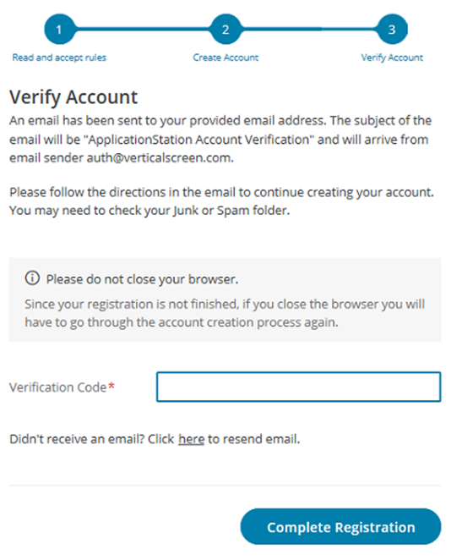

You will then receive the code for registration from the following email address auth@verticalscreen.com.

Registration Email
You created an account with ApplicationStation.

Username: Username

Please enter the following code onto our website to continue:
XXXXXXXX

Please Note: Don't delay; your verification code is only valid for 20 minutes.

If you did not request to create an account, please contact us.

Thank you
Application Station Team
applicationstation@certiphi.com
888-291-1369 x2006

After the Verification code is entered. You will then receive another email from the same auth@verticalscreen.com email confirming the username that was set up. The email you will receive is below. Once you create your Application Station Account, you will not have to create a new account – you will utilize the same account for all checks conducted through Certiphi Screening, Inc.

Verification Email
Your email address has been verified with ApplicationStation.

Username: <Username>

If this was not you, please contact us.

Thank you,
Application Station Team
applicationstation@certiphi.com
888-291-1369 x2006

The applicant will then be prompted to login to the Application Station. They will also be asked to answer one of the security questions that they just set up during the account creation process.

If the applicant is having any difficulty they can always reach out to our IT support team for assistance. 888-291-1369 ext. 2006

What to do if you need a Student Criminal Background Check?

The background check consists of the following.

Student CBC
Searches 7 years of residence history. *** IT coding is in place to generate a NC State Criminal always and only no matter address history &we only run county searches outside of NC when the subject has lived in other states a combined duration of 6 months or longer. ***

- TransUnion Social Search
- Courts - County Criminal Felony & Misd
- Courts - Federal Criminal Felony & Misd
- Courts - International Criminal Felony & Misd – only processed when an individual has resided outside of the U.S.
- Courts - State Criminal Felony & Misd – Always and only processing NC Statewide
- OIG & GSA Excluded Parties
- Sexual Offender Registry Search

The Student CBC total fee is $18.90.

Certiphi Screening accepts credit cards and PayPal. Payment is collected within ApplicationStation: Student Edition.

Western Carolina University – Parks and Recreation Management | Application Station Code
Student CBC | WCUPARKSRECMGMTSTUDENTCBC

- You will need to go to: https://applicationstation.certiphi.com/ in order to complete the background check.
- If this is your first time using the Application Station site then please click “Sign Up” to create an account. Once your account has been created please click “Log In”. If you already have an account then you can click “Log In” right away.
- Enter your Username and Password.
- Enter the Code: WCUPARKSRECMGMTSTUDENTCBC in the Application Station Code field.
- Follow the instructions on the Application Station web site to complete the application.

Background Investigations are completed, on average, within 3 to 5 business days. Once completed, you should receive an email from Certiphi Screening, studentedition@certiphi.com. Follow the link in the email to view the completed background investigation – we encourage you to save a copy of this report for your own records. Application Station includes instructions for filing a dispute should for feel the results are incorrect.

Report Delivery Manager

Report Delivery Manager (RDM) allows students to distribute an electronic copy of your background check and drug screen results to a third party for clinical rotations. RDM can be found in Application Station: Student Edition. Reports are available to students for 48 months. If reports are needed beyond 48 months, students must print a copy to be distributed as needed.

- Click the link below or paste it into your browser: https://applicationstation.certiphi.com
- Enter the Application Station Code applicable to the report you are trying to forward.
- To access the Report Delivery Manager, choose the “If you are returning” option on the left side of the home page and click “Sign back in.”
- Enter the username and password created at the time of submitting your background investigation and/or drug screen.
- Report Delivery Manager can be found at the bottom of the Welcome Back screen.
- To authorize a new third party to view a background check, click “Create a New Delivery.”
- Read the “Important Notice”, type your name and click “Agree.”
- Supply the third party’s contact information: Last Name, First Name and Organization. Report Access Keys are generated, including an ApplicationStation Code and Access PIN.

Certiphi Screening recommends that the student contact the third party and provide the ApplicationStation website address, code and PIN to the contact verbally. This method provides the highest level of security. However, the student can also authorize that an e-mail containing this information be sent to the contact at the clinical facility. If you wish to have an email containing the Access Keys to be sent directly to the clinical facility, follow steps 8 and 9.

- To authorize an e-mail, locate “Other Delivery Options, Option 2” and click “here to send an email.”
- Provide and confirm the recipient’s e-mail address, and then select either Option 1 or Option 2, which determines what information is sent to the recipient via e-mail.

The system provides confirmation that an e-mail has been sent, along with the ApplicationStation Code and Access PIN for future reference.

Staying in Touch with PRM

PRM Webpage: https://www.wcu.edu/learn/departments-schools-colleges/ceap/humanserv/prm/

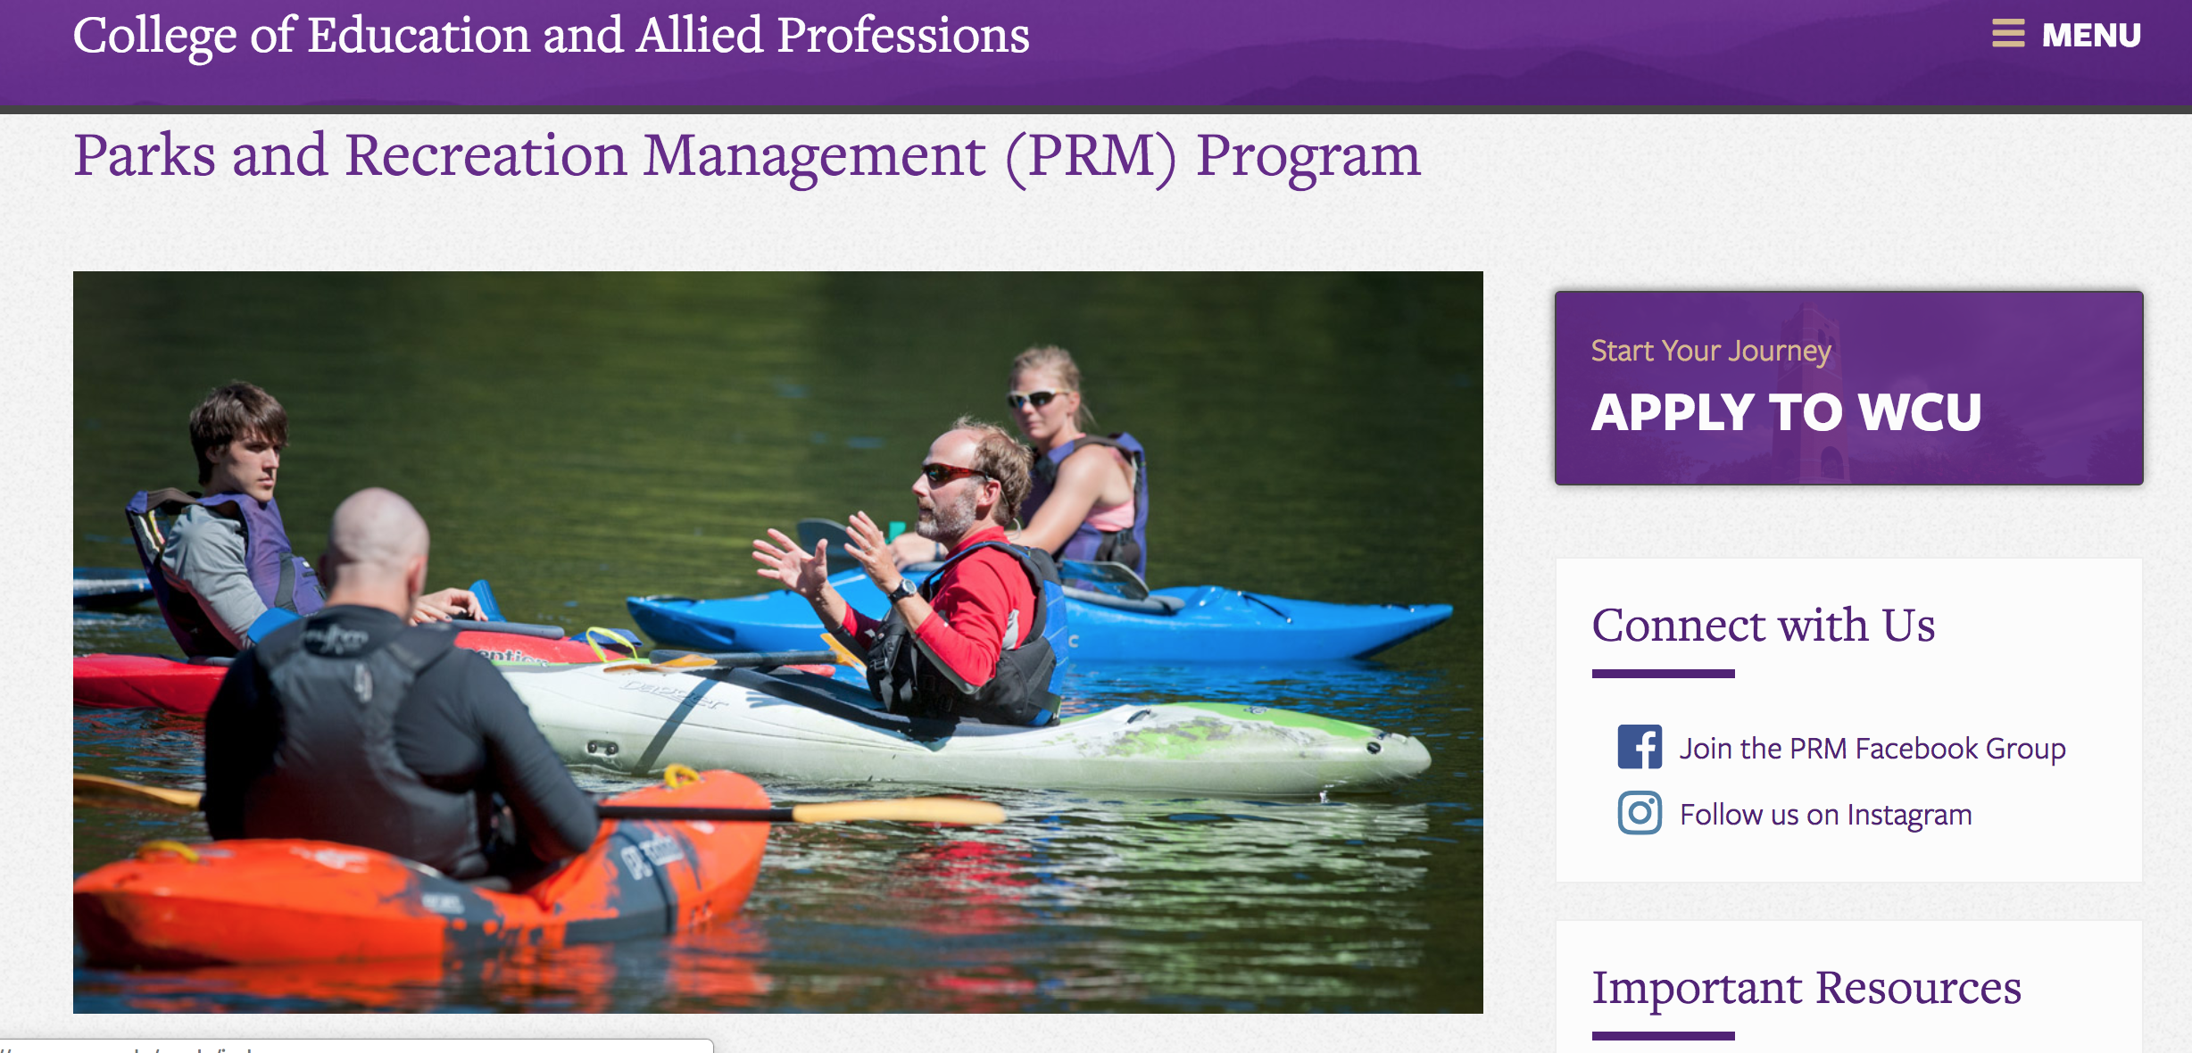

PRM Facebook Group: https://www.facebook.com/groups/PRMclub/?ref=bookmarks

PRM Faculty 2020-2021

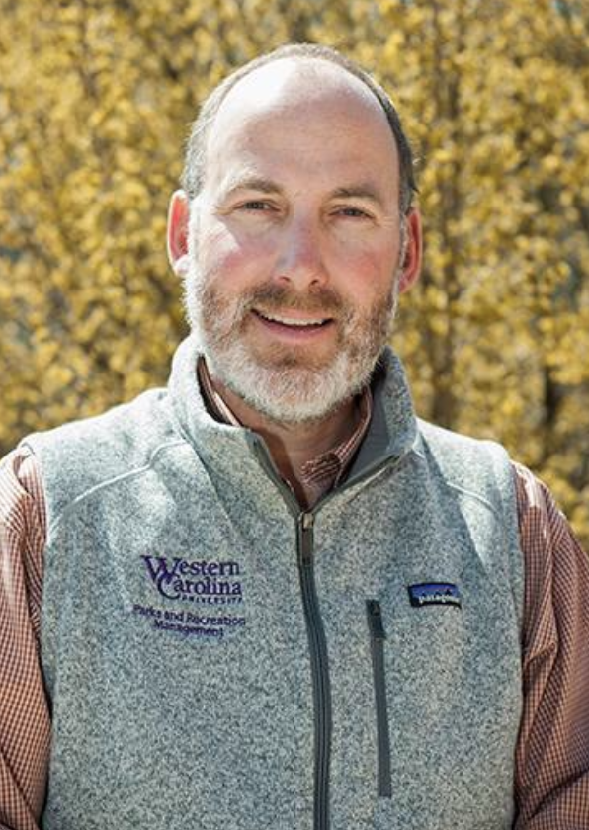
Dr. Andrew Bobilya
Program Director and Professor, Experiential & Outdoor Education (EOE) graduate program.

Professor, Parks & Recreation Management (undergraduate)

Dr. Callie Schultz
Program Director and Assistant Professor, Parks & Recreation Management (undergraduate)

Assistant Professor, Experiential & Outdoor Education (EOE) (graduate program)

Dr. Jeremey Schultz
Assistant Professor, Parks & Recreation Management (undergraduate)

Assistant Professor, Experiential & Outdoor Education (EOE) (graduate program)

PRM Club Advisor

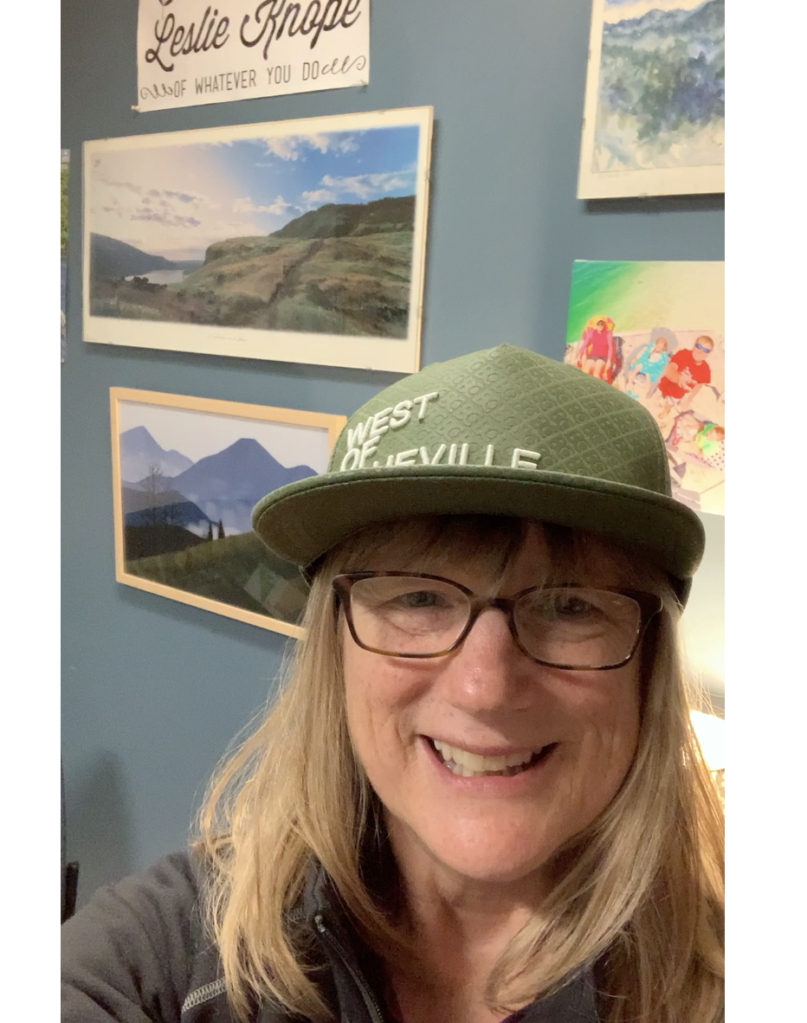
Debby Singleton, MA
Instructor, Parks & Recreation Management (undergraduate)

Rebekah Campbell, MS
Instructor, Parks & Recreation Management (undergraduate)

