**Submitting Your Professional Development Grant**

**Step 1:** Travel prior approval should be done in Chrome River using fund number provided by your department (this fund will not be used for travel reimbursement. If you are awarded a PDG grant a fund number will be provided). [Click Here to go to Chrome River (travel.wcu.edu)](http://travel.wcu.edu/)

**Step 2:** Once you have approval in Chrome River you will need to go in and print the PDF of the approval sheet and attach it with your PDG application.

In Chrome River, select your pre-approved submission.

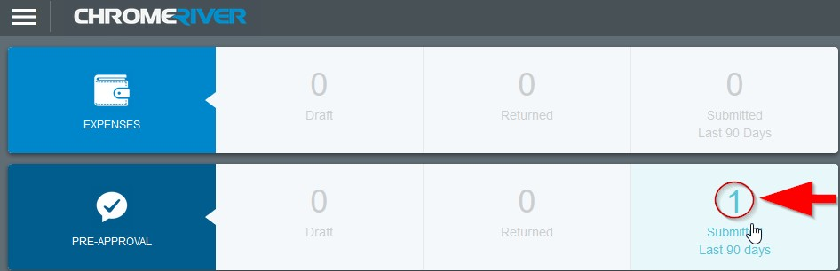

On the next screen, you will need to select the title of the submitted pre-approval.



You will now have the option to print a PDF. Please attach the PDF to your PDG application.



**Step 3:** Complete Application (page 2)

**Step 4:** Email Application with all supporting documents through the CFC webpage on the WCU website or by emailing [aparris@wcu.edu](mailto:aparris@wcu.edu)

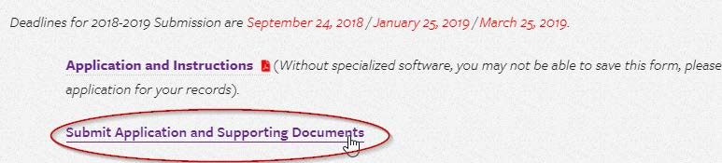

**All payment reimbursements must be processed by June 15, 2020. If not, the reimbursement will be funded out of the college’s fund. See** [**Controller’s Office**](https://www.wcu.edu/discover/campus-services-and-operations/controllers-office/for-faculty-and-staff/travel021218.aspx) **page for travel rules and guidelines.**

For Chrome River questions email Anita Hall [sahall@wcu.edu](mailto:sahall@wcu.edu)

For Travel reimbursement questions contact Carrie Hockman [cbhockman@wcu.edu](mailto:cbhockman@wcu.edu?subject=PDG%20Travel%20Reimbursement)

For all other questions, please email Annette Parris [aparris@wcu.edu](mailto:aparris@wcu.edu)

# 

# Professional Development Grant Proposal Cover Sheet

Western Carolina University Coulter Faculty Commons 172 Hunter Library

Cullowhee, NC 28723

Signature

Click or tap here to enter text.

Date

Applications that are eligible for the Chancellor’s Travel Fund are **not** eligible for a Professional Development Grant. Does this activity qualify for the Chancellor’s Travel FundYes No

*\*For example: If you are tenured or tenure track and are the sole presenter, you are likely eligible for the* [*Chancellors Travel Fund*](https://intranet.wcu.edu/academicaffairs/AA%20Faculty%20Support%20and%20Recognition/Forms/Title.aspx)*.*

Did you apply to present at this conference or event? Yes No

***Please fill out all form fields. Incomplete applications will not be considered.***

|  |  |
| --- | --- |
| Applicant’s Name | Click or tap here to enter text. |
| Department / Office # | Click or tap here to enter text. |
| Professional Development Grant Proposal Title | Click or tap here to enter text. |
| Name of Activity | Click or tap here to enter text. |
| Activity Site | Click or tap here to enter text. |
| Travel Dates | Click or tap here to enter text. |
| # of Professional Development Grants Received  in the past 2 years | Click or tap here to enter text. |
| Brief title of all Professional Development grants received in the past 2 years | Click or tap here to enter text. |

***Please complete the following questions*** *(250-word limit) Attach additional sheets if necessary.*

Please describe the proposed activity and explain how it would meaningfully contribute to the professional development of the applicant.

|  |
| --- |
| Click or tap here to enter text. |

How would the proposed activity strongly support program, department, and/or university mission?

|  |
| --- |
| Click or tap here to enter text. |

What is your status with WCU?

Tenured  Tenure Track  Non-Tenure Track

Adjunct  Emeritus  Phased Retirement

|  |  |  |  |  |
| --- | --- | --- | --- | --- |
| **Expense** | **$ Cost of Expense** | **Support Source** | **$ Amount of Support** |  |
| Total estimated cost (from Travel Preapproval Form) | Click or tap here to enter text. | Department | Click or tap here to enter text. |
|  | | College | Click or tap here to enter text. |
| Applicant | Click or tap here to enter text. |
| Other | Click or tap here to enter text. |
| **TOTAL Anticipated Expenses** | Click or tap here to enter text. | **Total**  **Support** | Click or tap here to enter text. | **Amount Requested**  Click or tap here to enter text. |

If this proposal cannot be fully funded from state resources, are you willing to pay the difference?

Yes  No

# *** PLEASE NOTE: IF funded, your name, title of grant proposal, and award will be published. ***