Available local resources. If you know of additional resources, please email us at servicelearning@wcu.edu.

***We strongly advocate for social distancing practices as a public service to your community. WCU is not endorsing or recommending engaging with service during this time. Please take the proper precautions as you consider this information.***

Primary source for WCU’s official COVID-19 updates (most current information): https://www.wcu.edu/coronavirus/index.aspx

Food and Supplies
- Jackson County’s Food Assistance Resource Guide (https://tinyurl.com/y78hvnoz) includes regularly-updated information about organizations that are offering groceries, food boxes, and meals.
- Community Table (https://communitytable.org/) To-go meals and food boxes may be picked up from 11am-5:30pm on Monday, Tuesday, Thursday, and Friday. Recipients should remain in their cars and follow the cones, and food will be brought to you.
- Fishes and Loaves (http://www.fishesandloavescashiers.org/) Distributes food boxes to Jackson County residents, every Monday & Thursday from 4:30-6:30 in Cashiers.
- Haywood County Transit, starting on Monday, March 30, will assist the Haywood County Corona Help Hotline, Mountain Projects, local churches, and several other civic groups in transporting groceries, prescriptions, and other essential goods. If you are in Haywood County & have needs, please call Haywood County Transit at 828.565.0362
- HomeBase (https://www.facebook.com/HOMEBASECM/) The HomeBase building is currently closed, but food, clothing, and hygiene supplies are available by calling or texting Jim Dean at 828.508.0035 or Melanie Vick at 828.565.2019.
- Jackson County Public Schools (https://tinyurl.com/tqlcdn2) JCPS will provide free meals for anyone age 1-18 during the extended school closure. If you do not have sufficient food & did not complete the meal delivery request form, call Ashley Taylor at 828.575.1403.
- MANNA FoodBank (https://www.mannafoodbank.org/where-to-get-help/) Food is available at pantries across the WNC area. In light of the daily changes due to COVID-19, for current information about free food distribution, call the MANNA Food Helpline at 800.820.1109.
- United Christian Ministries (https://www.ucmhelp.com/) has a food pantry and can also provide assistance on a case-by-case basis for other emergency needs. They are open 10am-3pm Mon, Thurs, Fri; 12:30-5pm on Tues; and 10am-12:30pm on Wed.
- WCU Dean of Students Emergency Fund (https://tinyurl.com/qqtag9a) WCU students in good standing may request emergency assistance (only available to WCU students).

Mental Health Support
- Alcoholics Anonymous: you can find a list of online meetings and forums here: http://aa-intergroup.org/directory.php
- Survive and Thrive Home Wellness Retreat (https://tinyurl.com/vxgbw5v) from WCU & Catamount School professor Nicole Kaysing
- Ten Percent Happier Coronavirus Sanity Guide (https://www.tenpercent.com/coronavirussanityguide) with meditations, podcasts, blog posts, etc.:
- WCU Counseling and Psychological Services is asking students to call 828.227.7469 to make an appointment rather than drop in. They also have tips to manage stress about the Coronavirus here:
https://www.wcu.edu/experience/health-and-wellness/caps/ (only available to WCU students)

Donations & Volunteers Needed
- Fishes and Loaves (http://www.fishesandloavescashiers.org/) Distributes food boxes to Jackson County residents, every Monday & Thursday in Cashiers. Volunteers are needed from 4:00-6:30pm, and can sign up by calling Larry Morris at 828.743.4931.
- HomeBase (to donate items, please call or text Jim Dean at 828.508.0035 to schedule a drop off time)
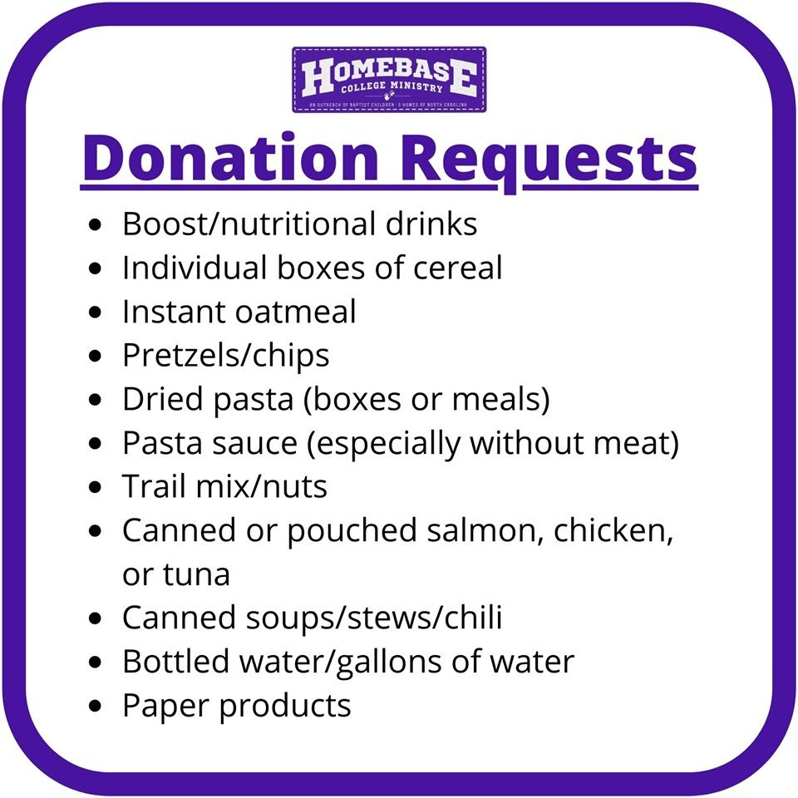
- Jackson County Department on Aging is collecting items for “safety bags” that will be distributed to homebound seniors in need. Needed items include Kleenex, toilet paper, paper towels, disinfectant spray or wipes, soap, pop top canned goods, crackers, peanut butter, canned meat, and crossword puzzles. Items can be dropped off Monday-Friday, 8am-5pm at the front entrance of the Department on Aging at 100 County Services Park, Sylva.
- Jackson County Public Schools (https://tinyurl.com/tqlcdn2) Community volunteers are needed. Anyone interested can sign up at www.jcpsnc.org/food. “We will plug in any volunteer where they are needed,” said Cabe. “We’re going to need people to deliver meals and possibly even prepare them depending on our own staff and who is able to work. We’re always requesting volunteers.”
If you would like more information about this topic, call Laura Cabe at (828) 586-2311 ext. 1936 or email lcabe@jcpsmail.org.
- MANNA FoodBank has waived their volunteer orientation requirements and are asking for people who are healthy and considered low risk for serious illness from COVID-19 to volunteer. Our community needs heightened support through this challenging time. We will be focusing on making Meal Boxes to hand out at distributions and packaging bulk food. If you or anyone you know is at low risk for COVID-19 and would like to volunteer please follow this link to sign up for volunteer shifts http://cerv.is/m?0330rCOVID19. It is important that volunteers arrive 5 minutes before the beginning of the volunteer shift. For these shifts new volunteers do not need to attend an orientation prior to their volunteer service.
- The Red Cross is asking for healthy people to donate blood. You can find dates and locations to give at redcrossblood.org.
- Thank Yous for Heroes (https://tinyurl.com/ty5jv36) If you would like to share a "thank you" with teachers, medical professionals, first responders, & other essential workers, you can do that here.

Updated 4/23/20

