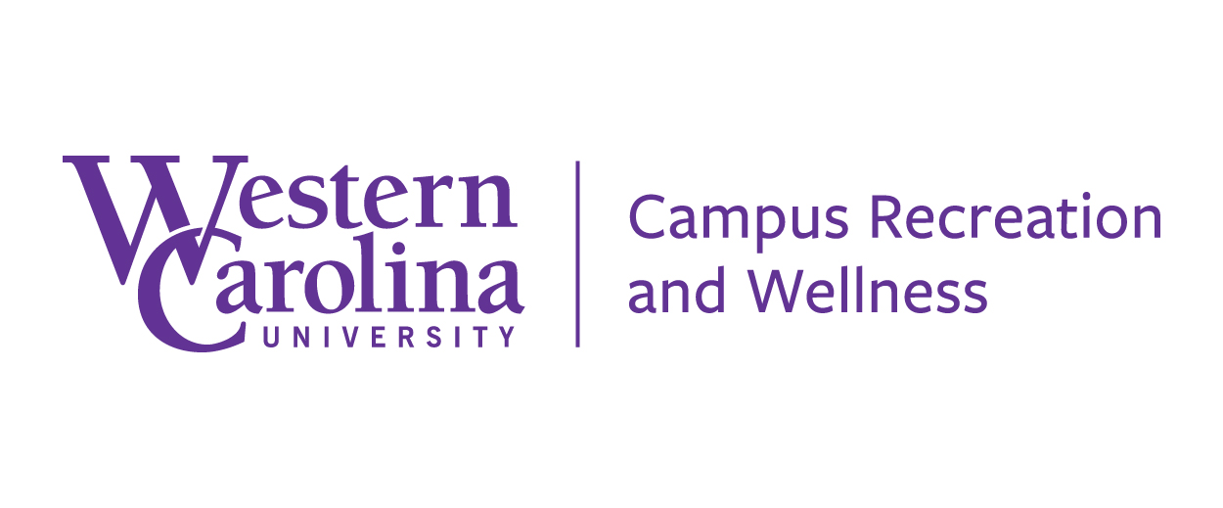

Club Sports

End of Year Report

Club Sport: ________________________________ Your Name: ___________

Please type in questions and hand in the printed sheet by May 1st.

- What were the high points of the 20-21 year for the club?

- How well did your club adjust to the COVID guidelines and restrictions this year?

- What is one aspect of your club that needs major improvement?

- Name 3 things your incoming officers should know before next Fall.

- Describe the culture within your club and its members. How well did the club retain its members?

- Describe any fundraiser, community service projects, or other extracurricular club activities you did with you members.

- What topics would you like to see covered during Club Officer Leadership Training? (ex: leadership, conflict resolution, financing, group dynamics, etc.)

- How can the CRW Club Sports Administration improve the club sport experience?

- Write in your requested practice schedule below for the Fall 21 semester. List exact times and locations you’re requesting.

Sunday | Monday | Tuesday | Wednesday | Thursday | Friday | Saturday

