Parks & Recreation Management
Course Descriptions
Western Carolina University

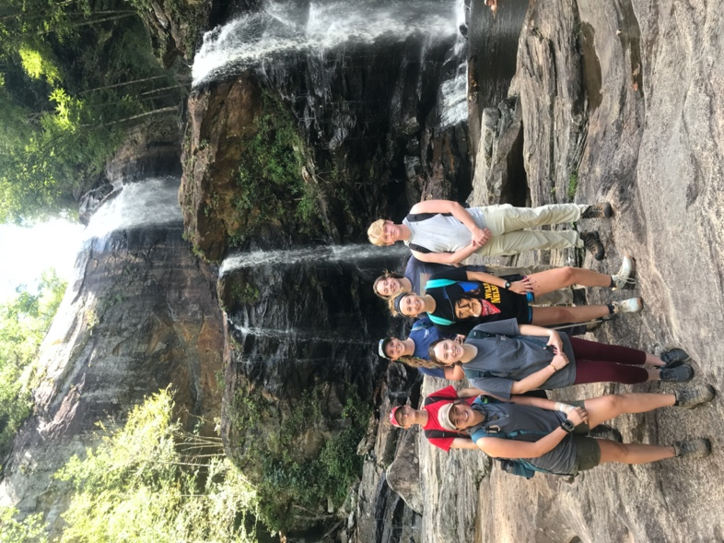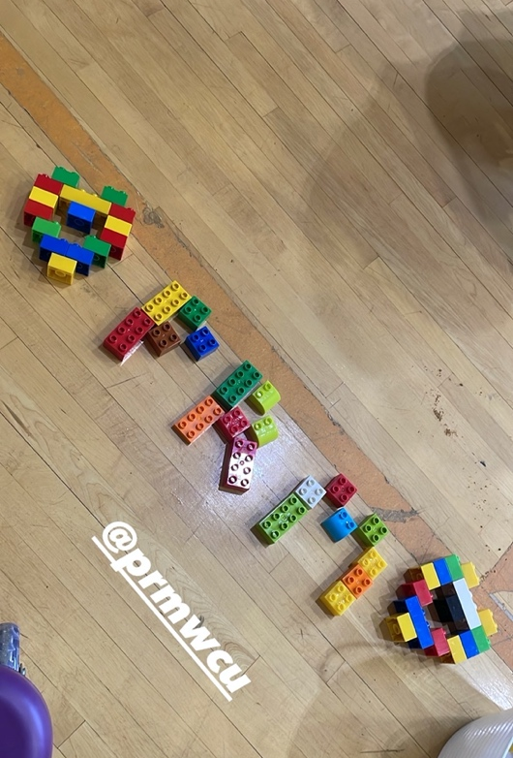
February 2023 Edition

Parks & Recreation Management Course Descriptions
CORE COURSES (Required for the major)

• PRM 250 - Foundations of Parks and Recreation Management
Concepts, philosophical orientations, and aspects of recreation, play, and leisure; the organization of leisure and recreation as a service and profession. Offered every semester.
Credits 3

• PRM 252 - Wilderness First Aid (Either Proof of certification or one of three First Aid options)
This course focuses on developing first aid skills to respond quickly to a sick or injured person until more advanced care is available. Students will earn a certificate in Wilderness First Aid (WFA) from the American Red Cross. Lecture & Lab. Offered every semester. (WFA options also available through outside agencies like Landmark Learning).
Credits 2

• PRM 254 - Introduction to Outdoor Pursuits Education
Instructional techniques for outdoor pursuits. Backcountry characteristics are reviewed in terms of hazards, use ethics, and safety. Activities vary depending upon instructor and semester. Lecture & Lab. Offered every semester.
Credits 4

• PRM 270 - Leadership and Group Dynamics in Recreation
Emphasis will be on appropriate theories and techniques for specific clientele and the different populations that are encountered as a recreation professional. Introduction to leading and facilitating groups. Offered every semeseter.
Credits 3

• PRM 275 - Diversity and Inclusion in PRM
This course seeks to foster diversity and inclusion in parks and recreation management by assisting students in gaining the awareness, understanding, knowledge, and abilities in working with those of a different ability, socio-economic status, gender, and race. Students will gain this understanding, knowledge, and ability through experiential class sessions, guest speakers, collaborative presentations and projects, and field visits. Offered every semester.
Credits 3

• PRM 357 - Wilderness First Responder (Either Proof of certification or one of three First Aid options)
This course trains participants to respond to emergencies in remote settings. The 80-hour curriculum includes standards for urban and extended care situations. Special topics include but are not limited to: wound management and infection, realigning fractures and dislocations, improvised splinting techniques, patient monitoring and long-term management problems, plus advice on drug therapies. Adult/Child Cardiopulmonary Resuscitation (CPR) with Automated External Defibrillation (AED) is included in this course. Students earn a certification in Wilderness First Responder (WFR). Course offered by Landmark Learning during fall or spring breaks or during the summer session.
Credits 4

• PRM 361 - Program Planning and Evaluation in PRM
Designed to equip students with a variety of program planning methodologies, including proposal and grant writing. Evaluative research methods are also included. Lecture & Lab.
Prerequisites PRM 250. *Background check required. *Offered Fall Only.
Credits 4

• PRM 362: Sustainable Recreation & Public Land Management
How do we balance both human and environmental needs when managing our (USA) public lands? This course explores the foundational philosophies of environmental sustainability, recreation, and land management. We examine the complexity of land management decisions, exploring impacts of public land use and designations on both natural resources and diverse human and non-human stakeholders. The course provides exposure to a variety of career paths in land management and recreation agencies and organizations.

• PRM 370 - Professional Planning in PRM
Orientation to the capstone internship selection process and requirements; preparation of resume, cover letter, outdoor activity log, Linked In profile, Capstone Portfolio, JobCat application. Spring semester only.
Credits 3

• PRM 383 - Mini-Internship I in PRM
• PRM 384 - Mini-Internship II in PRM
• PRM 385 - Mini-Internship III in PRM

The 3 mini-internships (50 hours each) provide students with exposure to various areas of professional practice within PRM and helps prepare students for their capstone internship. Students are required to complete three mini-internships of 50 hours each (PRM 383, 384, 385). S/U grading. Offered every semester and summer. Students may take up to 2 mini-internships within a semester or summer. *Background check required.
Credits 1

• PRM 430 - Entrepreneurship and Commercial Recreation
Analysis of types of commercial and private recreation enterprises, probable trends and directions, requirements and procedures for planning and organizing commercial recreation services.
Prerequisites PRM 361 or Permission of Instructor. Offered FALL semester only.
Credits 3

• PRM 461 - Management and Administration of PRM Services
Management, organization, and supervision in recreation and leisure service administration. Includes entre/intrapreneurship, planning processes, marketing, fiscal strategies, human services, evaluation, and research. Prerequisites PRM 361 or permission of instructor. Offered SPRING semester only.
Credits 3

• PRM 483 - Capstone Internship in PRM I (take with PRM 484)
The capstone internship in Parks and Recreation Management (PRM) is a culminating professional experience that allows students to connect theory and practice. Students select an agency and position that represents their focus area of study in PRM. Students are able to build a professional network, focus their aptitude for certain types of work and develop transferable skills that can be applied to a new or existing job. Minimum 200 contact hours. PRM 483 is usually taken in conjunction with PRM 484 Capstone Internship II to complete the required, 400-hour internship. Offered SUMMER. Completed after LAST spring semester only. Prerequisites PRM 370.
Credits 3

• PRM 484 - Capstone Internship in PRM II (take with PRM 483)
The capstone internship in Parks and Recreation Management (PRM) is a culminating professional experience that allows students to connect theory and practice. Students select an agency and position that represents their focus area of study in PRM. Students are able to build a professional network, focus their aptitude for certain types of work and develop transferable skills that can be applied to a new or existing job. Minimum 200 contact hours. PRM 484 is usually taken in conjunction with PRM 483 Capstone Internship in PRM I to complete the required, 400-hour internship. Offered SUMMER. Completed after LAST spring semester only. Prerequisites PRM 370.
Credits 3

• PRM 495 - Senior Seminar in Parks and Recreation Management
This class is the designated capstone senior seminar course for students majoring in Parks & Recreation Management. The course will focus on contemporary trends and issues facing parks and recreation professionals and related career preparation. Students will demonstrate the ability to effectively use scholarly resources to develop a research paper and presentation on a current trend/issue in the profession, culminating in a student-designed and facilitated research conference. Offered every semester.
Prerequisites PRM 361.
Credits 3

Parks & Recreation Management ELECTIVES
Students can select from a variety of PRM and non-PRM courses to fulfill elective requirements.

• PRM 200 - Introduction to Rock Climbing
This course is designed to introduce and familiarize both novice and intermediate students to the activity of rock climbing – including philosophy, safety, knots, belay techniques, site and equipment selection, and nature/conservation issues. We will utilize a progression from classroom learning to gym climbing at the CRC, to outdoor climbing at local areas in Western North Carolina. Furthermore, students in this course will learn techniques associated with rock climbing, gain knowledge of knots and gear (hardware and soft goods), and learn and demonstrate proper risk management associated with roped climbing. This class is designed with the beginner in mind and no prior experience is necessary. *All climbing will be top rope facilitation. Being comfortable with heights, practicing safe techniques, and physical exertion are necessary, as is participation in all activities to receive a passing grade in this course. *Requires weekend field trips as designated by the instructor.
Credits 2

• PRM 224 - Survey of Outdoor Adventure Activities
Introduction to various outdoor adventure activities (e.g., hiking, backpacking, overnight camping, cycling, stand up paddling, nature rx, and canoeing) focused on introductory skills necessary to engage in outdoor adventure activities and avoidance of survival situations. Various field trips to local natural resources allow students to become oriented to some of the nearby natural resources and learn various outdoor adventure pursuits. *Field trips may be on weekends during the semester. Often offered in summer sessions.
Credits 2-4

• PRM 255 - Active Recreation and Leisure
Active Recreation & Leisure will offer an exploration of active leisure pursuits and the connection between parks, recreation, physical activity, wellness, and public health. The course will prepare future professionals to lead, supervise, or program active leisure pursuits in a recreation setting. Learning opportunities will be experiential, engaging, cooperative, participatory, and applicable to the active recreation, leisure, and community health fields. Activities vary depending upon semester.
Credits 3

PRM 293 - Topics in Parks and Recreation Management
This is a special topics, 200 level course that can be used to introduce/pilot new classes in the PRM curriculum. Credits 1-3

• PRM 300 - Intermediate/Advanced Rock Climbing
This course will cover top rope site management techniques and will include site evaluation, evaluation of climbing hazard and risk, and minimum impact techniques. Introduction of anchors and rescues specific to top roping and rappelling will be covered. The student will develop a solid understanding of anchoring, belaying, rappelling, and basic partner rescues, as well knowledge related to the safety and management of top rope sites. (Please note that this is not a certification course). *Requires weekend field trips as designated by the instructor.
Prerequisites 200 or permission of instructor.
Credits 3

• PRM 310 - Stand Up Paddling
Introduction, practice, and successful execution of the skills needed to enjoy stand up paddle boarding. The course includes content information delivered through active participation, online learning modules, and small group discussions; on and off the water. Water venues for this course will include a variety of lakes and rivers in Western North Carolina. Water venues will be dependent upon weather factors, water levels, time constraints, student interest and fitness levels. Offered either various semesters and summer depending upon instructor availability.
Credits 3

• PRM 313 - Camp Counseling
This course is designed to prepare students for positions as camp counselors and provides the foundations for further preparation toward camp administration. Offered based on instructor availability.
Credits 3

• PRM 314 - Organization and Administration of Camping Agencies
The nature of camping; trends; elements of camp design and management. Offered infrequently.
Credits 3

• PRM 320 – Facilitating Environmental Education Experiences
Through readings, site visits, practice and discussion, students will learn about the theoretical and historical background of the field of environmental education. Students will gain practical experience developing and facilitating environmental education programs. Throughout this course, students will also gain knowledge of a variety of careers within the environmental education field. Additionally, students will gain hours towards the NC Environmental Education Certification (www.eenorthcarolina.org) as a part of the course work.
Credits 3

• PRM 321 – Introduction to Environmental Interpretation
Theory and principles of interpretation and environmental education as an interdisciplinary approach to learning in an outdoor setting. *May require multi-day field trip, weekend field trip, and projects with local schools. *Background check required.
Credits 3

• PRM 322 - International Adventure Travel & Global Citizenship
While “global citizenship” is a term that is utilized in a variety of contexts, its meaning is rarely defined. In this course, students will explore what it means to be a citizen, what it means to be a global citizen, and where international adventure travel comes into play in regard to “global citizenship.” In particular, students will explore ethical dilemmas in international adventure travel and will learn how to research and identify both positive and negative environmental, socio-cultural and economic impacts of tourism on the destination (various cultures). Students will explore such topics as technology and adventure travel, the commercialization of adventure travel, environmental impacts of adventure travel, social/cultural impacts of adventure travel. Students will explore world cultures and learn how to travel as a global citizen in order to lessen impacts and work toward justice in their travel experiences. (Liberal Studies P6, ULP). Offered ONLINE, most semesters and summer.
Credits 3

• PRM 330 - Aquatic Recreation Management
Organization, programming, facility design, and maintenance in various aquatic recreational environments. Course may lead to Certified Pool Operator certification. This course is cross-listed with SM 330. *Offered very infrequently.
Credits 3

• PRM 333 - Experiential Education Methods
This lecture/lab course is based upon experiential education theories and application of those theories to instruction techniques in diverse settings. Lecture & Lab. *Dependent upon instructor availability.
Credits 4

• PRM 340 - Challenge Course Facilitation
Behavior change, instruction, and personal growth taught in a challenge course setting. Includes operation of a ropes course, facilitation of activities, course technology and safety.
Credits 3

• PRM 341 - Group Facilitation Techniques
This course is for individuals who want to use adventure activities in settings where personal growth through small group intervention is the goal. *Background check required.
Credits 3

• PRM 351 – Wilderness Therapy
Wilderness Therapy is a behavioral healthcare field that is focused on facilitating outdoor experiences for therapeutic purposes. In this course, we explore the history of wilderness therapy, popular wilderness therapy theories and techniques, and address the question: what are the benefits, and even drawbacks, to doing therapy outside? In addition to hard-skills and conceptual knowledge, we will explore-through-experience a few therapeutic invitations that field staff may facilitate in wilderness therapy programs. Upon completion, students should be able to describe the process and the anticipated outcomes of wilderness therapy.
Credits 3

• PRM 352 - Beginner/Intermediate Whitewater Kayaking
This course is designed to give the student confidence and skill in whitewater and flat water kayaking and to provide an environment where students enjoy paddling and gain an appreciation and respect for a whitewater environment. Strong swimming ability is required for participation. Often offered in summer sessions. Requires off campus travel.
Credits 3

• PRM 353 - Beginning/Intermediate Whitewater Canoeing
This course focuses on the technical skills, risk management, ethics, communication, cooperation necessary to maneuver tandem and solo canoes in both flat and Class I/II whitewater. This course also seeks to encourage the philosophy that safety and success in tandem and solo flat and whitewater canoeing require more than the requisite technical skills for those paddling styles. Therefore, students will be encouraged to view those paddling styles as an interaction with others, which necessitates the employment of certain traits and ethics in addition to the technical skills previously mentioned. No certification is offered. Swimming skills are required. Often offered in summer sessions. Requires off campus travel.
Credits 3

• PRM 354 - Outdoor Living and Expedition Skills
This course provides students with the information and skills necessary to be safe, comfortable, and environmentally sound while traveling and living in an outdoor environment. Emphasis is on foundational skills including route finding, injury prevention, minimum impact camping, expedition planning and organization, shelter construction and backcountry cooking. This course is intended to be a basic outdoor living and expedition skill course for those intending to lead others in a wilderness setting. This course will not make you an accomplished outdoor leader, but hopefully will give you helpful experience and information to build upon. You do not need previous outdoor experience to take this course. Course includes a required 4- day backpacking trip. Prerequisites 254 or permission of instructor.
Credits 3

• PRM 360 - Recreation Research
An analysis of the principle methods of recreation research, the application of descriptive and inferential statistics to recreation research, and the development of a research proposal. *Offered very infrequently
Credits 3

• PRM 365: Nature Rx
Nature RX is geared towards students who want to explore the connection between Nature, Physical Activity, and Wellness. The focus will be on easy, accessible adventures surrounding Cullowhee and the importance of time in nature. During the semester we will focus on how our senses are affected/influenced by time in nature. Most learning modules will include “labs” to explore the science behind the research, other classes will involve discussion, outside nature-based activities, films, and guest speakers. The class has a definite spin towards the mind-body connection of nature with a focus on overall wellness and stress management. (Liberal Studies P4, ULP)
Credits: 3

• PRM 425 – Advanced Climbing & Rescue Techniques
Advanced climbing instruction and rescue techniques for many potential environments including rock, snow, and ice. The course includes institutional techniques used by different association/agencies and adaptations for diverse populations. Strong climbing ability is required. Prerequisites PRM 200 or permission of instructor. *Currently offered very infrequently.
Credits 4

• PRM 426 – Advanced Paddling & Rescue Techniques
Water-based outdoor instruction in canoeing, kayaking, rafting, and rescue techniques; includes institutional teaching techniques used by different agencies (e.g. American Canoe Association and Rescue 3 International). Strong swimming ability required. *Currently offered very infrequently.
Prerequisites PRM 352, or PRM 353, or permission of instructor.
Credits 4

• PRM 427 - Wilderness Education
An expedition style course, leader decision-making is taught through backpacking, mountaineering, and canoeing. National certification is possible through the Wilderness Education Association. Eight or sixteen day expedition. Location varies each year. Listed as a “travel” course.
Credits 3-6

• PRM 433 - Outdoor Recreation & Public Land Management
This course is designed to provide an overview of wildland recreation management history, principles, practices, and contemporary issues. Public land management will also be a focal point through examination of the major public land management agencies in the United States.
Credits 3

• PRM 434 - High Adventure Travel and Outfitting
Practical experience in creation, planning, logistics, execution, and evaluation of adventure travel. Overview of history, development, organization, impacts and trends.
Credits 3

• PRM 435 - Park and Recreation Sites, Facilities, and Programs
Planned tour to study specific types of parks and recreation sites, facilities, and/or programs related to current issues and practices. Generally listed as a “travel” course. Utah winter break ski/snowboard course is one example.
Credits 1-6

• PRM 454 - Expedition Management and Leadership
A wilderness leadership course which offers instruction in expedition leadership and management skills such as judgment and decision-making, group management, route and ration planning, land navigation, teaching and facilitation techniques, and risk management. Emphasis is on professional outdoor leadership development. Course includes a required expedition. The expedition will involve living, traveling and developing skills in a remote wilderness setting. Lecture & Lab. *Offered bi-yearly, SPRING semester.
Prerequisites PRM 254 or permission of instructor.
Credits 4

• PRM 480 - Independent Study
Independent Study to explore or research a topic of special interest to the student. Prerequisites Permission of program coordinator. Offered each semester and summer.
Credits 3

• PRM 486 - Field Experience
Field experience in cooperation with existing programs such as North Carolina Outward Bound School, NOLS, Landmark Learning, and Nantahala Outdoor Center, etc. 1-12 Lab.
Prerequisites Permission of instructor. Offered each semester and summer.
Credits 1-12

• PRM 493 - Topics in Parks and Recreation Management
This is a special topics, 400 level course that can be used to introduce/pilot new classes in the PRM curriculum.
Credits 1-3

•

PRM Curriculum

I. Liberal Studies 42 hours
II. PRM Major Requirements 41-45 hours
*All courses are offered each semester unless otherwise noted.

First Aid Requirement, provide either proof of certification at the WFA, WFR or EMT level, or choose one of the following:
PRM-252 (2) Wilderness First Aid or
PRM 357 (4) Wilderness First Responder (Landmark or SCC) or
HEAL 250 (2) First Aid and Safety Ed.
PRM 356 (4) Outdoor First Aid

PRM-250 (3) Foundations of Parks and Recreation
PRM-254 (4) Introduction to Outdoor Pursuits
PRM-270 (3) Leadership and Group Dynamics
PRM 275 (3) Diversity & Inclusion in PRM

PRM-361 (4) Program Planning and Evaluation (pre-requisite PRM 250)
PRM 362 (3) Sustainable Recreation & Public Land Management
PRM-383 (1) Mini-Internship I in PRM
PRM 384 (1) Mini-Internship II in PRM
PRM 385 (1) Mini-Internship III in PRM
**Mini-Internships may not exceed 2 per semester/summer.

PRM-430 (3) Entrepreneurship and Commercial Recreation (Fall) (pre-requisite PRM 361 or permission of instructor)
PRM-461 (3) Management and Administration of PRM (Spring) (pre-requisite PRM 250 & 361 or permission of instructor)

PRM-370 (3) Professional Planning in PRM (Spring)
PRM 483 (3) Capstone Internship in PRM I (pre-requisite PRM 370)
PRM 484 (3) Capstone Internship in PRM II (pre-requisite PRM 370)
**PRM 483/484 Capstone Internship taken during SUMMER after LAST spring semester.

PRM-495 (3) Senior Seminar in PRM (pre-requisite PRM 361)

III. Electives: 33-37 hours
*These can be from any program at WCU or a minor with another program/major.
*Overall total credits should be at least 120 hours with a GPA of at least 2.5

Total credits required to graduate 120 hours

PRM Electives
Please note that some courses are only offered certain semesters and years.
Courses denoted with * are currently not offered yet may be in the future.

_____ PRM 200: Introduction to Rock Climbing (2)
_____ PRM 224: Survey of Outdoor Adventure Activities (2-4)
_____ PRM 255: Active Recreation and Leisure (3)
_____ PRM 293: Topics in Parks & Recreation Management (1-3)
_____ PRM 300: Intermediate/Advanced Rock Climbing (2)
_____ PRM 310: Stand Up Paddling (3)
_____ PRM 313: Camp Counseling (3)
_____ PRM 314: Organization and Administration of Camping Agencies (3)*
_____ PRM 320: Facilitating Environmental Education Experiences (3)
_____ PRM 321: Introduction to Environmental Interpretation (3)
_____ PRM 322: International Adventure Travel & Global Citizenship (3) LS P6 ULP (online)
_____ PRM 330: Aquatic Recreation Management (3)*
_____ PRM 333: Experiential Education Methods (4)*
_____ PRM 340: Challenge Course Facilitation (3)*
_____ PRM 341: Group Facilitation Techniques (3)
_____ PRM 351: Wilderness Therapy (3)
_____ PRM 352: Beginner/Intermediate WW Kayaking (3)
_____ PRM 353: Beginner/Intermediate WW Canoeing (3)
_____ PRM 354: Outdoor Living and Expedition Skills (3)
_____ PRM 360: Recreation Research (3)*
______PRM 365: Nature Rx (3) LS P4 ULP
_____ PRM 425: Advanced Climbing & Rescue Techniques (4)
_____ PRM 426: Advanced Paddling & Rescue Techniques (4)
_____ PRM 427: Wilderness Education (3-6) (Summer)
_____ PRM 433: Outdoor Recreation & Public Land Management (3)
_____ PRM 434: High Adventure Travel and Outfitting (3)
_____ PRM 435: Park and Recreation Sites, Facilities, and Programs (1-6)
_____ PRM 454: Expedition Management and Leadership (4)
_____ PRM 485: Internship in Parks and Recreation Management (3)
_____ PRM 486: Field Experience (1-12)
_____ PRM 493: Topics Parks and Recreation Management (3)

