Celebration of the 100th Anniversary of the 19th Amendment

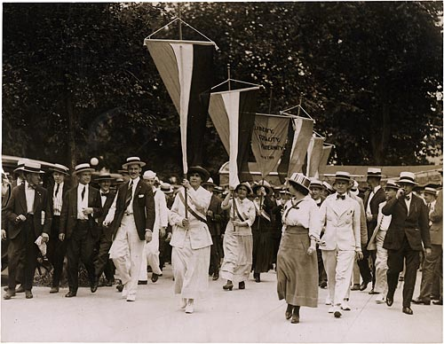
- Reference: https://www.ourdocuments.gov/doc_large_image.php?flash=false&doc=63
Short Intro Paragraph
The year 2020 marks the centennial anniversary of the 19th Amendment’s ratification, which enshrined women’s right to vote in the U.S. Constitution. During that time, women across the country and even in Western North Carolina were taking action for equal voting rights. While the 19th Amendment was a dramatic step forward in the fight for equality in America, its ratification did not come without sacrifice, dedication, and an uncompromising demand for justice. It is important to note that the 19th Amendment was not inclusive for all women, especially women of color, however it was a small step on a long path towards creating a more equitable voting process for all. With the ratification of the 19th Amendment and the passage of the Equal Voting rights act providing all women with the right to vote, women have been consistently outperforming men at the polls since the 1980s. The PPI, with help from the Mountain Heritage Center will explore the Suffrage Movement as well as the strides the United States has made for equity in voting practices.
Historical Roots of the Broader Suffrage Movement
The Suffrage Movement started before the Civil War with the organization of temperance, religious, and abolition groups, but it wasn’t until after the Civil War and the passing of the 14th and 15th Amendments to the U.S. Constitution that women began a serious campaign for voting rights believing that they should be autonomous from their fathers and husbands. Organizations formed like the National Woman's Suffrage Association, which fought for universal suffrage at the national level, and the American Woman Suffrage Association, which promoted suffrage through the actions of states, providing women a way to organize and campaign for their desire to obtain suffrage. Not to be left behind, North Carolina also had its share of suffrage organizations with the North Carolina Equal Suffrage Association being established in Asheville, NC, in 1894. Some legislators were concerned that women having the right to vote would disrupt accepted gender roles, and that it would provide black Americans equal rights. To combat those fears, women made the argument that they should vote because they are different from men, and enfranchising women could help strengthen white supremacy by canceling out any votes cast by black males. Overall, legislators weren’t convinced in all states that suffrage was a good idea, so the states’ rights approach was not successful, leaving no other option than federal action. On August 18th, 1920 the 19th Amendment to the United States Constitution was officially ratified, and for the first time that following November, select women were able to vote for the first time.

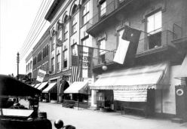
- Picture of the NCESA’s headquarters in Asheville, NC.
- Reference: https://www.ncpedia.org/north-carolina-equal-suffrage-assoc
Stats
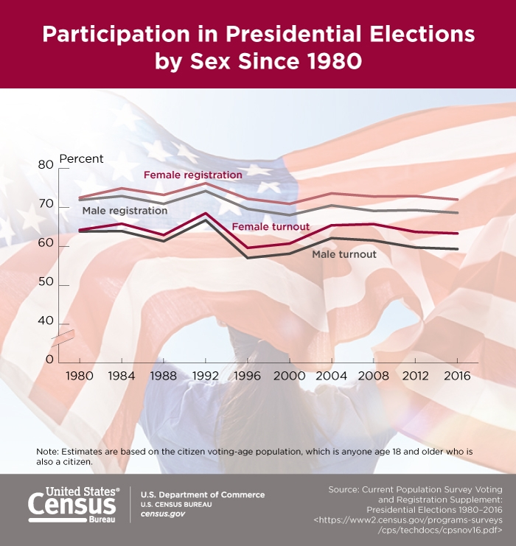
Since the ratification of the 19th Amendment and the passage of the Equal Voting Rights Act of 1965, women have been a powerful force within the voting population, and the statistics below show just how influential women are in the election process.

Pic Link from Bureau: (https://www.census.gov/library/visualizations/2020/comm/participation-president-election.html)
- As the graphic above illustrates, since 1980, women have been outperforming their men in both registering to vote and turning out to the polls on Election Day.
- In the most recent 2018 midterm election, 55% of women voted, while only 52% of men voted.
- Despite not ratifying the 19th Amendment until 1971, North Carolina received its first woman legislator on January 5th, 1921, in the form of Lillian Exum Clement, who represented Buncombe County on the Democratic ticket. As of 2019, 25.3% of the North Carolina General Assembly is composed of women, despite women making up 51.4% of the state’s population.
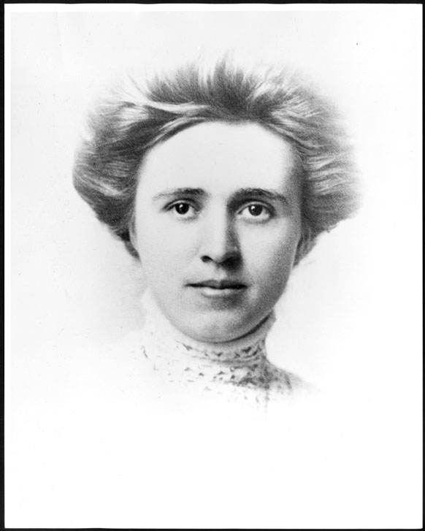
- Picture of NC’s first female legislator, Lillian Exum Clement
- Reference: https://mountainx.com/news/community-news/first_female_legislators_asheville_home_protected/
- At the federal level, as of 2020, the U.S. House of Representatives has 101 women (23.2%) and the U.S. Senate has 26 women (26%), while in the Executive Branch, as of this writing, no women have served as president or vice president of the United States.
- At Western Carolina University, where engaging in the democratic process is something heavily impressed upon the student body, female students outperformed their male counterparts in getting out to vote in 2012 and 2016, representing 59.5% and 59.1% of the student body vote, respectively.
- Despite young voters, generally speaking, not voting in the same proportions as their older peers, in 2018, the gender gap turnout was more apparent among younger voters than older ones, with male 18-24 year olds being outvoted by their female counterparts by a 5.8% margin, compared to those 65 and older (3.2%).
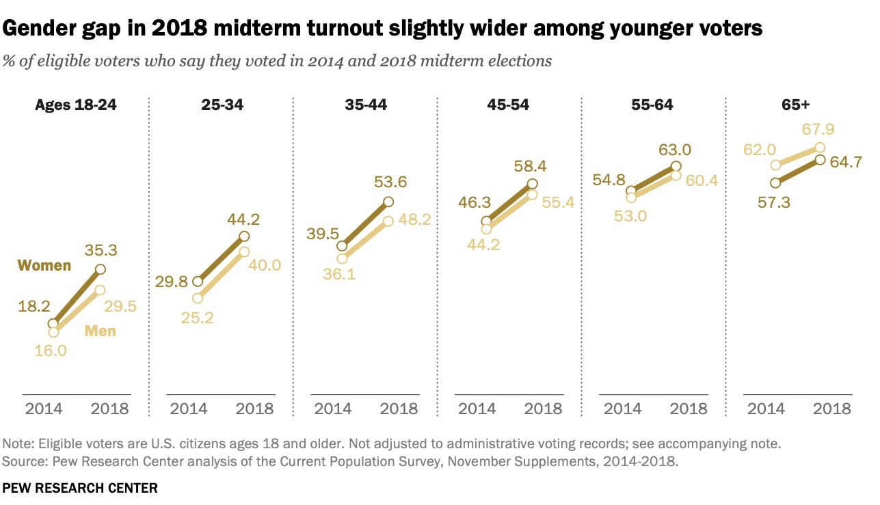
- Reference: https://www.pewresearch.org/fact-tank/2019/05/03/in-year-of-record-midterm-turnout-women-continued-to-vote-at-higher-rates-than-men/
The Public Policy Institute at WCU celebrates the work that went into securing women the right to vote in the 1920s, as well as the continued fight afterwards to ensure that all citizens in the United States had equal opportunity at the poles. Without the sacrifices and hardships these courageous women endured, we wouldn’t have female representation in our governmental systems, and the absence of their perspective and input within our democratic processes would doubtlessly have furthered inequities in this country. Given how women continue to be largely underrepresented in our governmental systems, much work remains to be done to ensure that 100 years from this centennial, women of all backgrounds and walks of life will have a truly equal voice in the political, social, and economic realms of this country, which will work to ensure a more just and equitable society.
If you would like to know more about the Suffrage Movement and how the passage of the 19th Amendment was influenced by women in Western North Carolina, be sure to stop by the Mountain Heritage Center (MHC) beginning September 14th to see their exhibit. The MHC will be open Monday through Friday, from 10 AM to 4 PM EST. Due to Covid-19 concerns, gallery capacity will be limited to 10 walk-in visitors at a time, however, advance reservations are not necessary. Admission to the MHC’s exhibits are open to the public and free of charge. For more information, call (828) 227-7129 or email lstiles@gmail.com.
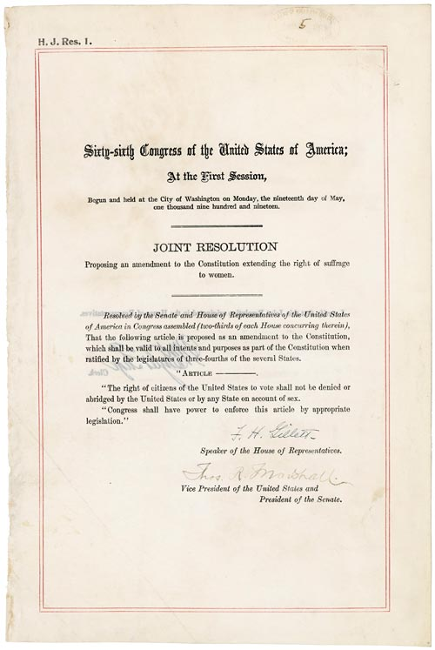
- Reference: https://www.ourdocuments.gov/doc_large_image.php?flash=false&doc=63

US Census Bureau, “Participation in Presidential Elections by Sex Since 1980,” The United States Census Bureau, accessed September 13, 2020, https://www.census.gov/library/visualizations/2020/comm/participation-president-election.html.
“Women’s Suffrage - The U.S. Movement, Leaders & Amendment,” History, accessed September 13, 2020, https://www.history.com/topics/womens-history/the-fight-for-womens-suffrage.
Tom Belton, “North Carolina Equal Suffrage Association,” NCPedia, 2006, https://www.ncpedia.org/north-carolina-equal-suffrage-assoc.
“Women’s Suffrage - The U.S. Movement, Leaders & Amendment.”
US Census Bureau, “Participation in Presidential Elections by Sex Since 1980.”
US Census Bureau, “Behind the 2018 U.S. Midterm Election Turnout,” The United States Census Bureau, accessed September 13, 2020, https://www.census.gov/library/stories/2019/04/behind-2018-united-states-midterm-election-turnout.html.
Kellie Slappey, “Lillian Exum Clement (1894-1925),” North Carolina History Project, accessed September 12, 2020, https://northcarolinahistory.org/encyclopedia/lillian-exum-clement-1894-1925/.
“Women in State Legislatures for 2019,” National Conference of State Legislatures, July 25, 2019, https://www.ncsl.org/legislators-staff/legislators/womens-legislative-network/women-in-state-legislatures-for-2019.aspx
US Census Bureau, “QuickFacts: North Carolina,” accessed September 12, 2020, https://www.census.gov/quickfacts/NC
“Women in the U.S. Congress 2020,” Rutgers University Center for American Women and Politics, June 12, 2015, https://cawp.rutgers.edu/women-us-congress-2020.
“A Special Report on Student Voting Habits from 2012 to 2016 Presidential Elections,” Western Carolina University Center for Service Learning, Accessed September 12, 2020, https://www.wcu.edu/WebFiles/PDFs/WCU_Student_Voting2017.pdf
Hannah Hartig, “In Year of Record Midterm Turnout, Women Continued to Vote at Higher Rates than Men,” Pew Research Center, May 3, 2019, https://www.pewresearch.org/fact-tank/2019/05/03/in-year-of-record-midterm-turnout-women-continued-to-vote-at-higher-rates-than-men/

