How to Set Up Interview Assignments in Big Interview
- Request a faculty Big Interview account if you have not already. You may request a faculty account by emailing Carrie Hachadurian, Associate Director of Career-Integrated Learning, cphachadurian@wcu.edu
- Log in to Big Interview by clicking on the Log In link in the upper right corner.
- After logging in with your faculty credentials, you should see your Dashboard. Click Interviews Interview Assignments
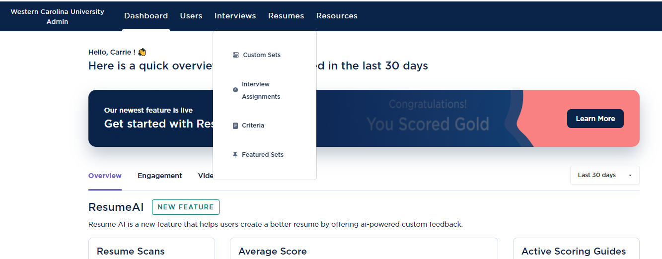

- Click the green Add New Assignment button
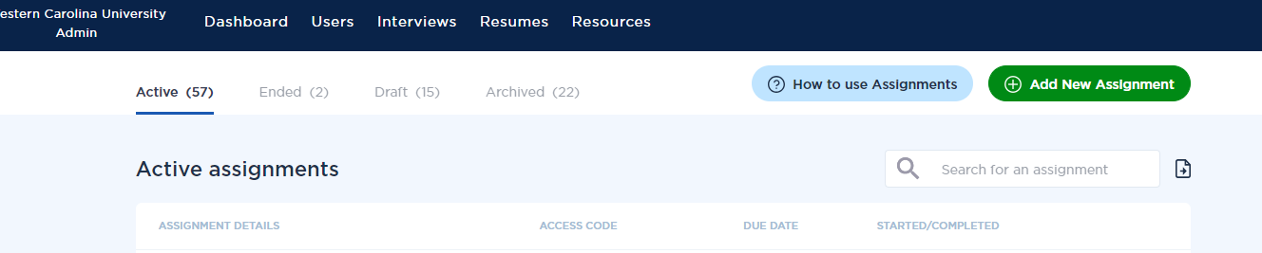

- Under Assignment Details, Give your assignment a name. We recommend your course abbreviation, number, and section number, plus Interview Assignment. (e.g. USI 130-02 Interview Assignment)
- Give your assignment a description (optional)
- Give it a due date
- You may opt to allow your students an unlimited number of retakes, or you can set it to no more than a specific number of retakes. You can also set this to 0 so that they get no retakes. Big Interview defaults to Unlimited.
- You can also set the maximum amount of time a student can use to answer a question. We recommend no more than 3 minutes per question. NOTE: If you want Big Interview to grade the interview based on AI feedback, the student should speak for at least 30 seconds.
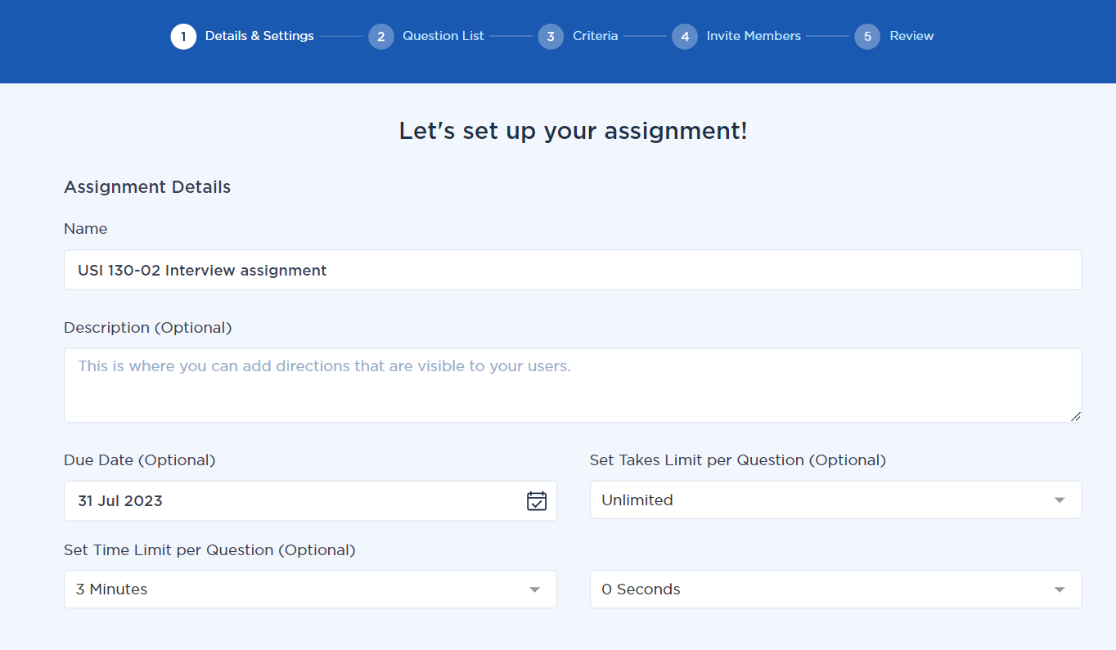
- Next, turn on Run VideoAI on all answers if you want Big Interview to grade the videos. (NOTE: you’ll also have a chance to watch each student video and grade how you see fit)
- You’ll also want to turn on Enable AI during Review so that you can see how Big Interview graded the student.
- You can turn on Allow Users to Share Externally if you want your students to be able to email their answers to others; otherwise, leave this turned off.
- IMPORTANT: Turn on Private Assignment, otherwise any admin will be able to see your students’ results.
- You can choose to have Big Interview email you any time a student finishes the assignment.
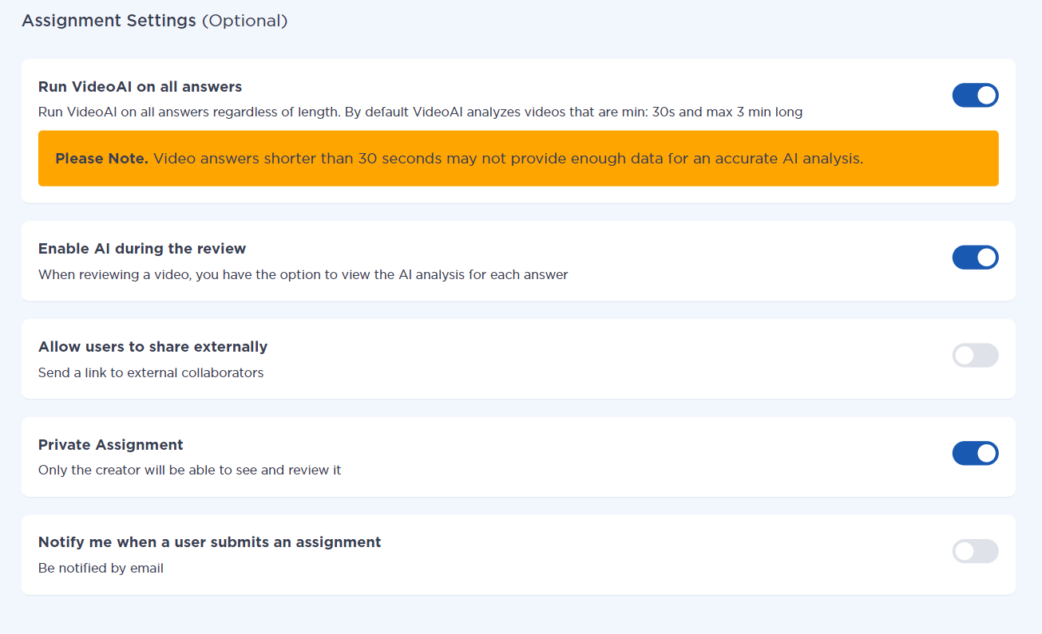
- Click Save and Continue
- Now you can build your question list. You have two options: Start with a template or Create Your Own. We recommend starting with a template as you can still edit the template as you see fit. Starting from scratch takes longer. Click Save and Continue
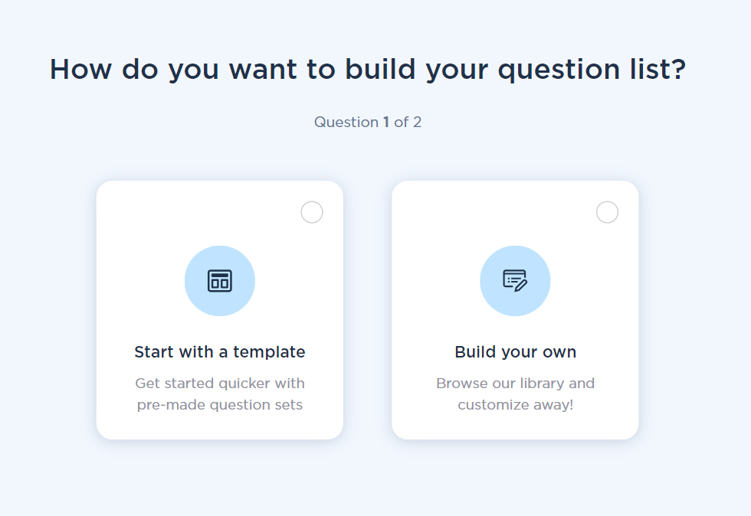

- If you chose to start with a template, choose one of the options on the next screen. We recommend New Grad General or Internship. You can preview each template before committing. If after you review the templates and you wish to create your own instead, click the Back button located at the bottom of your screen.
- If you are using the template option, you may review the list of questions Big Interview has chosen on the right under My Question List. If you do not like some of the questions, hit the X next to the question
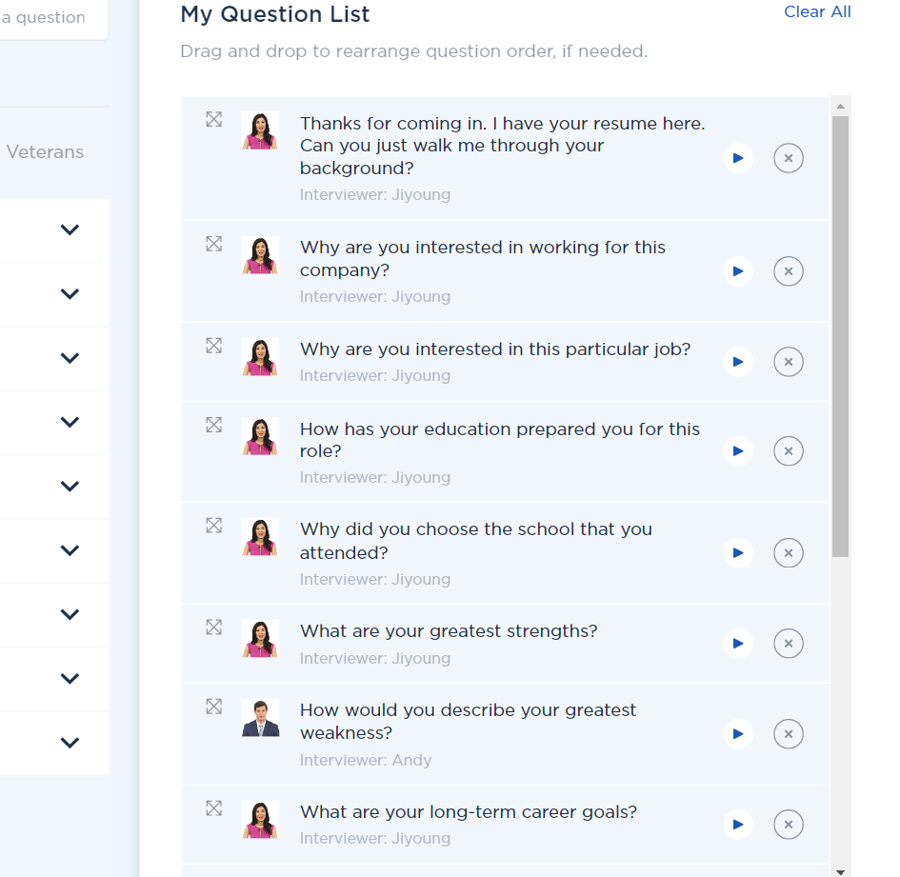

- If you would like to add any questions, you may review those on the left side of your screen under Add Questions to your List. Big Interview has suggested questions to ask by category. You can change the category by click on a new one in the horizontal list
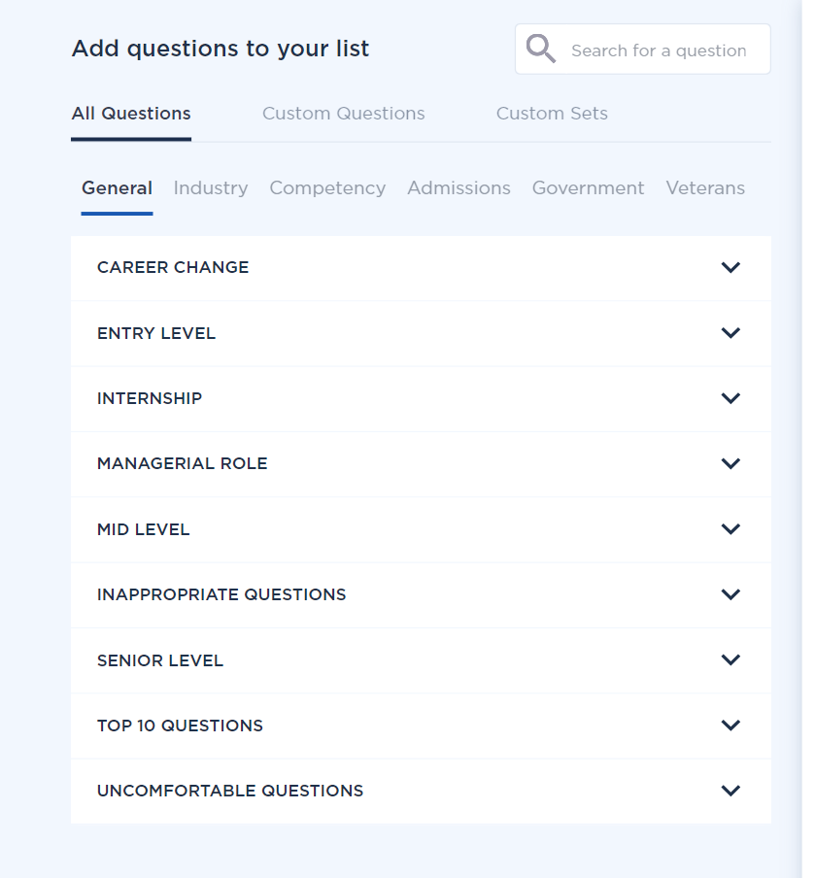

- If you do not see the question you would like students to answer, you may create your own by click on Custom Questions and then Add Custom Question.
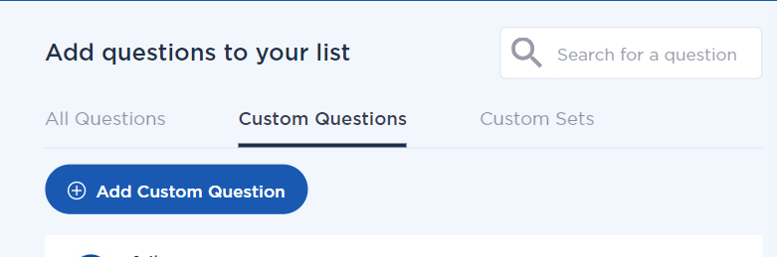
- You can choose to record yourself asking the question (you will appear in the interview module asking the question) or you can choose to upload your question from a previously recorded video.
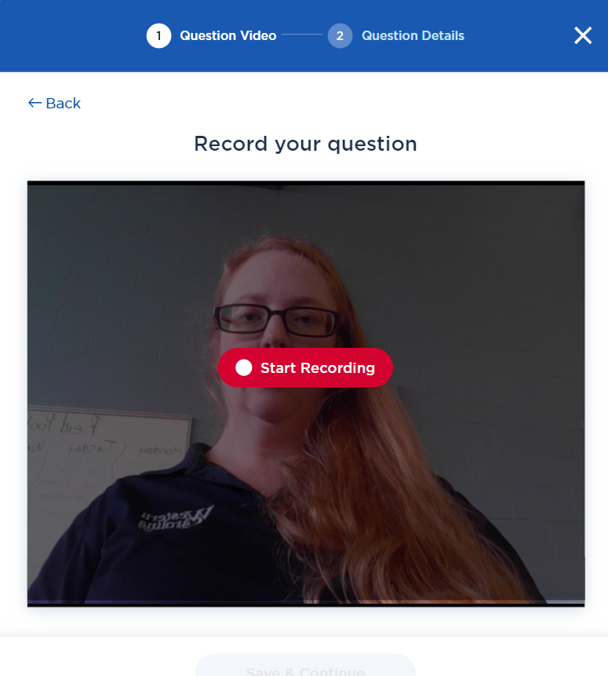
- Once you are satisfied with your list of questions, click Save and Continue
- Now we come to the Criteria section. This is how Big Interview grades assignment. You can choose to use default criteria or add custom criteria.
- Big Interview can grade on up to 12 criteria. Once you have set your criteria, click Save and Continue
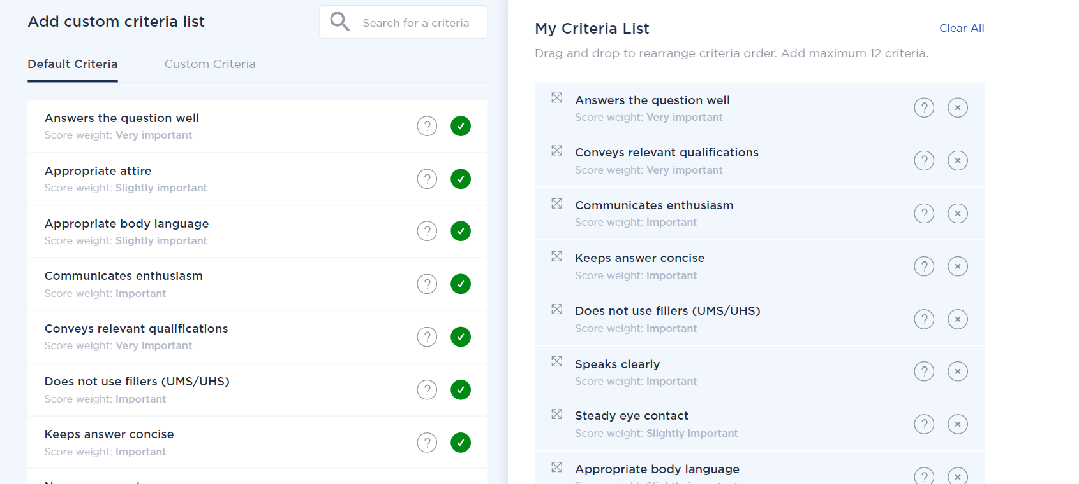

- . You can choose to have Big Interview email your students with the assignment link, but this is optional. If you want Big Interview to email your students, you can either upload a CSV file with your students’ names and email addresses, or you can manually add them. If you do not want Big Interview to contact your students, click the green Skip button at the bottom.

- Review your assignment details. Once you are satisfied, click Save and Publish.
NOTE: If you skipped having Big Interview email your students, you will need to copy the assignment code to distribute to your students via Canvas. Without the assignment code, they will not be able to access the assignment.

Make sure your students check their videos before submitting; if there’s an issue with their mic, Big Interview cannot grade their answers.

