UP Testimonial
by Lisa Shope, 2015

Coming into college all I truly thought about was parties and boys. My freshmen year in college I was going through a breakup and focused all my time on other things than what needed to be done. With that said, I was on the verge of getting kicked out of college and disappointing my friends and family.
It wasn't until I was assigned SPED 240 with Dr. Kelley that I had a spark about wanting to finish. In this class, we had to do so many hours of volunteer work with students with intellectual disabilities. Not only were we supposed to volunteer, but we also learned different types of disabilities and strategies that we, as future teachers, could use to make accommodations and modifications for our students.

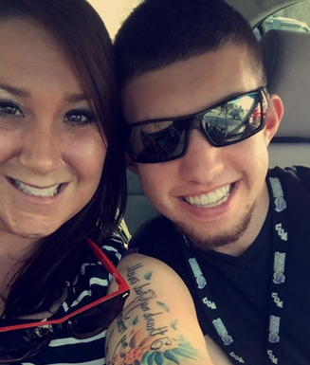
Lisa hanging out with Trace

The first shift I was assigned was working out in the CRC with Trace Shuler. Coming into this I had no idea what to expect; each individual is different even though you think you might understand their disability. Standing outside the gym was this tall, slim, white boy with big pretty teeth smiling from ear to ear. I quickly learned that he gets really shy and nervous when being around new people so I tried to talk about what his expectations were for us not only the supports, but also friends. I was slowing peeling back his layers getting him to open up more. Talking about fears and goals seemed to help him open his eyes to the fact that he is really in college and just like everyone else. By the end of the shift, I knew I was hooked.
Following that day, I picked up more hours and extra shifts just to be around the UP students. Shortly after that I was getting texts, phones calls, and Facetime chats before bed just because I might not have been able to see them that day.
The UP program totally changed my perspective about college. They say it will be the best time of your life, and to some that might be parties, drugs, and alcohol. For me it's movie nights in my room with UP students, singing and dancing on leisure time, preparing for speeches, and even seeing the UP students smile and feel confident about something they achieved that day.
Without the UP program I would be skimming by or would have failed out of college by now. This program teaches you how to understand and work with students with intellectual disabilities but even more, it teaches you how to find your true calling.
I don't consider these students any different than the person standing in front of you at Starbucks, they are just like everyone else! I am so protective when it comes to the UP students and would do anything they needed from me any time, any day.
The next semester I was offered a position with the UP Program as a paid support-- I was so excited! Having that responsibility and leadership is something I was scared of, but quickly I realized it is what I was meant to do. In a year, I brought my GPA up tremendously because I wanted to prove to everyone, and myself that this is what I want and these students make me push myself even further everyday. I have made so many friends and a mentor who I look up to as a role model.
Dr. Kelley goes over and beyond when it comes to her students and employees. I know that if there was anything I ever needed she would break her back to try and get it resolved. UP has saved my dreams of becoming a special education teacher and has also helped me from bottoming out of college to having a 3.98 semester GPA and making the chancellor's list. I have formed a family away from home and I am so excited about the new UP students who are coming in and showing them what WCU UP program is all about.
GO CATS!

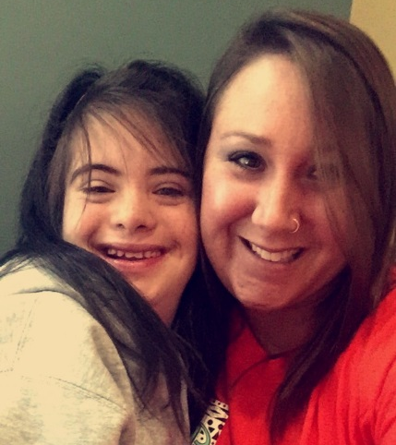
Ali Hale with Lisa
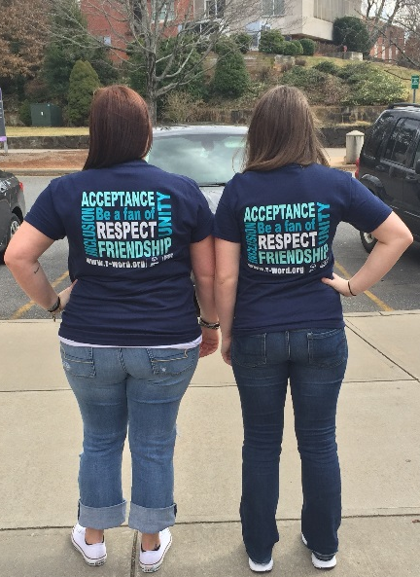
Lisa and friend at the Rally to End the R Word
Sarah Hubbard and Lisa
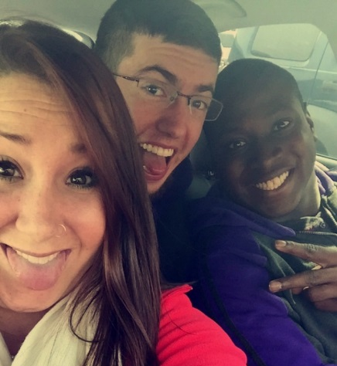
Lisa, Trace Shuler and Jalen Cash

