The 24th Annual Cullowhee Conference on Communicative Disorders Announces Speakers
Drs. Ronald and Sandra Gillam
Intervention to improve comprehension and production of discourse skills for school-age children: Translating theory into evidenced-based practice
Dr. Jeff Black
Closing the Research to Practice Gap: What Science Offers Teachers of Reading
Looking for a Quick Fix? Controversial Therapies in the Treatment of Language and Learning Disorders
Orthographic Processing: A Subcomponent or a Subtype of Dyslexia?
Also Featured
Poster sessions by students and interested stakeholders
When: April 7th 1:00 to 5:00 p.m.
April 8th 8:30 a.m. to 4:30 p.m.
Where: Western Carolina University—
UC Grand Room (Main Campus)
Fee: $50.00—please make checks payable to WCU NSSLHA—
Send to 158A HHS Building 3971 Little Savannah Road c/o
Dr. Bill Ogletree
Western Carolina University
Cullowhee, NC 28723
*To assure seating, checks must be received by March 24th. Payment is the same for one or both days. Please add $5 if you desire Continuing Education Units. Receipts will be available at the door.
Supervisors of graduate clinicians during the 2015/16 year have the registration portion waived.

Questions/Directions: Call Dr. Ogletree at (828) 227-3379 or email at Ogletree@wcu.edu

Speaker Bios
Dr. Ron Gilliam holds the Raymond and Eloise Lillywhite Endowed Chair in Speech-Language Pathology at Utah State University, where he serves as the Director of the Language, Education and Auditory Processing (LEAP) Brain Imaging Lab in the Emma Eccles Jones Early Childhood Education and Research Center. His research, which has been funded by the National Institutes of Health and the US Department of Education, primarily concerns information processing, language assessment, and language intervention with school-age children with specific language impairments.

Dr. Sandi Gilliam is an associate professor in the Department of Communicative Disorders and Deaf Education at Utah State University. Her primary research interests are in the areas of acquisition and disorders in language and literacy, multicultural populations, and assessment and intervention in school age children. She has produced numerous publications in peer-reviewed journals on the topic of evidence-based practice and making evidence-based decisions about language intervention with both pre-school and school-age children. Sandi has served on a number of ASHA Convention planning subcommittees in child language, reviewed for professional journals, and acted as guest editor for LSHSS. She has been the recipient of both internally and externally-funded grants.

Dr. Black is the medical director of the Luke Waites Center for Dyslexia and Learning Disorders at Texas Scottish Rite Hospital for Children and clinical professor of Pediatrics at The University of Texas Southwestern Medical Center. He has held faculty positions with the departments of pediatrics at the University of Maryland, the Medical University of South Carolina (MUSC) and the University of California at San Diego. He practiced general pediatrics part-time in Baltimore and taught ambulatory pediatrics at MUSC.

Time Ordered Agenda
April 7
12:30 Registration
1:00-2:00 Closing the Research to Practice Gap: What Science Offers Teachers of Reading
2:00-2:15 Break
2:15-3:30 Looking for a Quick Fix? Controversial Therapies in the Treatment of Language and Learning Disorders
3:30-5:00 Orthographic Processing: A Subcomponent or a Subtype of Dyslexia?

April 8
8:30-12:00 Introduction to Intervention to improve comprehension and production of discourse skills for school-age children: Translating theory into evidenced-based practice
12:00-12:45 Lunch break
12:45-1:30: Poster Sessions—Featuring WCU Faculty, Students, and local SLPs
1:30-4:30 Conclusion to Intervention to improve comprehension and production of discourse skills for school-age children: Translating theory into evidenced-based practice

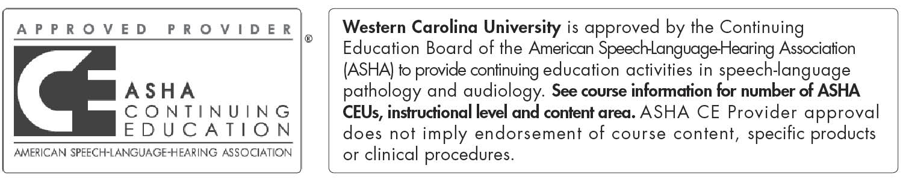
This program is offered for 1.0 ASHA CEUs (Intermediate level; Professional Area). ASHA CE Provider approval does not imply endorsement of course content, specific products, or clinical procedures. Please note that partial CEU credit will not be provided at the Cullowhee Conference. Participants will have to attend all events to be eligible for CEUs.

If planning on attending, please cut off bottom portion and mail to the CSD Department with a check payable to WCU NSSLHA (see above for address)

Name:
Email:
Phone:
I am attending the Cullowhee Conference on (check all that apply): April 7 April 8
Enclosed is a check for: $50.00 $55.00
I have supervised ___________________________________ (Student name) during the 15/16 year.

