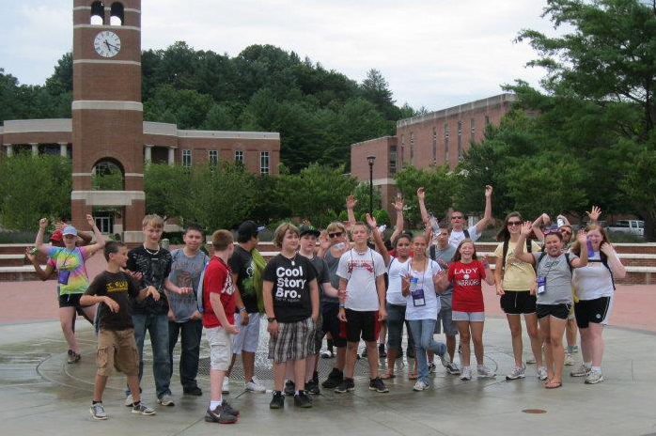
Get Amp’d

Project Discovery ~Talent Search Students sign up for
The AMP Program this summer!

See your Project Discovery ~ Talent Search Counselor 828-227-7137

Two days on the campus of Western Carolina University
Climbing Wall, Cool Science Activities and other adventures…plus
Good Food, Good Friends and Good Times!
No Cost!

June 15-16, 2015
Explore ~ Learn ~ Grow

AMP Adventure Program
Western Carolina University

It is never too late to be who you might have been. ~ George Eliot

It is not the mountain we conquer but ourselves. ~ Edmund Hillary

What to Expect:

Congratulations! You have been accepted to attend the Project Discovery~Talent Search AMP Adventure Program at WCU this summer!

Dates: Plan to arrive at WCU, Norton Hall 8:30am, Monday, June 15th and Plan to be picked up from the same location at 3:30pm, Tuesday, June 16th.

Cost? There is no cost to you for this program, because Project Discovery has paid for the $400 cost for you. You may wish to bring a small amount of spending money for any personal items during the program. Project Discovery will provide all equipment, food, instruction and cost. There are snack machines available, although we will do a good job feeding you! We will also visit the University gift shop at some point during our two days.

What to expect? This program is about ADVENTURE and what it brings to our lives. You will participate in several adventure activities during your stay, including the WCU climbing wall, really cool science projects and more. You will be one of 40 middle school students from Project Discovery’s target schools. We will eat our meals in the food court on campus. We will spend the night in the residence halls. Do expect to be challenged physically, and mentally. Not only will we be experiencing hands-on adventure, but we’ll discuss how taking healthy risks moves us toward our goals.

Parents:
When you come to pick up your student, plan to arrive by 3:30 pm for ice cream sundaes and a slide show of our experiences.

