Sustain! Campus as a Living Learning Lab
Lauren Bishop, Andy Coburn, Laura Cruz and Josh Whitmore
Ask any WCU student to describe campus and they will almost certainly mention things like buildings, trees, walkways, parking lots and mountains. And maybe even the fountain. Ask the same question in ten years -after campus has been transformed into a living, learning laboratory and become an integral component of teaching, learning, outreach and research - and you will hear students describing campus as sustainable, vibrant, dynamic, cutting-edge and ecologically- and socially-mindful.

Entitled “Sustain! Campus as Living Learning Lab” this innovative QEP proposal seeks to transform the campus of Western Carolina University into a shared physical space that promotes applied, active and experiential learning in which students, faculty and staff partner to generate new ideas and develop solutions that enhance sustainability, while providing opportunities for students to work on important and challenging problems in real-world settings.

The concept of a Living Learning Lab, coupled with a university-wide ethos of sustainability, will bring WCU into a growing national and international movement to address significant environmental issues in the academic arena. Large-scale sustainability efforts have become the hallmark of a number of leading public and private universities, and many of our peer institutions have distinguished themselves by undertaking a variety of major initiatives to limit greenhouse gas emissions, increase energy efficiency, improve air and water quality, change faculty and student consumption habits and more.

As a Living Learning Lab, WCU’s campus will become a medium for learning, innovation, recreation and community enjoyment; a symbol of the natural beauty of western North Carolina and a catalyst for integrating concepts of sustainability into curricular and co-curricular activities that reach across boundaries of all disciplines, sectors and geographies to engage students, promote scholarly activity and promote positive ecological, economical and societal change.

“Sustain! Campus as a Living Learning Lab” is a transformative educational experience that aligns with both WCU’s 2014 Master Plan and Strategic Plan - 2020 Vision: Focusing Our Future, (see especially Initiatives 1.1.2, 1.3.2, 2.1.3, and 5.2.1). This QEP will integrate concepts of sustainability, energy stewardship, green space and community while supporting the university’s commitment to promoting economic and ecological viability in western North Carolina.

An Ethos of Sustainability at WCU: Going Beyond Green
The term “sustainability” usually elicits mental images of recycling bins, climate change, hybrid vehicles and solar panels. While these “green” elements are certainly important, sustainability can best be thought of as the pursuit of human health and happiness, environmental quality and economic well-being for current and future generations (Pennsylvania State University, 2011).

At its core, sustainability is about the interdependence of living organisms and communities (both human and nonhuman) over the long haul (Stenzel, 2010). Sustainability touches our sense of ethic, spirit and culture and reflects our ideals at the highest level more than simply efficient planning. Instead of seeing environmental, social and economic needs as a collection of discrete characteristics or problems, sustainability looks at them as interdependent and connected.

Sustainability, therefore, is not a decree to be proclaimed or a problem to be solved. It is a way of living, or ethos, that forces us to consider our contribution to the challenges of our time, delivered in the context of our passion and purposes, requiring constant innovation, commitment, vigilance and learning. As an ethos, sustainability implies that the critical activities of a higher education institution are ecologically sound, socially just and economically viable, and that they will continue to be so for future generations. A truly sustainable university should not only emphasize these concepts in its curriculum and research, but also by preparing students to contribute as working citizens to an environmentally healthy, economically viable and equitable society.

As a public institution with considerable land, assets and utilities, Western can play a unique role in leveraging the teaching, research and operations that are at the core of our existence to address the critical issues of our time. We can take actions others cannot by advancing debates, technologies, instruction and discoveries that support a more sustainable future.

As a major educational force and significant business enterprise, Western Carolina University also plays a vital role in creating a sustainable society where the region’s economic, cultural and health needs are met, while the vitality of natural systems is maintained or enhanced.

When sustainability is understood, embraced and strongly linked to a university’s mission and vision, great things can happen!

Campus as a Living Learning Lab
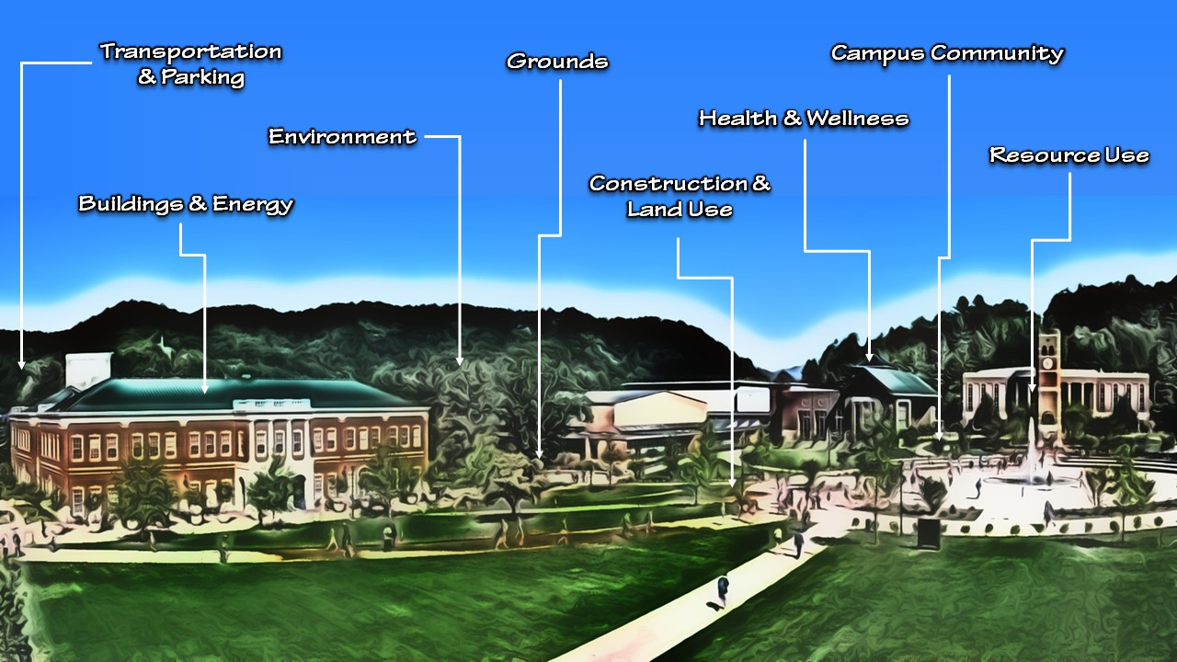
A Living Learning Lab is an innovative teaching/learning model that incorporates best practice elements of experiential and active learning, sustainability and multidisciplinary research to break through current curricular and operational paradigms (Portland State University, 2013). It combines problem-based teaching, research and applied work to develop actionable solutions that accelerate transitions to a more holistic and sustainable learning community through joint commitments from students, faculty, staff and local residents to design, implement, adapt and teach new approaches that address issues of equity, economy and ecology across a wide range of campus contexts (See Figure 1).
Figure 1: Campus as Living Learning Lab Model (Cohen and Lovell, 2013)

If we create a learning environment in which students, faculty and staff alike learn in the classroom laboratory, physical plant “laboratory" and natural “laboratory,” we can create a path for sustainability that goes beyond campus and has a profound influence on the environment at large over many years to come, while simultaneously enhancing students' learning experience.

Armed with a wealth of new knowledge about the world in which they live, our graduates will have a profound impact on the global environment through the choices they make and the actions they take. They will leave WCU prepared to become engaged citizens who understand the importance and responsibility of creating a sustainable future.

Eight Elements of Transforming Campus into a Living Learning Lab
Recent research conducted by institutions with successful Living Learning Lab programs suggests the following eight-element framework for successful adoption (Cohen and Lovell, 2013):

Element 1: Engage Campus Participants
The Sustain! QEP creates a learning environment that dissolves the boundaries of classrooms and generates immersive sustainability experiences. Of paramount importance for ensuring success is “buy-in” and continued involvement of departments, research centers and facilities that will pioneer sustainability education, implement sustainable practices and lead the innovation of technologies and practices.

At its core, a Living Learning Lab brings together facilities staff, faculty and students: three groups that rarely interact. Since facilities holds the key (often literally) to improving institutional energy efficiency and making campus facilities accessible laboratories for faculty to develop sustainability learning, successful development and integration of a Living Learning Lab curriculum hinges on the involvement and cooperation of these key campus stakeholders. Understanding the facilities world - and making facilities feel comfortable that research projects will be safe and well-defined—is crucial.

Element 2: Identify Key Programs and Academic Departments
The Sustain! QEP will involve leaders from Facilities, Human Resources, Student Affairs and Academic Affairs: a governance model that has been successful in bringing Living Learning Labs to other campuses.
In addition to support from leadership, the research also recommends getting buy-in from department heads and faculty. Hands-on, applied education is generally associated with technical training and the sciences, but because of the integrative nature of the sustainability concept, there will also be many opportunities to incorporate Living Labs into most, if not all, academic departments and programs.

Element 3: Build Credibility through Engagement and Data
The Sustain! QEP will utilize the Association for the Advancement of Sustainability in Higher Education’s (AASHE) Sustainability Tracking, Assessment & Rating System™ (STARS®) to collect, measure, compare and disseminate sustainability-related data, as well as assess the overall efficacy of the Campus as a Living Learning Lab concept. A multi-layered, scaffolded institutional assessment model that includes academic, co-curricular and cultural elements will also be incorporated into the Sustain Assessment strategy. Metrics will be assessed annually and used formatively to shape, develop and enhance this effort.

Element 4: Integrate Sustainability into the Curriculum
Sustainability already forms an integral part of several WCU strategic curricular focus areas including: creative arts (e.g. storytelling, natural crafts, nature-based sculpture, photography); teacher preparation (e.g. science education, special education, camps and field trips); health professions (e.g. water quality, environmental health, wellness); technology and innovation (e.g. natural products, ecosystem services, sensors) and recreation and tourism (virtual tours, sustainable tourism, education backpacks). WCU’s introductory Geosciences courses, for example, incorporate Cullowhee Creek into a water quality project that creates a shared, common experience for almost 1,000 WCU students each year.
Incorporating effective Living Learning Lab exercises into the broader curriculum will require creativity and careful planning as instructors find ways to connect a program’s learning outcomes (SLOs) to learning projects involving campus buildings or grounds.

Element 5: Expand Beyond Individual Programs of Study
Sustainability, by its integrative nature, lends itself to well to collaborative and interdisciplinary work. The Sustain! QEP will initiate and foster a variety of interdisciplinary projects, which has the dual benefit of increasing engagement between and among faculty from different disciplines while also supporting collaborative student projects that have the potential to address some of the core competencies most desired by North Carolina employers—including team work, communication across diverse audiences, project management and diversity.

Element 6: Build Public and Private Partnerships
WCU’s Millennial Campus initiative is a model for how the university wishes to strategically leverage public/private partnerships to support growth. Many successful campus-based Living Learning Lab efforts are conducted with public and private partners, ranging from energy providers to solar panel manufacturers to food services to local, state and federal government agencies. Partners are an integral part of implementing sustainability-related projects on campus, and will show an interest in leveraging their equipment and services to support, and be supported by, students and student learning.

Element 7: Engage and Expand beyond Campus
Due to its strategic location, WCU is uniquely positioned to integrate Living Learning Lab concepts and projects into the greater western NC region. The Sustain! QEP will transcend the boundaries of traditional learning by connecting students, faculty and staff to broader communities and landscapes at every scale as a resource for learning. Entrepreneurial and community partnerships will underscore the University’s commitment to creating a learning environment that extends beyond the borders of campus to include the entire western NC region in the context of 21st century challenges.

Element 8: Open the Living Learning Lab to the Community
WCU’s vision is to be “a national model for student learning and engagement that embraces its responsibilities as a regionally engaged university.” Implementing an effective Living Learning Lab will have a potential impact beyond the student body, serving as a learning model for community members. Combining regional development with student success, a Living Learning Lab in Cullowhee will significantly enhance Western’s reputation as a regional leader in sustainability, resource management and environmental stewardship.

Tangible Benefits of Campus as a Living Learning Lab
The core mission of Western Carolina University is the education of its students. One aspect of such education is the demonstration by its actions of the University’s concern for, and protection of, its natural and built environment. A sustainable campus is a community that supports equity and social justice, embodies responsible resource consumption, fosters a sense of place, instills pride and regional community engagement and supports sustainable development (Sobel, 2005). As a rural institution that is deeply engaged in the region, WCU’s commitment to sustainability will have a profound impact on the health and quality of life of a large and diverse population.

To fulfil its functions of teaching, research, outreach, partnerships and stewardship in ways that help society make the transition to more sustainable lifestyles, transforming campus into a Living Learning Lab will provide a number of tangible benefits to WCU including:

- Engagement: Actively employs the knowledge of the university community to address current and future environmental, economic and social challenges.
- Place: Reflects a commitment to campus and surrounding community.
- Sustainability: Implements lasting change to make a given place more resource-efficient, equitable and ecologically balanced, acknowledging a resource-finite world.
- Real-world learning: Links knowledge to action with problem-based, results-oriented learning opportunities.
- Fit: Supports a campus-wide vision of sustainability, advancing local and regional priorities.
- Adaptive: Takes an open-ended approach where ongoing assessment, capturing and reporting contributes to the collective knowledge base and improves future projects.
- Systems Thinking: Approaches problem solving by viewing all parts of an overall system, rather than reacting to specific parts and outcomes that can contribute to unintended consequences (Waters Foundation, 2015).
- Collaborative Action: Fosters deep multidisciplinary and community engagement that leads to on-the-ground project implementation.
- Evaluation and continuous improvement: Establishes mechanisms to monitor progress and evaluate impact over time.
- Student Success and Retention: A significant body of literature shows that experiential learning contributes to student success and retention and is a necessary and vital component of formal instruction in colleges and universities.
- Job Preparation: Employers are interested in a workforce that is competent in sustainability.

We are confident that the selection and implementation of “Sustain! Campus as a Living Learning Lab” as Western’s next QEP will make WCU a model for other regionally-engaged institutions and burnish a national reputation for excellence in, and commitment to, sustainable policies, principles and actions.

Sources Cited
Cohen, T. & Lovell, B. (2013). The Campus as a living laboratory, using the built environment to revitalize college education: A guide for community colleges. American Association of Community Colleges. Retrieved from http://theseedcenter.org/getattachment/Resources/SEED-Resources/SEED-Toolkits/Campus-as-a-Living-Lab/Campus-as-a-Living-Lab_FINAL.pdf
Penn State Institute for Sustainability. (2011). Retrieved from http://sustainability.psu.edu/sustainability-institute
Portland State University Institute for Sustainable Solution. (2013). Retrieved from https://www.pdx.edu/sustainability/iss
Sobel, D. (2004). Place-based education: connecting classrooms and communities. The Orion Society. ISBN 978-0913098554
Stenzel, P.L. (2010). Sustainability, the triple bottom line, and the global reporting initiative. Global Edge Business Review, 4(6), 1-2. Retrieved from https://globaledge.msu.edu/content/gbr/gbr4-6.pdf
Waters Foundation Systems Thinking in Schools. (2015). Retrieved from http://watersfoundation.org/

