PRM 270-02: Leadership and Group Dynamics
Parks & Recreation Management Human Services Department

Course # & Title: PRM 270-02: Leadership & Group Dynamics (3 credit hours)
Class Times: Tuesday & Thursday: 8:00am-9:15am
Locations: Reid 122H (lecture) Reid 112A (activity space)
Instructor: Debby Singleton, M.A., Instructor
Preferred Pronouns: she/her/hers
Office: Reid 122J
Office Hours: Check office door for daily availability or make an appointment.
Phone #: 227-3971 (office) E-mail: singleton@wcu.edu
TA: Ashley Johnson

CATALOG DESCRIPTION: Emphasis will be placed on appropriate theories and techniques for specific clientele and the populations that are encountered as a recreational professional.

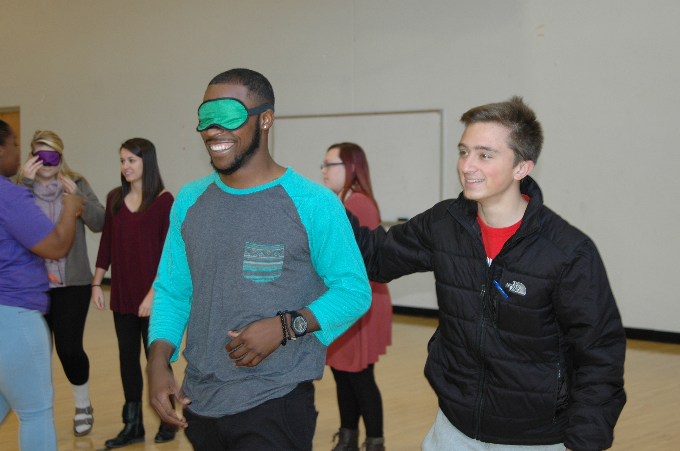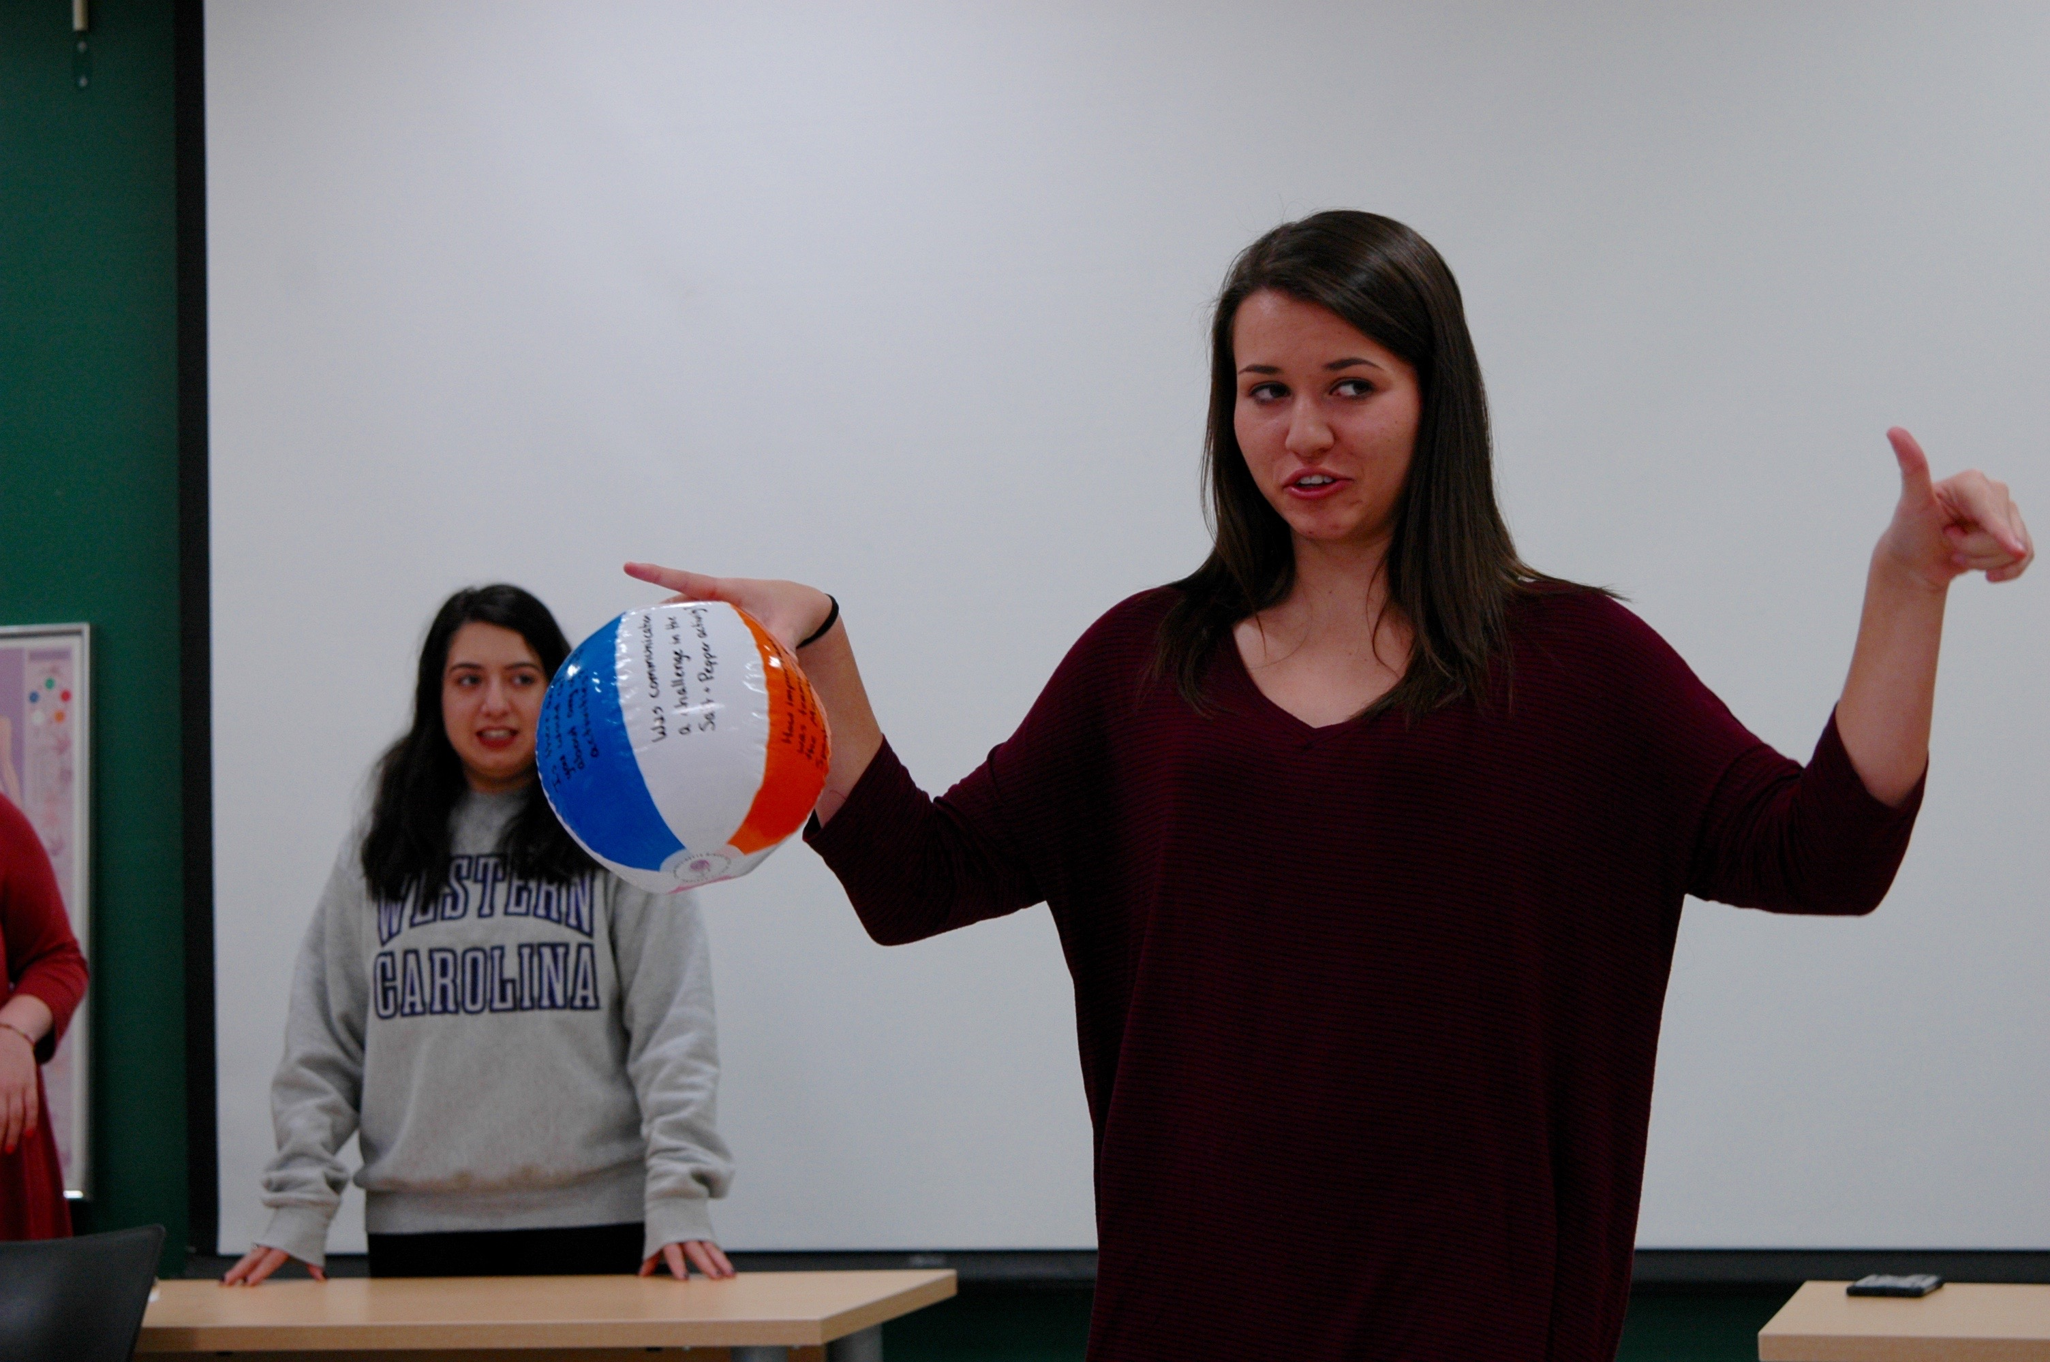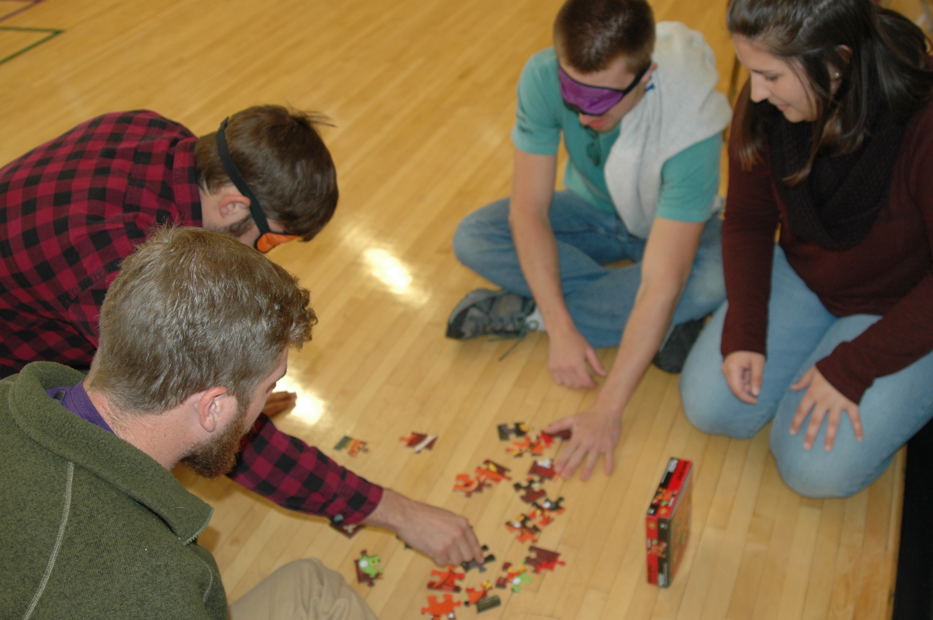

COURSE GOAL:
The primary goal of this course is to help the student become aware of the importance of effective facilitation and leadership within the context of a recreation setting. An additional purpose of the course is to encourage each student to carefully analyze individual values, responsibilities, and commitments within the context of personal leadership. The course is more than the study of recreation leadership; it is designed to help students develop their own leadership potential. From this perspective, students will explore basic leadership theory and recreation issues from a number of conceptual frameworks.

COURSE OBJECTIVES:
Students will be able to…
- Demonstrate basic knowledge of leadership concepts, styles, and theories (7.01c).
- Assess their own leadership skills, styles, strengths and weaknesses (7.01b).
- Practice, apply, and evaluate leadership and facilitation skills in a variety of small and large group settings (7.02).
- Articulate leadership considerations for working with diverse populations (7.02).
- Discuss small group management techniques including the basic principles of conflict management and resolution (7.01b).

CLASS CULTURE:
As a classroom of engaged learners, we agree that we will…
- Value and respect different opinions as well as the diversity that exists among us;
- Voice our passions, and not censor ourselves. By this we mean that we want to ensure that we can and should be able to share our thoughts and experiences without interruption especially if our perspectives are different from the class norms, expectations, or experiences of others;
- Stay focused on a scholarly examination of issues rather than judging individuals;
- Encourage questions and clarification;
- Be active participants* and come to class prepared
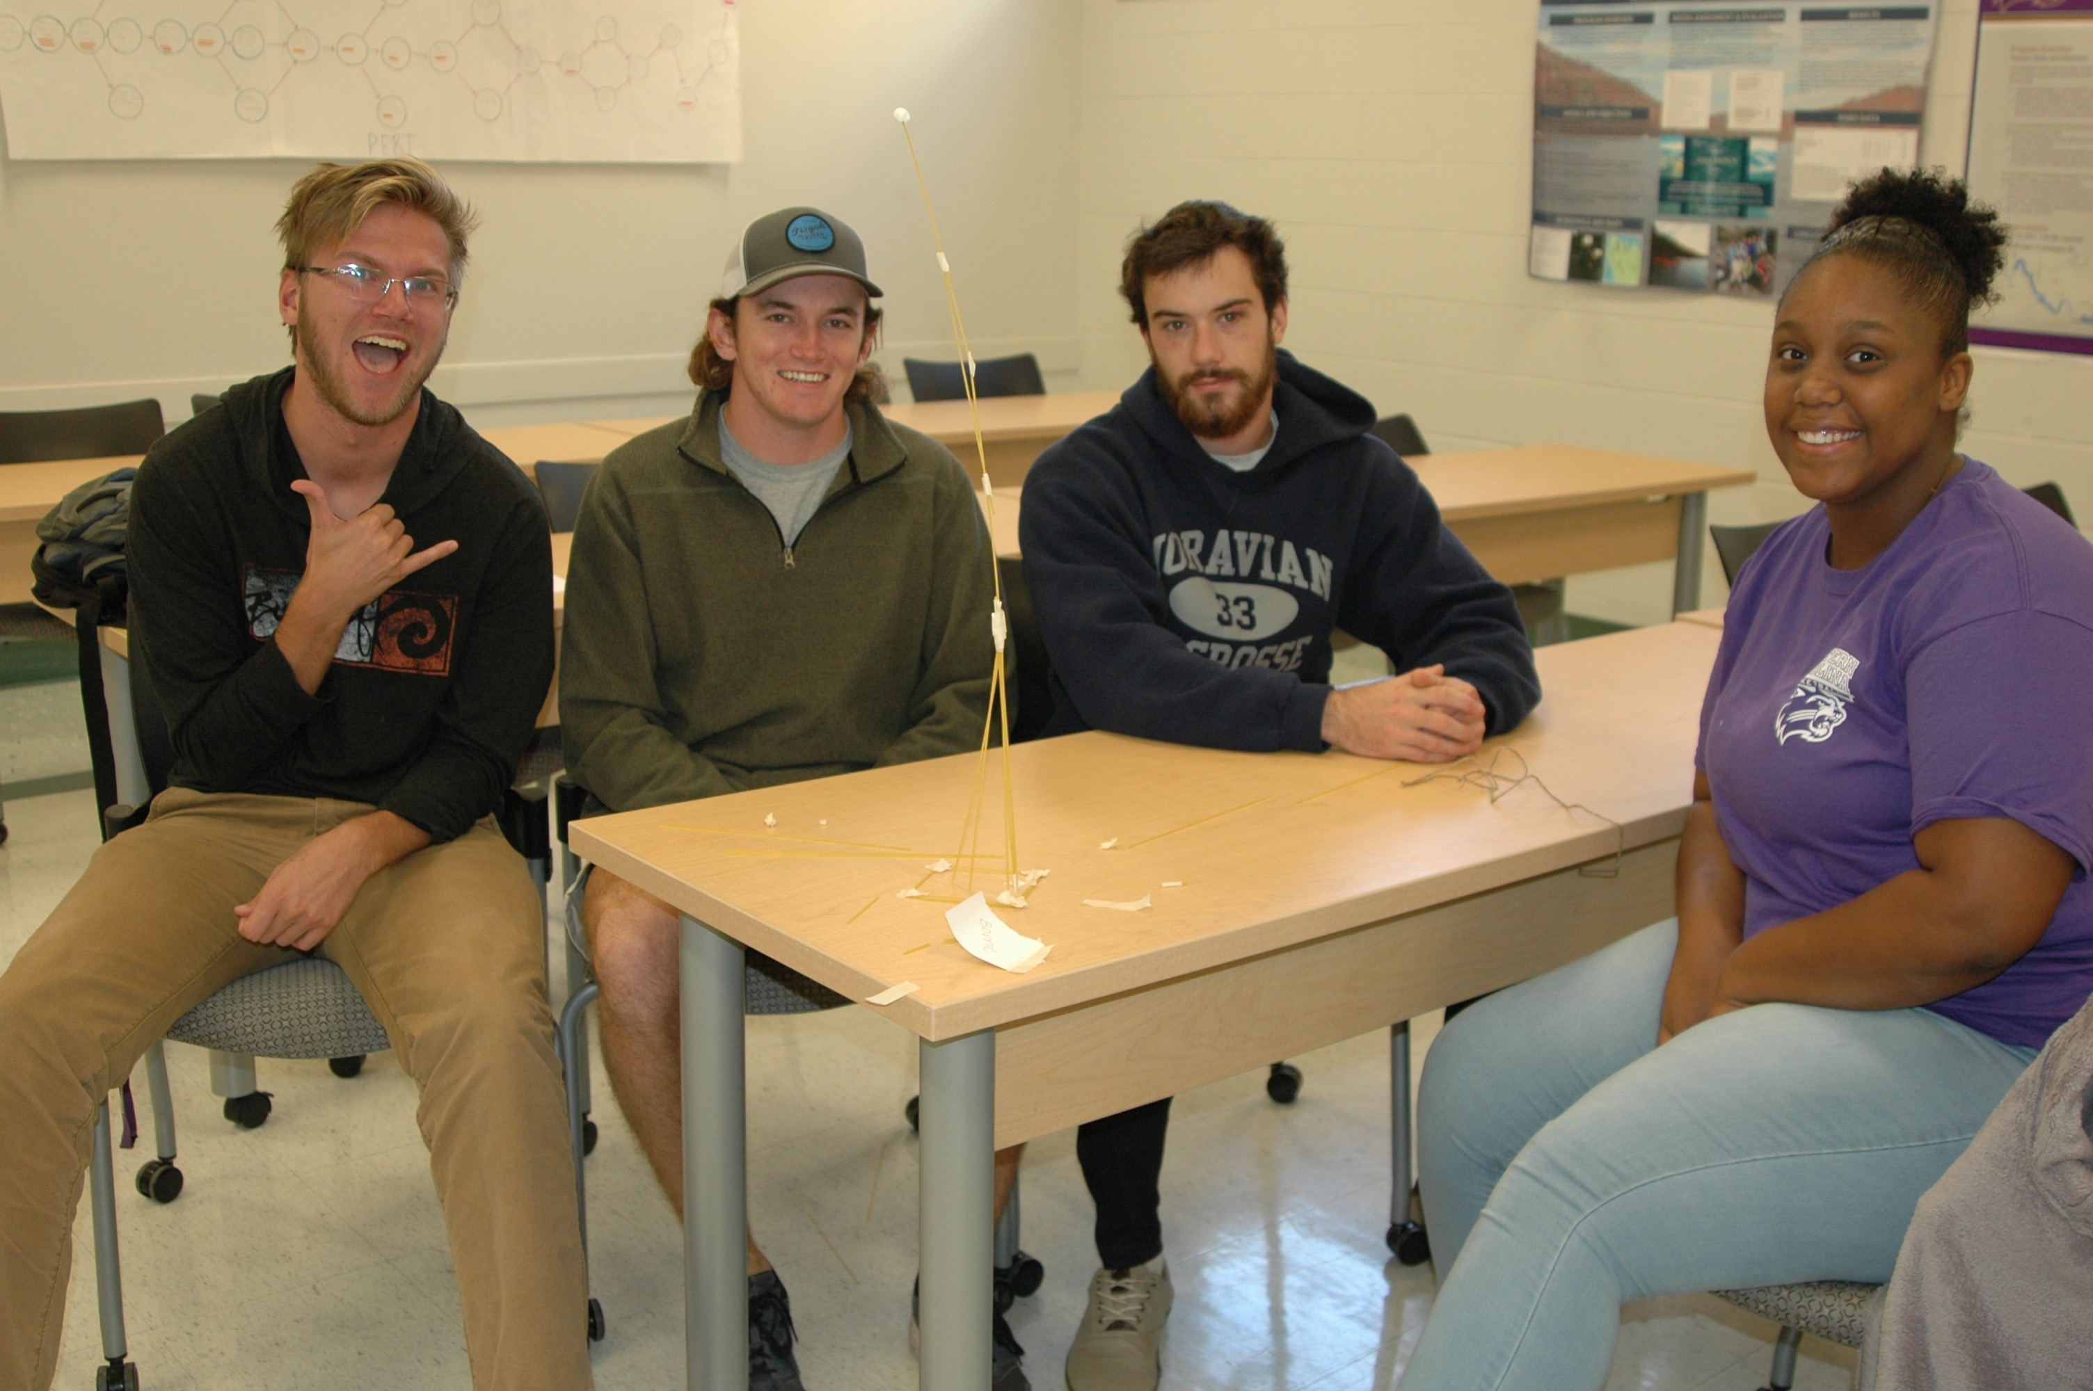

*Instructor’s Comment: I assume that you are here because you want to learn something about this topic and that you will take responsibility to be an active participant in this class. You and I share the same expectations of each other: we will be on time, we will be prepared for that day’s discussion by having done the assigned readings or activities, we will share our ideas and reactions in class discussion, we will be respectful of one another, and we will be engaged in learning about leadership and group dynamics. If you commit yourself to truly doing your best, I will give you the time and assistance you need to get the most out of this class. But the responsibility lies on you to become an engaged learner.

Assumptions and Choices
My assumptions:
- You are an honorable person who stands by her/his word.
- Your enrollment in this class was a willing choice. As such, you are intrinsically motivated to learn.
- You do not equate effort with understanding, and value the latter more highly.
- You are willing to take personal responsibility for your experiences in this class.
- More than likely, you will disagree with me and/or your classmates at some point and will do so respectfully.
- You will come to class prepared and ready to participate.

Choices to facilitate your success in this class:
- You may type and proofread all take-home assignments for content and grammar (including spelling).
- You may turn in your assignments any time up until the due date and may ask for feedback within a reasonable time frame.

What about using my computer/phone in class?
In-class technology is a double-edged sword. Studies have shown that using computers in class reduces learning, and a recent study draws a direct correlation between cell phone use (texting) in class and a low GPA.
However, computers provide incredible resources. If you use a computer in class, stay on task. Cell phones should be always be turned off or set to vibrate. If you must use your cell phone to take notes, please inform the instructor of your intent.
Per the above study, in an interest to raise you GPA…Texting is strictly forbidden – for every person I see texting, I will add an additional question to exams.
JK….for real though, no texting.
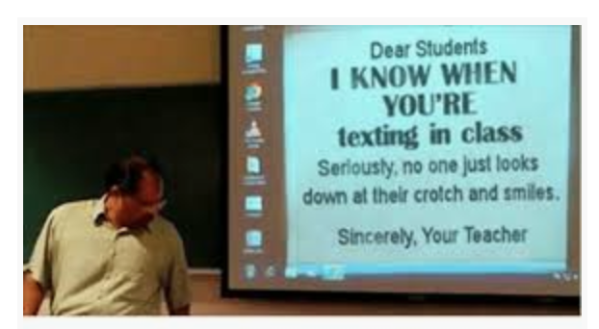

REQUIRED TEXTS & ASSIGNMENTS:

TEXTBOOK
Required Rental Textbook:
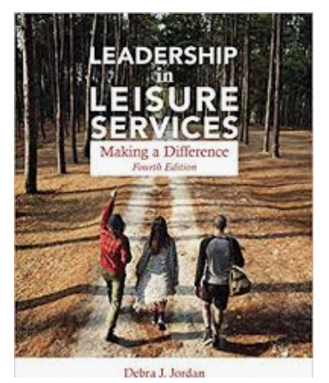
Jordan, D. & Ramsing, R. (2017). Leadership in Leisure Services: Making a Difference. (4th Ed.). Urbana: IL. Sagamore.
*New edition this year.

ONLINE RESOURCE
Cain, J. (nd). Teamwork & Teamplay. Downloadable articles, activities, and information. http://www.teamworkandteamplay.com/resources.html

Required Readings:
All other required readings for this course will be uploaded onto Blackboard. It is essential that students read all assigned material before the class period for which it is assigned. As Michel Foucault famously stated, “Knowledge is power.” In this class, an important way to gain knowledge is through reading. Take the time to read closely and thoroughly.
Please visit the end of this syllabus for a list of helpful texts available in our library that you may want to use for your assignments.

ASSIGNMENTS
This course has been organized around class readings and discussion, presentations, and writing opportunities. While each assignment overview is given below, the specific requirements of each assignment will be handed out separately and discussed in class well in advance of the due date.

- Leadership Essay (100 pts.)
Each student will research a leader they admire. The essay will include which leadership theory this particular leader falls under (there may be more than one). In addition, the student will discuss which styles of leadership this person uses most frequently. Finally, the student will examine their personal leadership style in comparison to the leader they admire.

- Human Development Stages Partners Presentation (200 pts.)
Each student will be paired with a peer (or in a triad) and lead the class through a 10 minute interactive presentation. Partners will teach the class a skill, hobby, craft, or game that would be appropriate for the human development stage assigned. Presentations should be creative and original. No Repeats! The partners will create a one page handout to accompany their presentation and provide tips for facilitating with that human development stage. Partners must provide a copy for each class participant as well as all materials necessary for the presentation. Grades will be determined through a combination of the professor’s assessment and peer evaluations.

- Group Project (300 points)
Students will work in small groups to prepare, deliver and evaluate an activity session to the class. The objective of this assignment is to have the student complete the experiential learning cycle for this course. The presentation should include a warm-up activity with briefing, an activity, which focuses on a specific group dynamic, a problem-solving activity, and a debriefing. You will also be required to investigate research, provide demographic data of your participants and conduct an evaluation of the activity. Students will submit a proposal with an outline of the activity and other required materials, deliver the activity to the class and then complete a reflective evaluation of the experience.

- Personal Leadership Assessment (100 pts.)
This assignment is designed to help you become aware of the personal strengths (and weaknesses) you have as a leader. Additionally, this will make you more aware of the various personality types, learning styles, and multiple intelligences that you will encounter throughout your career. Students will take several tests to determine their leadership style, research attributes of that style, then write a short essay reflection on personal leadership strengths and weaknesses.

- Critical Reading Assignments (200 pts.)
There will be many opportunities for students to earn points through a variety of assessments both in and out of class. Many of these will be unannounced, some may be issued as homework assignments or pop quizzes or attendance/reflection at university events. They will be centered around helping and encouraging students to digest the reading.

- Activity Notebook (100 pts.) To enhance a student’s preparation for leadership and facilitation opportunities, they will compile a notebook of games, initiatives, icebreakers, activities, problem-solving, trust-building and other activities which they could use in a recreational setting. A template will be provided to the student.

7. Extra Credit Opportunities: Throughout the semester, I will provide opportunities for extra credit that relate to leadership and group dynamics. These may include assisting with an after-school program, chaperoning a hike for elementary school students, serving as a volunteer for an outdoor related activity, assisting with Parents Night Out, or participating in a leadership opportunity. Each extra credit opportunity will be worth 10 points. To receive the points, students must submit a written, one paragraph (1/2 page) summary which includes the following criteria within one week of the completed activity:
  - Date of activity, time served/participated
  - Name of sponsoring organization and contact person
  - Why did you want to do this, what did you do, what did you take away from the experience?
  - Please include your name and email address (WCU please) as a right-indented header
  - Formatting is 12-point, Times New Roman font with 1” margins.
  - **Maximum amount of extra credit allowed is 30 points total for the semester.

For each assignment, a link in Bb will provide instructions, detailed assignment description, grading rubric, due date and submission requirements. The instructor will go over each assignment in class yet it is your responsible to read the assignment and ask questions if you do not understand something.

Written Assignment Policies

All written assignments are required to meet the following criteria:

- Have a font no smaller or bigger than 12-point with standard margins.
- Be completed on a computer
- Be double-spaced and in the appropriate format for the assignment.
- Have numbered pages, including the cover sheet
- Have a cover sheet listing the following:
  - Name and number of course (PRM 270: Leadership & Group Dynamics)
  - Student’s name
  - Date assignment is due
  - Named title
- Meet APA Publication Manuscript style, i.e., references, citing (direct and paraphrased quotes, headings, etc.). See Purdue Owl for help: http://owl.english.purdue.edu/owl/section/2/10/
- Use your spell-check, grammar, and thesaurus tools, which are provided in all word document software. I deduct points for errors, PROOF YOUR WORK!

Don’t be this kid.

Late Assignment Policy
All of the class assignments have a specified due date, so pay attention to the syllabus (read it and refer to it often). Assignments must be handed in on time. Each assignment is due the class period assigned or designated on the course schedule. Late assignments will be penalized (1 day late = minus 10% of total grade; 2 days late = minus 20%; etc.) If you are having a problem completing an assignment on time, please ask the instructor for assistance. This policy includes weekend days.

Test Make-up and Missed Class
If you are sick or unable to complete a test during the class period or time period allotted, you must notify the instructor one week prior to the time the test is scheduled or if sick, prior to the beginning of the test. If you do not contact the instructor at all, you will receive a grade of zero on the exam and no make-up. There are no make-up opportunities for quizzes or other class presentations/projects. If you are absent on the day the instructor describes an assignment, it is your responsibility to get the information from a classmate or check Blackboard.

Grading
Assignments | Points
Leadership Essay | 100
Partners Presentation | 200
Group Project | 300
Personal Leadership Assessment | 100
Critical Reading Assignments | 100
Activity Notebook | 100
Participation & Attendance | 100
Final Exam  Practical Exam | 200
Total  *Assignments or points allotted are subject to change. | 1000

Grading Scale:
A+ | 101+% | Greater than 1000 points
A | 93-100% | 930-1000 points | C | 73-76.9% | 730-769 points
A- | 90-92% | 900-929 points | C- | 70-72.9% | 700-729 points
B+ | 87-89.9% | 870-899 points | D+ | 67-69.9% | 670-699 points
B | 83-86.9% | 830-869 points | D | 63-66.9% | 630-669 points
B- | 80-82.9% | 800-829 points | D- | 60-62.9% | 600-629 points
C+ | 77-79.9% | 770-799 points | F | Below 60% | 599 or below
Seriously, this happens.

Course Policies and Expectations

Participation & Attendance: (100 pts.)

Participation accounts for 50 of these points, and attendance accounts for 50 points. Your participation makes a significant contribution to class discussion. When you are not present, we can’t hear your perspective or learn from the stories you share. Therefore, attendance will be taken each class period. The distinction between “excused” and “unexcused” absences is too arbitrary to enforce; therefore, we will follow the same policy you might encounter at a job—you are allowed THREE personal days/sick days. After that, you will lose 50% of your attendance grade per absence. At 4 absences, your attendance grade will be 25/50 points, at 5 absences, 0 points. That being said, I know that “life happens.” If you are experiencing some kind of personal crisis or other extenuating circumstance, please contact the instructor as soon as possible.

Summary of Attendance Policy
3 absences or less | No Penalty
4 absences | Attendance grade is now 25/50
5 or more absences | Attendance grade is now 0. Email from instructor, meet to discuss options
Summary of Participation Points
Fully engaged, active participation, entire semester= 50 points
Above Average participation, engaged at least 75% of the time= 40 points
Average participation, engaged at least 50% of the time= 30 points
Below Average participation, engaged at least 25% of the time= 20 points
Poor participation, not engaged= 0 points
Does anyone know this guy?

Risk Awareness:
Students should be aware that some physical activity is expected as partial fulfillment of the requirements of the class. This includes participation in practice lessons taught by the instructor and/or peers. Students should make the instructor aware of any physical limitations that will limit participation in the class. Students will be required to complete a Risk Awareness form at the beginning of the term.

Students may also find themselves in close proximity to others.

Class Attire:
During the majority of class periods we will be in the classroom with some activity interspersed. Please wear comfortable clothing that will not reveal too much of your body when you bend and move or result in a wardrobe malfunction. Some class periods will feature activities that require athletic type clothing, the instructor will let you know in advance if that is the case.
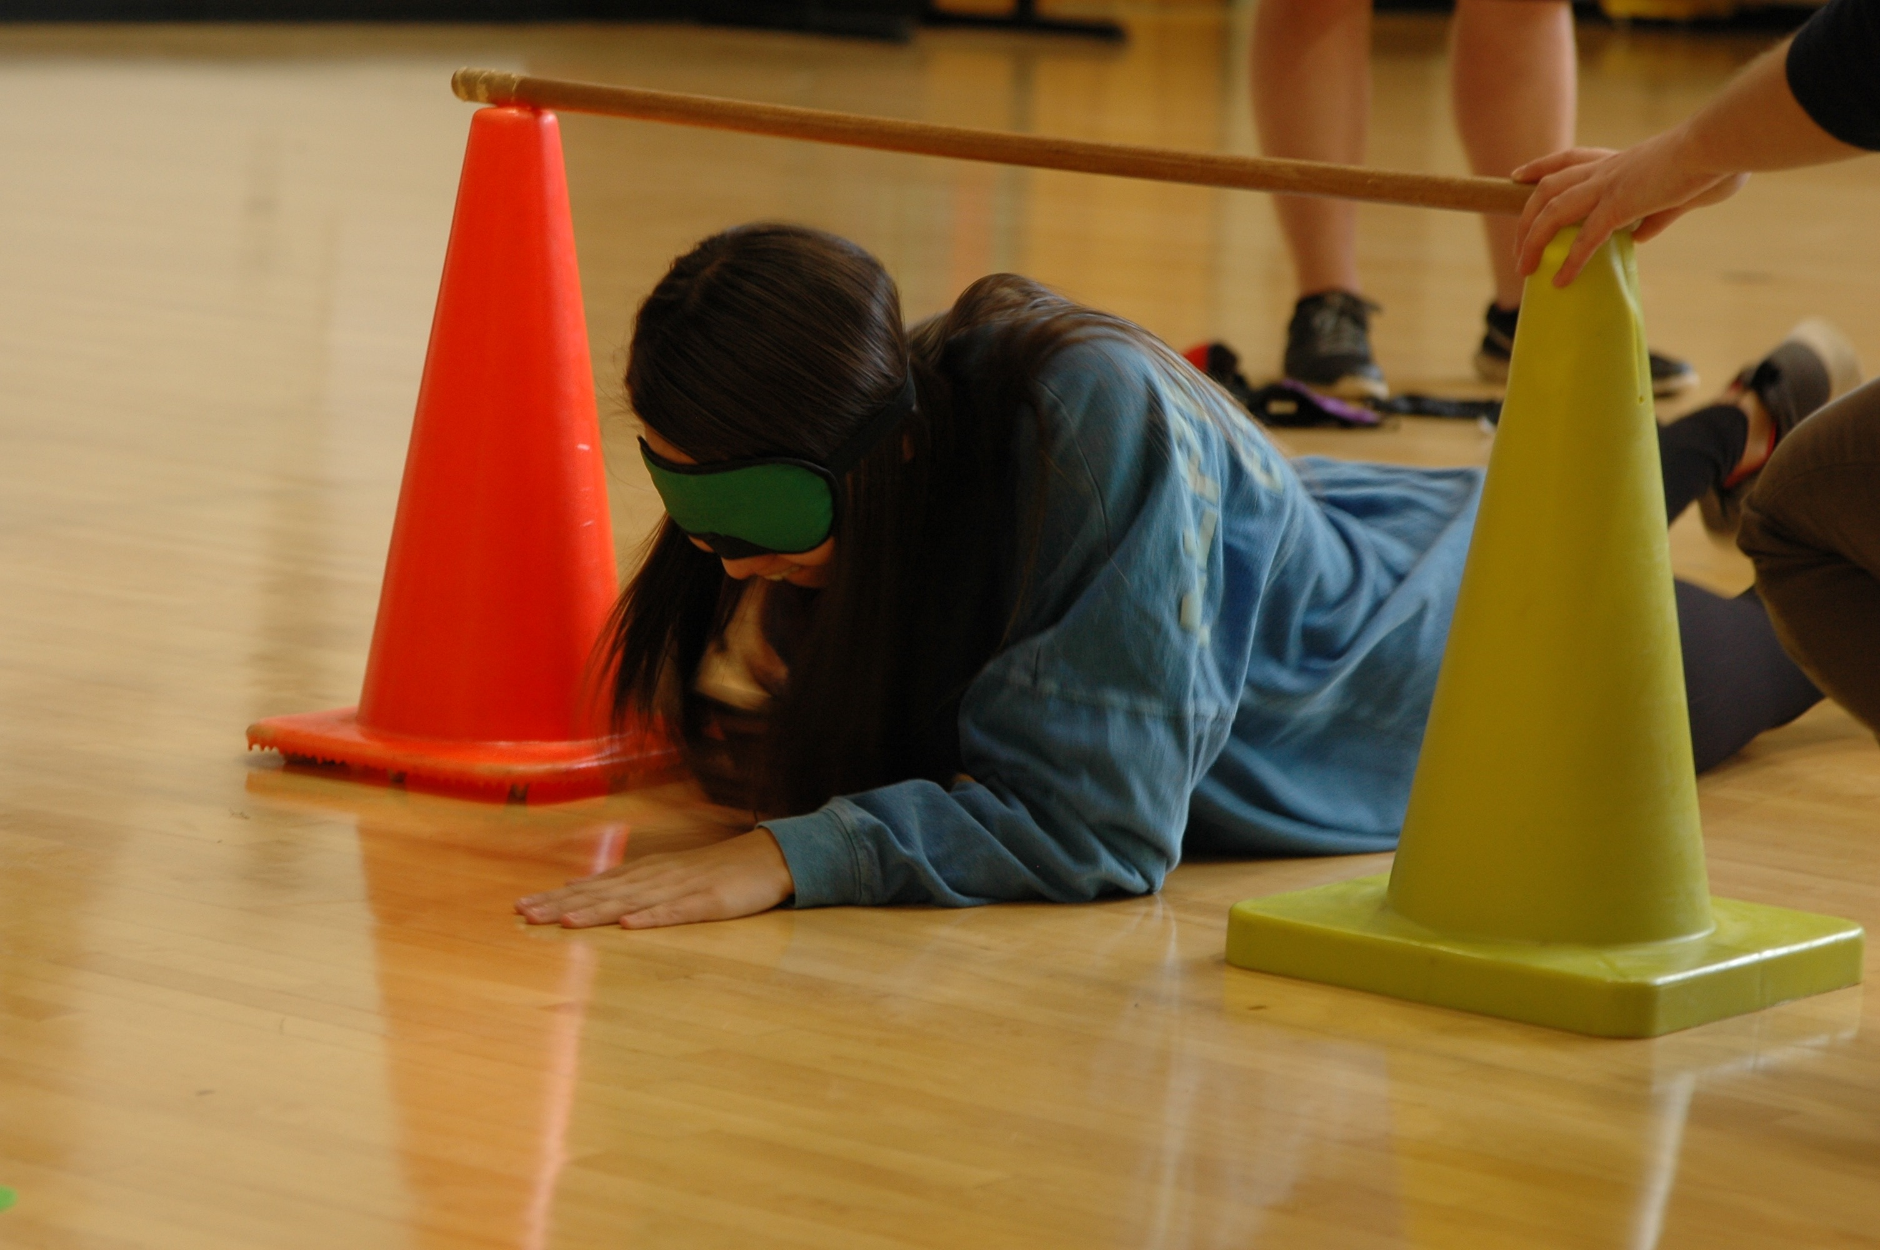

For presentations in the class, students should dress in “recreation professional/business casual” attire. This may include: khaki or dark pants/Bermuda (8-10”) length shorts, polo or button down shirt, casual dress or skirt. These items are NOT considered “professional attire”: jeans, shorts that are 5” or shorter in length, t-shirts, hats, sundresses, clothes that are dirty and/or stinky, greek wear, pajamas, sweat pants, tube tops, camo attire, etc.

Content Accommodations:
In the spirit of higher education, this course should present challenges, some of which may be ideological in nature, and you are encouraged to empower yourself to engage these challenges. This course has been designed to meet or exceed the quality of similar courses taught at top‐caliber universities around the world. Readings and materials assigned for this class have been carefully scrutinized and selected. As we study leadership in its various forms and contexts, we will apply the concepts we engage to a variety of examples, including those that occur in the venue of popular culture. Popular culture, as you are certainly aware, can contain potentially objectionable material. Please understand that all material that I will present in this class or require you to engage with has been selected for its overall value and its applicability to the course. That said, I will not make content accommodations for any material scheduled for this course. It is your responsibility to review the syllabus, readings, assignments, and materials to be sure that this is a course you wish to take. Should you have questions or concerns, please see me immediately.

Library Research
Hunter Library provides students with access to group and individual study spaces and to thousands of information resources: print and electronic books, newspapers, and scholarly journal articles. These resources can be searched online and often accessed there (http://library.wcu.edu) or can be searched and located in the library building. Students in need of research or library support can get help online (http://researchguides.wcu.edu/help), from your subject specialist, Elizabeth Marcus emarcus@email.wcu.edu, or from the research guide: http://researchguides.wcu.edu/prm

E-mail Etiquette
Electronic mail to and from your “@catamount.wcu.edu” address is the preferred method of communication. Please follow common e-mail rules:
- Use your @catamount.wcu.edu email address
- Use a short and accurate subject header
- Use a proper salutation (Hello, Good Morning, Greetings, etc.)
- Introduce yourself in the first paragraph (if needed)
- The message body should be written in a concise and clear manner. Please do not BS or ramble. Get to the point.
- Leave-taking (departing farewell) should be appropriate. (Respectfully yours, Sincerely, Take care, etc.)
- Sign you email with your full (First and Last) name
- Proofread for content, spelling and grammar.

For the visual learners…
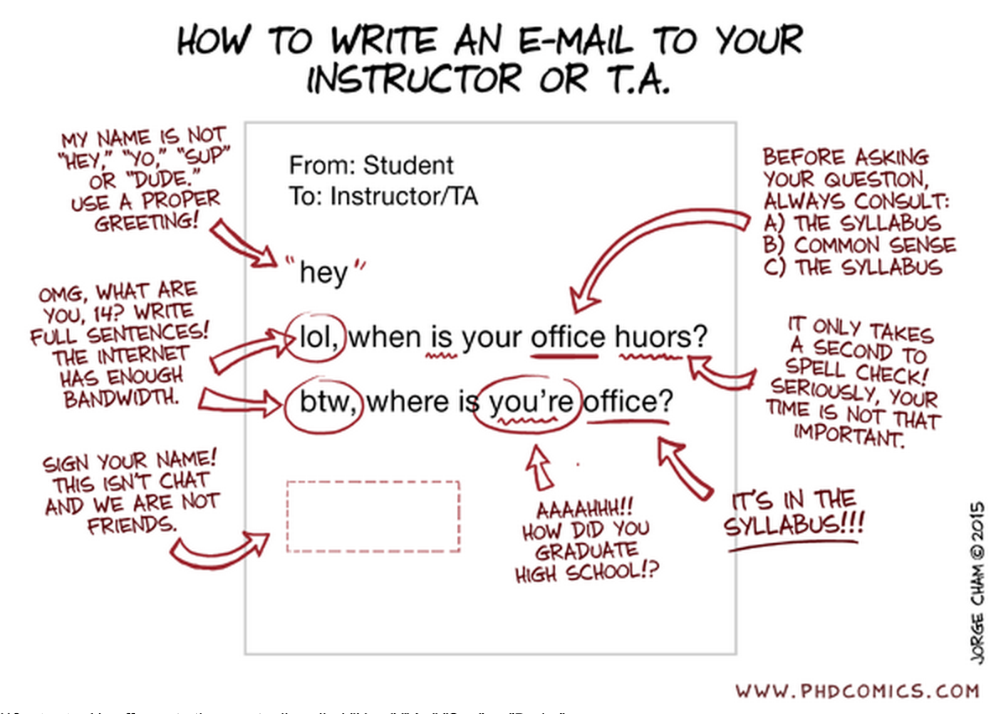

If you need additional information, read this article:
https://www.insidehighered.com/views/2015/04/16/advice-students-so-they-dont-sound-silly-emails-essay

Course Schedule: Please refer to the course schedule posted in Blackboard for the most current information. *The Schedule is “Fluid”, meaning that the topics for discussion may change depending upon student participation and interest; assignment dates may change due to student input or university scheduling; or unique opportunities may present themselves and be added. Students will be notified in a timely manner of schedule changes.

Course Evaluation Schedule: Students will be asked to participate in an online evaluation of this course. An email will be sent to students reminding them to complete the online course evaluations. The evaluations are scheduled to be available starting in early NOVEMBER THROUGH early DECEMBER .

Additional Resources available in the library for reference:
• Byl, J., Baldauf, H., Doyle, P. & Raithby, A. (2007). Chicken and Noodle Games. Champaign,
IL: Human Kinetics.
• Cain, J. (2012). Find Something To Do!. Brockport, NY: Teamwork & Teamplay.
• Cain, J. (2013). Rope Games. Brockport, NY: Teamwork & Teamplay.
• Cain, J., Cummings, M., & Stanchfield J. (2005). A Teachable Moment. Dubuque, IA:
Kendall/Hunt Publishing.
• Cavert, C. (1999). Affordable Portables. Oklahoma City, OK: Wood & Barnes Publishing &
Distribution.
• Cramer, H. (2007). Make it Take it, Fitness Games. Durham, NC: The Great Activities
Publishing Company.
• Drury, J.K. & Bonney, B.F. (1992). The Backcountry Classroom. Merriville, IN: ICS Books,
Inc.
• Hart, L. & Waisman, C. (2005). The Leadership Activity Book. New York, NY: American
Management Association.
• Kilty, K. (2006) Creating Health Habits: An Adventure Guide to Teaching Health & Wellness.
Beverly, MA: Project Adventure.
• Jackson, T. (1993). Activities That Teach. Cedar City, UT: Red Rock Publishing.
• Jones, A. (1998). 104 Activities That Build. Richmond, VA: Rec Room Publishing.
• Phipps, M. & Phipps, C. (2000). The Group Book: Effective Skills for Cooperative Groups.
Sylva, NC: System 4 Services. Available for purchase in WCU Bookstore.
• Rohnke, K. (1989). Cowstails & Cobras II. Dubuque, IA: Kendall/Hunt Publishing.
• Rohnke, K. (1984). Silver Bullets. Dubuque, IA: Kendall/Hunt Publishing.
• Rohnke, K. & Butler, S. (1995). Quicksilver. Dubuque, IA: Kendall/Hunt Publishing.
• Rohnke, K. & Grout. J. (1998). Back Pocket Adventure. Simon & Schuster Custom Publishing.
• Schoel, J., Prouty, D., & Radcliffe, P. (1988). Islands of Healing. Dubuque, IA: Kendall/Hunt
Publishing.
• Simpson, S. (2003). The Leader Who Is Hardly Known. Oklahoma City, OK: Woods & Barnes
Publishing.
• Sladkey, D. (2009). Energizing Brain Breaks. Energizingbrainbreaks.com (self-published)

Appendix A: Boilerplate
“The university requires me to pass along to you a whole litany of contractual information, some of which you may find important, some of which you may not. I have placed this information at the end of this syllabus; I suggest you refer to it as necessary.”

University Expectations and Support Services

Writing and Learning Commons (WaLC)

The Writing and Learning Commons (WaLC) is a free student service, located in BELK 207, providing course tutoring, writing tutoring, academic skills consultations, international student consultations, graduate and professional exam preparation resources, and online writing and learning resources for all students. To schedule tutoring appointments, visit the WaLC homepage (http://walc.wcu.edu) or call 828-227-2274.

Blackboard Support

The learning management system for this class is blackboard and can be found at: http://wcu.blackboard.com Additional help with blackboard can be found at: http://tc.wcu.edu, (828) 227-7487 or by visiting the Technology Commons located on the ground floor of the Hunter Library.

Accommodations for Students with Disabilities

Western Carolina University is committed to providing equal educational opportunities for students with documented disabilities and/or medical conditions. Students who require reasonable accommodations must identify themselves as having a disability and/or medical condition and provide current diagnostic documentation to the Office of Disability Services. All information is confidential. Please contact the Office of Disability Services at (828) 227-3886 or come by Suite 135 Killian Annex for an appointment.

Student Support Services
Student Support Services provides support to students who are either first-generation, low-income or those who have disclosed a disability with: academic advising, mentoring, one-on-one tutorial support, and workshops focused on career, financial aid and graduate school preparation. You may contact SSS at (828) 227-7127 or email sssprogram@wcu.edu for more information. SSS is located in the Killian Annex, room 138.

Civility and Ground Rules
The Western Carolina University Community Creed states: “I will respect the rights and well-being of others.” Each student may possess different ideas, as well as different ways of communicating those ideas. Because of these differences, respect and civility are integral to maintaining the quality of the academic environment and free inquiry.
(http://www.wcu.edu/student-life/policies-affecting-students/statement-of-student-rights-and-responsibilities.asp)

SafeAssign Tool
All written work submitted for this class is eligible for submission to the SafeAssign tool at the instructor’s discretion.
_____________________________________________________________________________________________________________________________________

WCU Policies

Sexual Harassment Policy
The University deems sexual harassment to include conduct constituting sexual harassment under Title VII of the Civil Rights Act of 1964 and Title IX of the Education Amendments of 1972.

Academic Integrity Policy
"I will practice personal and academic integrity" – WCU Community Creed

Academic Integrity Policy and Reporting Process
This policy addresses academic integrity violations of undergraduate and graduate students.
Students, faculty, staff, and administrators of Western Carolina University (WCU) strive to achieve the highest standards of scholarship and integrity. Any violation of the Academic Integrity Policy is a serious offense because it threatens the quality of scholarship and undermines the integrity of the community. While academic in scope, any violation of this policy is by nature, a violation of the Code of Student Conduct and will follow the same conduct process (see ArticleVII.B.1.a.). If the charge occurs close to the end of an academic semester or term or in the event of the reasonable need of either party for additional time to gather information timelines may be extended at the discretion of the Department of Student Community Ethics (DSCE).

General:
This policy addresses academic integrity violations of undergraduate and graduate students. Students, faculty, staff, and administrators of Western Carolina University (WCU) strive to achieve the highest standards of scholarship and integrity. Any violation of this policy is a serious offense because it threatens the quality of scholarship and undermines the integrity of the community.
Instructors have the right to determine the appropriate academic sanctions for violations of the Academic Integrity Policy within their courses, up to an including a final grade of “F” in the course in which the violation occurs.

Definitions:
1. Cheating – Using, or attempting to use, unauthorized materials, information, or study aids in any academic exercise.
2. Fabrication – Creating and/or falsifying information or citation in any academic exercise.
3. Plagiarism – Representing the words or ideas of someone else as one’s own in any academic exercise.
4. Facilitation – Helping or attempting to help someone to commit a violation of the Academic Integrity Policy in any academic exercise (e.g. allowing another person to copy information during an examination).

Undergraduate and Graduate Academic Integrity Process:
Additional information is available on the Student Success website under Student Community Ethics: http://www.wcu.edu/experience/dean-of-students/AcademicIntegrity/academicintegrity.asp

**Students who are caught cheating, fabricating, plagiarizing or facilitating academic dishonesty, will receive a grade of F in this course.
__________________________________________________________________________________________________________________________________

General Academic Info:
Academic Calendar includes dates for all breaks, university closures, final exams, etc. The academic calendar can be found at: http://www.wcu.edu/learn/academic-calendar.aspx
Final Exam
The university final exam schedule can be found here: https://www.wcu.edu/registrar/calendars/fall_final_exam.pdf

Important Dates
Students must be familiar with the class attendance, withdrawal, and drop-add policies and procedures. Please double check these dates online, as they sometimes change. Here is the link to these dates on WCU’s website: https://www.wcu.edu/WebFiles/registrar/REG_2018-2019_Academic_Calendar_FINAL.pdf
________________________________________________________________________________________________________________________________________

Syllabus Updates:

This syllabus, with its course schedule, is based on the most recent information about the course content and schedule planned for this course. Its content is subject to revision as needed to adapt to new knowledge or unanticipated events. Updates will remain focused on achieving the course objectives and students will receive notification of such changes. Students will be notified of changes and are responsible for attending to such changes or modifications as distributed by the instructor or posted to Blackboard

