PRM Digital Portfolio Instructions
DIGITAL PORTFOLIO (Linked In Profile)

Purpose: As a PRM major, you are required to complete a digital portfolio, which can be used to secure a Capstone Internship position and in future job searches. This digital portfolio is reviewed and graded for the first time in PRM 260, will be graded for a second time in PRM 370 (Internship Orientation). Potential employers may search for you online prior to a personal interview, phone call or email. Having a professional digital presence highlights your strengths, experiences, and unique skills, which the company may be searching for. Your digital portfolio is a “fluid” document, meaning that it should be updated on a regular basis.

I. Create a digital platform by using Linked In.
• Information for creating a profile on Linked In: https://university.linkedin.com/linkedin-for-students
• Actual Linked In website: https://www.linkedin.com/home

*Tips from Debby: Your Linked In profile is “fluid”. You can constantly update, revise, add, and delete. When you feel it is “gradable”, that is when you will connect with me. The best advice I can give you is to play around with the website and use the notes below to aid you in adding the required elements.

To get started… If you already have your Linked In profile created, sign in and skip down to section II. If not, you will need to “join now”. Follow the prompts below.

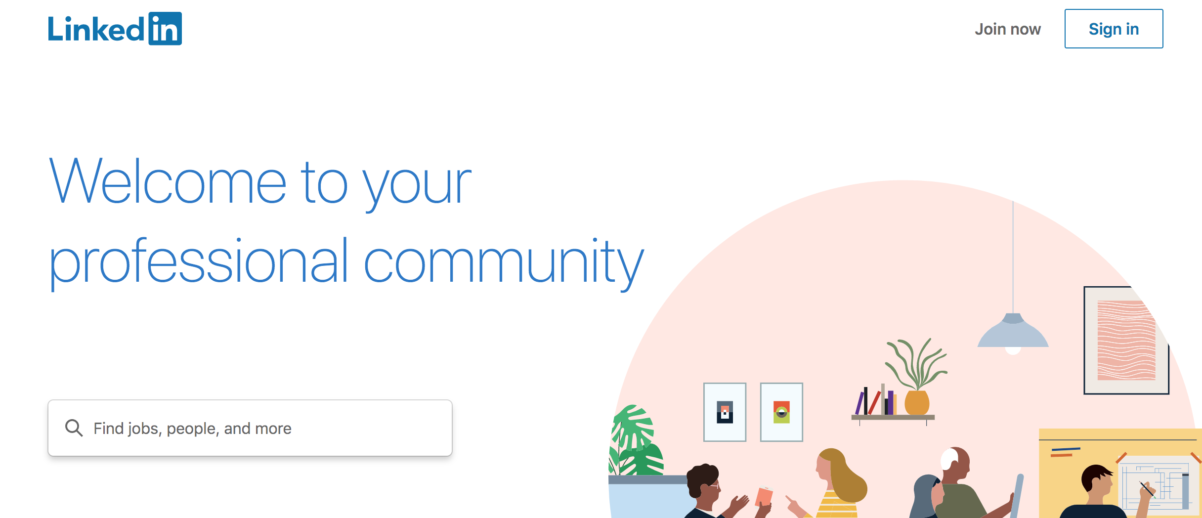

To create a NEW Linked In profile, you will need to enter your email address (use your personal email address because your WCU one will become deactivated once you graduate). You will also need to create a password.

Once you have created your account, you will get a page that looks like this:
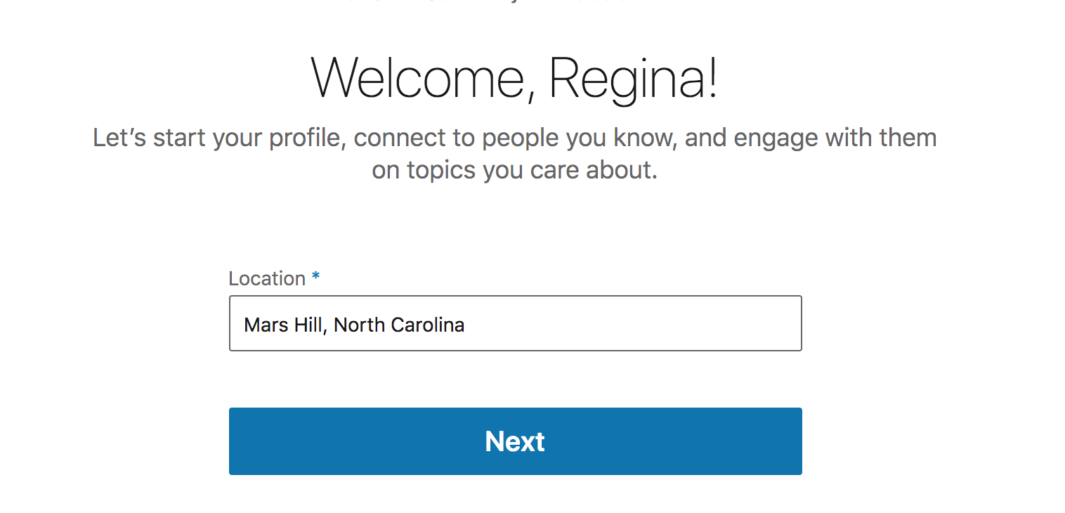 Enter the location you plan to use as your address.

Next you will get this prompt…
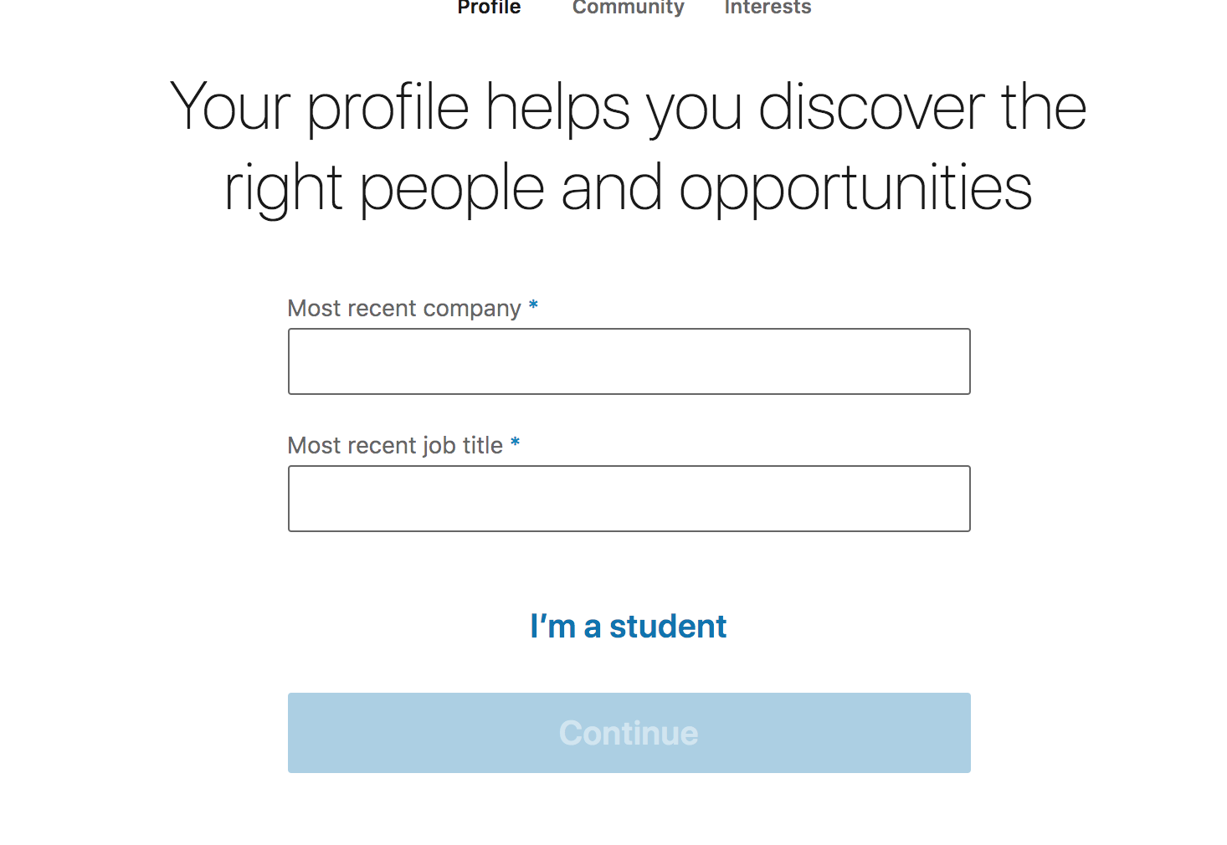 You can either enter your “company and position” or just select “student”.
I suggest you select “student?

Once you select “student”, it will take you to a page where you can enter the following information. Note that the pull down menus may not have what you are looking for. I had to type in “Parks & Recreation Management”.
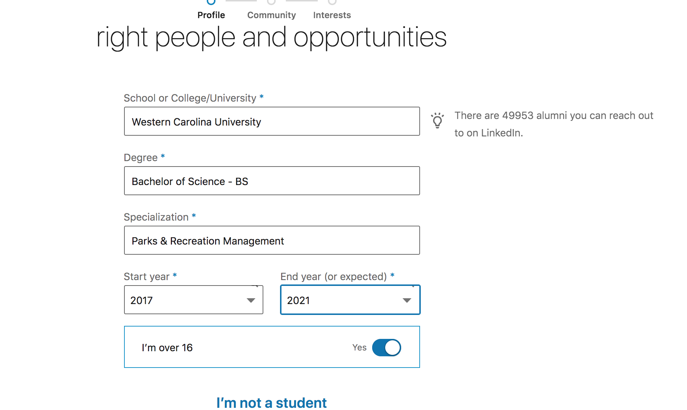
After those prompts, you will receive an email and type in a special code. Type in the code. Then you will be taken to a page where there are a TON of contacts you can link with, scroll down to the bottom and select “SKIP” for now. You can link with them later.

The next page will ask you to add a photo. Pick one that is a professional looking head shot.
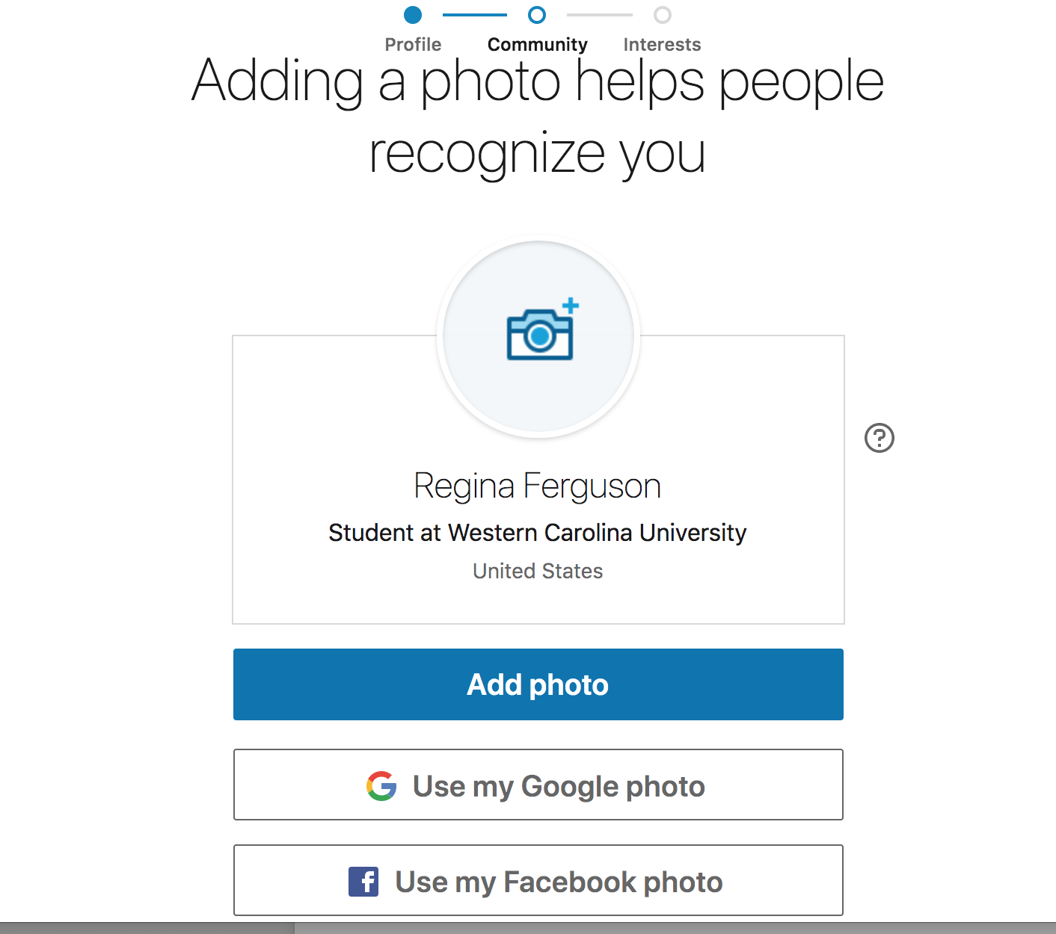

The photo I selected is okay, but not great. I have on a hat and sunglasses, not very professional. Try to do better than what I have uploaded here.

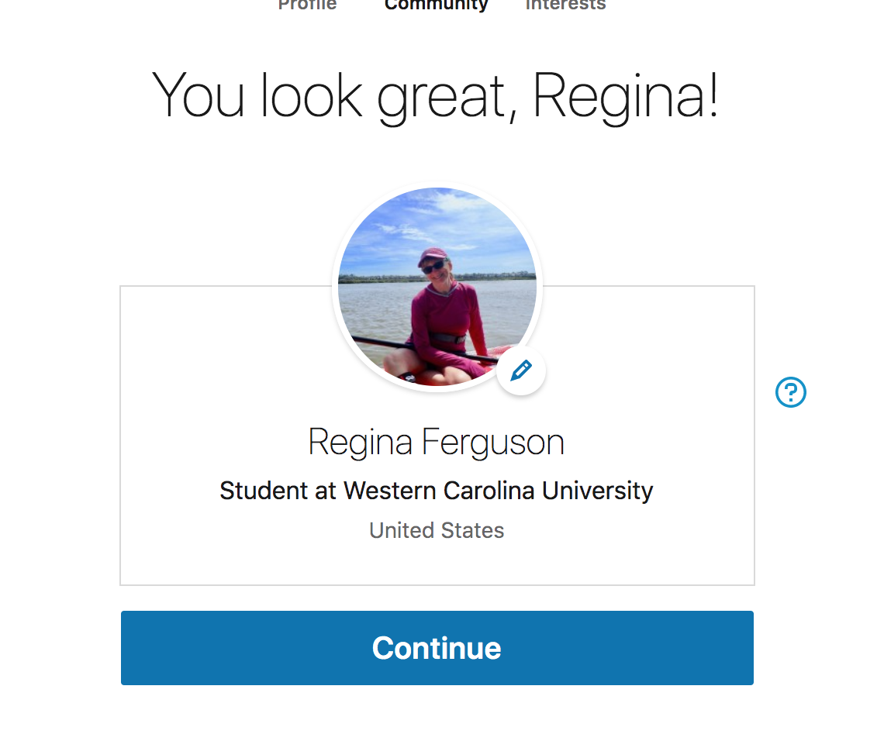
Linked In will take you through more “prompt” pages, where you can elect to enter information or “skip” and enter information later once you set up your complete profile.

When you get to this page, go to “Me” in the upper right corner and select “view profile”.

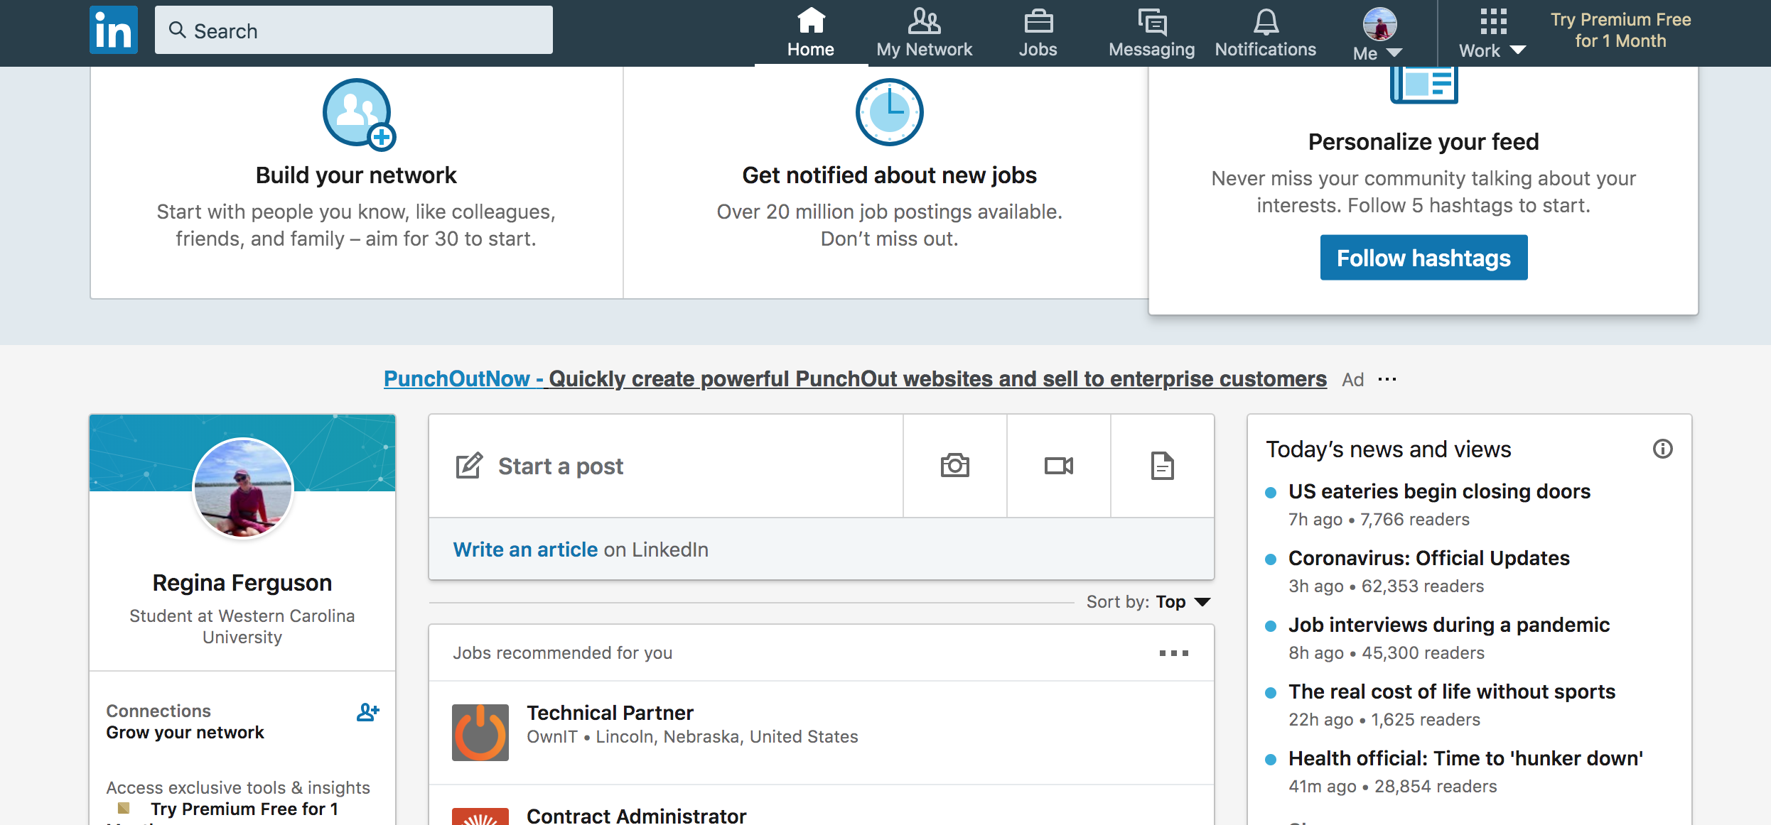

Now you will have a page that should look like this…

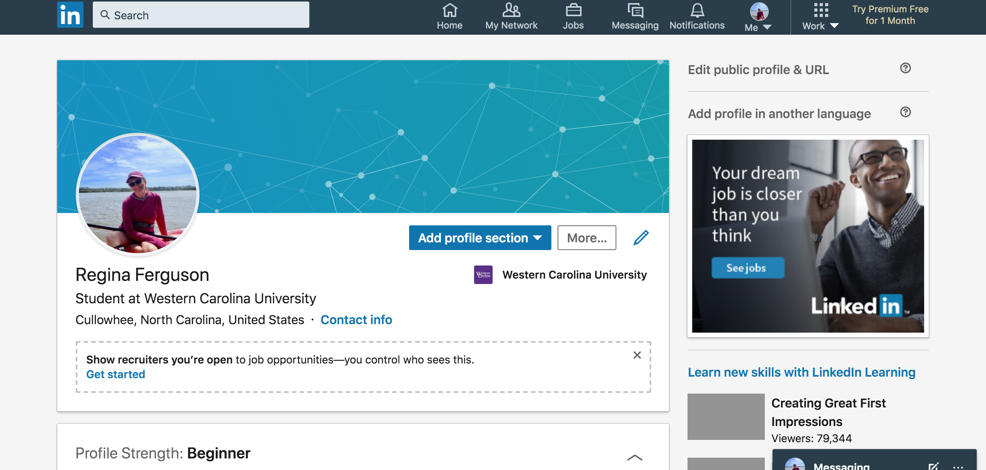

To edit and add to your profile, you can select “add profile section” or “more” or click on the “pencil” icon. Now you are ready to start creating your Linked In profile!!!

II. Items to include on your Linked In profile:

a. Photos: You will need a professional looking headshot and a landscape style photo for the top header. The head shot should be high quality, you alone, professionally dressed. The landscape style top header photo can be an actual landscape, a photo of you in “action”. Just make sure it fits the configuration. If you don’t have an appropriate landscape style photo, just leave the Linked In blue background for now.

b. First Name, Last Name, and Headline: Use the name you prefer. The headline is a short, memorable professional title or slogan. Check out the profiles of students and recent alumni you admire for ideas.
It also asks for “current position”, you can leave this blank or if your current work/intern position is something you are proud of, then include it. You will notice on mine (the real me: Debby Singleton), I have the same headline and current position. You can elect to show your education in the intro. You will be asked to include country, city, zip code (put the one that best matches the address you will be using on professional contacts). There is a drop down menu for industry as well, pick the one that best fits your professional career path.

c. About Section: Develop a professional summary in the “About” section and UPLOAD your current resume: This is similar to the first few paragraphs of your best cover letter. Concise and confident. It is a “snapshot” of who you are and what your qualifications are and possibly what you aspire to be. *This is where you will upload your current professional resume and outdoor activity log (if applicable). *This is also the only place you an upload documents.

d. Experience: Include all work or internship experiences and chronological order (most recent first). For each provide concise, clear description of duties using action verbs. Look to your resume for assistance. *Note that Linked In will automatically list these in order. If you have worked for the same agency more than once (such as a summer camp), you can list those as separate experiences with different times, but it will be linked with the original post (see my WCU experience for example).

e. Education. Include all of WCU and any community college you attended. Do not include high school unless it was a “special” course of study such as a magnet, arts, STEM, or international school. Under “degree” it should be “Bachelor of Science”. Under “field of study”, it should be Parks & Recreation Management, you will probably have to type this in and not choose the first item that pops up. Start year (when you began at WCU), end year (your anticipated graduation year). “Grade” refers to GPA, only include if over 3.0. “Activities and Societies” can be Greek organizations, club sports, PRM club, professional and honor fraternities, Honors College, etc. “Description”, this is where you can include a general synopsis of your career path in PRM, your minor, and maybe some courses or internships or experiences which help define your time at WCU. *If you are a DOUBLE Major, add a second “Education” section for WCU and put your other degree in this section.

f. Licenses & Certifications: Current certifications you have. Include the certification name, certification authority (organization who grants the cert), when you received it and when it expires (or if it doesn’t), and a website to the organization if it needs further explanation.

g. Volunteer Experience: What have you done in terms of service, volunteer work, service learning, etc. Include dates and a description. This can be pulled from your resume. *This is an optional category.

h. Skills & Endorsements: Include keywords or phrases that recruiters search for. Find relevant job listing that appeal to you and include the information that matches your skills set. **Include at least 5 Key Skills to begin with.

i. Accomplishments: Within this section you can add the following: Publications, Courses, Projects, Honors & Awards, Language, and Organizations. For your Linked In profile each section is STRONGLY ENCOURAGED to include if applicable. The REQUIRED ACCOMPLISHMENTS are noted by **.

(1) Honors and awards: During college, before college if applicable, dean’s list, Honor’s College, scholarships, undergraduate research, college athletic awards.

(2) Courses**: List classes that show off your skills and interests, the ones you feel are beneficial for future internships or jobs. For the classes, you can include a “brief” description in the title and you can include the course number.

(3) Organizations: This can be clubs, sports, groups, professional organizations, memberships (NCRPA, WEA, ACA, AMGA, PRM Club, etc)

(4) Projects**: Please include a brief synopsis/description of at least ONE of the following. The program/evaluation plan from PRM 361, the “abstract or synopsis” of your feasibility study, industry report, or business plan from PRM 430, an assignment in PRM 461, your research paper for PRM 495, an educational program you led during an internship, a trip plan for PRM 354, 454, or 427, a service project you organized, a special project during an internships or independent study, etc. **You will NOT be able to upload projects here.

(5) Publications (& Presentations): If you published an article for the Tent Peg or any other magazine, newspaper, etc. include the information here. *There is not a category for presentations, but you can make this section work for them. Definitely include your PRM 495 Senior Seminar presentation here or if you presented at NCUR or undergraduate research symposium.

(6) Languages: If you are fluent in another language, include it.

III. Grading: Once you have created your profile in Linked In, send a request to connect with the instructor through Linked In using this email address (drfsingleton@gmail.com). You will also need to complete the assignment module in Bb. Refer to Grading Rubric for details (next page).

PRM Capstone Portfolio Rubric (LinkedIn Profile) Name: _______________________________
Outstanding= Met all criteria, professional.
Average= Missing at least 2 required items. Could be more professional.
Fair= Missing 2 or more required items. Does not display professionalism.
*For items that do not have point values assigned, instruction discretion for awarding points.

Headings & Criteria  Items in BLUE are required for PRM 370 | Outstanding | Average | Fair | Actual Points | Comments
I. Opening Section/Introduction:  a. Professional looking, nice photo, preferably a head shot  Background photo is optional, landscape/panorama preferred  b. Headline: tell about yourself, concise, memorable | 20 | 16 | 13
II. Professional Summary: (within “About” section) what motivates you, what are your skills, what do you want to do next. Concise, confident.  a. Upload current professional resume.  b. Upload current outdoor resume/activity log (if applicable) | 10 | 8 | 6
III. Experiences: jobs, internships, volunteer work experiences you have held (found on your resume), along with what you have accomplished at each one (action verbs, concise) You can include photos or videos from those jobs (professional of course). | 25 | 20 | 15
IV. Education: include all college, community college, NOLS or OB if applicable, special trainings or certification courses. Do NOT include high school, unless special. Make sure you use the correct degree: Parks & Recreation Management | 15 | 12 | 9
V. Licenses & Certifications: List any current certifications you hold, include name, organization that certified you, when you received it and when it expires. | 10 | 8 | 6
VI. Skills & Endorsements: list at least 5 key skills. Use keywords found on job or intern ads you are interested in. | 10 | 8 | 6
VII. Volunteer experience and causes: what have you done in terms of service, volunteer work, service learning, etc. Include if applicable.
ACCOMPLISHMENTS
(1) Honors & awards: during college, dean’s list, chancellor’s list, Honor’s College, scholarships, college athletics, etc, Include if applicable.
(2) Courses: list classes that show off your skills and interests, the ones you feel are beneficial for future internships or jobs. For the classes, give a brief descriptive title. Course number not needed. | 5 | 3 | 2
(3) Organizations: this can be clubs, sports, groups, professional organizations, memberships (NCRPA, WEA, or ACA, AMGA, etc) Include if applicable.
(4) Projects: Descriptions  PRM 361 Project/Description/Abstract  PRM 430 Description/Abstract  PRM 461 Project/Description/Abstract or Assignment  PRM 495 Research Paper /Abstract  You may also include other projects or assignments you feel are professional and related to your career path. | 20 | 16 | 13
(5) Publications & Presentations: Tent Peg article (if applicable), PRM 495 Senior Seminar presentation, NCUR, etc.
6. Language: If you are fluent in another language, include it.
Overall Professionalism: No errors in punctuation, capitalization, spelling. | 10 | 8 | 6
Total Points | 125

