Announcing the 2014 Fall Lecture Series from WCU Communication Sciences & Disorders
Western Carolina University, Cullowhee, NC
Speaker: Emory E Prescott, M.S./CCC-SLP
“Integrating Wellness Concepts into Traditional Speech Pathology Treatment”
Lecture Description: This program informs on wellness techniques that can be included with
your current modalities of care for speech and language, to produce
more positive healthy outcomes from treatment for clients of all ages.
Practical & beneficial information on relevant treatment concepts that
can be implemented right away by both current and future clinicians.
When: October 23, 2014 from 4:00 to 7:00 p.m.
Where: Room 175 of Western Carolina University’s new Health and Human Sciences Building, 4121 Little Savannah Road, Cullowhee, NC 28723

How do I attend? Reserve a space by contacting Dr. Billy T. Ogletree at ogletree@wcu.edu
or call Dr. Ogletree at 828-227-3379.
Cost: A donation is requested, specified as a gift to The Ruby Drew Scholarship
Fund. There will be a $5 charge for those obtaining CEUs.
Time Ordered Agenda:
- 4:00 - 4:30 p.m. Current state of affairs of individual health
- 4:30 - 5:30 p.m. Breathing and hydration techniques, general knowledge of nutritional impact and wellness concepts
- 5:30 – 6:30 p.m. Best practice with complementary interventions, collaboration with nutrition and PT, associative theory of recovery
- 6:30 – 7:00 p.m. Health care cost reduction, question and answer
Learning Outcomes: Learners will be able to:
- Identify and describe at least 5 behavioral and environmental factors that positively contribute to successful treatment outcomes
- Gain insight on how lack of health increases risk, illness & cost
- Recognize low cost or no cost methods of wellness and learn how to implement them with the therapy client caseload
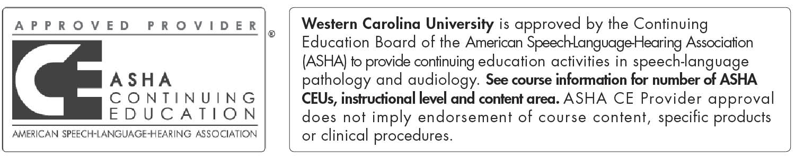
This course is offered for 0.3 ASHA CEUs (Intermediate level, Professional area)

About Emory Prescott: Emory has actively practiced as a clinical Speech Pathologist in various adult settings, including acute care, outpatient rehabilitation, home health, and skilled nursing for the past 21 years. She is an alumnus of WCU’s Communication Sciences and Disorders Program. Emory was previously the Director of Speech Pathology Services at Angel Medical Center and has been teaching the Master’s level Dysphagia course at Western Carolina University for the past two years. Emory is currently pursuing her Doctoral degree in Integrative Medicine.
Emory Prescott has no relevant financial relationships to disclose relative to this presentation.
Emory Prescott has no relevant non-financial relationships to disclose relative to this presentation.

