IMleagues Quick How-To’s for Club Officers

Accessing and Submitting Forms

- Click on locker
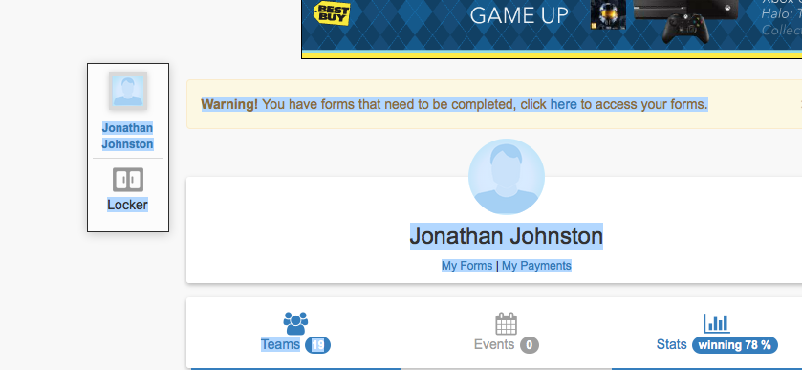

- To access form click each one

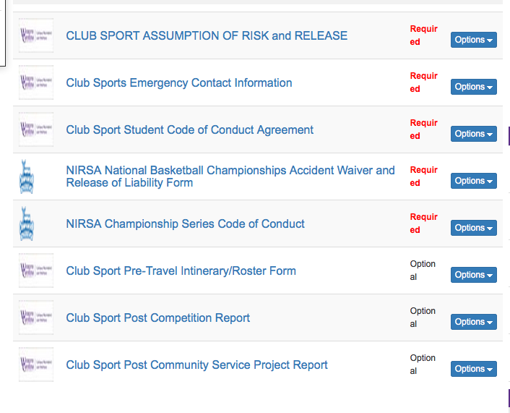

- Each form will look like this, then click submit at end.

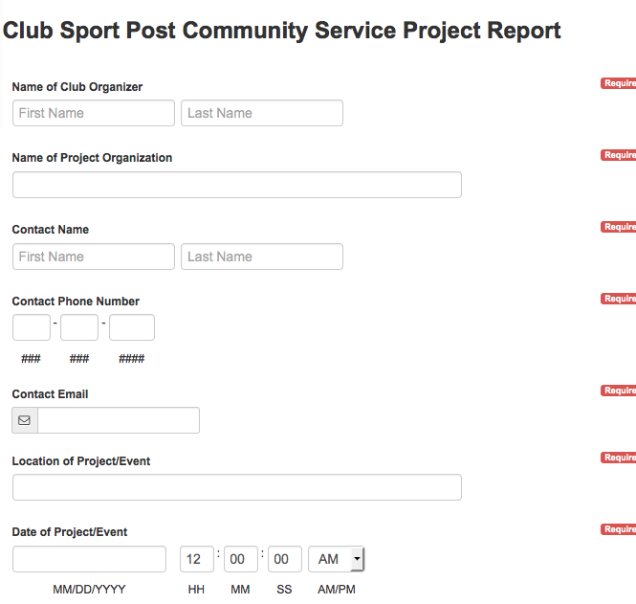

Accessing features within your Club Team

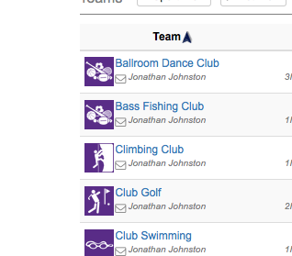
- Click on your club name

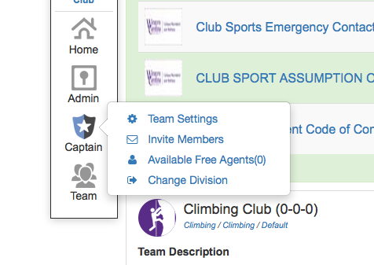
- To access Captain Settings

- Click to change Team Settings

- To change auto accepting of members, team description, etc. Team color and page colors need to stay as is. Logo ‘s will be the approved club sport logos

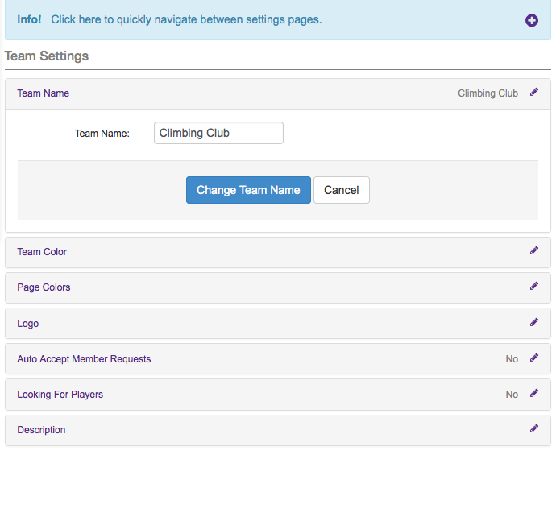

Accessing Club Roster

- Click on team Roster

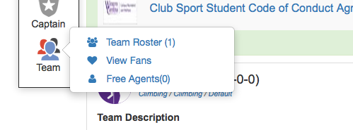

- Here you can view all forms submitted
- Change captain/co captain feature. *No players can be removed from this roster or official roster after the roster deadline even if they quit.
- Click export to print out form
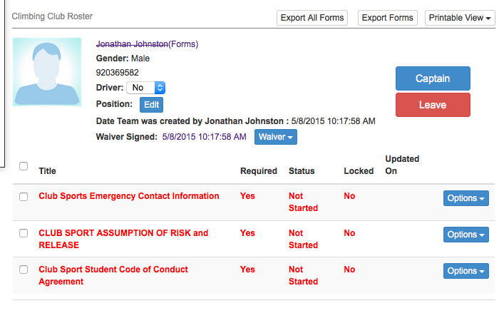

Miscellaneous Features

- On your home club page, you can message individuals or the whole team
- Edit team description. Probably should put facebook, twitter, website link here.

