The 23rd Annual Cullowhee Conference on Communicative Disorders Announces Speakers

Bonnie Henry & Susan Hutaff

Therapeutic Strategies for the Treatment of Executive Skills
Deficits in Children

Dr. William & Dr. Monica Harn
Current and Emerging Trends in Language Assessment and Treatment

When:
March 26th 1:00 to 5:00 p.m.
March 27th 8:30 a.m. to 5:00 p.m.

Where:
Western Carolina University
College of Health and Human Sciences
(Room 204 – Upper parking level entrance)

Speaker Bios

Susan E. Hutaff: Susan is a speech/language pathologist for Union Academy Charter School. She received an MS in Speech/Language Pathology from UNC-Chapel Hill. She has worked as an educational speech/language pathologist for over thirty years. Her major focus in practice has been helping students with language processing and social/communication disorders to be successful in the classroom and life. She has coauthored three publications: Reading to Read, For Parents Only – What Good Readers Do, and Action Based Communication Therapy. She has presented on topics such as the language and literacy connection, the educational impact of language disorders, music, movement and the brain, inclusive classroom-based practices and strategy based therapy.

Bonnie S. Henry: Bonnie is a speech/language pathologist for the Charlotte-Mecklenburg Schools. She received an MA in Speech/Language Pathology from Appalachian State University. She has worked for more than 30 years in rehab and the schools with a variety of disorders including language/learning impaired, Deaf and Hard of Hearing, and specific brain insult. Bonnie has presented extensively on topics such as ADHD, autism, language/learning impairments, and the treatment of neurological disorders. She is a creative professional, who has received grants to include the arts and technology in the treatment of speech and language disorders.

Monica L. Bellon-Harn, Ph.D., CCC-SLP, is Chair and Associate Professor of Speech and Hearing Sciences at Lamar University in Beaumont, Texas. Her research focus includes issues related to language treatment intensity and treatment outcomes within the context of linguistic diversity.
William E. Harn, Ph.D., CCC-SLP, is Dean of Graduate Studies and Professor of Speech and Hearing Sciences at Lamar University in Beaumont, Texas. His current interests include usage-based models of language and their potential application to speech and language intervention.

Time Ordered Agenda

March 26th
1:00 – 5:00 Bonnie Henry & Susan Hutaff

March 27th
8:30 – 12:00 Dr. William and Dr. Monica Harn
12:00 – 1:30 Lunch
1:30 – 5:00 Dr. William and Dr. Monica Harn
Therapeutic Strategies for the Treatment of Executive Skills Deficits in Children

Bonnie Henry & Susan Hutaff
Cullowhee Conference on Communicative Disorders
March 26, 2015; 1:00 – 5:00pm

Description:
Brain research has identified the prefrontal lobe as serving specific functions necessary for success in learning and life. The collection of cognitive skills localized in this area of the brain is known as executive functions. This set of behaviors includes attention, organization and flexibility of thought, emotional stability, working memory, and motivation. Educators see symptoms of deficits in executive function in children. These students have been described as being unmotivated, inattentive, disorganized, behavior problems and poor students. Research has provided a clearer understanding of the explanation of these behaviors. Executive function is developmental; there is a general pattern, beginning at birth and continuing into adulthood. Research has begun to link deficits in Executive Function to a variety of developmental disabilities, including autism, Aspergers syndrome, conduct disorder, and attention deficit hyperactivity disorder. Understanding what executive function is and the strategies that could be used to improve function is key to helping these students be successful in the classroom and in life. This presentation will explain Executive Functions and their developmental progression; provide information about assessment tools that can be used to describe Executive Function strengths and weaknesses in an evaluation; and present strategies to improve Executive Function in children.

Learner Objectives:
- The learner will be able to define executive functioning and tell how it is related to language skills.
- The learner will be able to describe students who suffer from executive functioning disorders.
- The learner will be able to relate at least two strategies that are beneficial in remediation of executive functioning disorders.

Current and Emerging Trends in Language Assessment and Treatment

Dr. William and Dr. Monica Harn
Cullowhee Conference on Communicative Disorders
March 27, 2015; 8:30 – 12:00 am; 1:30 – 5:00 pm

Description:
Usage-based models of language present an alternative to formal generative models that undergird many traditional child language assessment and treatment practices. In this presentation we will describe usage-based models and explore their implications for speech and language intervention. Key ideas will include interactive treatment, treatment intensity, treatment with dialect-speaking children, and how technological advances may facilitate assessment.

Learner Objectives:
Participants will be able to:
- Distinguish between traditional and usage-based approaches to assessment and treatment
- Identify treatment intensity factors that impact speech and language outcomes
- Describe child language treatment issues associated with dialect-speaking children

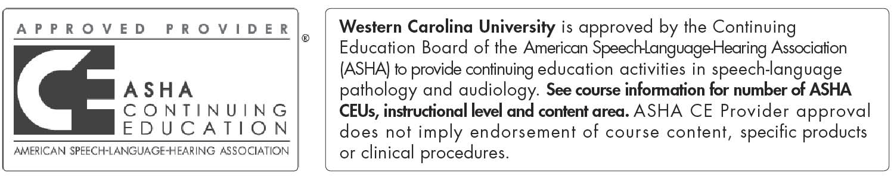
This program is offered for 1.0 CEUs (Intermediate level; Professional area)

Registration Form

**Please complete this form and send to the address below.**

First/Last Name: ___________________________________________________________

Email: _______________________________________

Mailing Address: _____________________________________________________________________________

Phone: _______________________________________________

Work Setting: _________________________________________________

How did you hear about the conference? __________________________________________________________

Continuing Education Units:
Please select the type(s) of CEUs requested:
_____ ASHA
_____ NCDPI
**Partial CEU credit will not be provided. Participants must attend both days of the conference to be eligible for CEUs.

Conference Fees:
- Attendance: $55.00
- ASHA CEU’s and NCDPI: additional $5.00 ($60.00 total)

Please make checks payable to WCU NSSLHA.

Mail your completed registration form and payment to:
Dr. Bill Ogletree
Western Carolina University
4121 Little Savannah Road
WCU HHS Building, Room 158 A
Cullowhee, NC 28723

*To assure seating, registration form and payment must be received by March 16th, 2014.

If you have questions/need directions, contact Dr. Ogletree via email at Ogletree@wcu.edu.

